AI ASSISTED CODING LAB ASSIGNMENT 14.2

ENROLLMENT NO :2503A51L21
BATCH NO: 19
NAME: LUNGHIMPOU KAMEI

Lab 14: Web Design Application – AI-Assisted HTML/CSS/JS Generation
Lab Objectives
- Design functional, visually appealing web applications using HTML, CSS, and JavaScript with AI assistance.
- Apply responsive, accessible, and interactive design principles.
- Create practical UI components for real-world web applications.
- Use AI to optimize layout, UX, and performance.

Task 1: Create a Responsive Web Page Layout
Instructions:
- Design a basic web page layout with a header, main content area, and footer using HTML and CSS.
- Use AI to assist in generating responsive CSS for different screen sizes.
- Ensure the layout is clean and visually organized.

PROMPT: Generate HTML and CSS code for a responsive web page with a header, navigation links, main content, and footer.
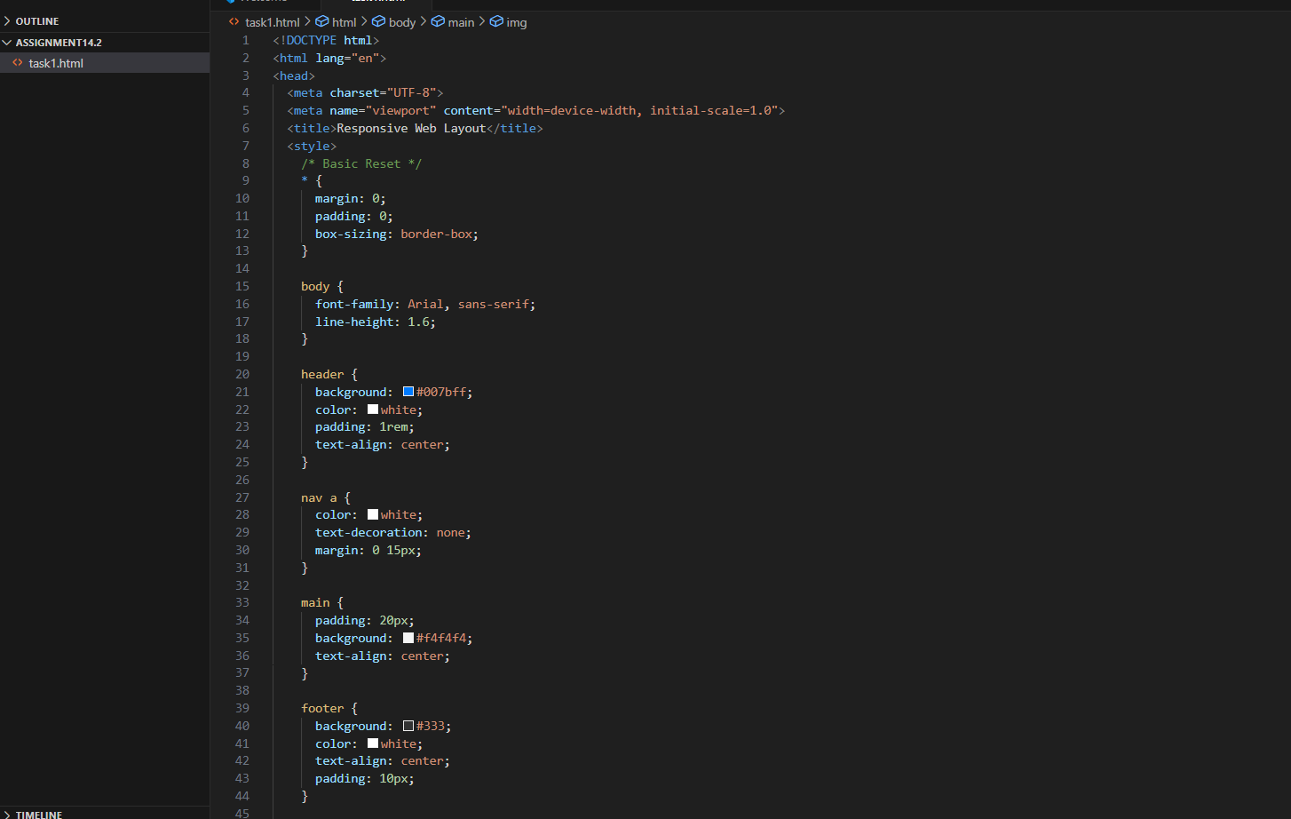
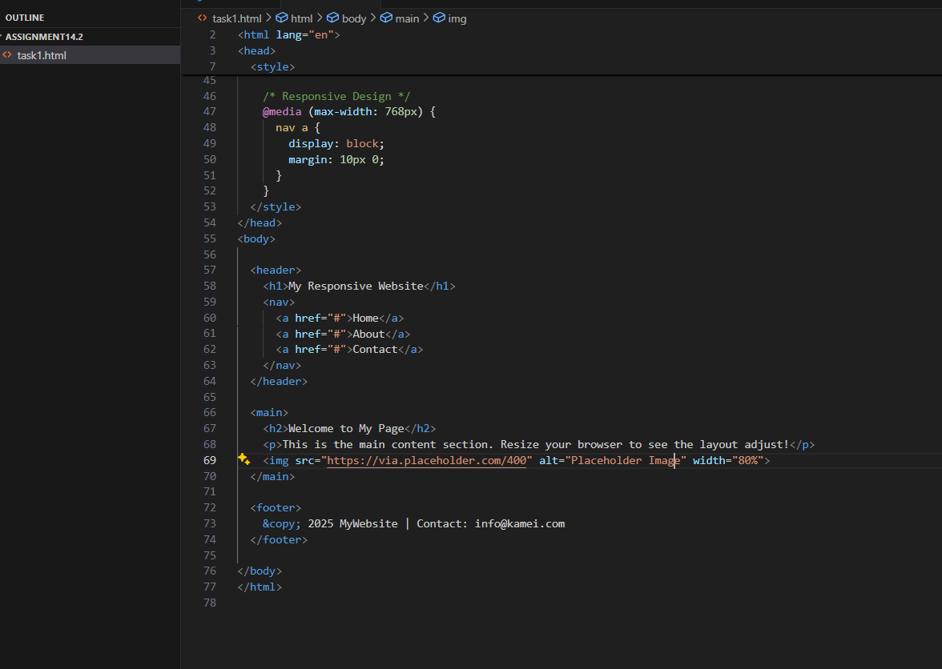

OUTPUT:
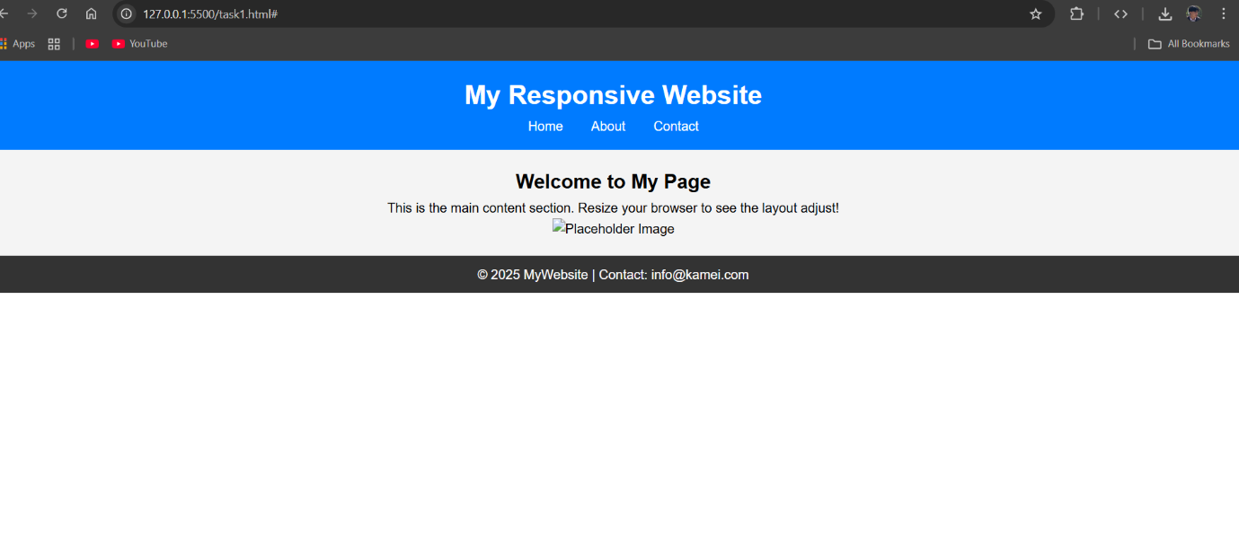OBSERVATION:
The web page layout adapts to various screen sizes. On smaller devices, navigation links stack vertically, showing that responsive design using media queries works effectively.

TASK2: Interactive Button with JavaScript
Instructions:
- Create a button on a web page.
- Use AI to generate JavaScript code that displays an alert message when the button is clicked.
- Ensure the code is clean and well-commented.

PROMPT: Create a simple HTML page with a button.
Write clean and well-commented JavaScript code that shows an alert message “Button clicked!” when the button is pressed.
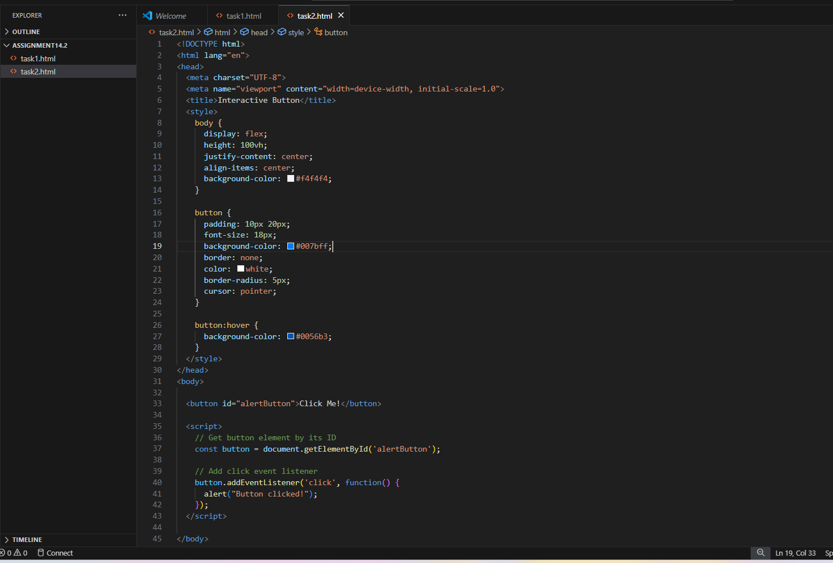
OUTPUT:
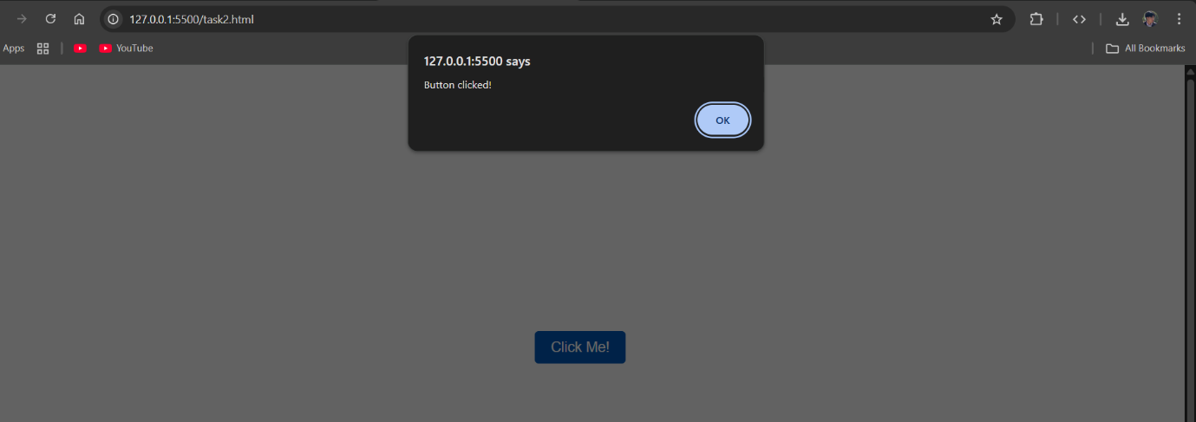
OBSERVATION:
When the button is clicked, a JavaScript alert message appears, confirming event handling works correctly. It demonstrates basic DOM interaction and user event response.

TASK3: Form with Validation
Instructions:
- Design a contact form with fields: Name, Email, Message.
- Use AI to generate JavaScript code for form validation (e.g., non-empty fields, valid email format).
- Add inline error messages if input is invalid.

PROMPT: Create a contact form using HTML, CSS, and JavaScript with fields for Name, Email, and Message.
Add JavaScript validation to check that all fields are filled and that the email is in a valid format.
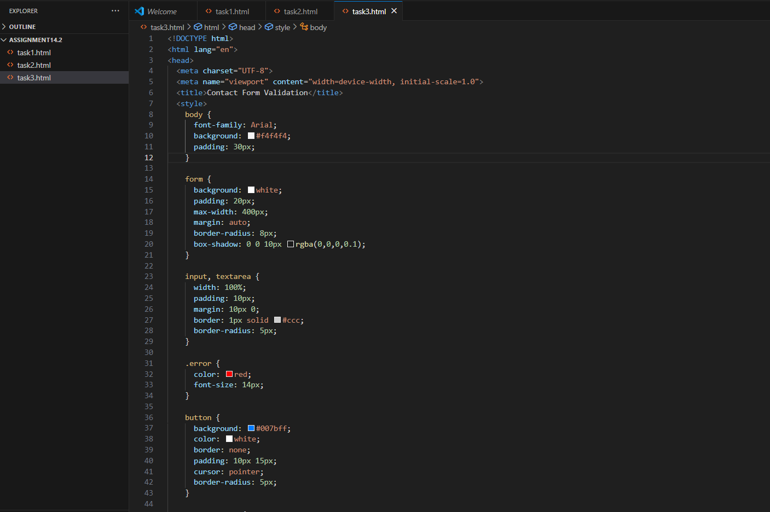
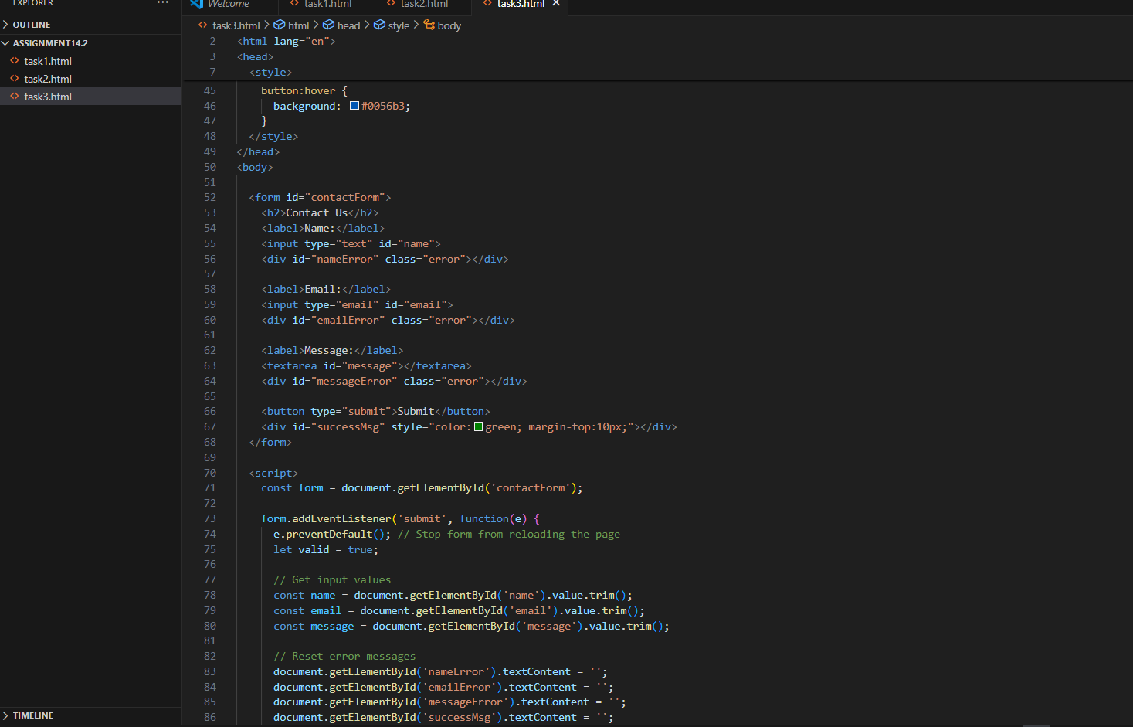
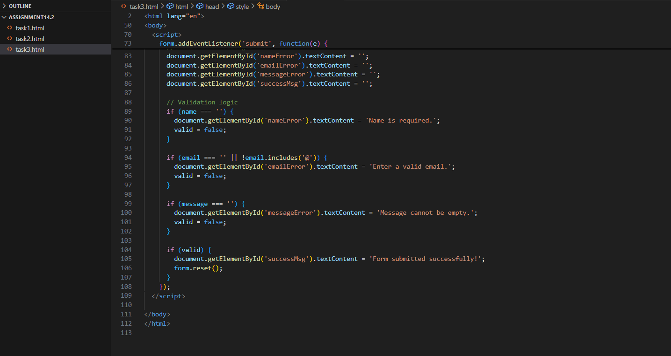
OUTPUT:
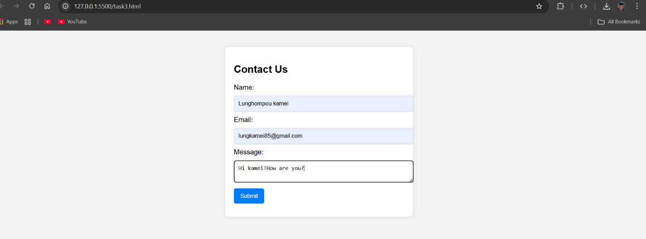
OBSERVATION:
The form checks for empty fields and invalid email formats. It shows inline error messages and confirms successful submission, proving client-side validation works properly.

TASK4: Dynamic Content Generation
Instructions:
- Create a list of items (e.g., product names) using HTML.
Use AI-generated JavaScript to dynamically add or remove items from the list when a button is clicked

PROMPT: Write HTML, CSS, and JavaScript code for a web page with a list of items and two buttons: “Add Item” and “Remove Item”.
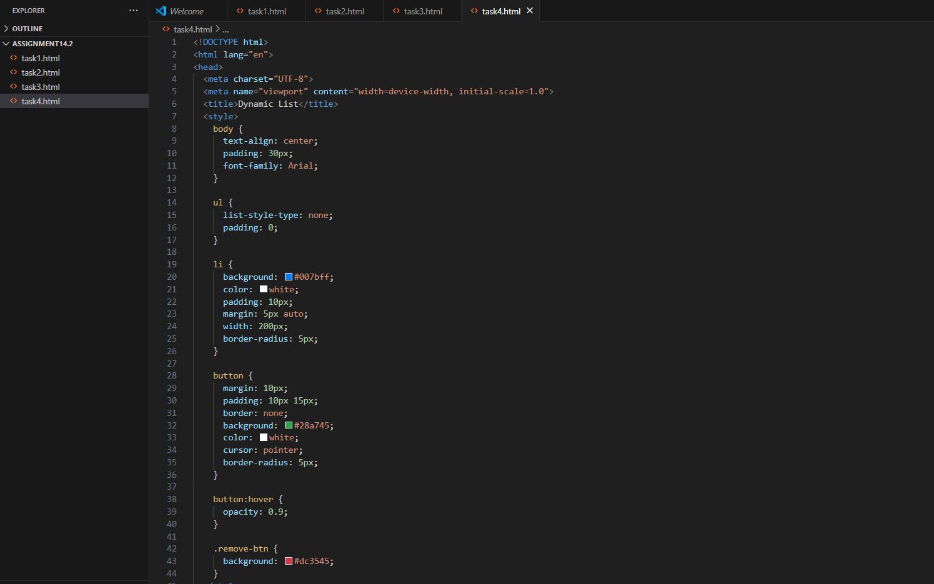
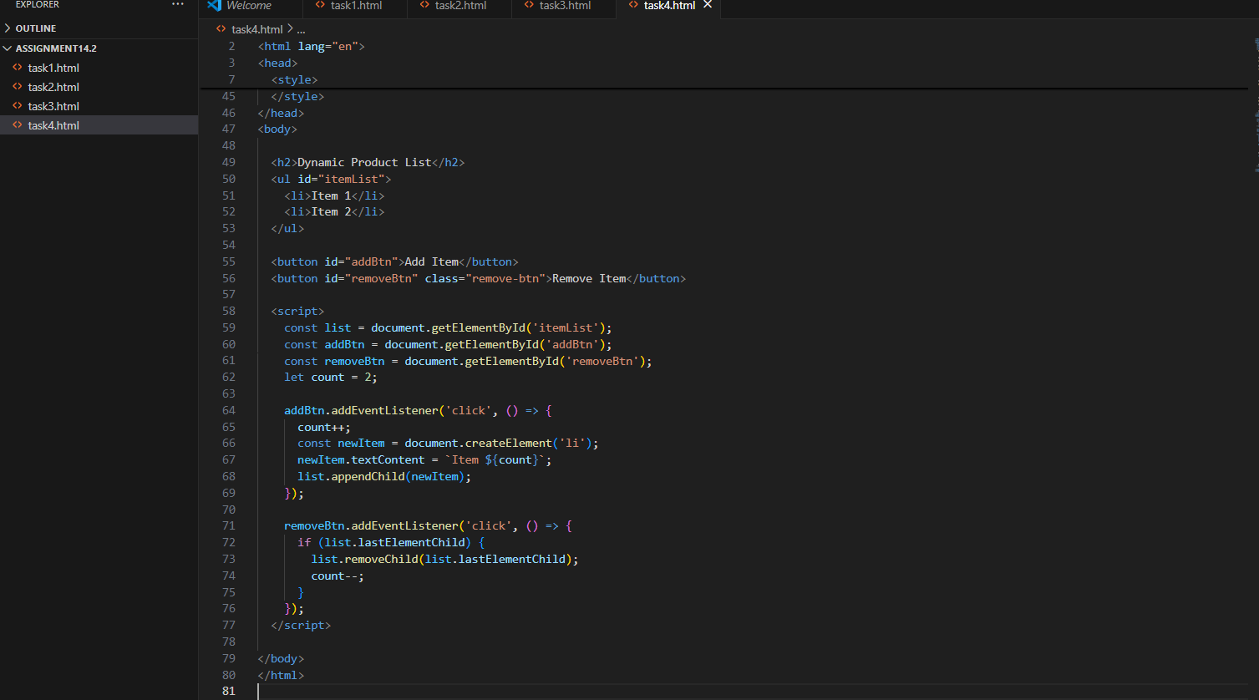
OUTPUT:
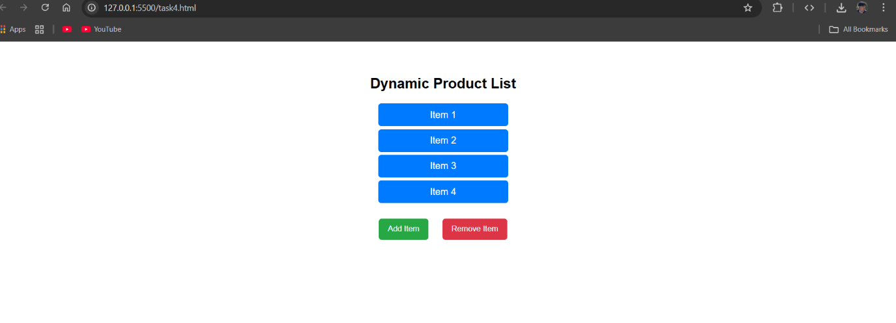
OBSERVATION:
The “Add Item” and “Remove Item” buttons modify the list dynamically without reloading the page. It shows real-time DOM manipulation using JavaScript.

Task 5: Styled Modal Popup
Instructions:
- Use AI to generate a modal popup that opens when a button is clicked.
- Style the modal using CSS with a semi-transparent overlay.
Include a close button that hides the modal.

PROMPT: Generate HTML, CSS, and JavaScript for a modal popup window.
The page should have a button labeled “Open Modal.”
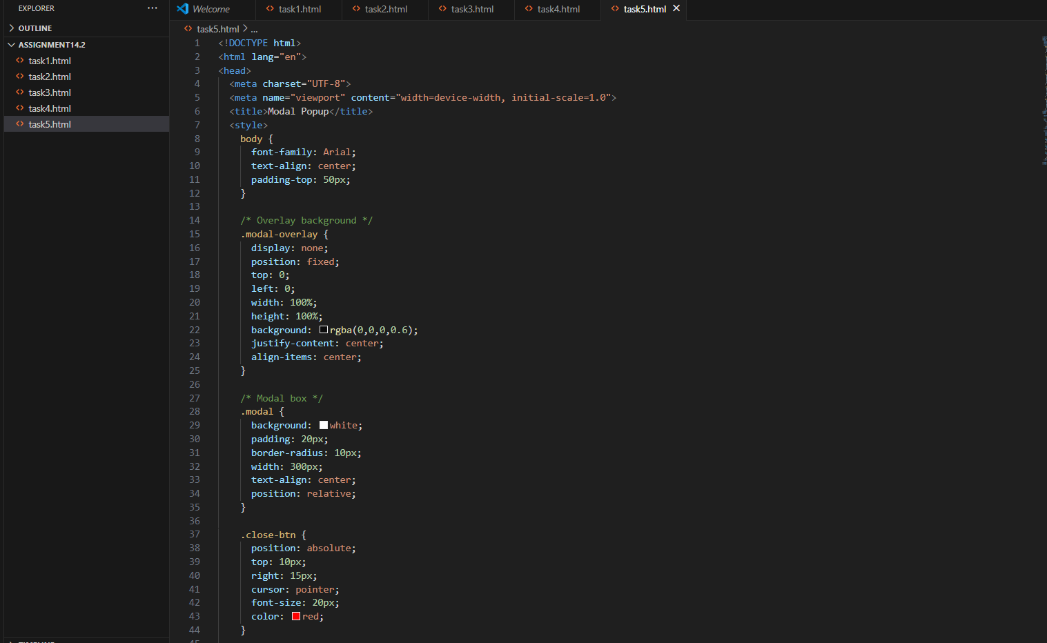
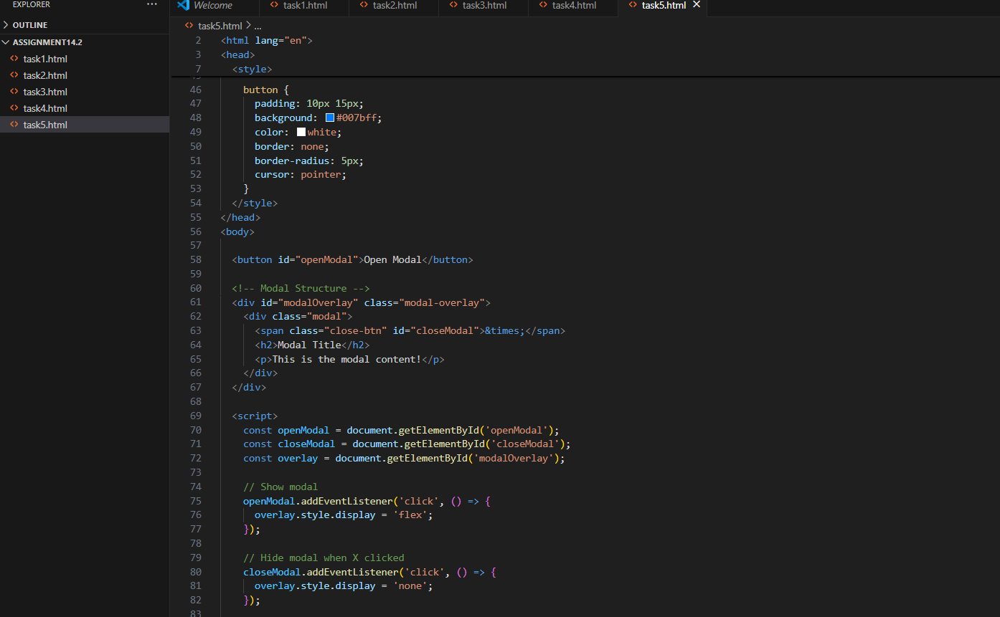
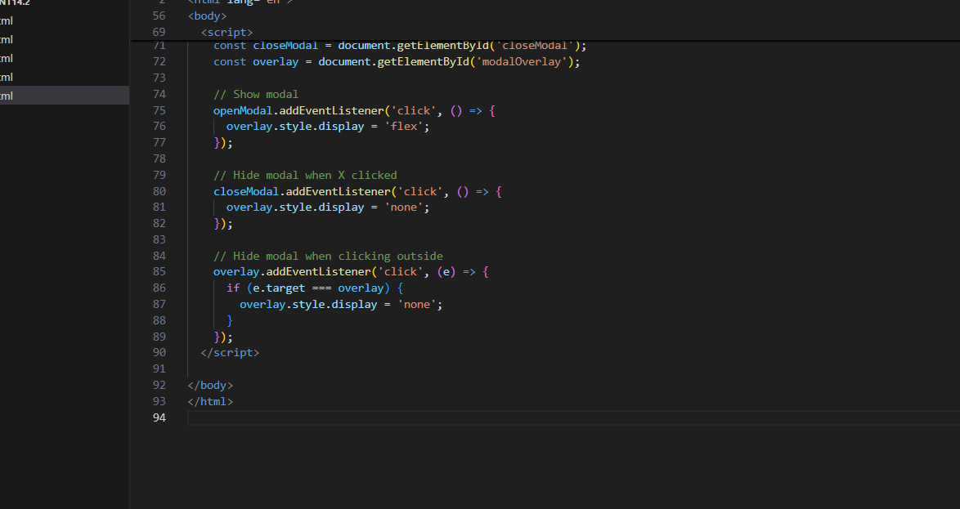
OUTPUT:
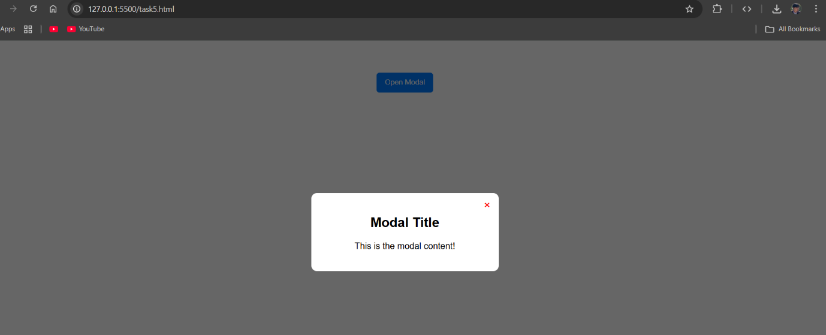
OBSERVATION:
The modal popup appears when the “Open Modal” button is clicked and closes when the “X” or overlay is clicked. This shows working overlay interaction and proper CSS styling for modals.

