AI ASSISTED CODING LAB ASSIGNMENT 15.3

ENROLLMENT NO :2503A51L21
BATCH NO: 19
NAME: LUNGHIMPOU KAMEI

Lab 15 – Backend API Development: Creating RESTful Services with AI
TASK1: Basic REST API Setup
Ask AI to generate a Flask REST API with one route:
GET /hello → returns {"message": "Hello, AI Coding!"}

PROMPT: Generate a python code Flask REST API with one route: GET /hello → returns JSON response {"message": "Hello, AI Coding!"}

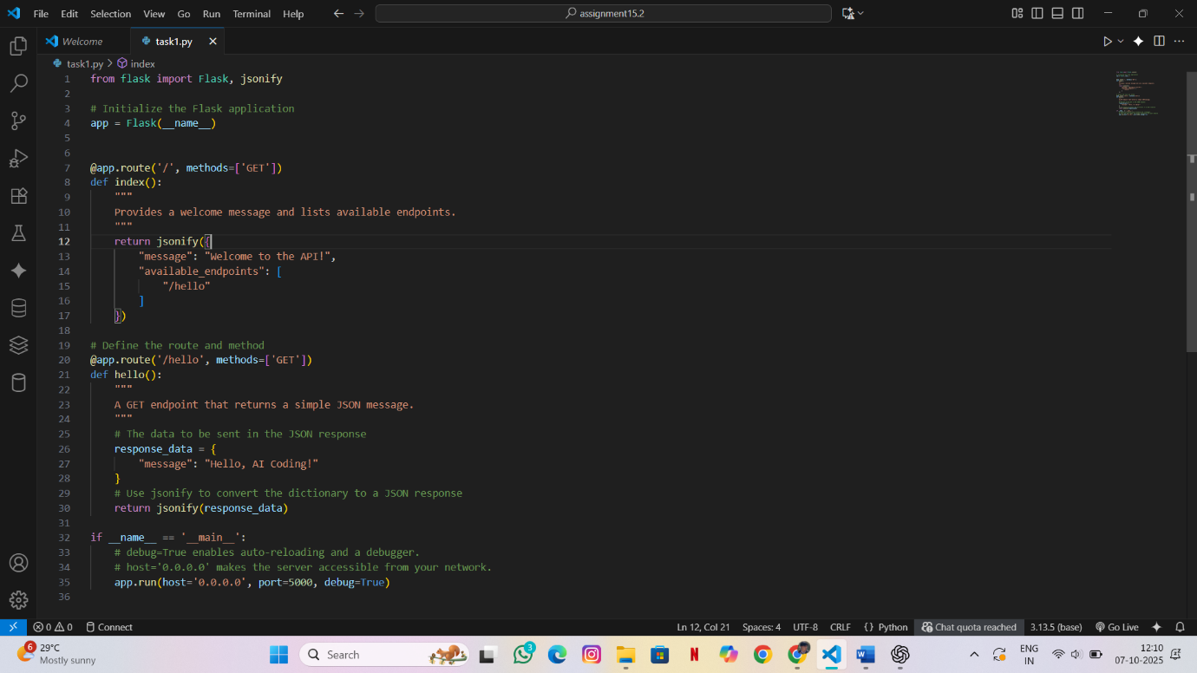

OUTPUT:
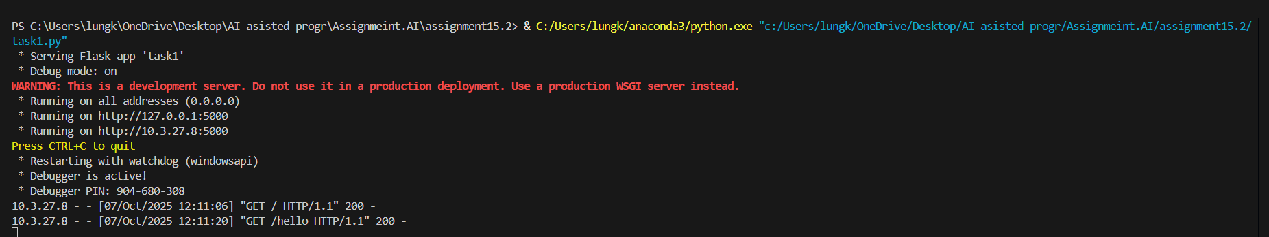
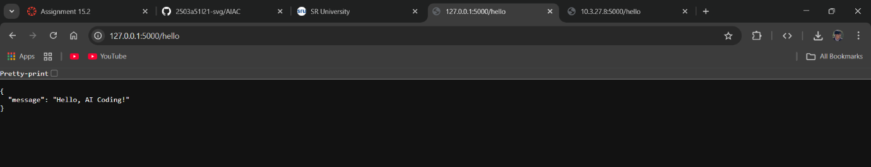

OBSERVATION:
- Flask application was created and executed successfully.
- Defined route /hello handled the GET request.
- The API returned JSON response {"message": "Hello, AI Coding!"}.
- Verified output on browser/Postman confirming correct REST API functionality.

TASK2: CRUD Operations (Students API)
Use AI to build REST endpoints for a Student API:
- GET /students → List all students.
- POST /students → Add a new student.
- PUT /students/<id> → Update student details.
- DELETE /students/<id> → Delete a student.

PROMPT: Generate a Flask REST API for managing students with CRUD operations using a list or dictionary.
Routes should include:
- GET /students (list all students)
- POST /students (add a student)
- PUT /students/<id> (update a student)
- DELETE /students/<id> (delete a student)
Return all responses in JSON format.
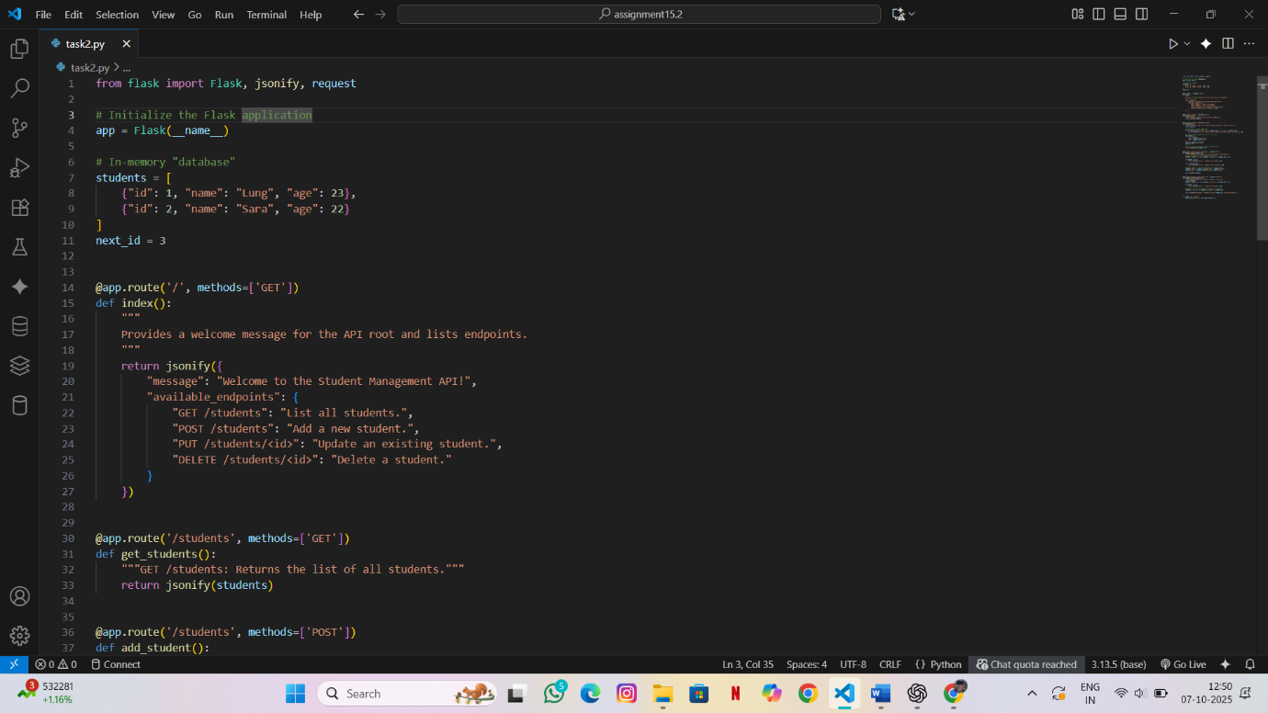
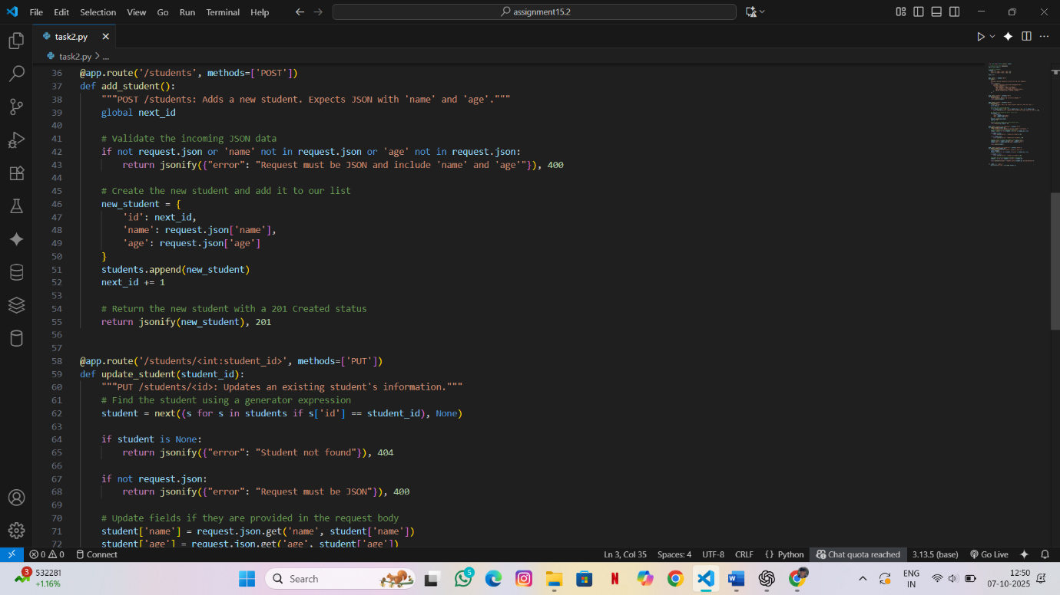
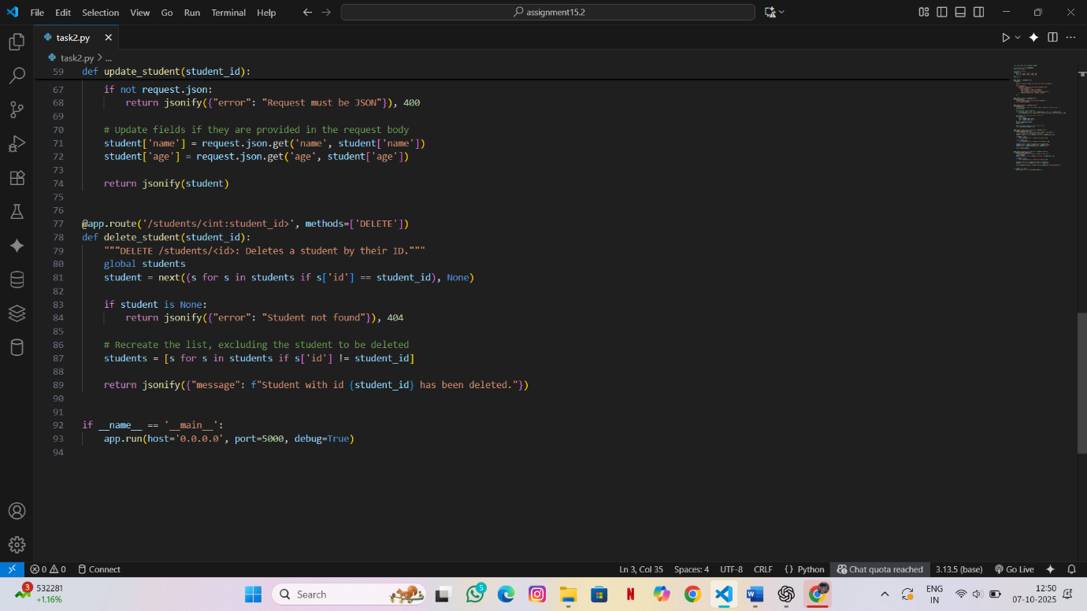

OUTPUT:
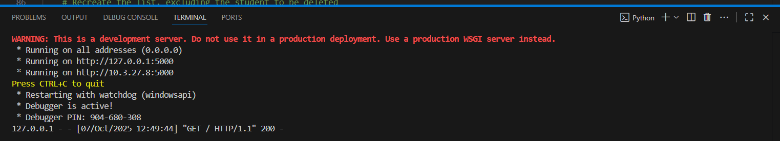
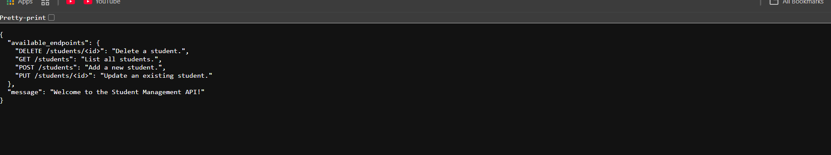
OBSERVATION:
- Flask app executed successfully without errors.
- CRUD routes (/students, /students/<id>) worked correctly.
- Able to add, update, view, and delete student records.
- JSON responses displayed proper messages and updated data.
- Verified functionality on Postman — API returned expected outputs.

TASK3: Complex Refactoring
Task: Provide this legacy class to AI for readability and modularity improvements:

Python Code
class Student:
def __init__(self, n, a, m1, m2, m3):
self.n = n
self.a = a
self.m1 = m1
self.m2 = m2
self.m3 = m3
def details(self):
print("Name:", self.n, "Age:", self.a)
def total(self):
return self.m1+self.m2+self.m3

PROMPT: Legacy Code-
class Student:
def __init__(self, n, a, m1, m2, m3):
self.n = n
self.a = a
self.m1 = m1
self.m2 = m2
self.m3 = m3
def details(self):
print("Name:", self.n, "Age:", self.a)
def total(self):
return self.m1+self.m2+self.m3
Generate a code to refractor this student class for better readability, naming, and modularity. Used docstring and consider marks in a list
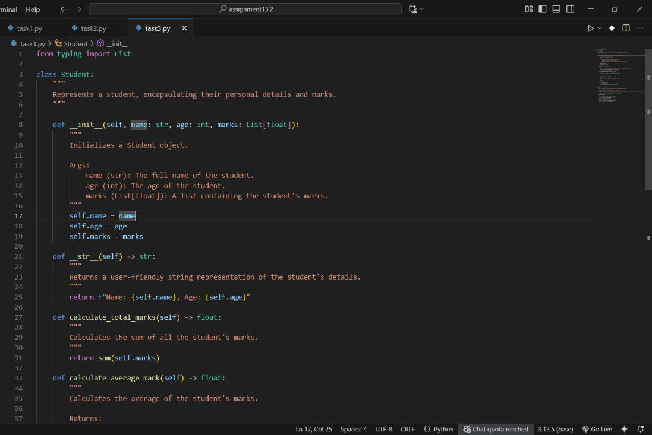
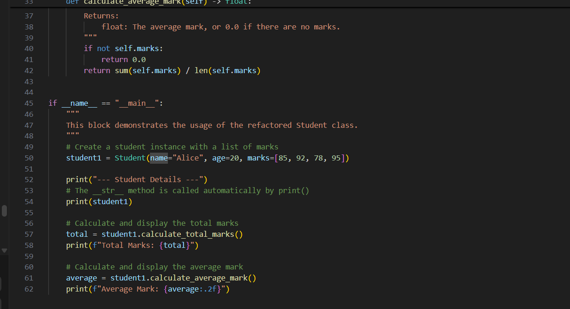

OUTPUT:
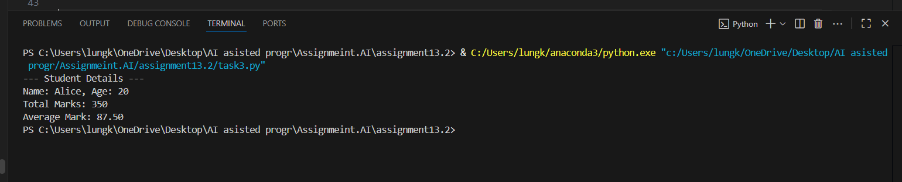

OBSERVATION:
Improved Readability: The class is significantly more readable than its legacy version, using clear names for attributes (name, age) and methods (calculate_total_marks), along with helpful docstrings and type hints.
Flexible and Pythonic Design: It replaces rigid, fixed attributes for marks with a flexible list, making the class more scalable. It also uses the Pythonic __str__ method for a clean, user-friendly string representation.

TASK4: Inefficient Loop Refactoring
Task: Refactor this inefficient loop with AI help

Python Code
nums = [1,2,3,4,5,6,7,8,9,10]
squares = []
for i in nums:
squares.append(i * i)

PROMPT: Legacy Code
nums = [1,2,3,4,5,6,7,8,9,10]
squares = []
for i in nums:
squares.append(i * i)
Write a code to Refactor this loop into a more efficient solution using list comprehension.
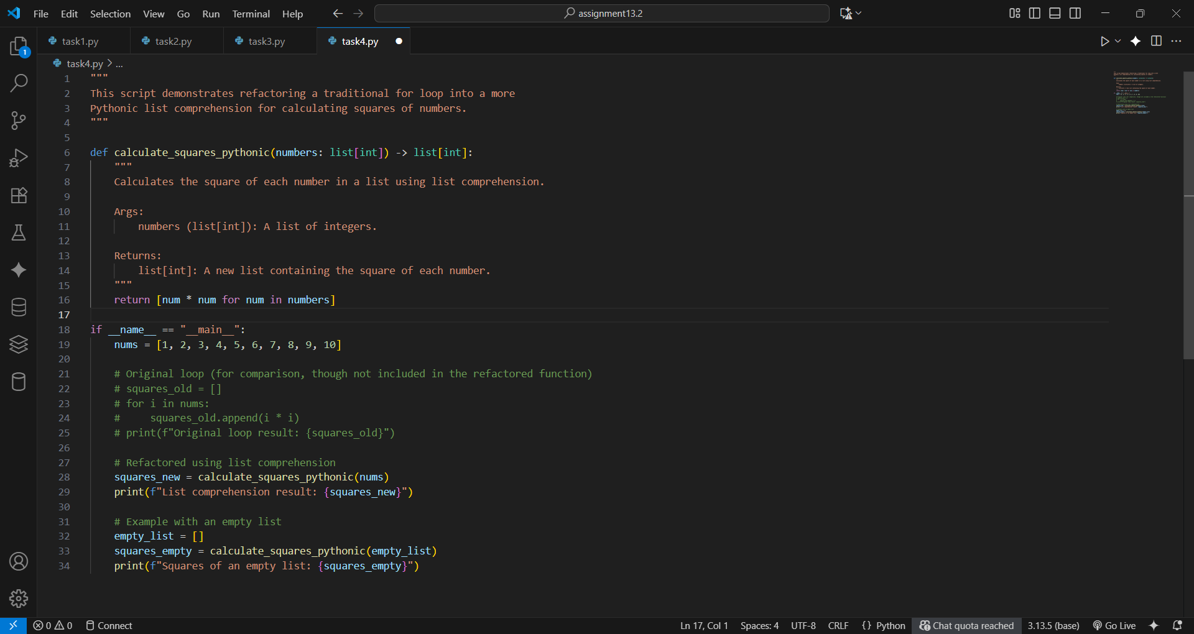

OUTPUT:
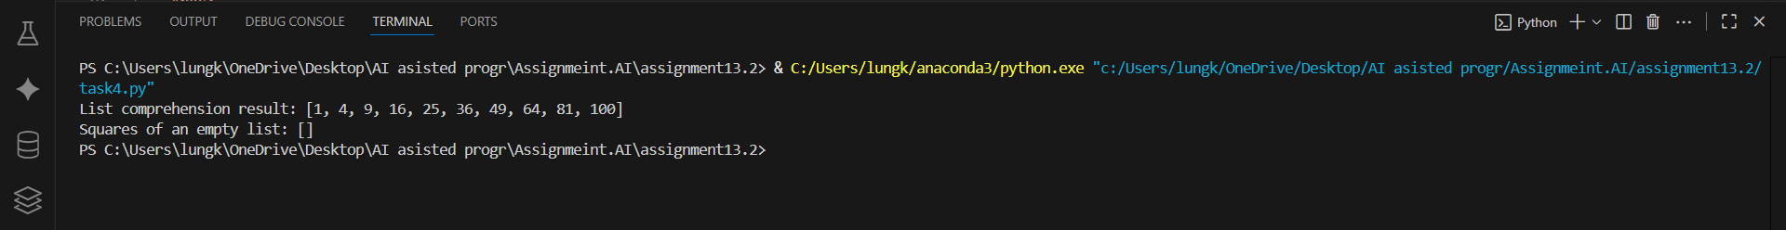

OBSERVATION:
. The list comprehension [num * num for num in numbers] is a single, readable line that directly describes its action: creating a new list by squaring each number.
.This is the standard, preferred method in Python for this task. It's not only cleaner but also often faster than a traditional for loop because it's highly optimized.

