ENROLLMENT NO:2503A51L21
Batch: 19

BATCH NO:19
NAME: LUNGHIMPOU KAMEI
labtest-3
Date – 11/11/2025
Question set -E6
Q1:
Scenario: In the domain of Transportation, a company is facing a challenge related to code
refactoring.
Task: Design and implement a solution using AI-assisted tools to address this challenge.
Include code, explanation of AI integration, and test results.
Deliverables: Source code, explanation, and output screenshots.
Prompt: Write a python code, in the domain of Transportation, a company has a vehicle management system with poorly structured and repetive code for handling cars, Buses, and Truck. Refactor the code
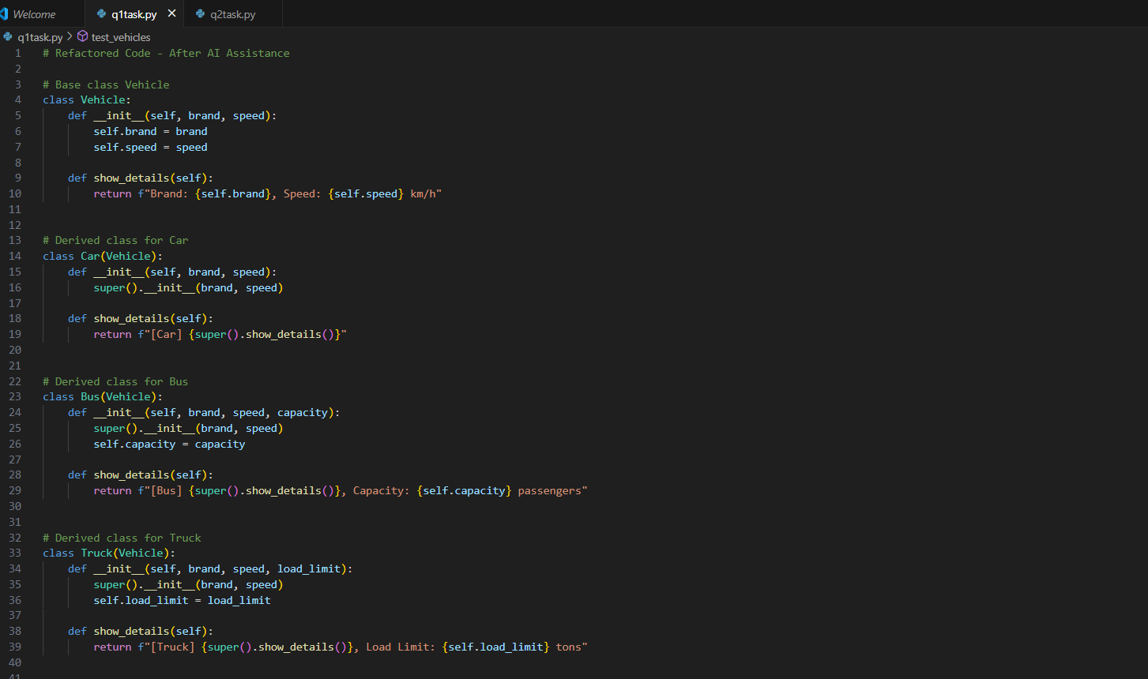
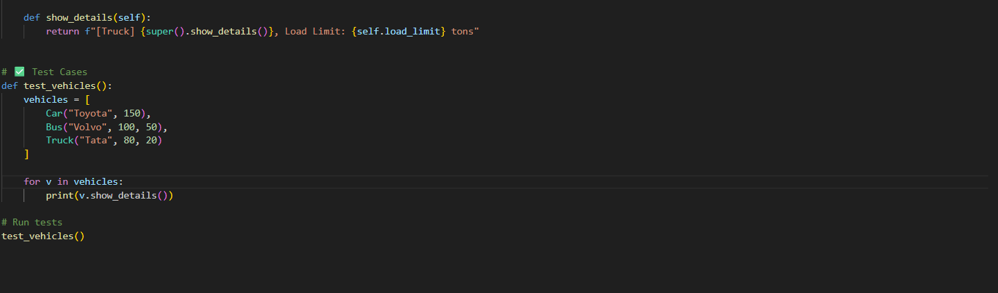
Output:
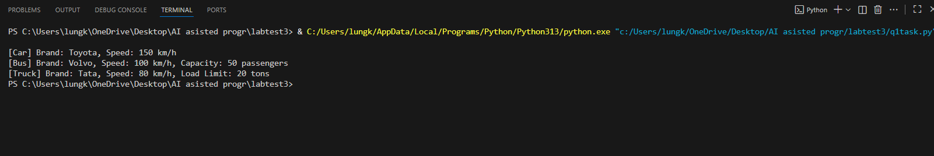
Observation:
1.Improves the code’s maintainability, scalability, readability and remove redundant.
2. The code uses inheritance and method overriding.
3. It shows how cars, buses, and truck shared common features of vehicle.
4. The code is clean and easy to understand.

Q2:
Scenario: In the domain of Environmental Monitoring, a company is facing a challenge
related to code refactoring.
Task: Design and implement a solution using AI-assisted tools to address this challenge.
Include code, explanation of AI integration, and test results.
Deliverables: Source code, explanation, and output screenshots.
Prompt: Generate a python code, in domain of Environmental Monitoring a company has unorganized for analysing Temperature, Humidity data. Refactor the data to make it clean and easier to understand.
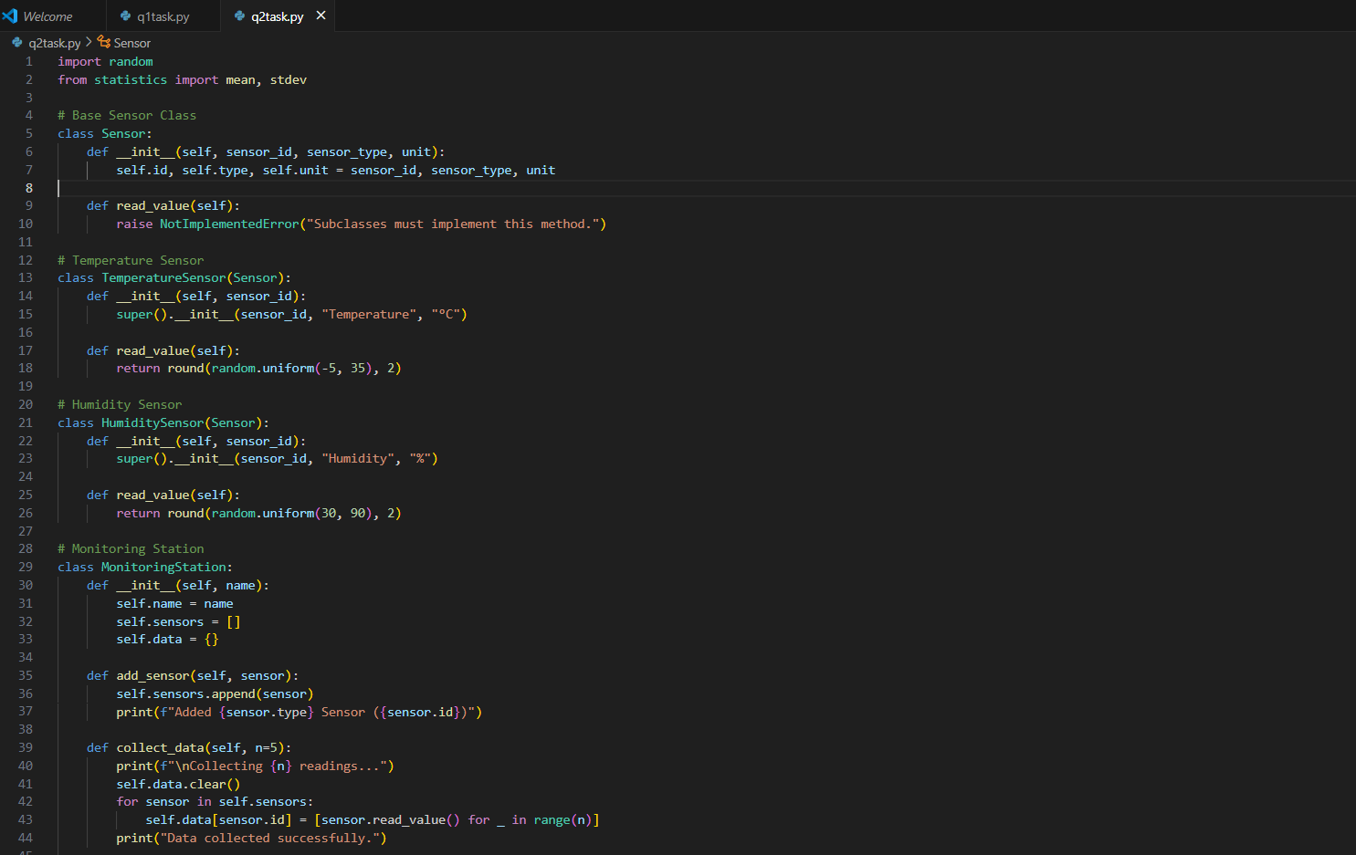
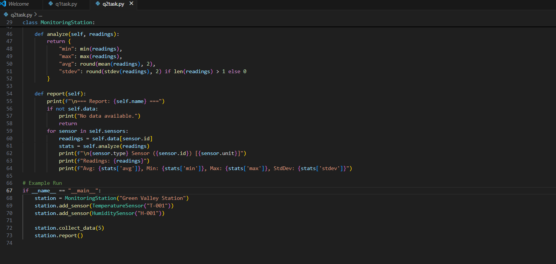
Output:
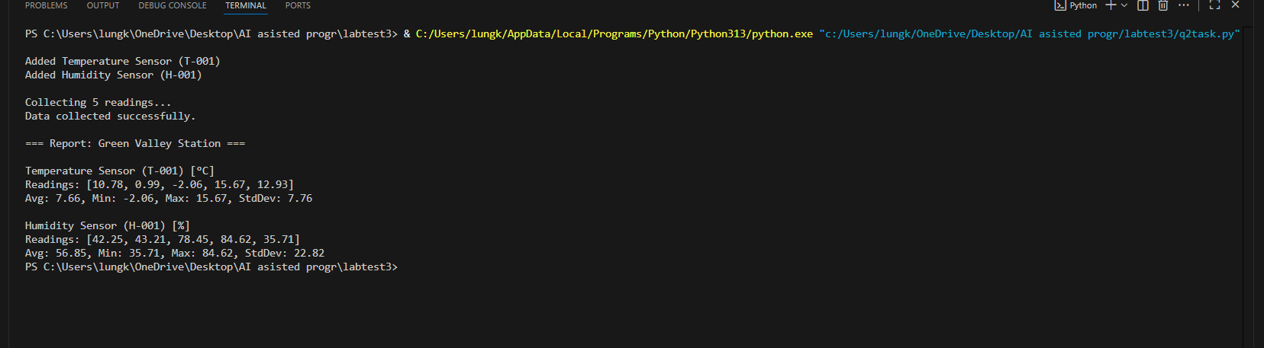

Observation:
In this program simulates an environmental monitoring system using temperature and humidity sensors. It collect random readings, analyse them, and display a simple report with average, minimum, maximum, and standard deviation values.

