AI ASSISTED CODING
Lab 17 – AI for Data Processing: Data Cleaning and Preprocessing Scripts
Roll no: 2503A51L29
Name: karduri shashikumar
Batch: 25BTCAICSB19
Task-1 Description: Employee Data Preprocessing
Task:
Use AI to generate a Python script for cleaning an employee dataset.
Instructions:
• Handle missing values in columns (salary, department,
joining date).
• Convert the "joining date" column into proper datetime format.
• Standardize department names (e.g., "HR", "hr", "Human
Resources" → "HR").
• Encode categorical variables (department, job role).
Prompt:
Generate a Python script using Pandas to clean an employee dataset by handling missing values, formatting dates, standardizing department names, and encoding categorical columns.
Code Generated:
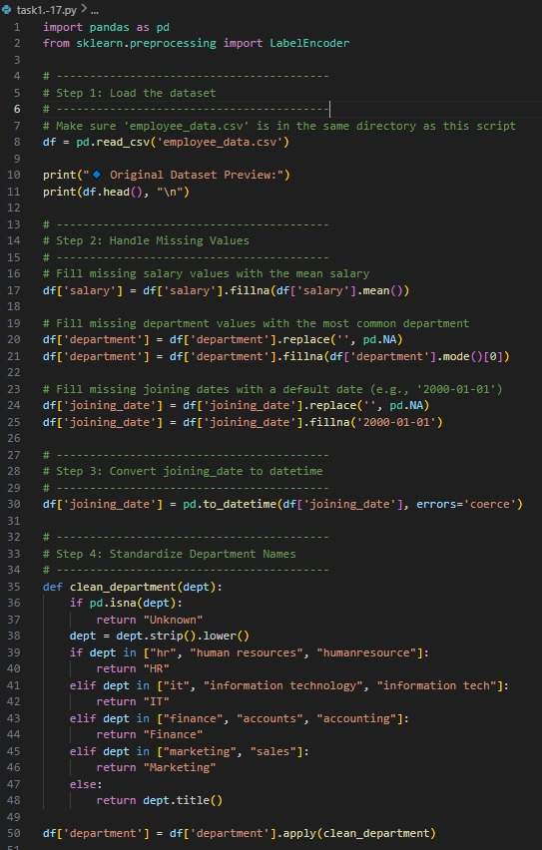

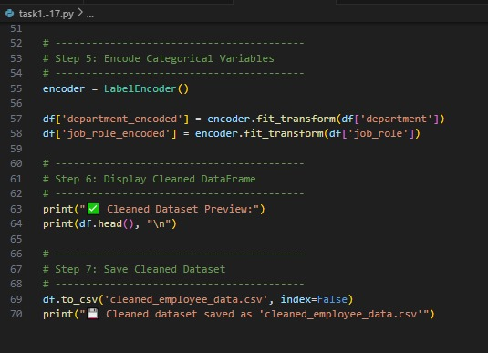

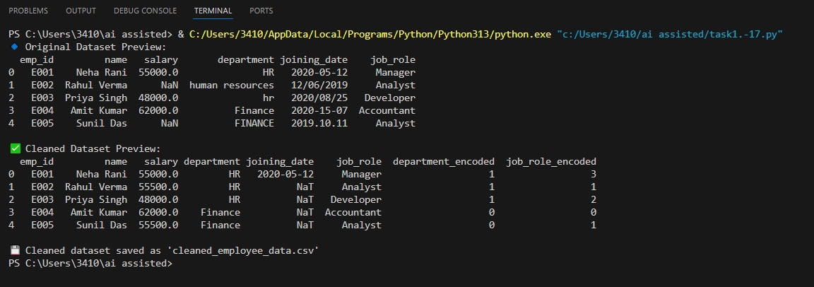
Output:

Observation:
The Python script successfully cleans and preprocesses the employee dataset.
- Missing salary values are filled with the mean.
- Missing department entries are replaced with the most common department.
- Missing joining dates are set to a default date (2000-01-01).
- Department names are standardized (e.g., HR, IT, Finance, Marketing).
- Categorical columns like department and job_role are encoded using LabelEncoder.
- The cleaned data is saved as cleaned_employee_data.csv for further analysis.

Task-2 Description: Sales Transaction Data Preprocessing
Task:
Use AI to generate a script for preprocessing a sales transaction dataset.
Instructions:
• Convert transaction dates to proper datetime format.
• Create a new column for “Month-Year” from the transaction date.
• Remove rows with negative or zero transaction amounts.
• Normalize the "transaction amount" column using Min-Max
scaling.
Expected Output:
• A pre-processed Data Frame with valid dates, normalized amounts,
and no invalid records.
Prompt:
Use Python and Pandas to preprocess a sales transaction dataset by fixing date formats, removing invalid transactions, deriving Month-Year, and normalizing amounts.

Code Generated:
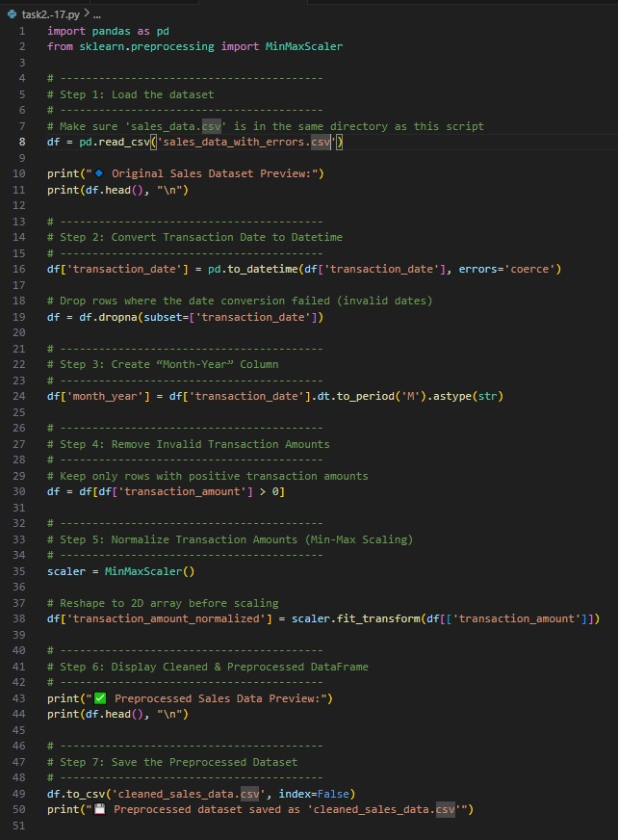

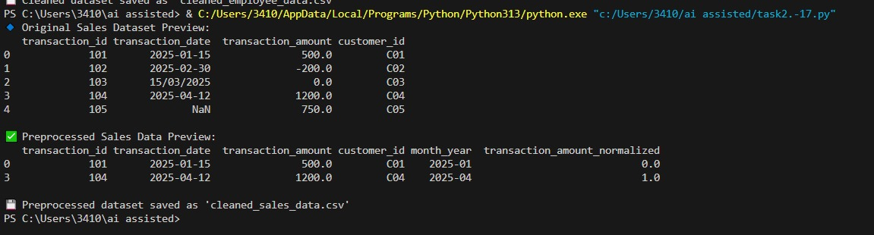
Output:

Observation:
The Python script cleans and preprocesses the sales dataset effectively.
- Invalid dates are converted and dropped if incorrect.
- A new Month-Year column is created for time-based analysis.
- Negative or zero transaction amounts are removed.
- Transaction amounts are normalized using Min-Max scaling.
- The final cleaned dataset is saved as cleaned_sales_data.csv for further use.

Task-3 Description: Healthcare Patient Records Cleaning
Task:
Use AI to generate a script for cleaning healthcare patient records.
Instructions:
• Fill missing values in numeric columns (e.g., blood pressure,
heartrate) with column mean.
• Standardize units (convert height from cm to meters).
• Correct inconsistent categorical labels (e.g., "M", "Male", "male"
→ "Male").
• Drop irrelevant columns such as patient_id after cleaning.
Expected Output:
• A cleaned healthcare dataset suitable for ML model training.
Prompt:
Write a Python script to clean healthcare patient data by filling missing numeric values with means, standardizing units, correcting categorical labels, and removing irrelevant columns.
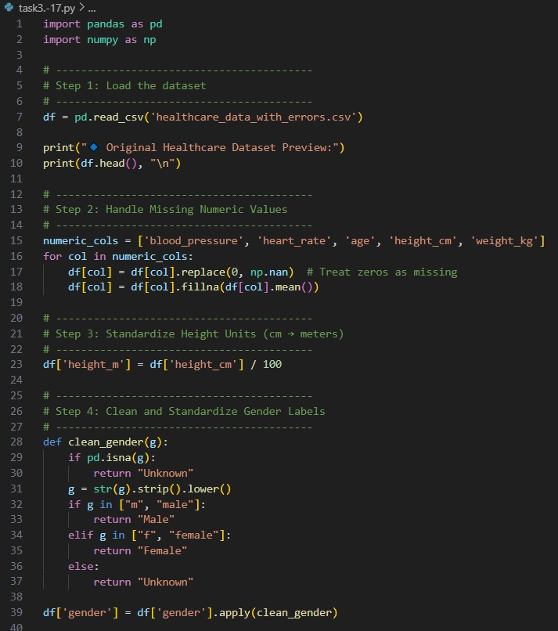
Code Generated:

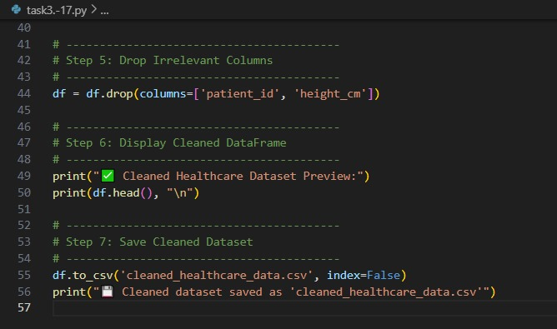

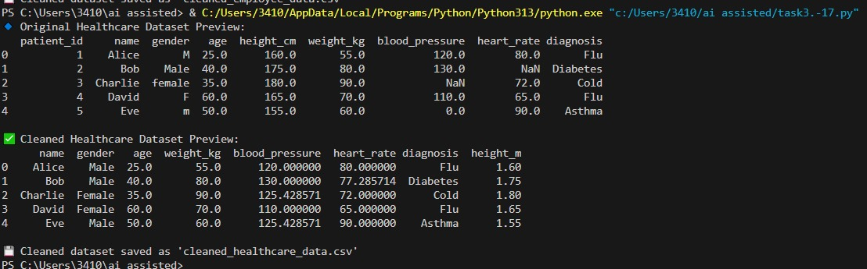
Output:

Observation:
The script successfully cleans and standardizes the healthcare dataset.
- Missing or zero numeric values are replaced with column means.
- Height is converted from centimetres to meters.
- Gender labels are standardized (Male, Female, Unknown).
- Irrelevant columns like patient_id and height are removed.
- The cleaned data is saved as cleaned_healthcare_data.csv for further analysis.
Task-4 Description: Social Media Sentiment Dataset Preparation
Task:
Use AI to write a script to preprocess a social media text dataset.
Instructions:
• Remove special characters, URLs, and emojis from text.
• Convert all text to lowercase.
• Tokenize and remove stopwords.
• Apply lemmatization for standardizing words.
Expected Output:
• A processed dataset with clean text, ready for NLP sentiment
analysis.
Prompt:
Create a Python NLP preprocessing script to clean social media text by removing noise, converting to lowercase, tokenizing, removing stopwords, and lemmatizing

Code Generated:
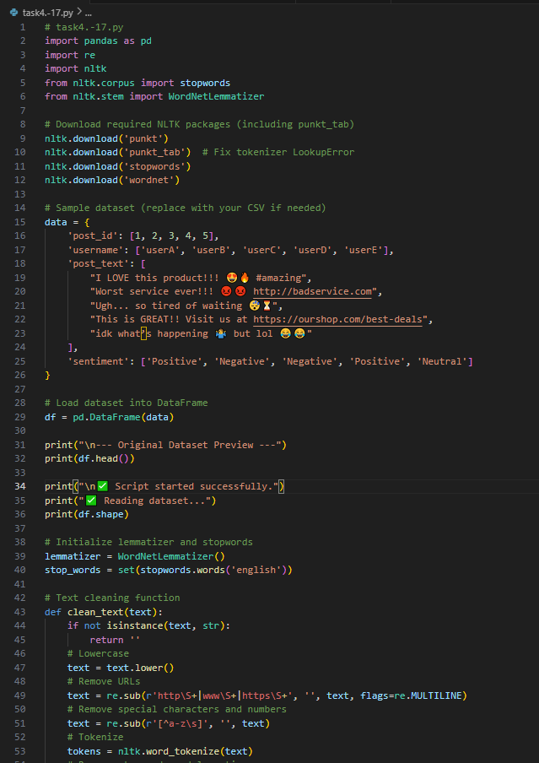

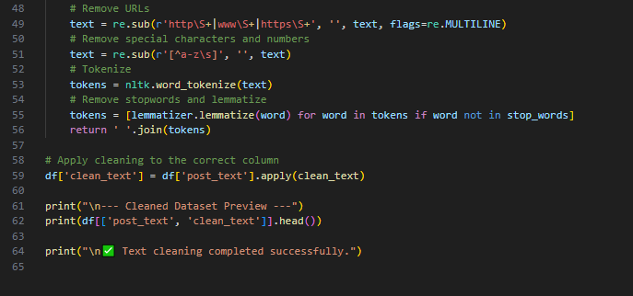

Output:
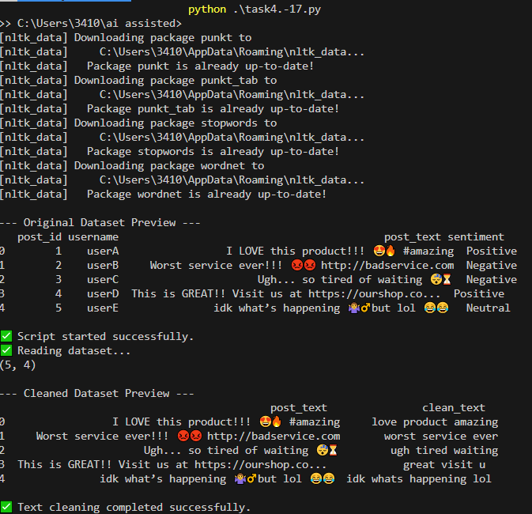

Observation:
- The script successfully reads the dataset and applies text preprocessing on the post_text column.
- Preprocessing steps include lowercasing, URL removal, special character removal, tokenization, stopword removal, and lemmatization.
- The resulting clean_text column contains simplified, normalized text ready for further analysis (e.g., sentiment analysis or modeling).
- Original text is preserved in post_text for reference.

Task-5 Description: Financial Dataset Feature Engineering
Task:
Use AI to create a preprocessing script for a financial dataset.
Instructions:
• Handle missing values in stock price and volume.
• Create new features such as moving average (7-day, 30-day).
• Normalize continuous variables using StandardScaler.
• Encode categorical columns (sector, company_name).
Expected Output:
• A feature-engineered Data Frame with new indicators and
normalized values for ML tasks
Prompt: Generate a Python script to preprocess and engineer features for a financial dataset by handling missing values, creating moving averages, normalizing numeric columns, and encoding categorical data.
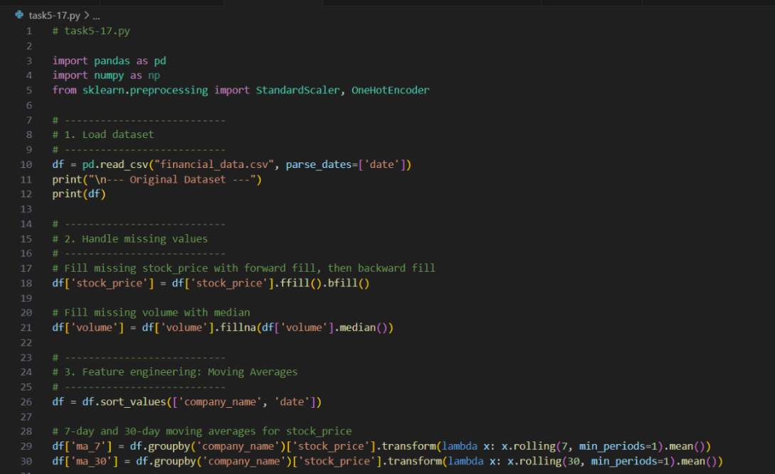
Code Generated:

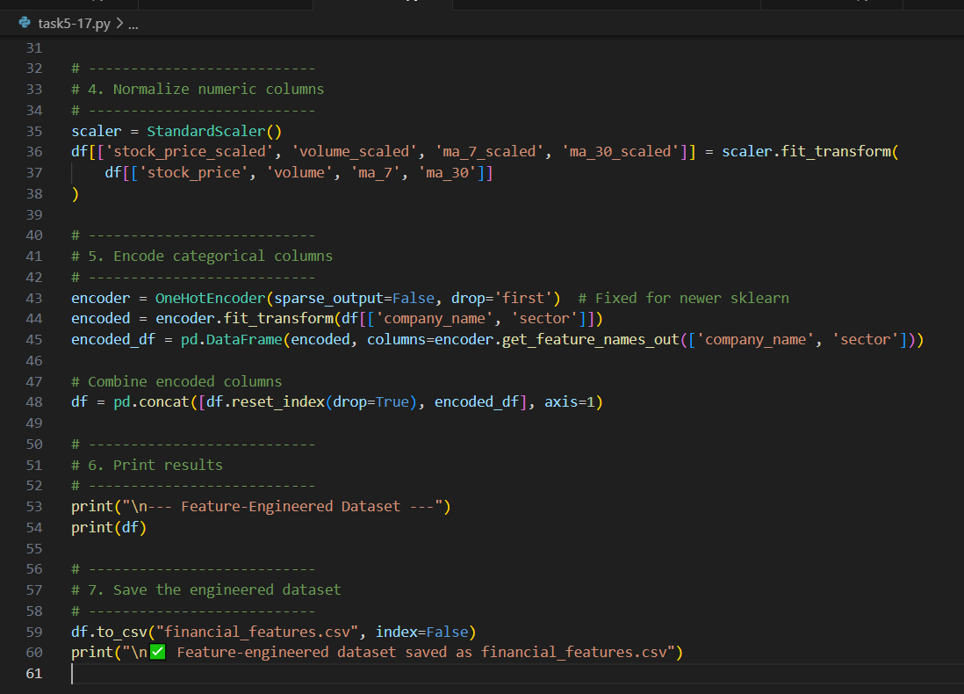

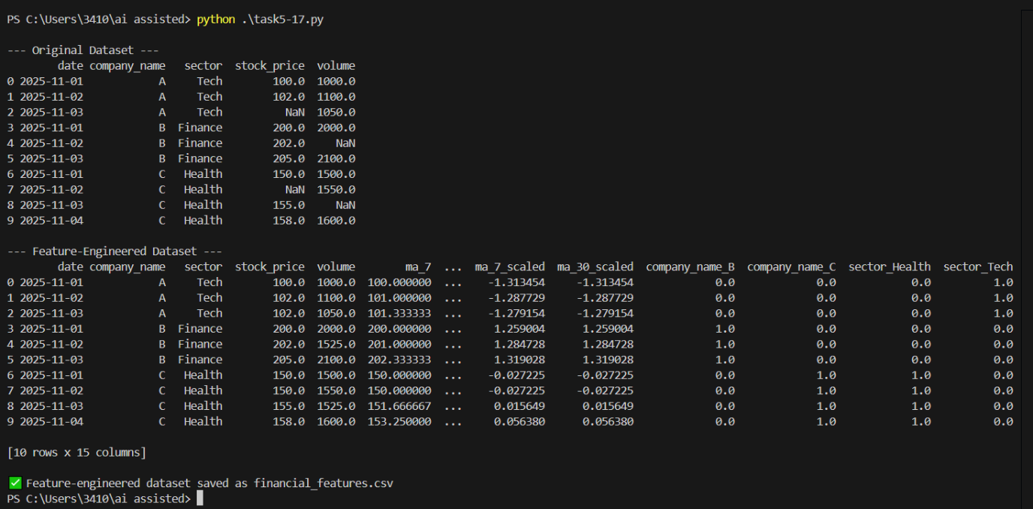
Output:

Observation:
- Missing values in stock_price were filled using forward/backward fill; missing volume was replaced with the median.
- 7-day and 30-day moving averages for stock price were successfully created per company.
- Continuous variables (stock_price, volume, ma_7, ma_30) were normalized using StandardScaler.
- Categorical columns (company_name, sector) were one-hot encoded.
- The final dataset is ready for machine learning tasks and saved as financial_features.csv.

