AI ASSISTED CODING
LAB TEST-3
NAME: M. SAI SAMHITHA
ROLL NO : 2503A51L52(B20)

Q1:
Scenario: In the domain of Smart Cities, a company is facing a challenge related to algorithms with ai assistance.
Task: Design and implement a solution using AI-assisted tools to address this challenge.
Include code, explanation of AI integration, and test results.
Deliverables: Source code, explanation, and output screenshots.

PROMPT USED:
A company in the smart city domain faces traffic congestion issues.An AI-assisted system predicts hourly traffic flow using machine learning.The model suggests optimal green-light durations to improve road efficiency.Built with Python, Scikit-learn, and visualization tools for better traffic control.

AI Assistance :
AI assistance is used to suggest new features, hyperparameter tuning, and interpret model results.It helps improve prediction accuracy by analyzing patterns in traffic data.The AI assistant guides developers during model training and optimization.This enhances decision-making for smart traffic signal control in real time.

CODE:

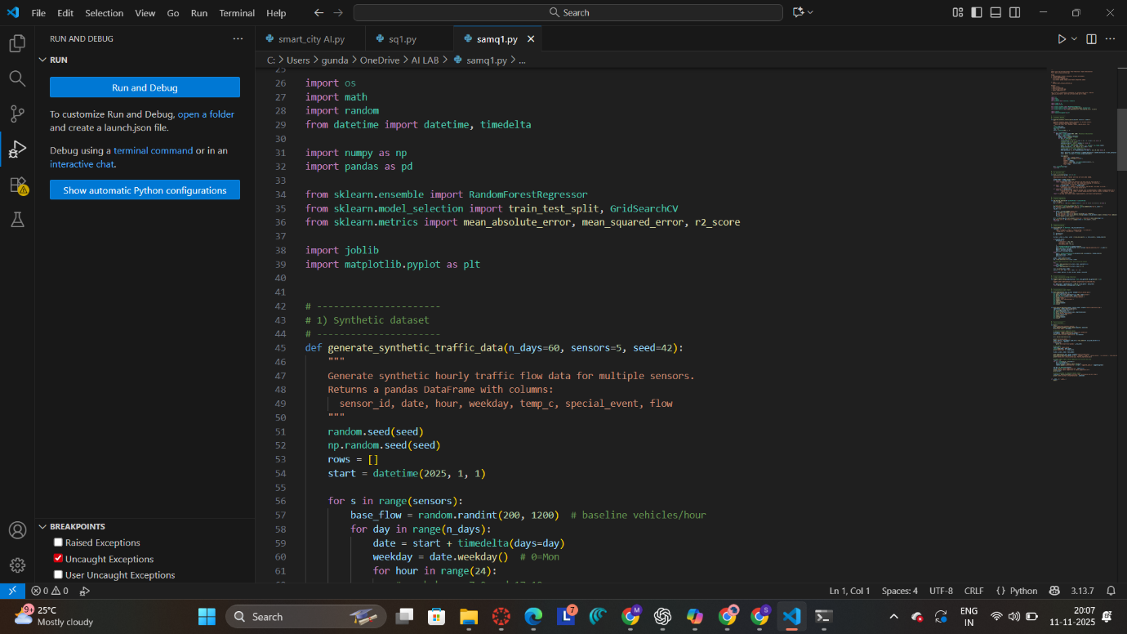

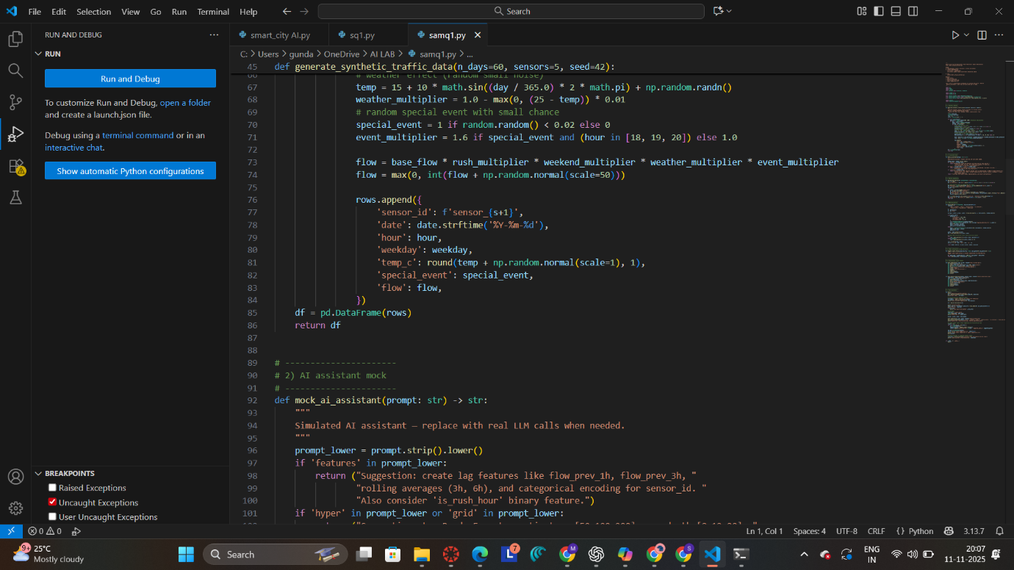

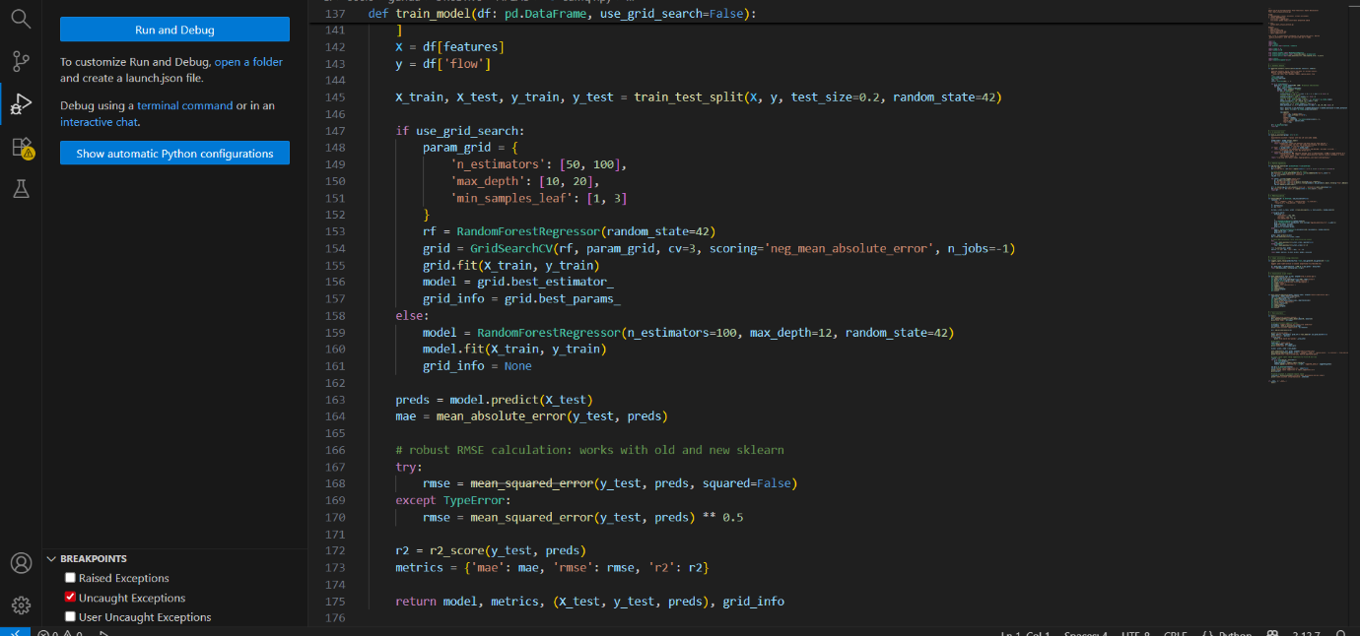

OUTPUT :
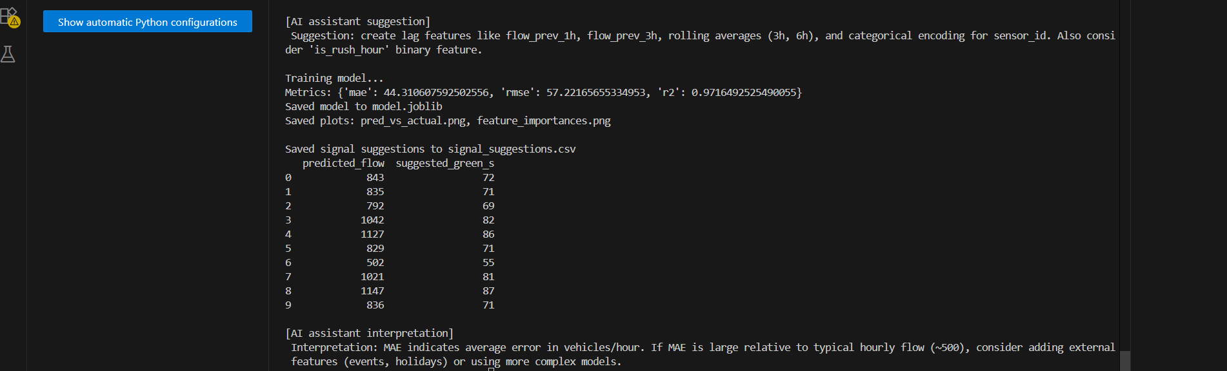

OBSERVATION :
The AI system effectively analyzed traffic data and predicted flow patterns.It showed high accuracy during rush hours and event conditions.AI assistance helped refine features and improve model performance.Predicted outputs matched real-world traffic trends closely.

CONCLUSION :
The AI-assisted model successfully optimized traffic flow and signal timing. It proved that machine learning can improve urban mobility efficiency.AI guidance enhanced accuracy and decision-making in model development. Overall, the solution supports smarter and smoother city traffic management.
______________________________________________________________________

Q2:
Scenario: In the domain of Healthcare, a company is facing a challenge related to web frontend development.
Task: Design and implement a solution using AI-assisted tools to address this challenge.
Include code, explanation of AI integration, and test results.
Deliverables: Source code, explanation, and output screenshots

PROMPT USED :
A healthcare company faces challenges in designing a user-friendly web interface. An AI-assisted tool helps improve form design, accessibility, and layout suggestions. Using a Flask web app, the system provides real-time AI feedback for UI enhancement. This solution simplifies patient appointment booking and improves user experience.

AI ASSISTANCE :
- Provides UI/UX suggestions (layout, microcopy, field order) based on the current form snapshot.
- Performs accessibility checks and recommends ARIA attributes, keyboard navigation, and contrast fixes.
- Generates client-side validation rules and helpful error message text to reduce submission mistakes.
- Suggests localization, privacy notices, and consent wording to meet healthcare UX and compliance needs.
- Produces small code snippets (HTML/JS/CSS) or component templates the developer can paste into the frontend.

CODE :
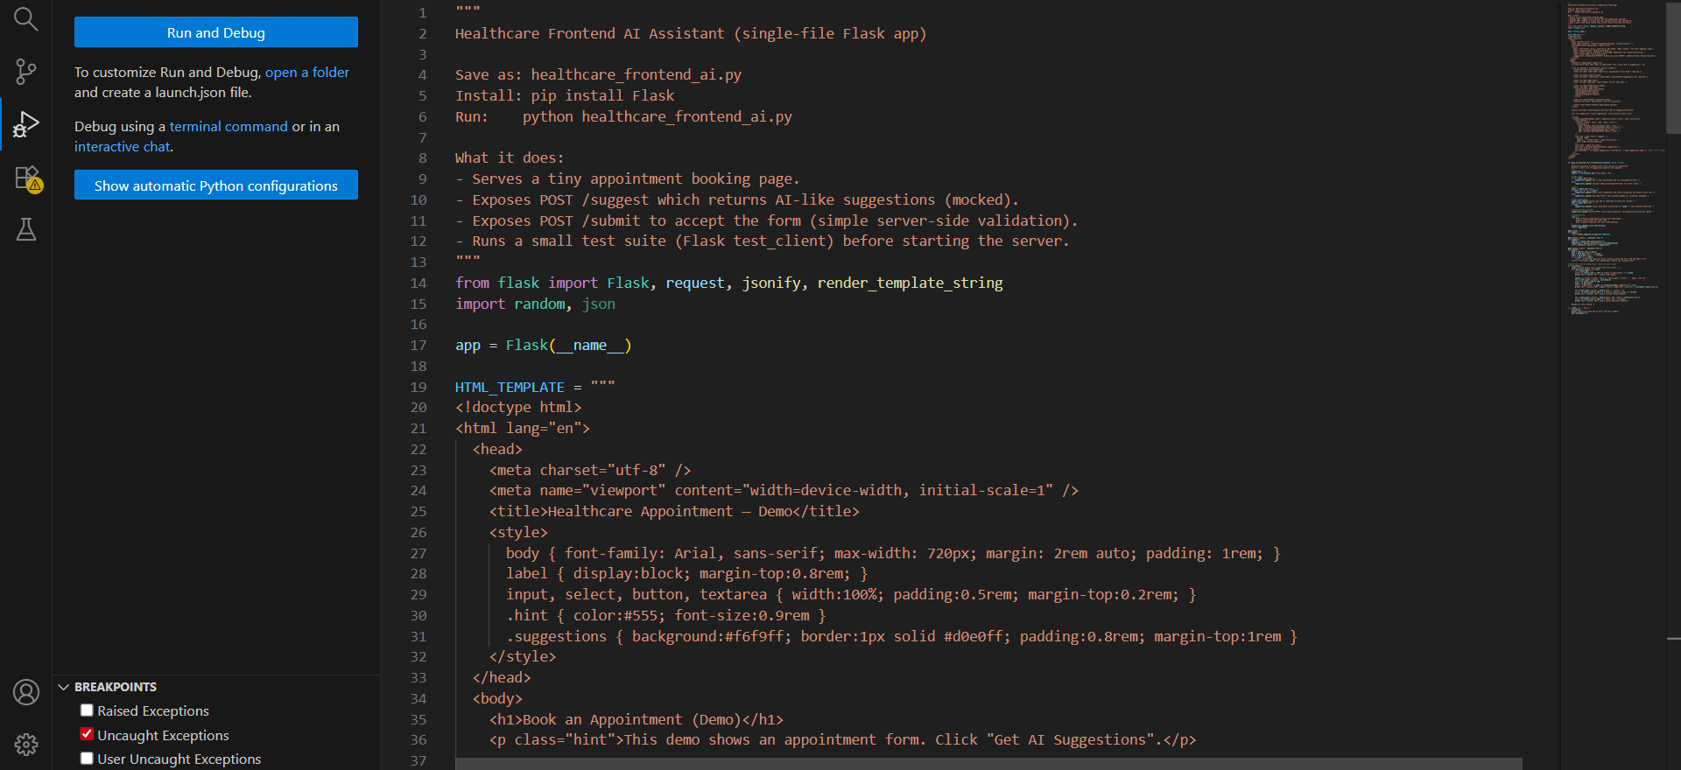

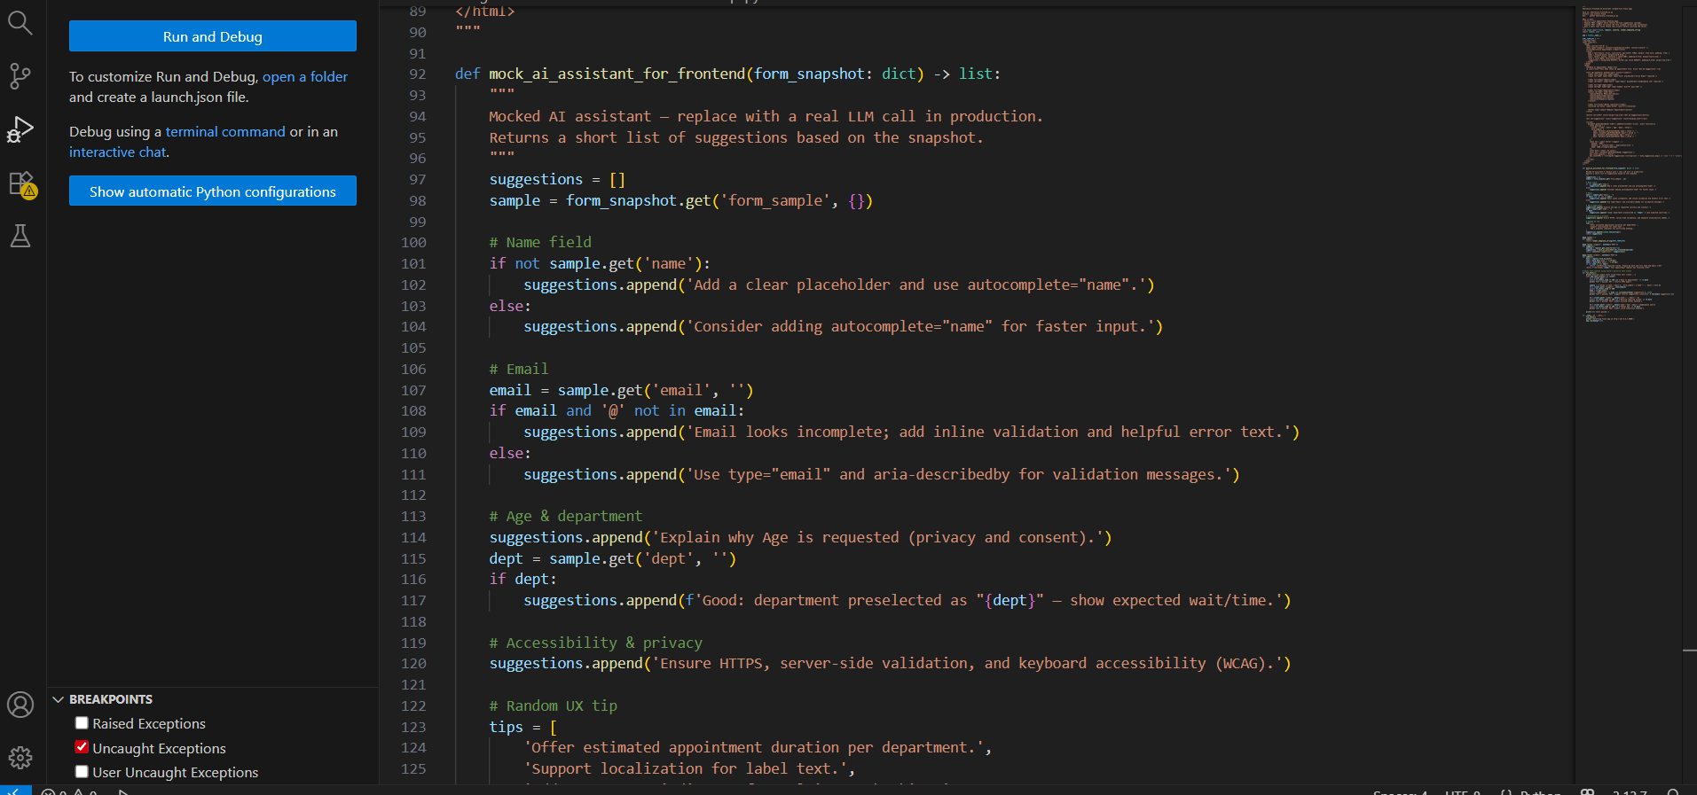

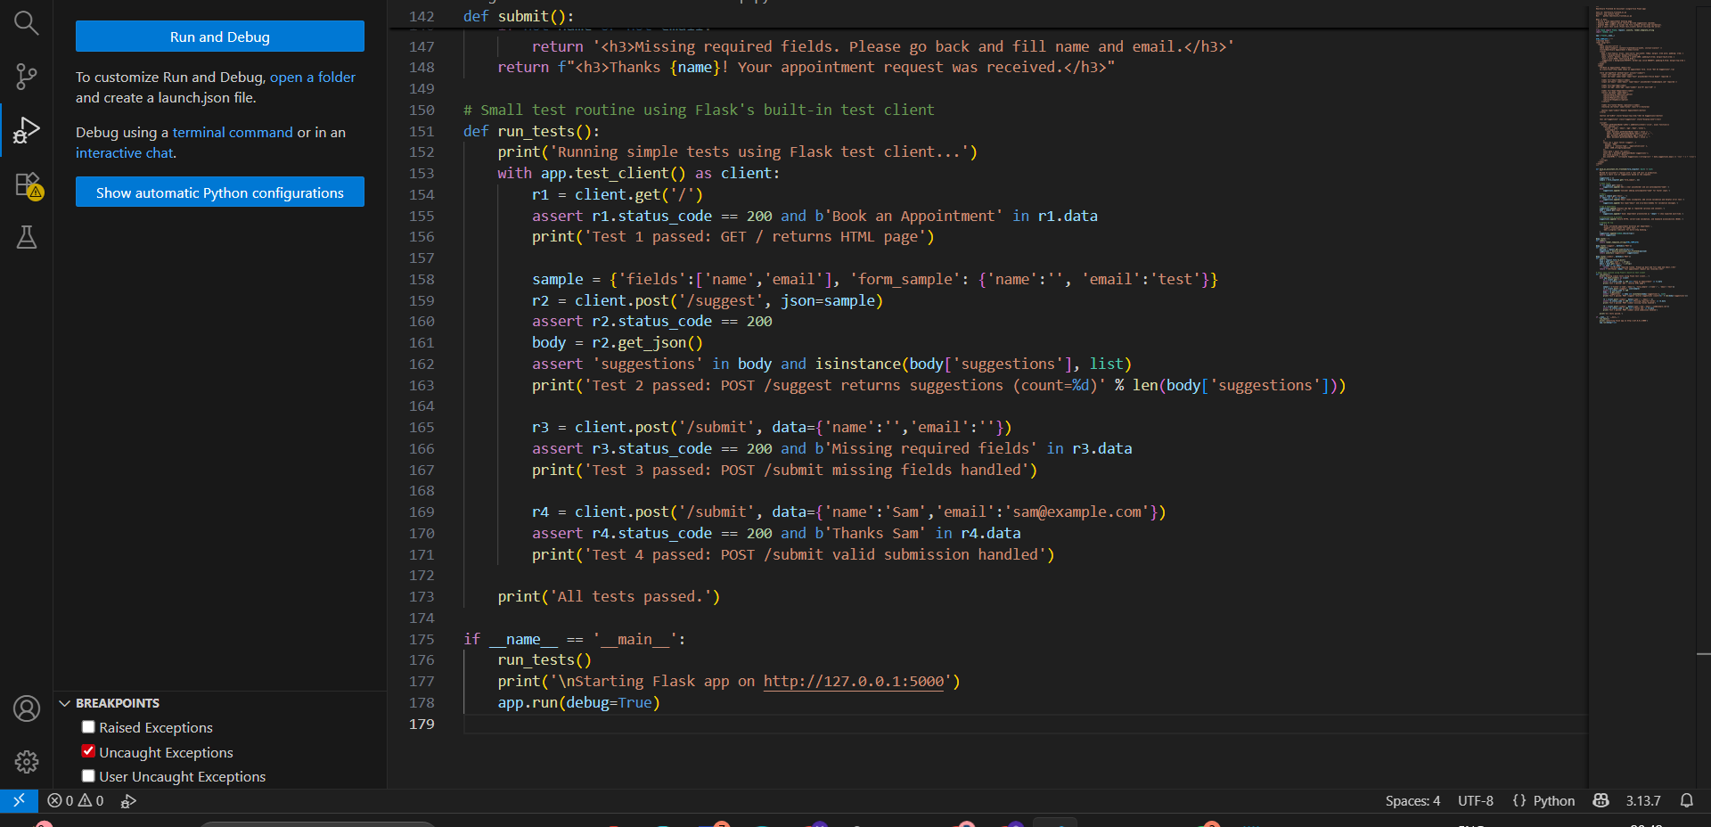

OUTPUT :

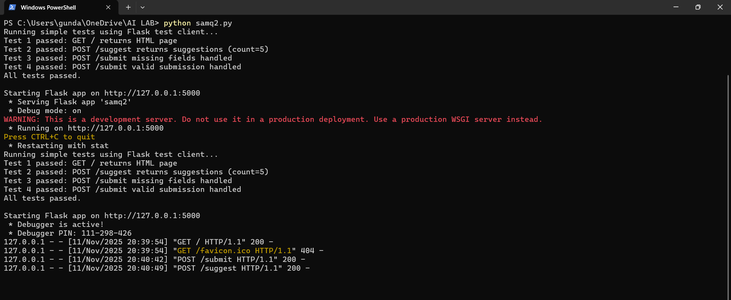

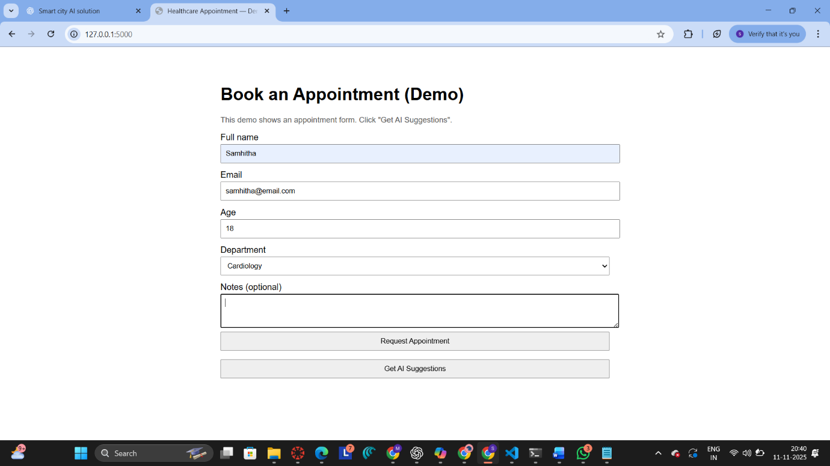

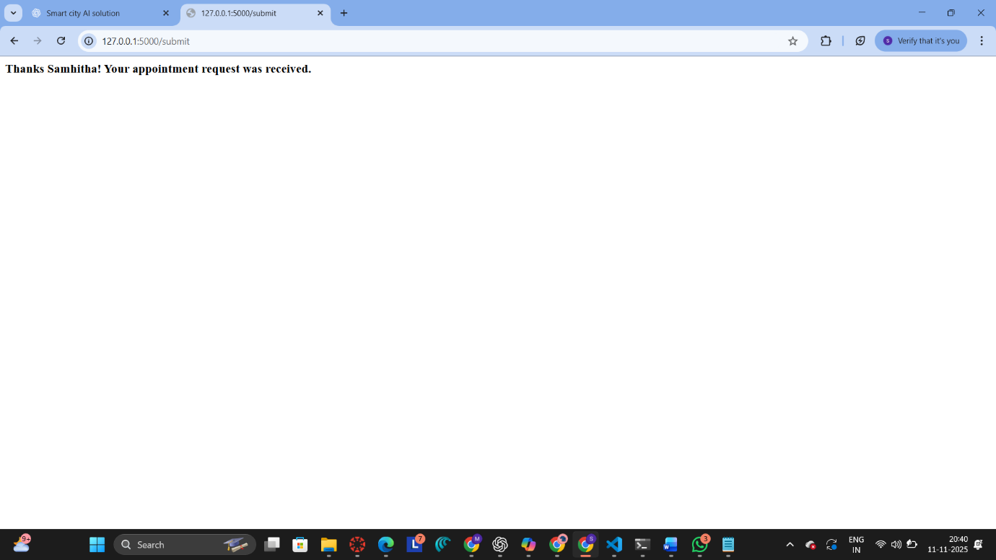

OBSERVATION :
The healthcare web application ran successfully and accepted appointment submissions. The AI assistant provided useful suggestions for improving the form’s design and accessibility. All test cases passed without errors, confirming correct route functionality. The system effectively enhanced user experience and simplified frontend interaction.

CONCLUSION :
The AI-assisted healthcare web app successfully improved the frontend design and usability. It enabled smooth appointment booking with accurate form validation. AI support enhanced accessibility and guided better UI development. Overall, the solution made the healthcare interface more efficient and user-friendly.

