PROJECT PROPOSAL
Ocean Waste Trend Analysis and Waste Management Effectiveness Study (1900-2026)
Prepared by: [Your Name] | Date: [Date]

1. Project Overview
This project proposes a data-driven study of how ocean waste has grown over 127 years (1900-2026) and whether waste management has kept pace with that growth. Using a cleaned annual dataset covering plastic, fishing and other waste, together with waste collected, waste recycled and a management efficiency index, the project will quantify long-term trends, identify the main drivers of ocean waste, and evaluate how effective collection and recycling efforts have been. The outcome will be a set of analysis workbooks, visualizations and a findings report that can support awareness, planning and further research.

2. Problem Statement
Ocean pollution is widely discussed, but the relationship between waste generation, collection, recycling and the waste that ultimately reaches the ocean is rarely examined in one consistent, long-term dataset. It is unclear which waste sources contribute most, whether improvements in management efficiency have translated into less ocean waste, and how reliable the reported figures are. This project addresses these questions using the available data.

3. Objectives
- Measure the long-term growth of ocean waste and identify the periods of fastest change.
- Determine which waste source (plastic, fishing or other) contributes most to ocean waste.
- Assess whether rising management efficiency has offset the growth in waste, using collection and recycling rates.
- Check the internal consistency of the data and flag anomalies for review.
- Present the results through clear charts, summary statistics and a written report.

4. Dataset Description
The dataset contains 127 yearly records (1900-2026) with no missing values and no duplicate years. All waste quantities are measured in MT, as given in the source file.
Variable | Description
Year | Calendar year, 1900-2026
Plastic / Fishing / Other Waste (MT) | Waste generated, by source
Waste Collected (MT) | Waste collected for management
Waste Recycled (MT) | Waste recycled
Ocean Waste (MT) | Waste ending up in the ocean
Management Efficiency (%) | Index of waste management efficiency

5. Methodology
- Data preparation: validate the dataset, check for gaps and duplicates, and reconcile ocean waste against waste generated minus waste collected.
- Derived metrics: total waste generated, collection rate, recycling rate, plastic share of waste, year-over-year change and a reporting gap column, all built as live Excel formulas.
- Statistical analysis: mean, median, standard deviation, peak years, decade-wise averages and correlations between variables.
- Visualization: native Excel charts covering trends over time, waste by source, collected versus recycled versus ocean waste, efficiency versus collection rate, decade averages, and plastic versus ocean waste.
- Reporting: a summary of findings, data-quality notes and recommendations.

6. Preliminary Findings
An initial analysis of the data has already produced the following results, which this project will extend and validate.
- Ocean waste grew about 160 times, from 0.11 MT in 1900 to a peak of 17.64 MT in 2025, with growth accelerating sharply after 1960.
- Plastic is the dominant driver. It rose from near zero before 1950 to 16 MT by 2026 (about 79% of waste generated) and correlates almost perfectly with ocean waste.
- Management efficiency rose from 1% to 40%, yet ocean waste still increased. Only about 18% of generated waste is collected, and about 41% of that is recycled.
- Since 2000, ocean waste has grown by roughly 0.45 MT per year.
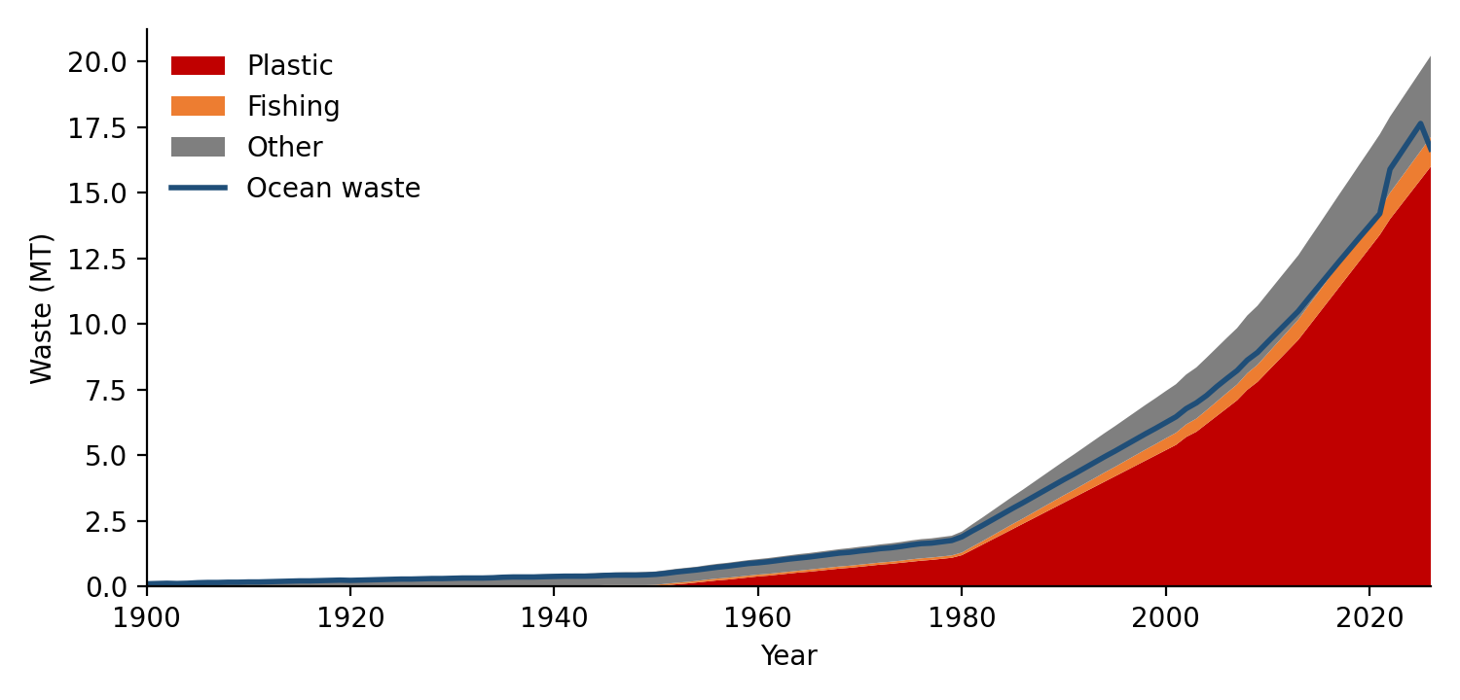
Figure 1. Waste generated by source and ocean waste, 1900-2026

Key milestones
Year | Plastic (MT) | Ocean Waste (MT) | Collected (MT) | Recycled (MT) | Mgmt Efficiency
1900 | 0.00 | 0.11 | 0.00 | 0.00 | 1%
1950 | 0.01 | 0.47 | 0.11 | 0.00 | 6%
1980 | 1.20 | 1.90 | 0.20 | 0.05 | 10%
2000 | 5.20 | 6.25 | 1.20 | 0.35 | 23%
2020 | 12.90 | 13.75 | 2.90 | 1.18 | 35%
2026 | 16.00 | 16.67 | 3.55 | 1.47 | 40%

7. Data Quality Issues to Resolve
- For 2022-2025, reported ocean waste is 1.0-1.4 MT higher than waste generated minus waste collected; all other years match within 0.02 MT.
- The 2026 value falls below 2025 and matches the formula exactly, which suggests it may be a projection rather than a measured figure.
- Management Efficiency (%) is an index and does not equal collected divided by generated, so a separate collection rate is calculated.
The project will trace these points back to the original data source and document any corrections.

8. Deliverables
- Analysis workbook with derived metrics, summary statistics, decade analysis and key findings.
- Visualization workbook with eight linked charts.
- GitHub repository with a README describing the data and methods.
- Final written report summarizing results, limitations and recommendations.

9. Proposed Timeline
Phase | Activity | Duration
1 | Data validation and cleaning | Week 1
2 | Derived metrics and statistical analysis | Week 2
3 | Visualization and dashboard design | Week 3
4 | Anomaly investigation and source verification | Week 4
5 | Final report, documentation and GitHub release | Week 5

10. Tools and Technologies
Microsoft Excel for formulas and charts, Python (pandas, openpyxl) for data processing and workbook generation, LibreOffice for recalculation and verification, and GitHub for version control and sharing.

11. Expected Outcomes
The project will give a clear, evidence-based picture of how ocean waste has changed over time, which sources matter most, and how far current management has gone in reducing it. It will also produce a reusable, formula-driven workbook and a documented list of data issues, so the analysis can be repeated when new data becomes available.

12. Limitations and Future Scope
The study depends on the accuracy of a single annual dataset with one measurement unit, and it cannot establish causation between management efficiency and ocean waste. Future work could add regional breakdowns, additional waste categories, forecasting of future ocean waste, and comparison with external sources such as national or international waste statistics.

