Lab 11: Data Structures with AI: Implementing Fundamental Structures
Name: Ch.Umesh Chandra
Rollno: 2503A52364
Batch: 13

Task Description #1 (Stack Implementation)
Task: Use AI to generate a Stack class with push, pop, peek, and is_empty methods.
Prompt:
Generate a Python Stack class using a list. Implement push(), pop(), peek(), and is_empty(). Provide a simple example using 10, 20, and 30, and explain the LIFO behavior clearly.
Input:
class Stack:
def __init__(self):
self.items = []
def push(self, item):
self.items.append(item)
def pop(self):
if self.is_empty():
return None
return self.items.pop()
def peek(self):
if self.is_empty():
return None
return self.items[-1]
def is_empty(self):
return len(self.items) == 0
stack = Stack()
stack.push(10)
stack.push(20)
stack.push(30)
print("Top element:", stack.peek())
print("Popped element:", stack.pop())
print("Is stack empty?", stack.is_empty())
Output:
Summary:
A Stack follows LIFO (Last In, First Out). push() adds an element, pop() removes the top element, peek() returns the top element without removing it, and is_empty() checks whether the stack contains any elements.

Task Description #2 (Queue Implementation)
Task: Use AI to implement a Queue using Python lists.
Prompt:
Generate a Python Queue class using a list. Implement enqueue(), dequeue(), peek(), and size(). Demonstrate the operations with 10, 20, and 30 and explain FIFO behavior.
Input:
class Queue:
def __init__(self):
self.items = []
def enqueue(self, item):
self.items.append(item)
def dequeue(self):
if len(self.items) == 0:
return None
return self.items.pop(0)
def peek(self):
if len(self.items) == 0:
return None
return self.items[0]
def size(self):
return len(self.items)
queue = Queue()
queue.enqueue(10)
queue.enqueue(20)
queue.enqueue(30)
print("Front element:", queue.peek())
print("Dequeued element:", queue.dequeue())
print("Queue size:", queue.size())
Output:
Summary:
A Queue follows FIFO (First In, First Out). enqueue() adds an element at the rear, dequeue() removes the front element, peek() returns the front element, and size() returns the number of elements.

Task Description #3 (Singly Linked List)
Task: Use AI to generate a Singly Linked List with insert and display methods.
Prompt:
Generate a Python singly linked list using a Node class and a LinkedList class. Implement insertion at the end and display all elements from the head to None. Demonstrate the list using 10, 20, 30, and 40.
Input:
class Node:
def __init__(self, data):
self.data = data
self.next = None
class LinkedList:
def __init__(self):
self.head = None
def insert(self, data):
new_node = Node(data)
if self.head is None:
self.head = new_node
return
current = self.head
while current.next is not None:
current = current.next
current.next = new_node
def display(self):
current = self.head
while current is not None:
print(current.data, end=" -> ")
current = current.next
print("None")
linked_list = LinkedList()
linked_list.insert(10)
linked_list.insert(20)
linked_list.insert(30)
linked_list.insert(40)
print("Linked List:")
linked_list.display()
Output:
Summary:
A singly linked list consists of nodes. Each node stores data and a link to the next node. insert() adds a node at the end and display() traverses the list from the head to None.

Task Description #4 (Binary Search Tree – BST)
Task: Use AI to create a BST with insert and in-order traversal methods.
Prompt:
Generate a Python Binary Search Tree with recursive insertion and in-order traversal. Insert 50, 30, 70, 20, 40, 60, and 80, then display the in-order traversal and explain why it produces sorted values.
Input:
class Node:
def __init__(self, data):
self.data = data
self.left = None
self.right = None
class BST:
def __init__(self):
self.root = None
def insert(self, root, data):
if root is None:
return Node(data)
if data < root.data:
root.left = self.insert(root.left, data)
elif data > root.data:
root.right = self.insert(root.right, data)
return root
def inorder(self, root):
if root is not None:
self.inorder(root.left)
print(root.data, end=" ")
self.inorder(root.right)
bst = BST()
values = [50, 30, 70, 20, 40, 60, 80]
for value in values:
bst.root = bst.insert(bst.root, value)
print("In-order Traversal:")
bst.inorder(bst.root)
Output:
Summary:
A Binary Search Tree stores smaller values on the left and larger values on the right. In-order traversal visits left, root, and right, producing the values in sorted order.

Task Description #5 (Priority Queue)
Task: Use AI to implement a Priority Queue using Python's heapq.
Prompt:
Generate a Python PriorityQueue class using heapq. Implement enqueue(), dequeue(), and display(). Use priorities 3, 1, and 2 and explain why the smaller priority number is served first.
Input:
import heapq
class PriorityQueue:
def __init__(self):
self.queue = []
def enqueue(self, priority, item):
heapq.heappush(self.queue, (priority, item))
def dequeue(self):
if not self.queue:
return None
priority, item = heapq.heappop(self.queue)
return item
def display(self):
print("Priority Queue:")
for priority, item in sorted(self.queue):
print(f"Priority {priority}: {item}")
pq = PriorityQueue()
pq.enqueue(3, "Task C")
pq.enqueue(1, "Task A")
pq.enqueue(2, "Task B")
pq.display()
print("Dequeued:", pq.dequeue())
print("Dequeued:", pq.dequeue())
Output:
Summary:
A Priority Queue serves elements according to priority instead of insertion order. Python's heapq implements a min-heap, so a smaller priority number is served first.

Task Description #6 (Deque)
Task: Use AI to implement a double-ended queue using collections.deque.
Prompt:
Generate a Python double-ended queue using collections.deque. Implement insertion and removal at both the front and rear, then demonstrate the operations with 5, 10, and 20.
Input:
from collections import deque
class DequeDS:
def __init__(self):
self.items = deque()
def insert_front(self, item):
self.items.appendleft(item)
def insert_rear(self, item):
self.items.append(item)
def remove_front(self):
if not self.items:
return None
return self.items.popleft()
def remove_rear(self):
if not self.items:
return None
return self.items.pop()
def display(self):
print("Deque:", list(self.items))
dq = DequeDS()
dq.insert_rear(10)
dq.insert_rear(20)
dq.insert_front(5)
dq.display()
print("Removed from front:", dq.remove_front())
print("Removed from rear:", dq.remove_rear())
dq.display()
Output:
Summary:
A Deque (Double-Ended Queue) allows insertion and deletion of elements from both the front and rear. collections.deque provides efficient append, appendleft, pop, and popleft operations.

Task Description #7 (Real-Time Application Challenge – Campus Resource Management)
Scenario: The college wants a Campus Resource Management System for attendance tracking, event registration, library borrowing, bus scheduling, and cafeteria orders.
Prompt:
Choose the most suitable data structure for the cafeteria order scenario and implement it in Python. The structure must serve students in the same order in which their orders arrive. Demonstrate adding, displaying, and serving orders.
Input:
from collections import deque
class CafeteriaQueue:
def __init__(self):
self.orders = deque()
def add_order(self, student_name, order):
self.orders.append((student_name, order))
def serve_order(self):
if not self.orders:
return None
return self.orders.popleft()
def display_orders(self):
if not self.orders:
print("No pending orders.")
return
print("Pending Orders:")
for student, order in self.orders:
print(f"{student} - {order}")
cafeteria = CafeteriaQueue()
cafeteria.add_order("Rahul", "Dosa")
cafeteria.add_order("Priya", "Burger")
cafeteria.add_order("Arjun", "Biryani")
cafeteria.display_orders()
print("\nServing:", cafeteria.serve_order())
print("Serving:", cafeteria.serve_order())
print("\nRemaining Orders:")
cafeteria.display_orders()
Output: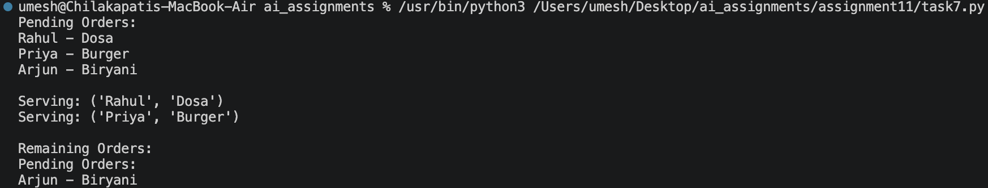

Summary:
A FIFO Queue is appropriate for the cafeteria because orders should be served in the same order in which students place them. collections.deque provides efficient insertion at the rear and removal from the front.

Task Description #8 (Smart E-Commerce Platform – Data Structure Challenge)
Scenario: An e-commerce company needs shopping cart management, order processing, top-selling product tracking, product search, and delivery route planning.
Prompt:
Choose and implement the most suitable data structure for the order-processing part of the e-commerce system. Orders must be processed in the order they are placed. Demonstrate adding, displaying, and processing orders.
Input:
from collections import deque
class OrderQueue:
def __init__(self):
self.orders = deque()
def add_order(self, order_id, customer_name):
self.orders.append((order_id, customer_name))
def process_order(self):
if not self.orders:
return None
return self.orders.popleft()
def display_orders(self):
if not self.orders:
print("No pending orders.")
return
print("Pending Orders:")
for order_id, customer in self.orders:
print(f"Order ID: {order_id}, Customer: {customer}")
order_queue = OrderQueue()
order_queue.add_order(101, "Rahul")
order_queue.add_order(102, "Priya")
order_queue.add_order(103, "Arjun")
order_queue.display_orders()
print("\nProcessing:", order_queue.process_order())
print("Processing:", order_queue.process_order())
print("\nRemaining Orders:")
order_queue.display_orders()
Output: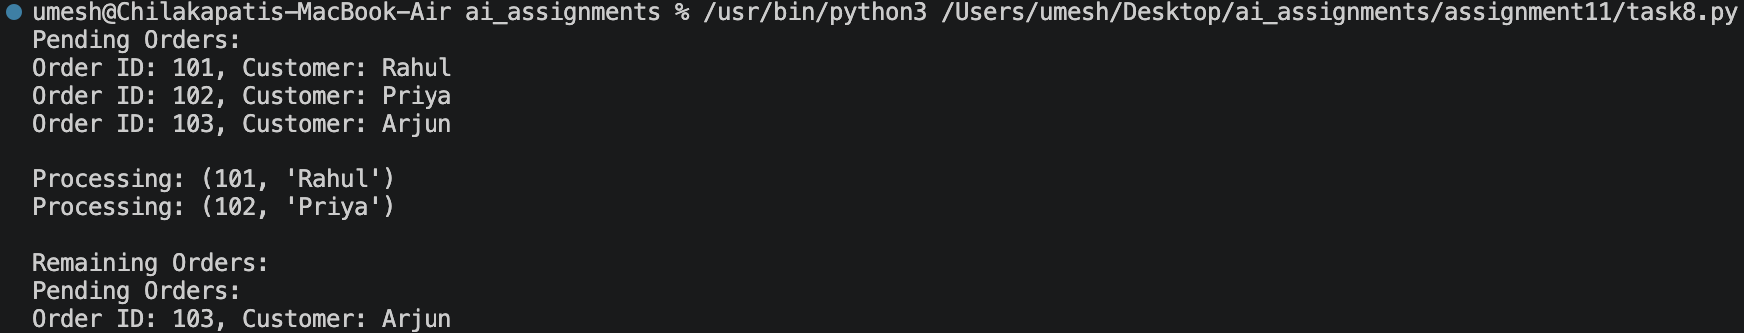
Summary:
A FIFO Queue is suitable for order processing because it preserves the order in which customers place their orders. add_order() adds a new order at the rear, while process_order() removes the oldest order first.

