Lab 3: Prompt Engineering – Improving Prompts and Context Management
Name: Ch.Umesh Chandra
Rollno: 2503A52364
Batch: 13

Task Description #1 (Zero-Shot Prompting (Palindrome Number Program))
Write a zero-shot prompt without providing examples to generate a Python function that checks whether a given number is a palindrome. Record the AI-generated code, test multiple inputs, and identify logical errors or missing edge-case handling.
Prompt:
Write a Python function that checks whether a given integer is a palindrome. Return True if it is a palindrome and False otherwise. Include a simple test with user-provided values.
Input:
def is_palindrome(number):
if number < 0:
return False
text = str(number)
return text == text[::-1]

for value in [121, 123, 0, -121]:
print(value, is_palindrome(value))
Output:

Summary:
A zero-shot prompt gives the AI the task without examples. The generated logic is simple and handles common cases; the negative-number convention should be stated explicitly because requirements may differ.

Task Description #2 (One-Shot Prompting (Factorial Calculation))
Write a one-shot prompt by providing one input-output example and ask the AI to generate a Python function to compute factorial. Required example: Input 5 → Output 120.
Prompt:
Generate a Python function to calculate the factorial of a non-negative integer.
Example: Input: 5 → Output: 120. Validate that the input is not negative.
Input:
def factorial(number):
if number < 0:
raise ValueError("Factorial is not defined for negative integers.")

result = 1
for value in range(2, number + 1):
result *= value
return result

print(factorial(5))
Output:
Summary:
The example clarifies the expected input-output relationship. The generated solution uses an iterative approach and explicitly rejects negative inputs. Compared with a zero-shot prompt, the example can make the desired output behavior clearer.

Task Description #3 (Few-Shot Prompting (Armstrong Number Check))
Write a few-shot prompt with multiple input-output examples to guide an AI in generating a Python function to check whether a number is an Armstrong number.
Prompt:
Generate a Python function that checks whether an integer is an Armstrong number.
Examples:
Input: 153 → Output: Armstrong Number
Input: 370 → Output: Armstrong Number
Input: 123 → Output: Not an Armstrong Number
Use these examples to match the requested output style and handle invalid negative input clearly.
Input:
def is_armstrong(number):
if number < 0:
return False

digits = str(number)
power = len(digits)
total = sum(int(digit) ** power for digit in digits)
return total == number

for value in [153, 370, 123]:
result = "Armstrong Number" if is_armstrong(value) else "Not an Armstrong Number"
print(value, "→", result)
Output:

Summary:
Multiple examples establish both positive and negative cases and the desired output wording. This can improve consistency in the generated program and make expected behavior easier to infer.

Task Description #4 (Context-Managed Prompting (Optimized Number Classification))
Design a context-managed prompt with clear instructions and constraints to generate an optimized Python program that classifies a number as prime, composite, or neither. Ensure input validation and efficient logic.
Prompt:
Context: You are writing a Python utility for number classification.
Task: Classify an integer as Prime, Composite, or Neither.
Constraints: 0 and 1 are Neither; negative values are invalid; use efficient trial division only up to the square root of the number; return clear labels; include sample tests and explain the logic.
Input:
import math

def classify_number(number):
if not isinstance(number, int) or number < 0:
return "Invalid input"
if number < 2:
return "Neither"

for divisor in range(2, math.isqrt(number) + 1):
if number % divisor == 0:
return "Composite"
return "Prime"

for value in [0, 1, 2, 17, 18, -5]:
print(value, "→", classify_number(value))
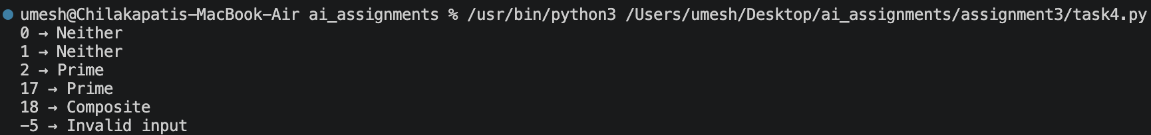
Output:

Summary:
The context-managed prompt specifies role, task, constraints, edge cases, and optimization requirements. Checking divisors only through the square root reduces unnecessary iterations compared with checking all values below the number.

Task Description #5 (Zero-Shot Prompting (Perfect Number Check))
Write a zero-shot prompt without examples to generate a Python function that checks whether a given number is a perfect number. Test multiple inputs and identify missing conditions or inefficiencies.
Prompt:
Write a Python function that checks whether a positive integer is a perfect number. Return True if the sum of its proper positive divisors equals the number, otherwise return False. Include sample tests.
Input:
def is_perfect(number):
if number <= 1:
return False

divisor_sum = 1
for divisor in range(2, int(number ** 0.5) + 1):
if number % divisor == 0:
divisor_sum += divisor
pair = number // divisor
if pair != divisor:
divisor_sum += pair

return divisor_sum == number

for value in [6, 28, 12, 1]:
print(value, is_perfect(value))
Output:
Summary:
The program rejects values that cannot be perfect numbers and uses divisor pairs up to the square root to reduce work. A simple zero-shot prompt may otherwise produce a less efficient loop through every possible divisor.

Task Description #6 (Few-Shot Prompting (Even or Odd Classification with Validation))
Write a few-shot prompt using the supplied examples to generate a Python program that determines whether a number is even or odd, including proper input validation.
Prompt:
Generate a Python program that accepts an integer and prints whether it is Even or Odd. Examples:
Input: 8 → Output: Even
Input: 15 → Output: Odd
Input: 0 → Output: Even
The program must also handle negative integers and reject non-integer input with a clear message.
Input:
def classify_even_odd(value):
if isinstance(value, int):
return "Even" if value % 2 == 0 else "Odd"
return "Invalid input"

test_values = [8, 15, 0, -4, -7, "abc"]

for value in test_values:
print(value, "→", classify_even_odd(value))
Output: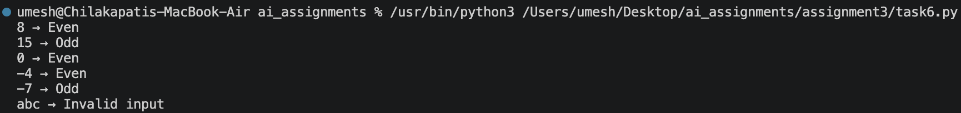
Summary:
The multiple examples establish the expected output format and include both even and odd cases. Additional validation requirements make the generated solution more robust for negative and non-integer inputs.

