Lab 4.1: Advanced Prompt Engineering – Zero-shot, One-shot, and Few-shot Techniques
Name: Ch.Umesh Chandra
Rollno: 2503A52364
Batch: 13

Task Description #1 (News Headline Classification using Zero-shot, One-shot, and Few-shot Techniques)
A news aggregation platform wants to automatically categorize headlines into Politics, Sports, Technology, and Entertainment without training a machine learning model. Generate prompts for an LLM and evaluate the expected classifications using the same test headlines for all three prompting strategies.
Prompt:
Generate Python code that builds zero-shot, one-shot, and few-shot prompts for an LLM to classify a news headline into exactly one of Politics, Sports, Technology, and Entertainment. Use the same test headlines for all three prompting strategies and evaluate the classifications.
Input:
CATEGORIES = ("Politics", "Sports", "Technology", "Entertainment")
SAMPLE_HEADLINES = [
("Government announces new education policy", "Politics"),
("Parliament passes a new tax reform bill", "Politics"),
("India wins the T20 cricket series", "Sports"),
("Football club signs a new international player", "Sports"),
("Tech company launches a new AI-powered smartphone", "Technology"),
("Cybersecurity firm reports a major data breach", "Technology"),
("Upcoming movie breaks box office records", "Entertainment"),
("Popular actor announces a next film project", "Entertainment"),
]
TEST_HEADLINES = SAMPLE_HEADLINES[:4]
def zero_shot_prompt(headline):
return (
"Classify the following news headline into exactly one of these categories: "
f"{', '.join(CATEGORIES)}.
Headline: {headline}
Category:"
)
def one_shot_prompt(headline):
return (
"Example:
Headline: Government announces new education policy
"
"Category: Politics
"
f"Classify this headline as {', '.join(CATEGORIES)}.
"
f"Headline: {headline}
Category:"
)
def few_shot_prompt(headline):
examples = "
".join([
"Headline: Parliament passes a new tax reform bill
Category: Politics",
"Headline: India wins the T20 cricket series
Category: Sports",
"Headline: Cybersecurity firm reports a major data breach
Category: Technology",
"Headline: Upcoming movie breaks box office records
Category: Entertainment",
])
return (
f"{examples}
Classify the following headline as exactly one of "
f"{', '.join(CATEGORIES)}.
Headline: {headline}
Category:"
)
def classify_without_an_llm(headline):
text = headline.lower()
keywords = {
"Politics": ("government", "parliament", "senate", "tax", "climate"),
"Sports": ("cricket", "football", "player", "series"),
"Technology": ("tech", "ai", "smartphone", "cybersecurity", "data breach"),
"Entertainment": ("movie", "actor", "film", "streaming", "series"),
}
return max(
CATEGORIES,
key=lambda category: sum(word in text for word in keywords[category])
)
def evaluate():
methods = {
"Zero-shot": zero_shot_prompt,
"One-shot": one_shot_prompt,
"Few-shot": few_shot_prompt,
}
for name, prompt_builder in methods.items():
correct = sum(
classify_without_an_llm(headline) == category
for headline, category in TEST_HEADLINES
)
print(f"{name}: {correct}/{len(TEST_HEADLINES)} correct")
print(prompt_builder(TEST_HEADLINES[0][0]), "
")
if __name__ == "__main__":
evaluate()
Output: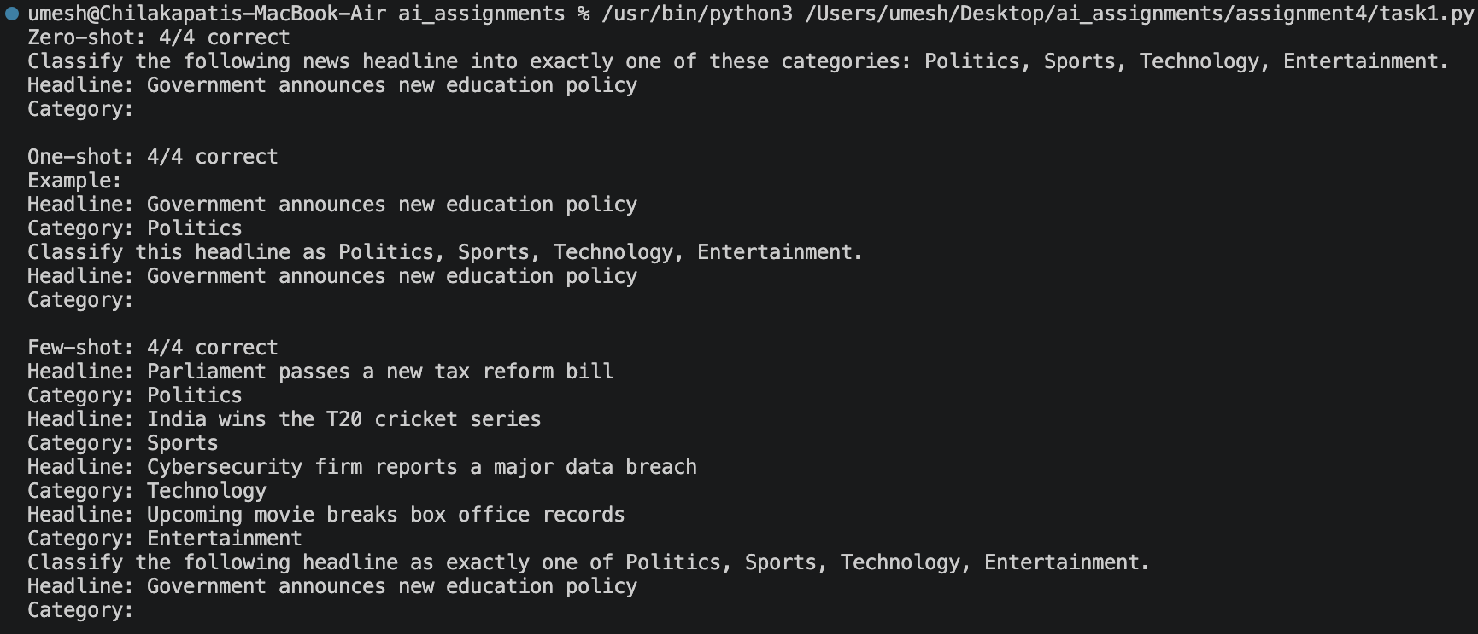

Summary:
Zero-shot works without examples, one-shot provides one labeled example, and few-shot provides multiple examples. The same test headlines are used for all three strategies so their results can be compared fairly.

Task Description #2 (Customer Email Classification)
Generate a Python customer email classification system using prompt engineering. The categories are Billing, Technical Support, Feedback, and Others.
Prompt:
Generate Python prompt designs for customer email classification using zero-shot, one-shot, and few-shot prompting. Reply with only the category name and demonstrate the prompts on a new customer email.
Input:
CATEGORIES = ["Billing", "Technical Support", "Feedback", "Others"]
sample_emails = [
("Billing", "I was charged twice for my monthly subscription."),
("Technical Support", "The mobile app crashes whenever I try to log in."),
("Feedback", "The new dashboard is clean and easy to navigate."),
("Others", "What are your office hours on public holidays?"),
("Billing", "Please send me a copy of my latest invoice."),
]
def zero_shot_prompt(email):
return f"""Classify the customer email into exactly one category:
{', '.join(CATEGORIES)}.
Reply with only the category name.
Email: {email}"""
def one_shot_prompt(email):
category, example = sample_emails[0]
return f"""Classify emails as Billing, Technical Support, Feedback, or Others.
Reply with only the category name.
Example:
Email: {example}
Category: {category}
New email:
{email}"""
def few_shot_prompt(email):
examples = "
".join(
f"Email: {text}
Category: {category}"
for category, text in sample_emails[:3]
)
return f"""Classify the new customer email as Billing, Technical Support,
Feedback, or Others.
Reply with only the category name.
Labeled examples:
{examples}
New email:
{email}"""
if __name__ == "__main__":
new_email = "My payment was declined, but the amount is still showing as pending."
print("ZERO-SHOT
", zero_shot_prompt(new_email))
print("
ONE-SHOT
", one_shot_prompt(new_email))
print("
FEW-SHOT
", few_shot_prompt(new_email))
Output: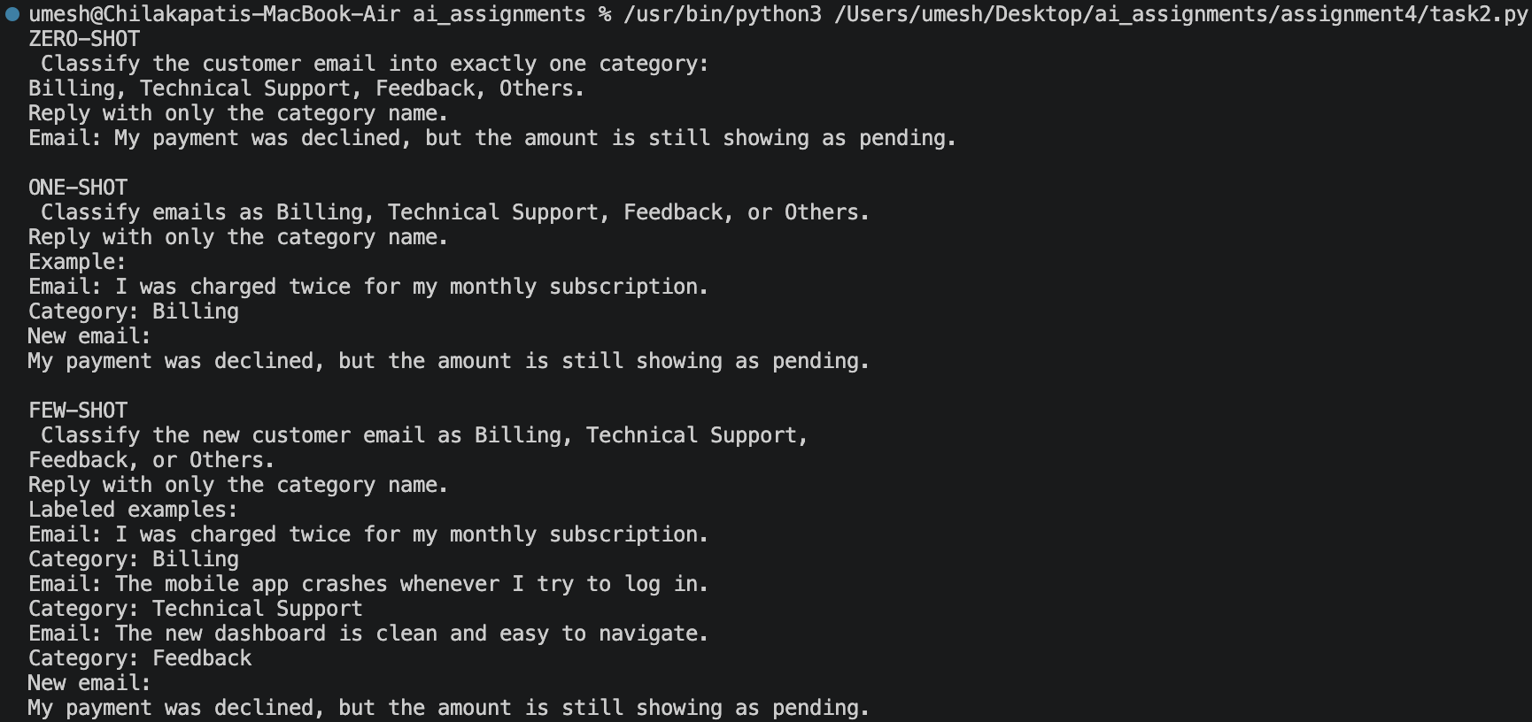

Summary:
Zero-shot is concise but provides no labeled reference. One-shot improves consistency through one example. Few-shot provides several labeled examples and generally gives stronger guidance, although it uses more prompt tokens.

Task Description #3 (Intent Classification for Chatbot Queries)
Generate intent classification using zero-shot, one-shot, and few-shot prompts. The chatbot intents are Account Issue, Order Status, Product Inquiry, and General Question.
Prompt:
Generate Python prompt builders for zero-shot, one-shot, and few-shot intent classification. Return only the intent name and include a way to compare accuracy using the same test queries.
Input:
INTENTS = ["Account Issue", "Order Status", "Product Inquiry", "General Question"]
TEST_QUERIES = [
("My password reset email never arrived.", "Account Issue"),
("Can you tell me the status of order #4821?", "Order Status"),
("Is this phone compatible with wireless charging?", "Product Inquiry"),
("What are your customer service hours?", "General Question"),
]
def zero_shot_prompt(query):
return f"""Classify this customer query into exactly one of these intents:
{', '.join(INTENTS)}.
Reply with only the intent name.
Customer query: {query}
Intent:"""
def one_shot_prompt(query):
return f"""Classify each customer query into exactly one of these intents:
{', '.join(INTENTS)}.
Reply with only the intent name.
Example:
Customer query: Where is my order?
Intent: Order Status
Customer query: {query}
Intent:"""
def few_shot_prompt(query):
examples = [
("I cannot log in to my account.", "Account Issue"),
("Where is my order?", "Order Status"),
("Does this laptop come with a warranty?", "Product Inquiry"),
("How can I contact customer support?", "General Question"),
]
labeled_examples = "
".join(
f"Customer query: {text}
Intent: {intent}"
for text, intent in examples
)
return f"""Classify the customer query into exactly one of these intents:
{', '.join(INTENTS)}.
Reply with only the intent name.
{labeled_examples}
Customer query: {query}
Intent:"""
def evaluate(predictions):
results = [
(query, expected, predicted, expected == predicted)
for (query, expected), predicted in zip(TEST_QUERIES, predictions)
]
accuracy = sum(row[3] for row in results) / len(results)
return accuracy, results
if __name__ == "__main__":
query = TEST_QUERIES[0][0]
print("ZERO-SHOT
", zero_shot_prompt(query))
print("
ONE-SHOT
", one_shot_prompt(query))
print("
FEW-SHOT
", few_shot_prompt(query))
Output: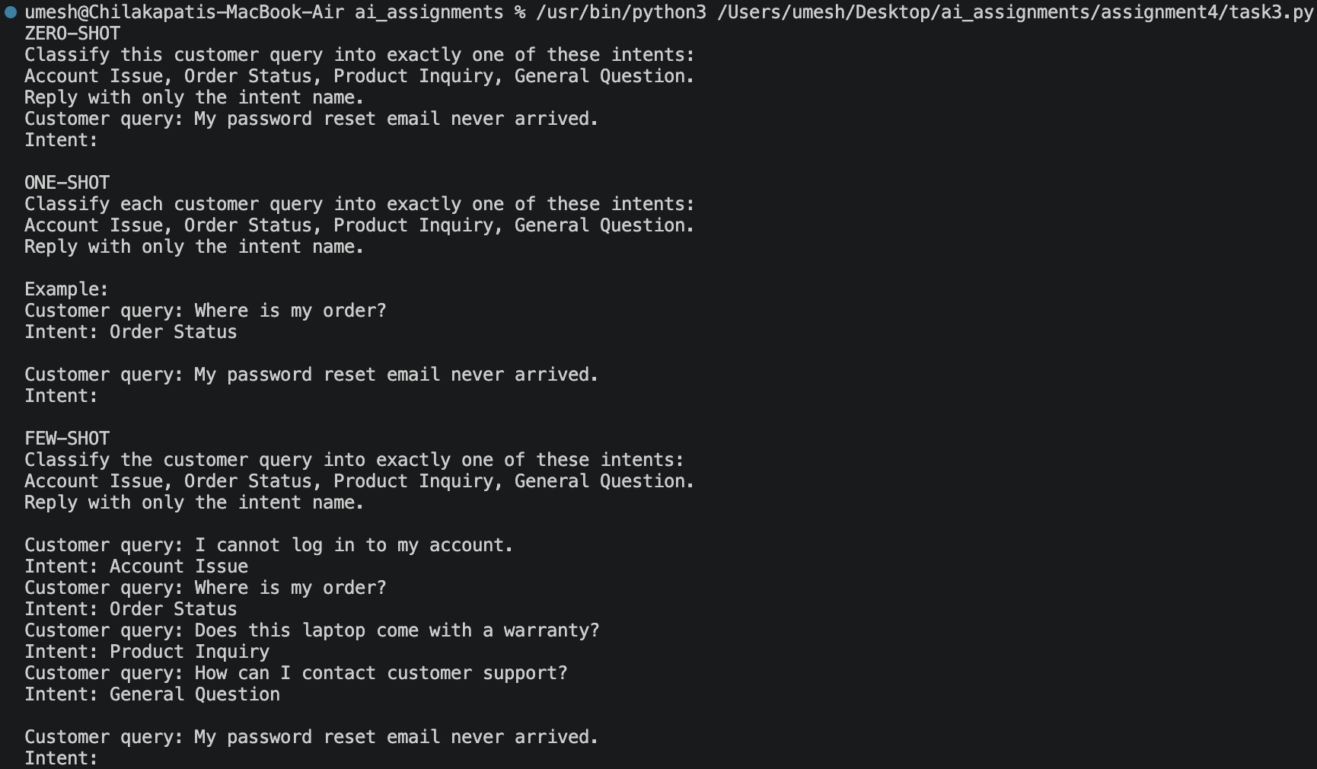

Summary:
Zero-shot is the baseline, one-shot improves format consistency, and few-shot provides examples for all four intent boundaries. The same TEST_QUERIES should be sent to the same LLM with each prompt before comparing accuracy.

Task Description #4 (Student Feedback Analysis)
Generate Python prompt designs for classifying university student feedback sentiment as Positive, Negative, or Neutral.
Prompt:
Generate Python prompt designs for classifying university student feedback as Positive, Negative, or Neutral. Include one-shot and few-shot examples and explain how examples improve classification accuracy.
Input:
zero_shot_prompt = """
Classify the following university student feedback as exactly one of:
Positive, Negative, or Neutral.
Return only the label.
Feedback: {feedback}
""".strip()
one_shot_prompt = """
Classify university student feedback as exactly one of: Positive, Negative,
or Neutral. Return only the label.
Example:
Feedback: "The library is quiet, comfortable, and has excellent resources."
Label: Positive
Feedback: {feedback}
Label:
""".strip()
few_shot_prompt = """
Classify university student feedback as exactly one of: Positive, Negative,
or Neutral. Return only the label.
Examples:
Feedback: "The professors are supportive and the lectures are engaging."
Label: Positive
Feedback: "The computer lab is overcrowded and several computers do not work."
Label: Negative
Feedback: "The cafeteria serves food at reasonable prices."
Label: Neutral
Feedback: {feedback}
Label:
""".strip()
def explain_example_benefit():
return (
"Examples show the expected labels and how to interpret ambiguous wording. "
"Multiple, varied examples help the model recognize positive, negative, "
"and neutral patterns consistently, reducing confusion and improving "
"classification accuracy."
)
if __name__ == "__main__":
feedback = "The new study spaces are helpful, but they close too early."
print(zero_shot_prompt.format(feedback=feedback))
print("
" + explain_example_benefit())
Output:
Summary:
Examples show the expected labels and how to interpret ambiguous wording. Multiple varied examples help the model recognize positive, negative, and neutral patterns consistently, reducing confusion and improving classification accuracy.

Task Description #5 (Course Recommendation System)
Generate a prompt-based course recommendation system. The learner query is classified as Beginner, Intermediate, or Advanced and then mapped to an appropriate course category.
Prompt:
Generate a prompt-based course recommendation system using zero-shot, one-shot, and few-shot prompting. Classify the learner query as Beginner, Intermediate, or Advanced, return a short reason, and map the level to a suitable course type.
Input:
def zero_shot_prompt(query):
return f"""Classify this learner query as exactly one of Beginner,
Intermediate, or Advanced.
Return only the level and a short reason.
Learner query: {query}"""
def one_shot_prompt(query):
return f"""Classify learner queries as Beginner, Intermediate, or Advanced.
Return only the level and a short reason.
Example query: What is a variable in Python?
Example label: Beginner
Learner query: {query}"""
def few_shot_prompt(query):
return f"""Classify learner queries as Beginner, Intermediate, or Advanced.
Use these labeled examples and return only the level and a short reason.
Query: What is a variable in Python?
Label: Beginner
Query: How do I use list comprehensions and decorators?
Label: Intermediate
Query: How can I optimize a distributed neural network for low latency?
Label: Advanced
Learner query: {query}"""
def recommend_course(level):
courses = {
"beginner": "Introduction and fundamentals courses",
"intermediate": "Applied projects and skill-building courses",
"advanced": "Expert, optimization, and research courses",
}
return courses.get(level.strip().lower(), "Unknown level")
def main():
query = input("Enter a learner query: ").strip()
print("
ZERO-SHOT PROMPT:
" + zero_shot_prompt(query))
print("
ONE-SHOT PROMPT:
" + one_shot_prompt(query))
print("
FEW-SHOT PROMPT:
" + few_shot_prompt(query))
if __name__ == "__main__":
main()
Output: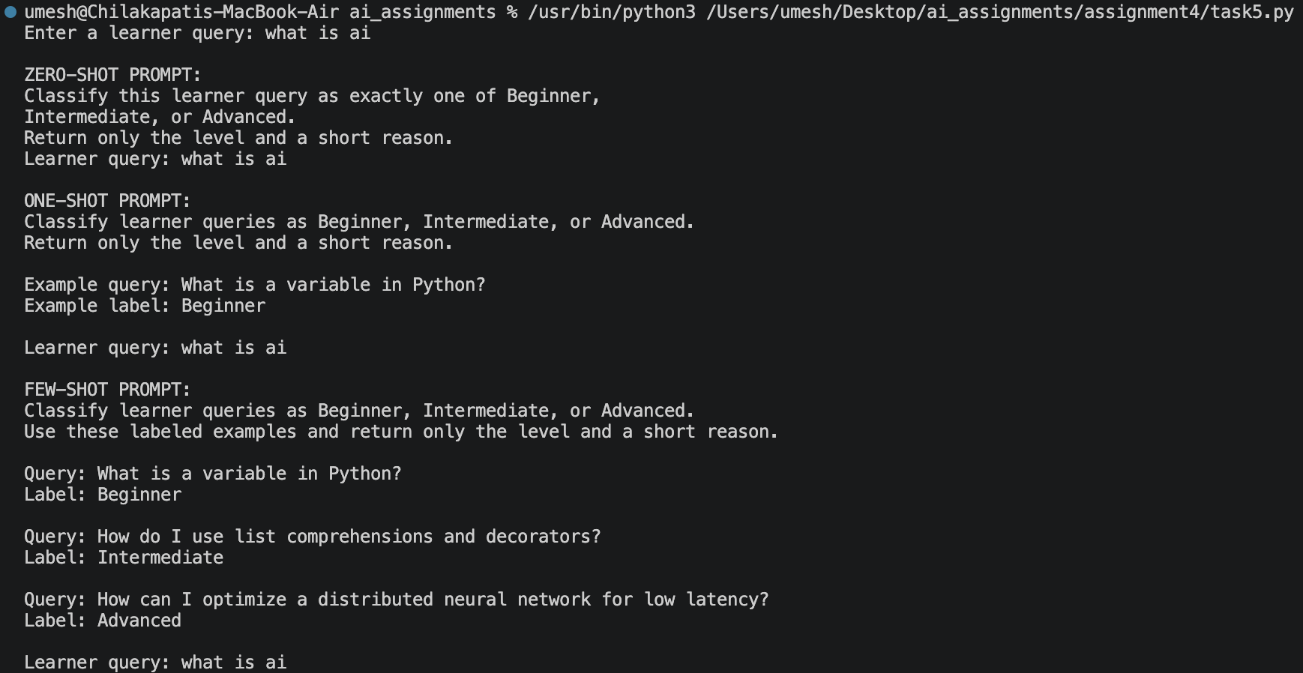

Summary:
Few-shot prompting clarifies the boundaries between Beginner, Intermediate, and Advanced by providing multiple labeled examples. The recommendation function then maps the predicted level to an appropriate course category.

Task Description #6 (Social Media Post Moderation)
Generate Python prompt designs for social-media post moderation. Posts must be classified as Acceptable, Offensive, or Spam.

Prompt:
Generate Python prompt designs for social-media post moderation using zero-shot, one-shot, and few-shot prompting. Define Acceptable, Offensive, and Spam clearly and explain the common limitations of zero-shot moderation.
Input:
def zero_shot_prompt(post: str) -> str:
return f"""Classify the following social media post as exactly one of:
Acceptable, Offensive, or Spam.
Definitions:
- Acceptable: Safe, relevant, and non-abusive content.
- Offensive: Hate, harassment, threats, or seriously abusive content.
- Spam: Unwanted repetitive advertising, scams, or promotional content.
Return only the category name.
Post: {post}"""
def one_shot_prompt(post: str) -> str:
return f"""Classify each post as exactly one of: Acceptable, Offensive, or Spam.
Return only the category name.
Example:
Post: "Thanks for sharing this helpful information!"
Category: Acceptable
Post: {post}
Category:"""
def few_shot_prompt(post: str) -> str:
return f"""Classify the post as exactly one of: Acceptable, Offensive, or Spam.
Return only the category name.
Examples:
1. Post: "The sunset looks beautiful today."
Category: Acceptable
2. Post: "People like you should leave this community."
Category: Offensive
3. Post: "You won a prize! Click this link and pay a small fee now."
Category: Spam
4. Post: "I disagree, but I respect your point of view."
Category: Acceptable
Post: {post}
Category:"""
def moderation_challenges() -> str:
return """Zero-shot moderation can be inconsistent because labels may be ambiguous,
context and cultural norms vary, sarcasm and coded language are difficult to detect,
and new slang or evasion techniques may not match the model's assumptions.
It can also produce false positives or negatives. Clear definitions,
representative examples, human review, and regular evaluation are needed."""
if __name__ == "__main__":
post = input("Enter a post to moderate: ")
print("
Zero-shot prompt:
", zero_shot_prompt(post))
print("
One-shot prompt:
", one_shot_prompt(post))
print("
Few-shot prompt:
", few_shot_prompt(post))
print("
Challenges:
", moderation_challenges())

Output: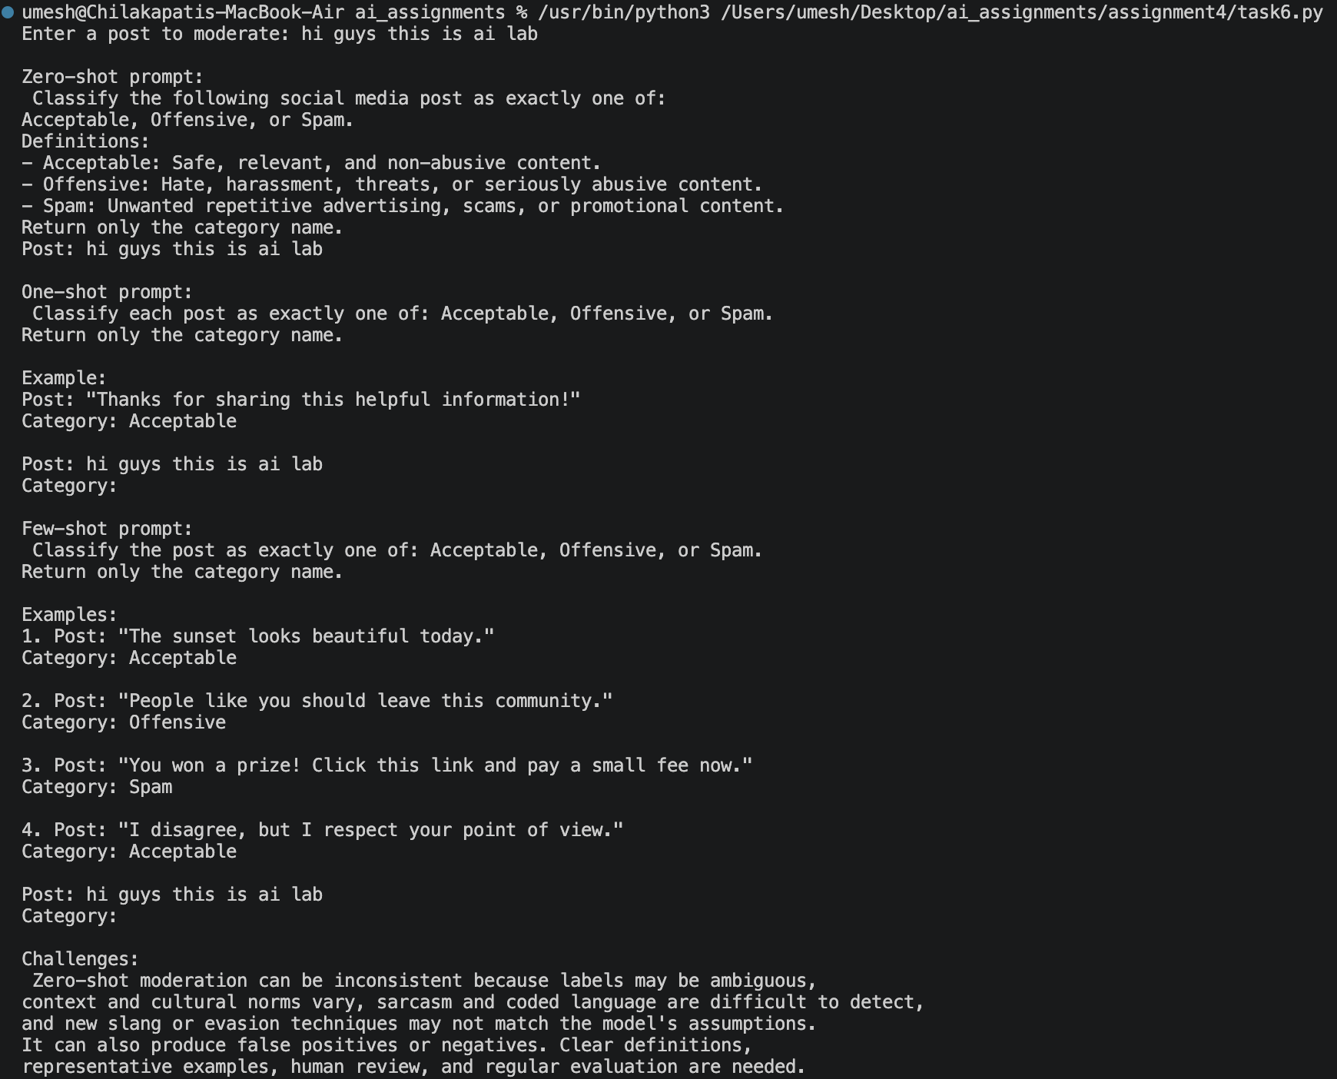

Summary:
Zero-shot moderation can be inconsistent because labels may be ambiguous, context and cultural norms vary, and sarcasm, coded language, slang, and borderline advertising are difficult to classify. Clear definitions, representative examples, human review, and regular evaluation are needed.

