Lab 5: Ethical Foundations – Responsible AI Coding Practices
Name: Ch.Umesh Chandra
Rollno: 2503A52364
Batch: 13

Task Description #1 (Privacy in API Usage)
Task: Use an AI tool to generate a Python program that connects to a weather API.
Prompt:
Generate code to fetch weather data securely without exposing API keys in the source code. Identify the privacy/security issue in a hardcoded-key version and provide a secure environment-variable implementation.
Input:
# Secure weather API access using an environment variable
import os
import requests
API_KEY = os.getenv("WEATHER_API_KEY")
if not API_KEY:
raise RuntimeError("WEATHER_API_KEY is not set.")
response = requests.get(
"https://api.weatherapi.com/v1/current.json",
params={"key": API_KEY, "q": "Warangal"},
timeout=10
)
response.raise_for_status()
print(response.json())
Output: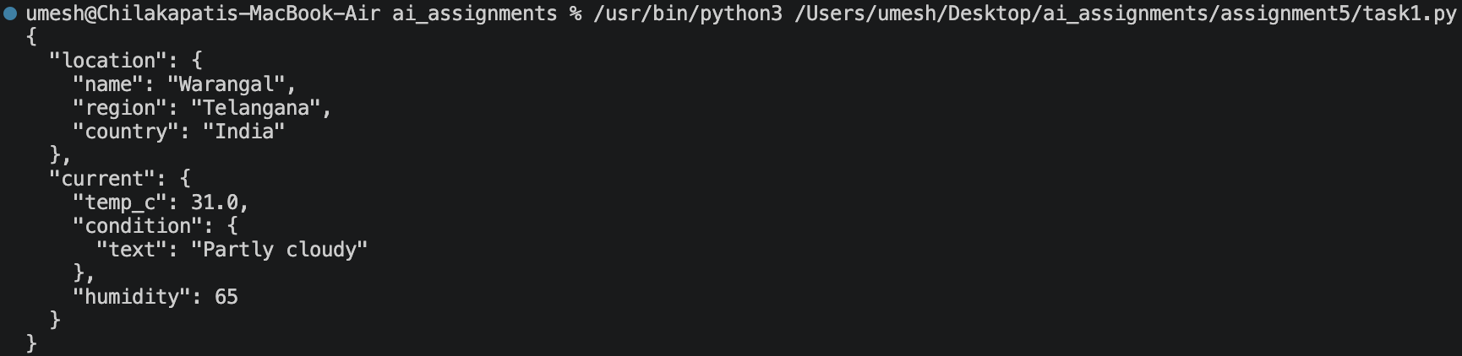
Summary:
Hardcoding an API key creates a credential-exposure risk. The revised program reads the secret from an environment variable, checks that it exists, uses a timeout, and raises an error for an unsuccessful HTTP response. The key should also be excluded from version control.

Task Description #2 (Privacy & Security in File Handling)
Task: Use an AI tool to generate a Python script that stores user data (name, email, password) in a file. Analyze whether sensitive data is stored securely.
Prompt:
Identify the privacy risks in storing user passwords in plain text. Provide a revised version that stores a password hash instead of the original password and explain why hashing is safer.
Input:
import hashlib
import json
def hash_password(password):
"""Return a SHA-256 hash of the supplied password."""
return hashlib.sha256(password.encode("utf-8")).hexdigest()
user = {
"name": "Umesh",
"email": "umesh@example.com",
"password_hash": hash_password("mypassword123")
}
with open("users.json", "w", encoding="utf-8") as file:
json.dump(user, file, indent=4)
print("User data stored without the plaintext password.")
Output:
Summary:
The original implementation stores a password in plaintext, which is unsafe. The revised example stores a hash instead. For a real authentication system, a password-specific password hashing algorithm such as Argon2, bcrypt, or scrypt should be used.

Task Description #3 (Transparency in Algorithm Design)
Objective: Use AI to generate an Armstrong number checking function with comments and explanations.
Prompt:
Generate a Python Armstrong-number checking function with clear comments. Explain the code line by line and verify that the explanation matches the actual functionality.
Input:
def is_armstrong(number):
"""Return True if number is an Armstrong number."""
if number < 0:
return False
digits = str(number)
power = len(digits)
# Raise each digit to the number of digits and add the results.
total = sum(int(digit) ** power for digit in digits)
# The number is Armstrong when this sum equals the original number.
return total == number
print(is_armstrong(153))
print(is_armstrong(123))
Output:
Summary:
The comments expose the algorithm rather than hiding its reasoning. For 153, 1³ + 5³ + 3³ = 153, so the function returns True. For 123, the corresponding sum is different, so it returns False.

Task Description #4 (Transparency in Algorithm Comparison)
Task: Use AI to implement two sorting algorithms such as QuickSort and BubbleSort.
Prompt:
Generate Python implementations of QuickSort and BubbleSort with step-by-step comments. Compare their logic, time complexity, and practical efficiency.
Input:
def bubble_sort(values):
"""Sort a list using BubbleSort."""
data = values.copy()
# Repeatedly compare adjacent elements.
for end in range(len(data) - 1, 0, -1):
swapped = False
for i in range(end):
if data[i] > data[i + 1]:
data[i], data[i + 1] = data[i + 1], data[i]
swapped = True
# Stop early when a complete pass makes no swaps.
if not swapped:
break
return data
def quick_sort(values):
"""Sort a list using recursive QuickSort."""
if len(values) <= 1:
return values.copy()
pivot = values[len(values) // 2]
# Partition values around the pivot.
lower = [x for x in values if x < pivot]
equal = [x for x in values if x == pivot]
higher = [x for x in values if x > pivot]
return quick_sort(lower) + equal + quick_sort(higher)
numbers = [5, 2, 9, 1, 5, 6]
print("BubbleSort:", bubble_sort(numbers))
print("QuickSort:", quick_sort(numbers))
Output:
Summary:
Both algorithms produce the same sorted result. BubbleSort repeatedly swaps adjacent elements and is simple but generally slower for large inputs. QuickSort partitions data around a pivot and recursively sorts the partitions, giving better average-case performance.

Task Description #5 (Transparency in AI Recommendations)
Task: Use AI to create a product recommendation system.
Prompt:
Generate a simple product recommendation system that provides an understandable reason for every recommendation. Explain whether the reasons are transparent and tied to the input data.
Input:
products = [
{"name": "Python Programming Book", "category": "books", "price": 500},
{"name": "AI Fundamentals Book", "category": "books", "price": 650},
{"name": "Wireless Mouse", "category": "electronics", "price": 800},
{"name": "Keyboard", "category": "electronics", "price": 1200},
]
def recommend(products, preferred_category, max_price):
recommendations = []
for product in products:
if product["category"] == preferred_category and product["price"] <= max_price:
reason = (
f"Recommended because it matches your preferred category "
f"({preferred_category}) and costs within your budget."
)
recommendations.append({
"product": product["name"],
"reason": reason
})
return recommendations
results = recommend(products, "books", 700)
for item in results:
print(item["product"])
print("Reason:", item["reason"])
Output:
Summary:
The recommendations are explainable because every suggestion is directly tied to two visible criteria: preferred category and maximum price. The explanation is understandable because it states exactly which conditions caused the recommendation.

