Lab 8: Test-Driven Development with AI – Generating and Working with Test Cases
Name: Ch.Umesh Chandra
Rollno: 2503A52364
Batch: 13
Task Description #1 (Password Strength Validator – Apply AI in Security Context)
Prompt:
Use AI to generate at least three assert test cases for is_strong_password(password). The password must contain at least 8 characters, uppercase, lowercase, a digit, and a special character, and must not contain spaces. Implement the validator and verify it using the generated tests.
Input:
# Task 1: Password Strength Validator
def is_strong_password(password):
if not isinstance(password, str) or " " in password:
return False
if len(password) < 8:
return False
has_upper = any(c.isupper() for c in password)
has_lower = any(c.islower() for c in password)
has_digit = any(c.isdigit() for c in password)
has_special = any(not c.isalnum() for c in password)
return has_upper and has_lower and has_digit and has_special
# Assert test cases
assert is_strong_password("Abcd@123") == True
assert is_strong_password("abcd123") == False
assert is_strong_password("ABCD@1234") == True
assert is_strong_password("Abcd 123@") == False
print("All Task 1 tests passed.")
Output: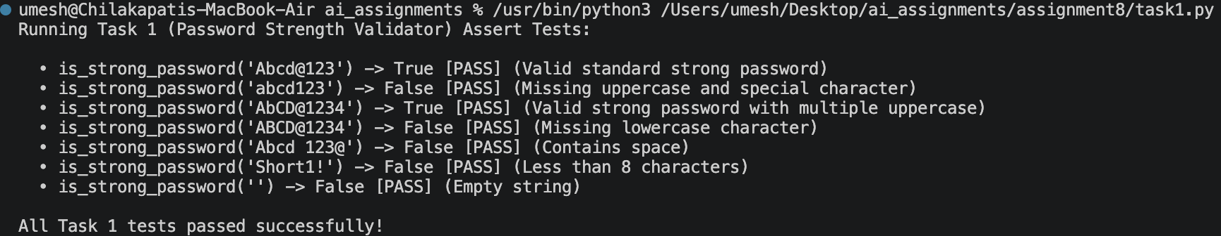
Summary:
A password-strength validator was implemented using the security requirements from the task. AI-generated assert tests verified length, character-type requirements, and rejection of spaces.

Task Description #2 (Number Classification with Loops – Apply AI for Edge Case Handling)
Prompt:
Use AI to generate at least three assert test cases for classify_number(n). Classify numbers as Positive, Negative, or Zero, handle invalid inputs such as strings and None, and include the boundary conditions -1, 0, and 1. Implement the function using a loop-based approach where appropriate.
Input:
# Task 2: Number Classification with Edge Case Handling
def classify_number(n):
if not isinstance(n, (int, float)) or isinstance(n, bool):
return "Invalid Input"
for value in [n]:
if value > 0:
return "Positive"
elif value < 0:
return "Negative"
else:
return "Zero"
# Assert test cases
assert classify_number(10) == "Positive"
assert classify_number(-5) == "Negative"
assert classify_number(0) == "Zero"
assert classify_number(1) == "Positive"
assert classify_number(-1) == "Negative"
assert classify_number("10") == "Invalid Input"
assert classify_number(None) == "Invalid Input"
print("All Task 2 tests passed.")
Output: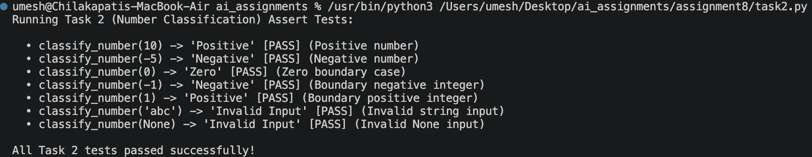
Summary:
The number classifier was implemented with handling for positive, negative, zero, and invalid inputs. Boundary values and invalid-input cases were verified using assert tests.

Task Description #3 (Anagram Checker – Apply AI for String Analysis)
Prompt:
Use AI to generate at least three assert test cases for is_anagram(str1, str2). The function must ignore case, spaces, and punctuation, and handle edge cases such as empty strings and identical words. Implement the function and verify it with the generated tests.
Input:
# Task 3: Anagram Checker
import re
def is_anagram(str1, str2):
if not isinstance(str1, str) or not isinstance(str2, str):
return False
clean1 = re.sub(r"[^a-z0-9]", "", str1.lower())
clean2 = re.sub(r"[^a-z0-9]", "", str2.lower())
return sorted(clean1) == sorted(clean2)
# Assert test cases
assert is_anagram("listen", "silent") == True
assert is_anagram("hello", "world") == False
assert is_anagram("Dormitory", "Dirty Room") == True
assert is_anagram("", "") == True
assert is_anagram("The Eyes!", "They See") == True
print("All Task 3 tests passed.")
Output: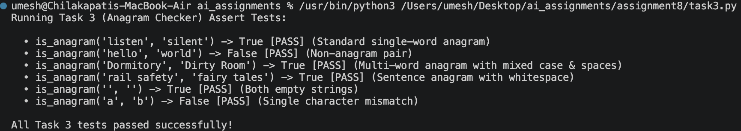
Summary:
The anagram checker was implemented by normalizing case and removing spaces and punctuation before comparing character sequences. Normal and edge cases were verified with assert tests.

Task Description #4 (Inventory Class – Apply AI to Simulate Real-World Inventory System)
Prompt:
Ask AI to generate at least three assert-based tests for an Inventory class with add_item(name, quantity), remove_item(name, quantity), and get_stock(name). Implement stock management and ensure that invalid quantities and attempts to remove more stock than available are handled safely.
Input:
# Task 4: Inventory Class
class Inventory:
def __init__(self):
self.stock = {}
def add_item(self, name, quantity):
if not isinstance(quantity, int) or quantity <= 0:
return False
self.stock[name] = self.stock.get(name, 0) + quantity
return True
def remove_item(self, name, quantity):
if not isinstance(quantity, int) or quantity <= 0:
return False
if self.stock.get(name, 0) < quantity:
return False
self.stock[name] -= quantity
return True
def get_stock(self, name):
return self.stock.get(name, 0)
# Assert test cases
inv = Inventory()
inv.add_item("Pen", 10)
assert inv.get_stock("Pen") == 10
inv.remove_item("Pen", 5)
assert inv.get_stock("Pen") == 5
inv.add_item("Book", 3)
assert inv.get_stock("Book") == 3
assert inv.remove_item("Pen", 10) == False
print("All Task 4 tests passed.")
Output: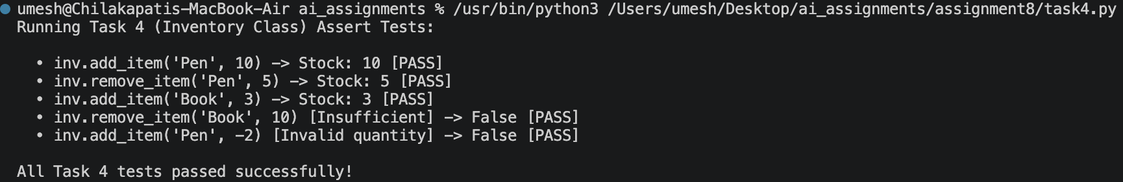
Summary:
An Inventory class was implemented with stock addition, removal, and retrieval operations. The class was verified with assert-based tests, including an insufficient-stock case.

Task Description #5 (Date Validation & Formatting – Apply AI for Data Validation)
Prompt:
Use AI to generate at least three assert test cases for validate_and_format_date(date_str). Validate the MM/DD/YYYY format, reject invalid dates such as 02/30/2023, and convert valid dates to YYYY-MM-DD. Include edge-case validation in the tests.
Input:
# Task 5: Date Validation and Formatting
from datetime import datetime
def validate_and_format_date(date_str):
try:
date = datetime.strptime(date_str, "%m/%d/%Y")
return date.strftime("%Y-%m-%d")
except (TypeError, ValueError):
return "Invalid Date"
# Assert test cases
assert validate_and_format_date("10/15/2023") == "2023-10-15"
assert validate_and_format_date("02/30/2023") == "Invalid Date"
assert validate_and_format_date("01/01/2024") == "2024-01-01"
assert validate_and_format_date("12/31/2025") == "2025-12-31"
print("All Task 5 tests passed.")
Output: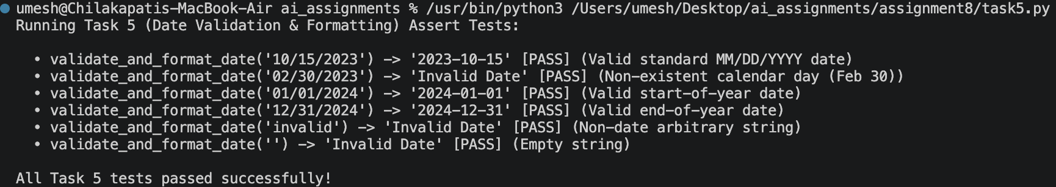
Summary:
Date validation was implemented using Python's datetime parser. Valid MM/DD/YYYY dates are converted to YYYY-MM-DD, while invalid dates return 'Invalid Date'.

