Lab 9: Documentation Generation - Automatic documentation and code comments
Name: Ch.Umesh Chandra
Rollno: 2503A52364
Batch: 13
Problem 1 (Documentation Styles for find_max)
Consider the following Python function:
def find_max(numbers):
return max(numbers)
Task: Write documentation for the function in all three formats: (a) Docstring, (b) Inline comments, and (c) Google-style documentation. Critically compare the three approaches, discuss their advantages, disadvantages, and suitable use cases, and recommend which style is most effective for a mathematical utilities library.
Prompt:
Generate documentation for the find_max() function in three distinct styles: (a) a standard Python docstring, (b) inline code comments, and (c) a comprehensive Google-style docstring. Provide a critical comparison of the three approaches discussing their advantages, disadvantages, and ideal use cases. Finally, recommend and justify the most effective documentation style for a mathematical utilities library.
Input:
# (a) Docstring format
def find_max(numbers):
"""Return the largest value in a sequence of numbers."""
return max(numbers)

# (b) Inline comments format
def find_max_with_comments(numbers):
# max() returns the largest value in the supplied sequence.
return max(numbers)

# (c) Google-style documentation format
def find_max_google(numbers):
"""Find the maximum value in a sequence of numbers.

Args:
numbers (list of int or float): A non-empty sequence containing numeric values.

Returns:
int or float: The largest value present in the sequence.

Raises:
ValueError: If the supplied sequence is empty.
"""
if not numbers:
raise ValueError("Cannot find maximum of an empty sequence.")
return max(numbers)

if __name__ == '__main__':
data = [10, 25, 7, 18]
print('find_max result:', find_max(data))
print('find_max_with_comments result:', find_max_with_comments(data))
print('find_max_google result:', find_max_google(data))
Output:
Summary:
Critical Comparison of Documentation Styles:
1. Standard Docstring:
• Advantages: Compact, easy to write, immediately attached to __doc__, and rendered by Python help().
• Disadvantages: Does not specify parameter types, return constraints, or exceptions raised.
• Suitable Use Cases: Simple internal functions, small utility scripts, and self-evident helper methods.
2. Inline Comments:
• Advantages: Explains complex algorithm mechanics directly beside the relevant line of execution.
• Disadvantages: Completely invisible to external callers, help(), and documentation generators like Sphinx or pydoc. Prone to becoming outdated when code is refactored.
• Suitable Use Cases: Explaining complex math tricks, bitwise operations, or temporary workarounds inside a function.
3. Google-Style Documentation:
• Advantages: Clean, highly structured human-readable sections (Args, Returns, Raises); supported natively by Sphinx, pydoc, and IDE tooltips.
• Disadvantages: Takes slightly more time to write and maintain.
• Suitable Use Cases: Public APIs, shared enterprise packages, and mathematical libraries.

Recommendation for Mathematical Utilities Library:
Google-style documentation is the most effective choice. Mathematical libraries demand rigorous specifications of argument constraints (matrices, floats, vectors), domain boundaries, and explicit exceptions (e.g. ValueError for empty sequences or domain errors). Structured Google-style docstrings enable automated generation of clean API documentation via Sphinx and MathJax, making the library reliable for other developers.

Problem 2 (Documentation Styles for login)
Consider the following Python function:
def login(user, password, credentials):
return credentials.get(user) == password
Task: Write documentation in all three formats. Critically compare the approaches, and recommend which style would be most helpful for new developers onboarding a project, and justify your choice.
Prompt:
Document the login() authentication function in three formats: a concise docstring, inline comments, and a structured Google-style docstring. Critically compare the approaches and recommend which documentation style is most beneficial for onboarding new developers to an existing software project.
Input:
# (a) Docstring format
def login(user, password, credentials):
"""Check whether a user's password matches the stored credential."""
return credentials.get(user) == password

# (b) Inline comments format
def login_with_comments(user, password, credentials):
# Look up user in credentials dictionary and verify supplied password matches
return credentials.get(user) == password

# (c) Google-style documentation format
def login_google(user, password, credentials):
"""Authenticate a user against stored user credentials.

Args:
user (str): The unique username attempting authentication.
password (str): The plain-text password provided by the user.
credentials (dict): A dictionary mapping valid usernames (str) to passwords (str).

Returns:
bool: True if user exists and password matches, False otherwise.
"""
return credentials.get(user) == password

if __name__ == '__main__':
creds = {'umesh': 'secret123', 'alice': 'pass456'}
print('Valid login:', login('umesh', 'secret123', creds))
print('Invalid password:', login_with_comments('umesh', 'wrong', creds))
print('Valid login (Google style):', login_google('alice', 'pass456', creds))
Output:
Summary:
Critical Comparison:
• Docstrings give an immediate high-level summary of what the function accomplishes without requiring internal code inspection.
• Inline comments explain internal steps, but they fail to declare input/output contracts and are invisible to external consumers.
• Google-style documentation creates an explicit, contract-driven interface that clearly declares input data structures, expected types, and return values.

Recommendation for Onboarding New Developers:
Google-style documentation is by far the most effective for onboarding new developers. New engineers frequently waste time guessing dictionary key schemas and return conventions. Google-style explicitly defines that credentials must be a dict mapping usernames (str) to passwords (str), and that the return value is a strict boolean. This allows new developers to consume existing functions safely without needing to read through the underlying implementation.

Problem 3 (Calculator – Automatic Documentation Generation)
Design a Python module named calculator.py. The module must contain: add(a, b), subtract(a, b), multiply(a, b), divide(a, b). Each function must have an appropriate docstring. Display the module documentation in the terminal using Python's documentation tools. Generate and export the module documentation in HTML format using the pydoc utility, and open the generated HTML file in a web browser to verify the output.
Prompt:
Create calculator.py containing add, subtract, multiply, and divide functions with Google-style docstrings. Show the commands to display the documentation in the terminal and export it into an HTML file using pydoc. Verify the generated HTML documentation in a web browser.
Input:
# File: calculator.py
"""Basic arithmetic calculator utilities.

This module provides fundamental arithmetic operations including addition,
subtraction, multiplication, and division with comprehensive docstrings.
"""

def add(a, b):
"""Return the sum of two numbers.

Args:
a (int or float): The first number.
b (int or float): The second number.

Returns:
int or float: The sum of a and b.
"""
return a + b

def subtract(a, b):
"""Return the difference between two numbers.

Args:
a (int or float): The first number.
b (int or float): The number to subtract from a.

Returns:
int or float: The difference (a - b).
"""
return a - b

def multiply(a, b):
"""Return the product of two numbers.

Args:
a (int or float): The first number.
b (int or float): The second number.

Returns:
int or float: The product (a * b).
"""
return a * b

def divide(a, b):
"""Return the quotient of two numbers.

Args:
a (int or float): The dividend.
b (int or float): The divisor.

Returns:
float: The quotient of a divided by b.

Raises:
ZeroDivisionError: If b is zero.
"""
if b == 0:
raise ZeroDivisionError("Cannot divide by zero.")
return a / b

# Terminal Documentation & HTML Export Commands:
# 1. Display module documentation in terminal:
# python3 -m pydoc calculator
# 2. Export documentation as standalone HTML file:
# python3 -m pydoc -w calculator
# 3. Open HTML file in browser to verify output:
# open calculator.html
Output:
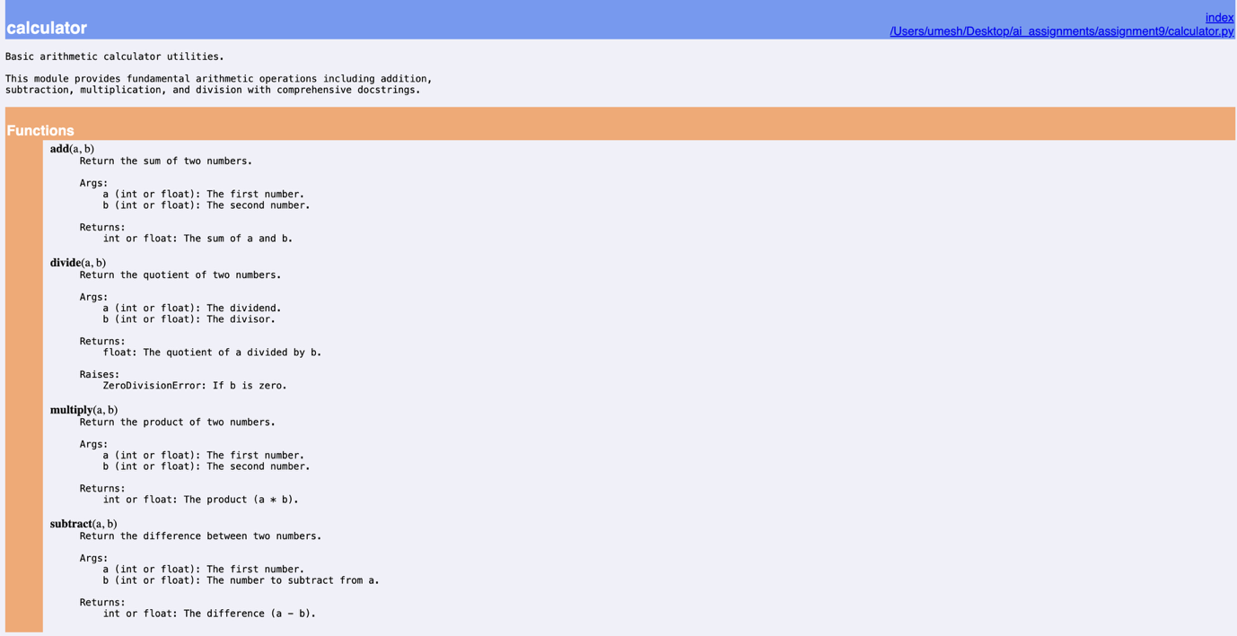

Summary:
Automatic documentation generation with pydoc converts Python docstrings into accessible reference materials without third-party dependencies.
• Terminal viewer (python3 -m pydoc calculator) parses docstrings dynamically and renders formatted manpage-style help in the console.
• HTML generation (python3 -m pydoc -w calculator) generates a standalone calculator.html page complete with CSS styling, function signatures, and hyperlinked navigation.
Opening calculator.html in a web browser verifies that docstrings written in Google style translate into structured, professional documentation ready for production deployment.

Problem 4 (Conversion Utilities Module)
Write a module named conversion.py with: decimal_to_binary(n), binary_to_decimal(b), decimal_to_hexadecimal(n). Use Copilot for auto-generating docstrings, generate documentation in the terminal, and export the documentation in HTML format and open it in a browser.
Prompt:
Implement a Python module conversion.py with decimal_to_binary(n), binary_to_decimal(b), and decimal_to_hexadecimal(n) functions accompanied by clear, auto-generated docstrings. Demonstrate terminal documentation generation and HTML export using pydoc, and verify the resulting HTML page.
Input:
# File: conversion.py
"""Number conversion utility functions.

This module provides functions for converting numbers between decimal,
binary, and hexadecimal representations.
"""

def decimal_to_binary(n):
"""Convert a decimal integer to binary representation.

Args:
n (int): The decimal integer to convert.

Returns:
str: The binary string representation without the '0b' prefix.
"""
return bin(n)[2:]

def binary_to_decimal(b):
"""Convert a binary string to a decimal integer.

Args:
b (str): A string representing a binary number.

Returns:
int: The decimal integer value.
"""
return int(b, 2)

def decimal_to_hexadecimal(n):
"""Convert a decimal integer to uppercase hexadecimal representation.

Args:
n (int): The decimal integer to convert.

Returns:
str: The uppercase hexadecimal string without the '0x' prefix.
"""
return hex(n)[2:].upper()

# Terminal Documentation & HTML Export Commands:
# python3 -m pydoc conversion
# python3 -m pydoc -w conversion
# open conversion.html

Output:
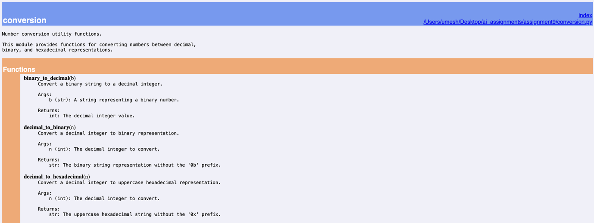

Summary:
The conversion module demonstrates automated docstring generation for number conversion functions.
Using pydoc -w conversion automatically parses the conversion utilities and writes conversion.html.
Browser verification confirms that mathematical radix conversions are clearly documented with expected argument types and return formats.

Problem 5 (Course Management Module)
Create a module course.py with functions: add_course(course_id, name, credits), remove_course(course_id), get_course(course_id). Add docstrings with Copilot, generate documentation in the terminal, and export the documentation in HTML format and open it in a browser.
Prompt:
Design a Python module course.py implementing add_course, remove_course, and get_course using a dictionary catalogue. Add comprehensive docstrings, view the module documentation in the terminal using pydoc, and export it as an HTML documentation file for browser viewing.
Input:
# File: course.py
"""Course management module.

This module provides basic operations to manage university courses,
including adding, removing, and retrieving course information.
"""

courses = {}

def add_course(course_id, name, credits):
"""Add a course to the catalogue.

Args:
course_id (str): Unique course identifier (e.g., 'CS101').
name (str): Full course title.
credits (int): Number of credit units.

Returns:
dict: The newly stored course record.
"""
course = {
"course_id": course_id,
"name": name,
"credits": credits
}
courses[course_id] = course
return course

def remove_course(course_id):
"""Remove a course from the catalogue.

Args:
course_id (str): Unique course identifier to remove.

Returns:
bool: True if the course was found and removed, False otherwise.
"""
return courses.pop(course_id, None) is not None

def get_course(course_id):
"""Retrieve course information by course ID.

Args:
course_id (str): Unique course identifier.

Returns:
dict or None: Course record if found, None otherwise.
"""
return courses.get(course_id)

# Terminal Documentation & HTML Export Commands:
# python3 -m pydoc course
# python3 -m pydoc -w course
# open course.html
Output:
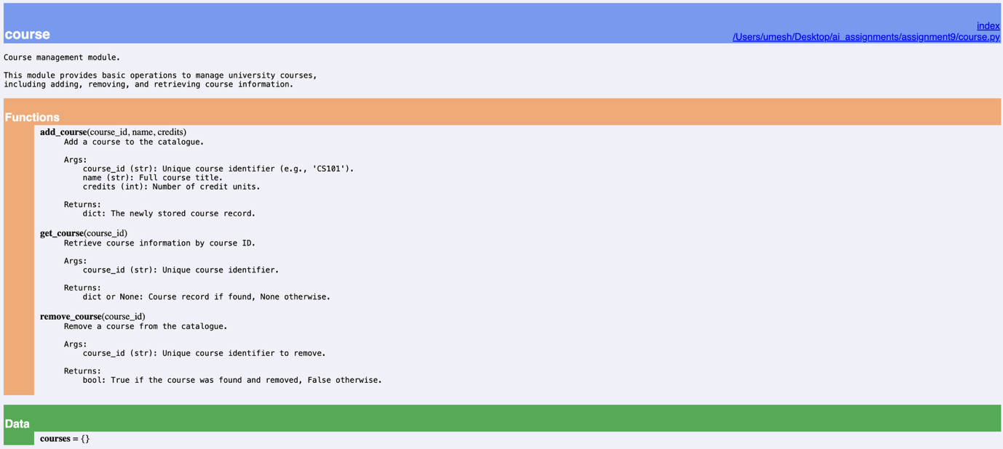
Summary:
The course management module illustrates how pydoc captures both functions and global module data (courses = {}).
Exporting via pydoc -w course produces course.html, which serves as a ready-to-deploy web reference for API consumers and developer onboarding.

