ASSIGNMENT – 2.1
NAME : J. Sai Prakash
ROLL_NO : 2503A52380
Task Description #1 – Statistical Summary for Survey Data

TASK 1:

Use Google Gemini in Colab to generate a python function that reads a list of numbers and calculates the mean, minimum, and maximum values.

PROMPT:
Write a python function that takes a list of numbers and calculates the mean, minimum, and maximum values. Display the results clearly and provide a sample input and output.

CODE:

def statistical_summary(numbers):
mean = sum(numbers) / len(numbers)
minimum = min(numbers)
maximum = max(numbers)
return mean, minimum, maximum

# Example survey data
data = [10, 20, 15, 30, 25, 18, 12]

mean, minimum, maximum = statistical_summary(data)

print("Mean:", mean)
print("Minimum:", minimum)
print("Maximum:", maximum)

OUTPUT:
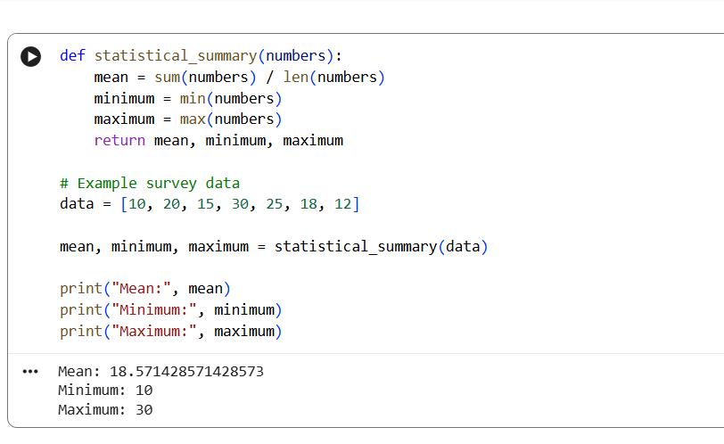

JUSTIFICATION:

- The statistical_summary() function accepts a list of numbers.
- sum(numbers) / len(numbers) calculates the mean.
- min(numbers) finds the minimum value.
- max(numbers) finds the maximum value.
- The function returns all three statistical values.
- The output displays the mean, minimum, and maximum clearly.

Task Description #2 – Armstrong Number – AI Comparison

TASK 2:
Generate an Armstrong number checker using Gemini and GitHub Copilot and compare their outputs, logic style, and clarity.

PROMPT:
Write a Python program to check whether a given number is an Armstrong number. Use a simple and clear approach and display whether the number is an Armstrong number or not.

CODE:

def is_armstrong(number):
digits = str(number)
power = len(digits)
total = sum(int(digit) ** power for digit in digits)

return total == number

num = int(input("Enter a number: "))

if is_armstrong(num):
print(num, "is an Armstrong number")
else:
print(num, "is not an Armstrong number")

OUTPUT:
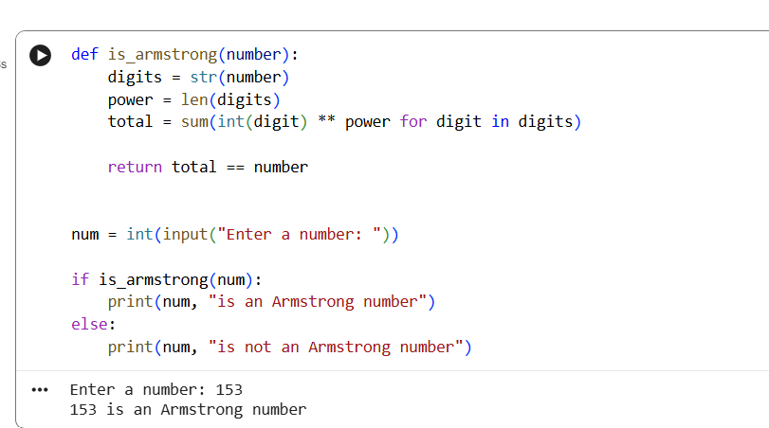

JUSTIFICATION:

- Both programs correctly identify an Armstrong number.
- Gemini uses string conversion to process each digit.
- GitHub Copilot uses mathematical operations to extract digits.
- Both approaches produce the expected output.
- The comparison helps understand different AI-generated coding approaches.

Task Description #3 – Leap Year Validation Using Cursor AI

TASK 3:
Use Cursor AI to generate a Python program that checks whether a given year is a leap year. Use two different prompts and observe the changes in code.

PROMPT:
Create a Python function to check whether a year is a leap year. The function should return True or False and test it with multiple years.

CODE:

def check_leap_year(year):
if year % 400 == 0:
return True
elif year % 100 == 0:
return False
elif year % 4 == 0:
return True
else:
return False

year = int(input("Enter a year: "))

if check_leap_year(year):
print("Leap Year")
else:
print("Not a Leap Year")
OUTPUT:
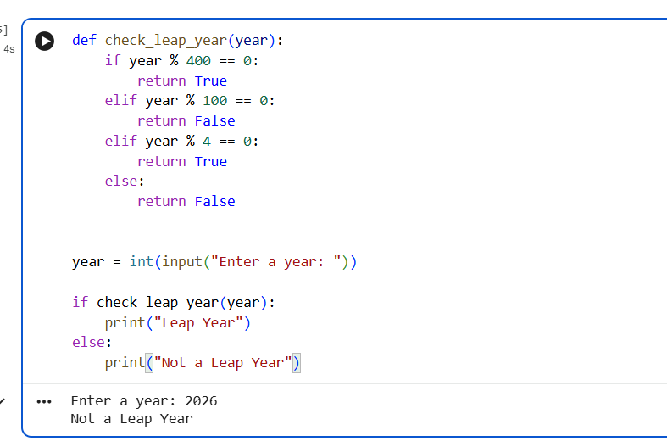

JUSTIFICATION:

- Version 1 directly checks a single year.
- Version 2 uses a reusable function.
- Version 2 can easily test multiple years.
- Both versions use the leap-year conditions.
- The second version is more reusable because the logic is inside a function.

Task Description #4 – Student Logic + AI Refactoring (Odd/Even Sum)

TASK 4:
Write a Python program that calculates the sum of odd and even numbers in a tuple, then refactor it using an AI tool.

PROMPT:
Refactor this Python program to calculate the sum of odd and even numbers in a tuple. Make the code shorter, readable, and efficient.

CODE:

numbers = (1, 2, 3, 4, 5, 6, 7, 8)

odd_sum = 0
even_sum = 0

for num in numbers:
if num % 2 == 0:
even_sum += num
else:
odd_sum += num

print("Sum of odd numbers:", odd_sum)
print("Sum of even numbers:", even_sum)
OUTPUT:
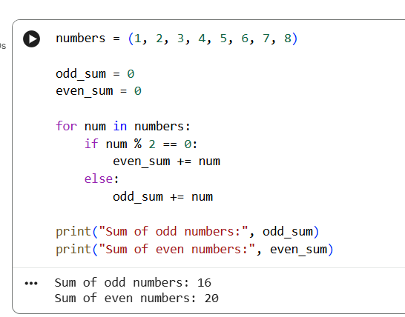

JUSTIFICATION:

- The original program uses a loop and two variables.
- The refactored version uses sum() with generator expressions.
- The code is shorter and avoids manually updating the sums.
- Both programs produce the same output.
- AI refactoring improves readability and reduces unnecessary code.

