ASSIGNMENT – 5
NAME : J. Sai Prakash
ROLL_NO : 2503A52380
Task Description #1 – Privacy in API Usage

TASK 1:
Use an AI tool to generate a python program that connects to a weather API

PROMPT:
Generate python code to fetch weather data securely without exposing API keys in the code.

ORIGINAL AI CODE:

# Weather API Example

import requests

api_key = "123456789"
city = "Hyderabad"

url = f"https://api.openweathermap.org/data/2.5/weather?q={city}&appid={api_key}"

response = requests.get(url)

print(response.json())
SECURITY ISSUE:
- The API keys is directly written in the source code.
- Anyone who gets access to the code can see the API key.
- The key may be misused by unauthorized users.

SECURE VERSION:
# Secure Weather API Usage

import os
import requests

api_key = os.getenv("WEATHER_API_KEY")
city = "Hyderabad"

url = "https://api.openweathermap.org/data/2.5/weather"

params = {
"q": city,
"appid": api_key
}

response = requests.get(url, params=params)

print(response.json())

OUTPUT:
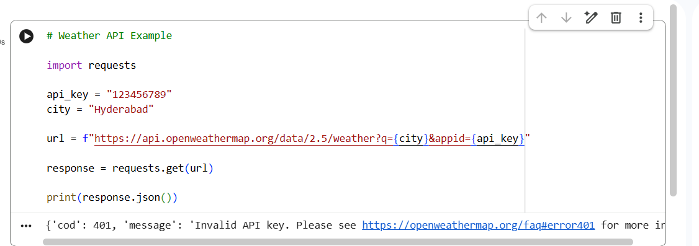
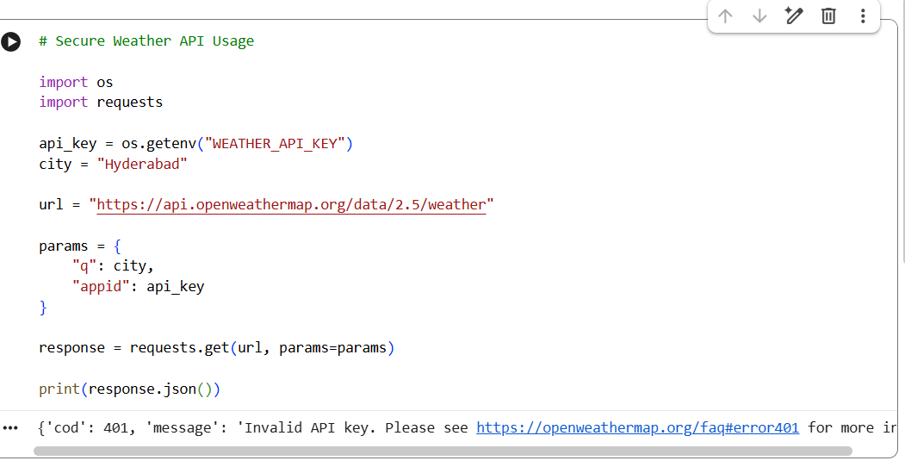

JUSTIFICATION:

- The original code exposes the API key directly.
- Hardcoding sensitive keys is a security risk.
- The revised code uses an environment variable.
- os.getenv() retrieves the key without storing it directly in the program.
- This approach reduces the risk of accidentally exposing credentials.
*The secure version does not hardcode the API key. It retrieves the key using an environment variable. Since no valid API key is configured in the Colab environment, the API returns an invalid API key error.

Task Description #2 – Privacy & Security in File Handling

TASK 2:
Use an AI tool to generate a Python script that stores user data such as name, email, and password in a file.

PROMPT:
Generate Python code to store user name, email, and password in a file. Then identify the privacy risks and modify the code so that passwords are not stored in plain text.

ORIGINAL CODE:
# User Data Storage

name = "Rahul"
email = "rahul@gmail.com"
password = "password123"

with open("users.txt", "w") as file:
file.write(name + "\n")
file.write(email + "\n")
file.write(password + "\n")

print("User data stored successfully.")

PRIVACY RISKS:
- The password is stored as plain text.
- Anyone with access to the file can read the password.
- Storing passwords directly is unsafe.
- Sensitive user information should be protected.

REVISED CODE:
# Secure Password Storage using Hashing

import hashlib

name = "Rahul"
email = "rahul@gmail.com"
password = "password123"

hashed_password = hashlib.sha256(
password.encode()
).hexdigest()

with open("users.txt", "w") as file:
file.write("Name: " + name + "\n")
file.write("Email: " + email + "\n")
file.write("Password Hash: " + hashed_password + "\n")

print("User data stored securely.")

OUTPUT:
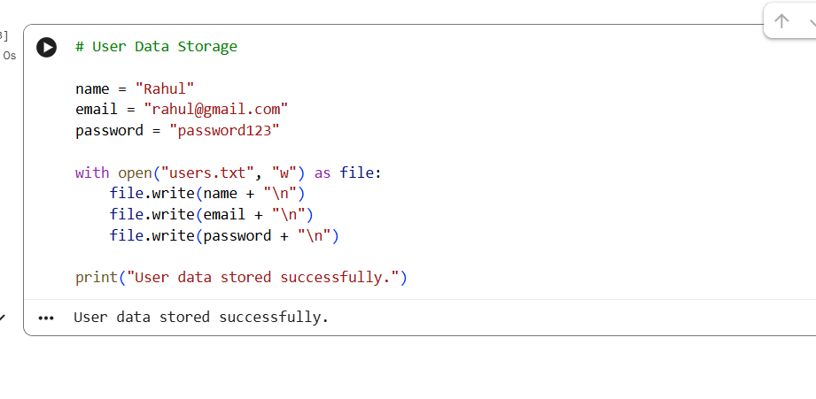
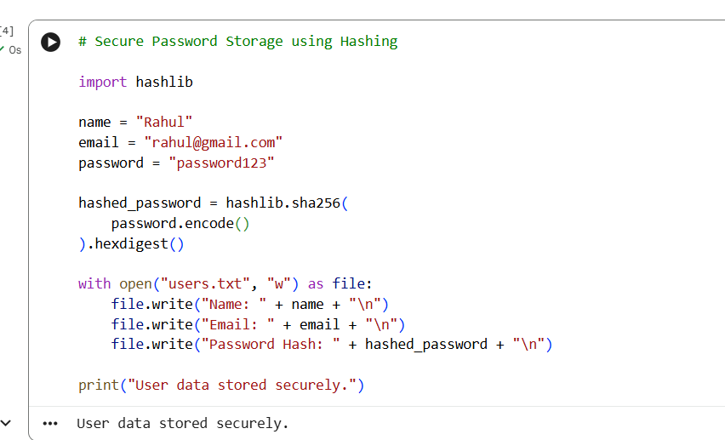

JUSTIFICATION:

- The original program stores the password in plain text.
- Plain-text passwords can be easily exposed if the file is accessed.
- The revised program converts the password into a hash.
- The stored value is therefore not the original password.
- This demonstrates the importance of protecting sensitive user information.
Task Description #3 - Transparency in Algorithm Design

TASK 3:
Use AI to generate an Armstrong number checking function with comments and explanations.

PROMPT:
Generate a Python function to check whether a number is an Armstrong number. Include comments explaining each step and provide a simple line-by-line explanation.

CODE:
# Armstrong Number Checker

def is_armstrong(number):
# Convert the number into a string
digits = str(number)

# Count the number of digits
power = len(digits)

# Store the sum of powered digits
total = 0

# Process each digit
for digit in digits:
total += int(digit) ** power

# Check whether the sum equals the original number
return total == number

# Test the function
num = 153

if is_armstrong(num):
print(num, "is an Armstrong number")
else:
print(num, "is not an Armstrong number")

OUTPUT:
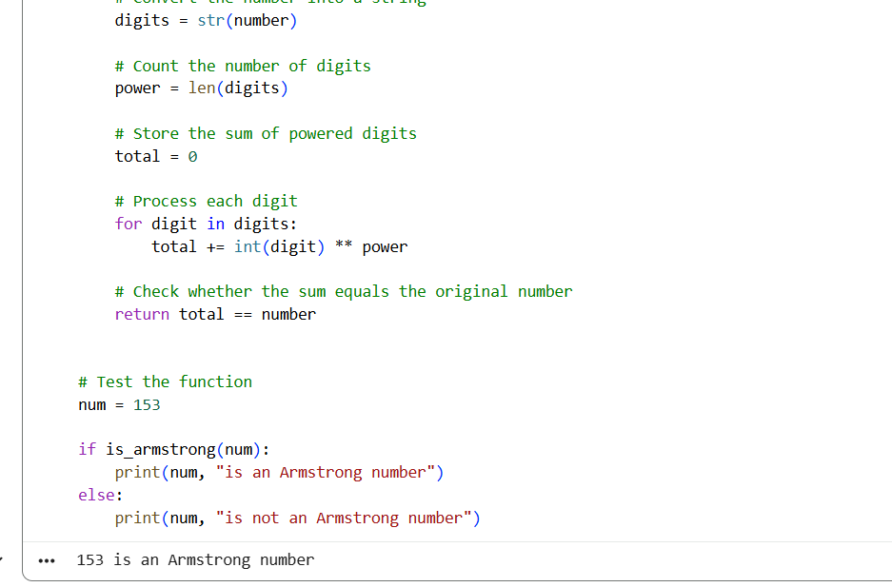

JUSTIFICATION:
- Comments make the algorithm easier to understand.
- Each important step is clearly explained.
- The explanation matches the actual functionality of the code.
- Transparent code allows developers to understand and verify AI-generated logic.

Task Description #4 – Transparency in Algorithm Comparison

TASK 4:
Use AI to implement two sorting algorithms, such as QuickSort and BubbleSort, and explain how they work.

PROMPT:
Generate Python code for QuickSort and BubbleSort, and include comments explaining step-by-step how each works and where they differ.

QUICK SORT CODE:

# QuickSort Algorithm

def quick_sort(arr):
# If the list has 0 or 1 element, it is already sorted
if len(arr) <= 1:
return arr

# Select the first element as pivot
pivot = arr[0]

# Elements smaller than pivot
left = [x for x in arr[1:] if x <= pivot]

# Elements greater than pivot
right = [x for x in arr[1:] if x > pivot]

# Recursively sort both parts
return quick_sort(left) + [pivot] + quick_sort(right)

numbers = [5, 2, 8, 1, 3]

print("QuickSort:", quick_sort(numbers))

BUBBLE SORT CODE:

# BubbleSort Algorithm

def bubble_sort(arr):
n = len(arr)

# Compare adjacent elements
for i in range(n):
for j in range(0, n - i - 1):

# Swap if elements are in the wrong order
if arr[j] > arr[j + 1]:
arr[j], arr[j + 1] = arr[j + 1], arr[j]

return arr

numbers = [5, 2, 8, 1, 3]

print("BubbleSort:", bubble_sort(numbers))

OUTPUT:
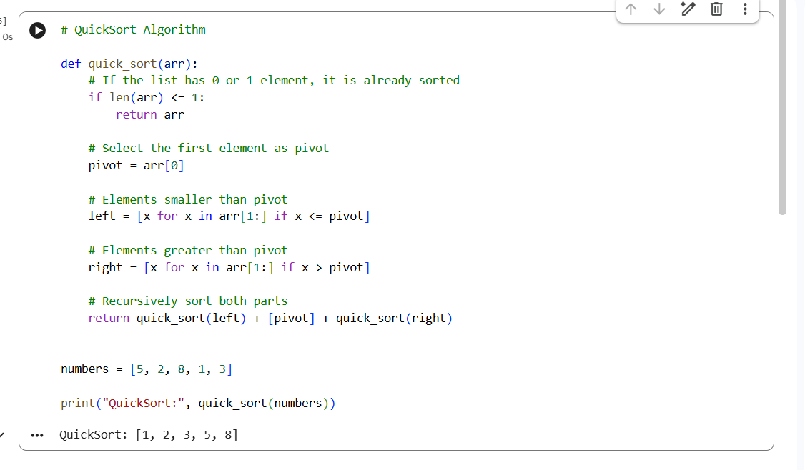

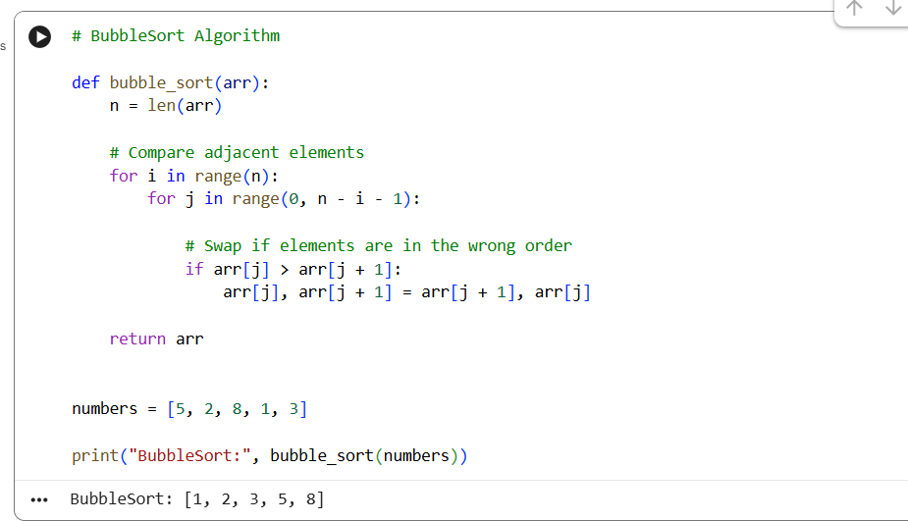

JUSTIFICATION:

- QuickSort divides the list around a pivot and recursively sorts the two parts.
- BubbleSort repeatedly compares adjacent elements and swaps them when necessary.
- Both algorithms correctly sort the input list.
- Comments make the algorithm steps transparent.
- Comparing two algorithms helps understand differences in their logic and efficiency.

