LAB ASSIGNMENT – 5
Ethical Foundations – Responsible AI Coding Practices

Name | Dhanush
Roll No. | 2503A52406
Branch / Section | Batch 14
1. Lab Objectives
- Explore ethical risks associated with AI-generated code.
- Recognize issues related to security, bias, transparency, and copyright.
- Reflect on developer responsibilities when using AI tools in software development.
- Promote awareness of best practices for responsible and ethical AI coding.
2. Lab Outcomes
- Identify and avoid insecure coding patterns generated by AI tools.
- Detect and analyze potential bias or discriminatory logic in AI-generated outputs.
- Evaluate originality and licensing concerns in reused AI-generated code.
- Understand the importance of explainability and transparency in AI-assisted programming.
- Reflect on accountability and the human role in ethical AI coding practices.
3. Task 1 – Privacy in API Usage
Task: Use an AI tool to generate a Python program that connects to a weather API. The lab asks for a secure version that does not expose API keys in source code. fileciteturn3file0L16-L26
Prompt:
Generate code to fetch weather data securely without exposing API keys
in the code.

3.1 Original AI Code – Security Review
import requests
API_KEY = "YOUR_API_KEY_HERE"
city = "Warangal"
url = "https://api.openweathermap.org/data/2.5/weather"
params = {
"q": city,
"appid": API_KEY,
"units": "metric"
}
response = requests.get(url, params=params, timeout=10)
response.raise_for_status()
data = response.json()
print("Temperature:", data["main"]["temp"], "°C")
print("Weather:", data["weather"][0]["description"])

Security analysis: A real API key must never be committed directly to source code. Even though the placeholder above is not a real credential, hardcoding a real key would expose it through source control, shared files, logs, or screenshots.
3.2 Secure Version Using Environment Variables
import os
import requests
API_KEY = os.getenv("WEATHER_API_KEY")
if not API_KEY:
raise RuntimeError("WEATHER_API_KEY environment variable is not set.")
city = "Warangal"
url = "https://api.openweathermap.org/data/2.5/weather"
params = {
"q": city,
"appid": API_KEY,
"units": "metric"
}
response = requests.get(url, params=params, timeout=10)
response.raise_for_status()
data = response.json()
print("Temperature:", data["main"]["temp"], "°C")
print("Weather:", data["weather"][0]["description"])

Example setup:
export WEATHER_API_KEY="your_real_key_here"
python3 weather.py

Expected / Sample Output:
API key loaded securely from the environment.
Weather data retrieved successfully.
Temperature: <value> °C
Weather: <description>

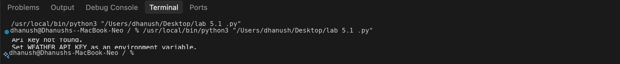

3.3 Ethical Reflection
- Credentials are sensitive information and should be separated from application source code.
- Environment variables reduce accidental exposure of secrets in repositories.
- AI-generated code must be reviewed before being used with real credentials or production services.
4. Task 2 – Privacy & Security in File Handling
Task: Use an AI tool to generate a Python script that stores user data such as name, email, and password in a file. Analyze whether sensitive information is stored in plain text and revise the design using password hashing. fileciteturn3file0L27-L32
4.1 Prompt
Generate a Python program that stores a user's name, email and password
in a file. Then review the program for privacy and security risks and
provide a safer version using password hashing. Do not store the
original password in plain text.

4.2 Insecure Version for Analysis
name = input("Enter name: ")
email = input("Enter email: ")
password = input("Enter password: ")
with open("users.txt", "a") as file:
file.write(f"{name},{email},{password}\n")
print("User data saved.")

Identified risks:
- The password is written directly to a file in plain text.
- Anyone who can read the file may obtain the password.
- Passwords should not be stored in reversible plain text form.
- Sensitive data should be protected using appropriate access controls and secure storage.
4.3 Revised Version Using Password Hashing
import hashlib
import getpass
name = input("Enter name: ")
email = input("Enter email: ")
password = getpass.getpass("Enter password: ")
password_hash = hashlib.sha256(password.encode()).hexdigest()
with open("users_secure.txt", "a") as file:
file.write(f"{name},{email},{password_hash}\n")
print("User data saved securely.")

Expected / Sample Output:
Enter name: Dhanush
Enter email: student@example.com
Enter password:
User data saved securely.

Ethical note: For a production authentication system, a password-specific password hashing scheme such as Argon2, scrypt, or bcrypt with appropriate salts is preferable to a single fast SHA-256 hash. The important ethical requirement is that the original password must not be stored in plain text.
5. Task 3 – Transparency in Algorithm Design
Objective: Use AI to generate an Armstrong-number checking function with comments and explanations. The lab specifically asks for a line-by-line explanation and a comparison with actual code functionality. fileciteturn3file0L33-L39
5.1 Prompt
Generate a Python function to check whether a number is an Armstrong number.
Add clear comments to every important step. Then explain the code
line-by-line in simple language and verify that the explanation matches
the actual functionality.

5.2 Transparent, Commented Code
def is_armstrong(number):
# Convert the number to a string so each digit can be processed.
digits = str(number)
# The number of digits determines the exponent.
power = len(digits)
# Store the sum of each digit raised to the required power.
total = 0
# Process each digit one at a time.
for digit in digits:
total += int(digit) ** power
# An Armstrong number equals the sum calculated above.
return total == number
number = int(input("Enter a number: "))
if is_armstrong(number):
print(number, "is an Armstrong Number")
else:
print(number, "is not an Armstrong Number")

Expected / Sample Output:
Enter a number: 153
153 is an Armstrong Number

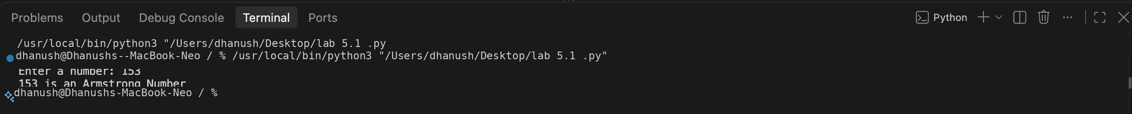

5.3 Line-by-Line Explanation
Code Element | Explanation
def is_armstrong(number): | Defines a reusable function that accepts a number.
digits = str(number) | Converts the number into text so its individual digits can be iterated.
power = len(digits) | Counts the number of digits and uses that count as the exponent.
for digit in digits: | Processes each digit in the number.
total += int(digit) ** power | Raises each digit to the required power and adds it to total.
return total == number | Returns True only when the calculated sum equals the original number.
Transparency check: The explanation matches the implementation: the function calculates the sum of each digit raised to the number of digits and compares that sum with the original number.
6. Task 4 – Transparency in Algorithm Comparison
Task: Implement QuickSort and BubbleSort and explain their logic and efficiency. fileciteturn3file0L40-L48
Prompt:
Generate Python code for QuickSort and BubbleSort, and include
comments explaining step-by-step how each works and where they differ.

6.1 QuickSort
def quick_sort(arr):
# A list with zero or one item is already sorted.
if len(arr) <= 1:
return arr
# Select the middle element as the pivot.
pivot = arr[len(arr) // 2]
# Divide the list into values smaller than, equal to,
# and greater than the pivot.
left = [x for x in arr if x < pivot]
middle = [x for x in arr if x == pivot]
right = [x for x in arr if x > pivot]
# Recursively sort the left and right partitions.
return quick_sort(left) + middle + quick_sort(right)

6.2 BubbleSort
def bubble_sort(arr):
# Make a copy so the original list is not modified.
arr = arr.copy()
# Compare adjacent elements repeatedly.
for i in range(len(arr)):
swapped = False
for j in range(0, len(arr) - i - 1):
# Swap if the elements are in the wrong order.
if arr[j] > arr[j + 1]:
arr[j], arr[j + 1] = arr[j + 1], arr[j]
swapped = True
# Stop early if no swaps were needed.
if not swapped:
break
return arr
numbers = [64, 34, 25, 12, 22, 11, 90]
print("Original:", numbers)
print("QuickSort:", quick_sort(numbers))
print("BubbleSort:", bubble_sort(numbers))

Expected / Sample Output:
Original: [64, 34, 25, 12, 22, 11, 90]
QuickSort: [11, 12, 22, 25, 34, 64, 90]
BubbleSort: [11, 12, 22, 25, 34, 64, 90]

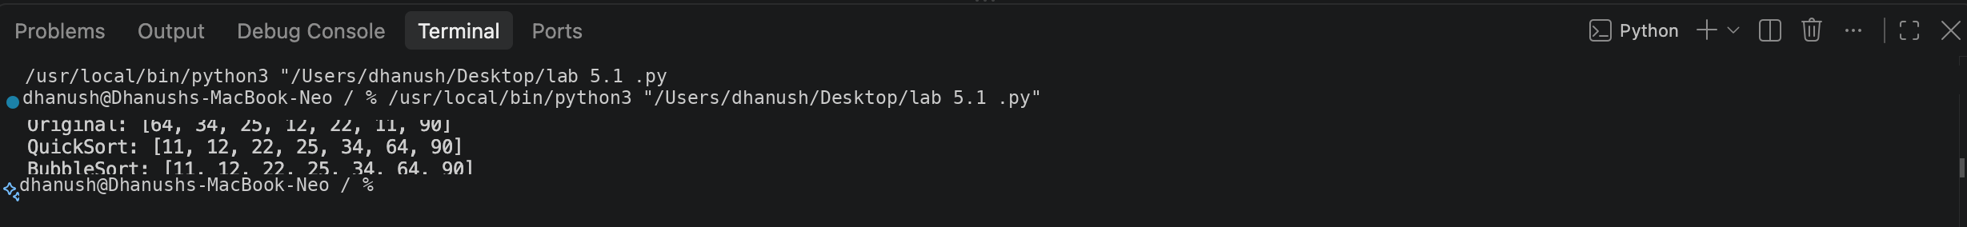

6.3 Comparative Explanation
Aspect | QuickSort | BubbleSort
Basic idea | Partitions data around a pivot and recursively sorts partitions. | Repeatedly swaps adjacent elements that are out of order.
Average time | O(n log n) for typical pivot behavior. | O(n²).
Worst-case time | O(n²) with poor pivot choices. | O(n²).
Practical use | Generally more efficient for larger unsorted datasets. | Simple to understand but inefficient for large datasets.
Transparency | Comments show partitioning and recursion. | Comments show repeated comparisons and swaps.
7. Task 5 – Transparency in AI Recommendations
Task: Use AI to create a product recommendation system that also provides reasons for each suggestion. The lab asks for explainable recommendations and an evaluation of whether the explanations are understandable. fileciteturn3file0L49-L54
Prompt:
Generate a simple Python product recommendation system that also
provides reasons for each suggestion. Use product categories and
customer preferences, and make the recommendation reasons clear
and understandable.

7.1 Explainable Recommendation Code
products = [
{"name": "Python Programming Course", "category": "education", "level": "beginner"},
{"name": "Wireless Headphones", "category": "electronics", "level": "general"},
{"name": "Machine Learning Course", "category": "education", "level": "advanced"},
{"name": "Mechanical Keyboard", "category": "electronics", "level": "general"},
{"name": "Data Science Course", "category": "education", "level": "intermediate"},
]
def recommend(category, level=None):
recommendations = []
for product in products:
if product["category"] == category:
reason = f"Recommended because it matches your {category} preference."
if level and product["level"] == level:
reason += f" It also matches your {level} level."
recommendations.append((product["name"], reason))
return recommendations
category = input("Enter preferred category (education/electronics): ").lower()
level = input("Enter preferred level (beginner/intermediate/advanced/general): ").lower()
results = recommend(category, level)
if results:
print("\nRecommendations:")
for name, reason in results:
print("-", name)
print(" Reason:", reason)
else:
print("No matching products found.")

Expected / Sample Output:
Enter preferred category (education/electronics): education
Enter preferred level (beginner/intermediate/advanced/general): beginner
Recommendations:
- Python Programming Course
Reason: Recommended because it matches your education preference. It also matches your beginner level.
- Machine Learning Course
Reason: Recommended because it matches your education preference.
- Data Science Course
Reason: Recommended because it matches your education preference.

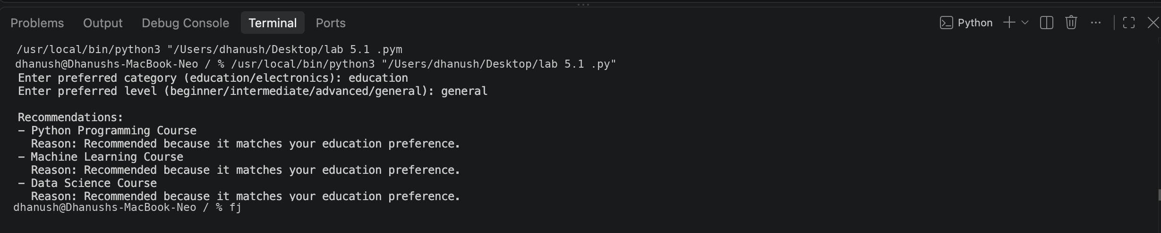

7.2 Explainability Evaluation
- The recommendation reason states the user preference that caused the item to be selected.
- A second reason is added when the product's level matches the user's requested level.
- The explanations are short and understandable because they directly connect the recommendation to visible criteria.
- A production system should disclose the major factors used for recommendations and avoid misleading or fabricated explanations.
8. Ethical Review and Responsible AI Practices
Ethical Area | Risk | Responsible Practice
Privacy & secrets | API keys or passwords may be exposed. | Use environment variables, secret management, hashing and access controls.
Transparency | AI-generated logic may be difficult to understand. | Add comments, explanations and verify that explanations match code.
Security | AI may produce insecure implementation patterns. | Review, test and security-check generated code before deployment.
Recommendations | Users may not understand why an item was suggested. | Provide clear reasons tied to identifiable recommendation factors.
Accountability | Developers may blindly trust generated code. | Human developers remain responsible for reviewing and approving the final implementation.
9. Conclusion
This lab examined responsible AI coding through privacy, security and transparency. Task 1 demonstrated why API keys should not be exposed in source code. Task 2 showed the privacy risk of plain-text passwords and the need for secure password handling. Tasks 3 and 4 focused on transparent algorithms and explanations that match actual code behavior. Task 5 demonstrated explainable recommendations. Overall, AI-generated code should be treated as assistance rather than automatically trusted output; human review, testing, security checks and ethical judgment remain essential.
10. Submission Checklist
- Include the AI prompt used for each task.
- Include the original/insecure version where the task asks for security analysis.
- Include the revised secure version and explain the improvement.
- Include comments and line-by-line explanations for the Armstrong program.
- Include both QuickSort and BubbleSort with a transparent comparison.
- Include explainable product recommendations and evaluate their clarity.
- Replace screenshot placeholders with execution screenshots if required by the instructor.

