LAB 8.1
Test-Driven Development with AI
Generating and Working with Test Cases
Dhanush
2503A52406
Batch 14

Objectives
- Introduce Test-Driven Development (TDD) using AI code generation tools.
- Generate test cases before code implementations.
- Reinforce testing, validation, error handling, and clean, reliable code.
- Build code based on AI-generated test expectations.
Learning Outcomes
- Use AI tools to write test cases for Python functions and classes.
- Implement functions based on test cases in a test-first style.
- Use unittest or pytest concepts for testing.
- Analyze completeness and coverage of AI-generated tests.
- Compare AI-generated and manually written test cases.

Task 1: Password Strength Validator – Apply AI in Security Context
Generate at least 3 assert test cases for is_strong_password(password) and implement the validator. Requirements: minimum 8 characters, uppercase, lowercase, digit, special character, and no spaces.
Required / Example Test Cases
assert is_strong_password("Abcd@123") == True
assert is_strong_password("abcd123") == False
assert is_strong_password("ABCD@1234") == True
Implementation
# AI-generated test cases
def test_password_strength():
assert is_strong_password("Abcd@123") == True
assert is_strong_password("abcd123") == False
assert is_strong_password("ABCD@1234") == True
# Implementation
def is_strong_password(password):
if len(password) < 8:
return False
if " " in password:
return False
has_upper = False
has_lower = False
has_digit = False
has_special = False
for char in password:
if char.isupper():
has_upper = True
elif char.islower():
has_lower = True
elif char.isdigit():
has_digit = True
else:
has_special = True
return has_upper and has_lower and has_digit and has_special
# Run tests
test_password_strength()
print("All password validation tests passed.")
Expected Output: All password validation tests passed.

Task 2: Number Classification with Loops – Apply AI for Edge Case Handling
Generate at least 3 assert test cases for classify_number(n) and implement it using loops. Classify Positive, Negative, or Zero; handle invalid strings and None; include boundary values -1, 0, and 1.
Required / Example Test Cases
assert classify_number(10) == "Positive"
assert classify_number(-5) == "Negative"
assert classify_number(0) == "Zero"
assert classify_number(1) == "Positive"
assert classify_number(-1) == "Negative"
assert classify_number("10") == "Invalid"
assert classify_number(None) == "Invalid"
Implementation
# AI-generated test cases
def test_number_classification():
assert classify_number(10) == "Positive"
assert classify_number(-5) == "Negative"
assert classify_number(0) == "Zero"
assert classify_number(1) == "Positive"
assert classify_number(-1) == "Negative"
assert classify_number("10") == "Invalid"
assert classify_number(None) == "Invalid"
# Implementation
def classify_number(n):
if n is None:
return "Invalid"
if not isinstance(n, (int, float)):
return "Invalid"
numbers = [n]
for number in numbers:
if number > 0:
return "Positive"
elif number < 0:
return "Negative"
else:
return "Zero"
# Run tests
test_number_classification()
print("All number classification tests passed.")
Expected Output: All number classification tests passed.

Task 3: Anagram Checker – Apply AI for String Analysis
Generate at least 3 assert test cases for is_anagram(str1, str2) and implement it. Ignore case, spaces, and punctuation; handle edge cases such as empty strings and identical words.
Required / Example Test Cases
assert is_anagram("listen", "silent") == True
assert is_anagram("hello", "world") == False
assert is_anagram("Dormitory", "Dirty Room") == True
Implementation
# AI-generated test cases
def test_anagram():
assert is_anagram("listen", "silent") == True
assert is_anagram("hello", "world") == False
assert is_anagram("Dormitory", "Dirty Room") == True
assert is_anagram("", "") == True
assert is_anagram("Python", "Python") == True
# Implementation
def is_anagram(str1, str2):
clean1 = ""
clean2 = ""
for char in str1:
if char.isalnum():
clean1 += char.lower()
for char in str2:
if char.isalnum():
clean2 += char.lower()
return sorted(clean1) == sorted(clean2)
# Run tests
test_anagram()
print("All anagram tests passed.")
Expected Output: All anagram tests passed.

Task 4: Inventory Class – Apply AI to Simulate Real-World Inventory System
Generate at least 3 assert-based tests for the Inventory class. Required methods: add_item(name, quantity), remove_item(name, quantity), and get_stock(name).
Required / Example Test Cases
inv = Inventory()
inv.add_item("Pen", 10)
assert inv.get_stock("Pen") == 10
inv.remove_item("Pen", 5)
assert inv.get_stock("Pen") == 5
inv.add_item("Book", 3)
assert inv.get_stock("Book") == 3
Implementation
# AI-generated test cases
def test_inventory():
inv = Inventory()
inv.add_item("Pen", 10)
assert inv.get_stock("Pen") == 10
inv.remove_item("Pen", 5)
assert inv.get_stock("Pen") == 5
inv.add_item("Book", 3)
assert inv.get_stock("Book") == 3
# Implementation
class Inventory:
def __init__(self):
self.stock = {}
def add_item(self, name, quantity):
if name in self.stock:
self.stock[name] += quantity
else:
self.stock[name] = quantity
def remove_item(self, name, quantity):
if name in self.stock:
self.stock[name] -= quantity
def get_stock(self, name):
return self.stock.get(name, 0)
# Run tests
test_inventory()
print("All inventory tests passed.")
Expected Output: All inventory tests passed.

Task 5: Date Validation & Formatting – Apply AI for Data Validation
Generate at least 3 assert test cases for validate_and_format_date(date_str). Validate MM/DD/YYYY, handle invalid dates, and convert valid dates to YYYY-MM-DD.
Required / Example Test Cases
assert validate_and_format_date("10/15/2023") == "2023-10-15"
assert validate_and_format_date("02/30/2023") == "Invalid Date"
assert validate_and_format_date("01/01/2024") == "2024-01-01"
Implementation
from datetime import datetime
# AI-generated test cases
def test_date_validation():
assert validate_and_format_date("10/15/2023") == "2023-10-15"
assert validate_and_format_date("02/30/2023") == "Invalid Date"
assert validate_and_format_date("01/01/2024") == "2024-01-01"
# Implementation
def validate_and_format_date(date_str):
try:
date = datetime.strptime(date_str, "%m/%d/%Y")
return date.strftime("%Y-%m-%d")
except ValueError:
return "Invalid Date"
# Run tests
test_date_validation()
print("All date validation tests passed.")
Expected Output: All date validation tests passed.

Execution Screenshots
The screenshots below are the original screenshots supplied for this lab. They are included without modification. The available screenshots primarily show the password-validation execution; therefore they are not falsely assigned to Tasks 2–5.
Original Screenshot 1
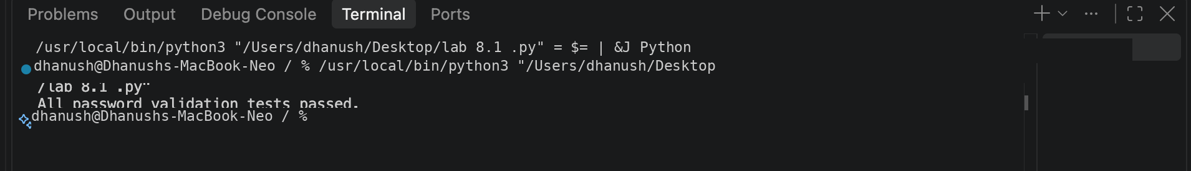
Original Screenshot 2
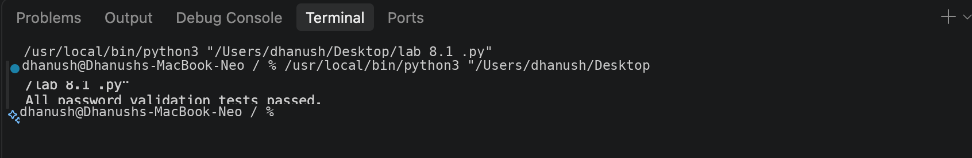
Original Screenshot 3
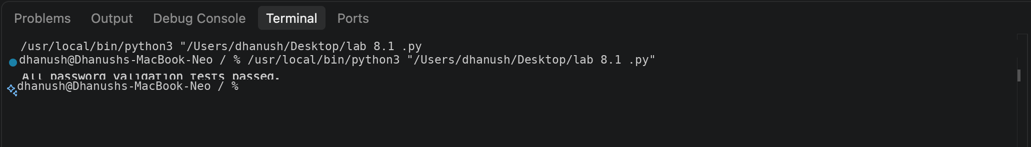
Original Screenshot 4
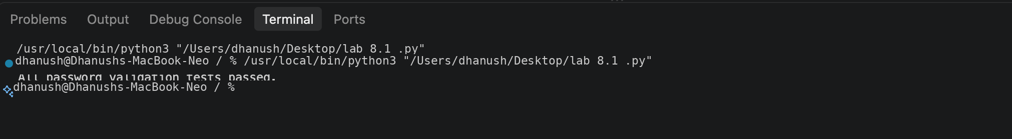
Original Screenshot 5

End of Lab 8.1

