 | SR UNIVERSITY  Campus Warangal
 | Program: II - B. Tech (CS& AI) Batch:
 | Name: T.RAJINI Reg. No: 2503A52428
 | Department: Computer Science and AI Semester: I
 | AI Assisted Coding-Assignment Date: 27-10-2026

- QUESTION:

Task 1: Student Management REST API
Story: A college wants to develop a REST API to manage student information. Students should be able to retrieve student records and register new students.
Tasks:
- Use an AI coding assistant to generate a backend REST API using Python Flask.
- Implement GET /students to retrieve student details and POST /students to add a new student.
- Test the API using Postman or a browser and verify the JSON responses

2.PROMPT:
Build a Python Flask API with GET /students and POST /students. Return JSON, validate new student data, assign IDs, and show how to run and test it.

3.CODE: 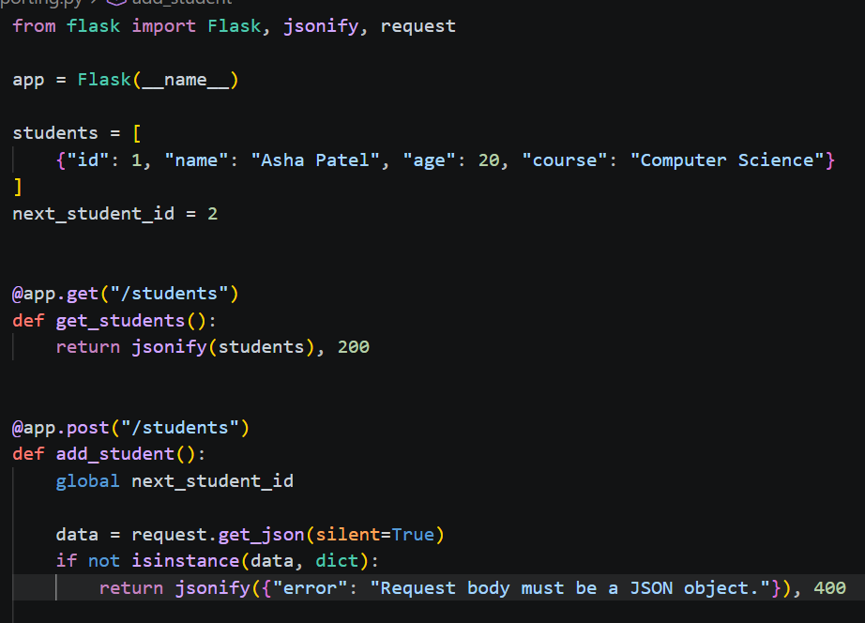

4.OUTPUT:
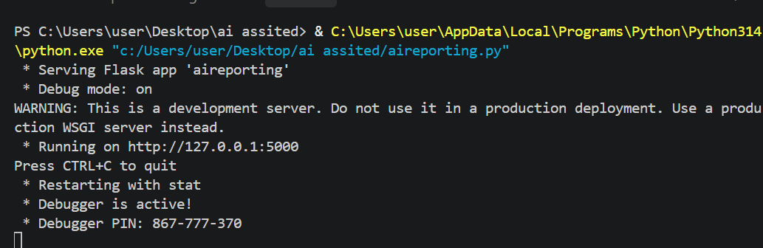

5.OBSERVATION: Both APIs return data in JSON format. They can list records and add new ones; the bookstore API can also find a book by ID.

1.QUESTION:

Task 2: Online Bookstore REST API
Story: A bookstore wants a backend API to manage its book inventory and allow customers to view available books.
Tasks:
- Use an AI coding assistant to generate a REST API using Python Flask.
- Implement GET /books to retrieve all books, GET /books/{id} to retrieve a specific book, and POST /books to add a new book.
- Test the endpoints and verify that the API returns the correct book details in JSON format.
Common instruction: Review the AI-generated code, identify and correct at least one error or improvement, and demonstrate the working API.
2.PROMPT:
Build a Python Flask API with GET /books, GET /books/<id>, and POST /books. Return JSON, validate new book data, handle missing IDs with 404, and show how to run and test it.
3.CODE:
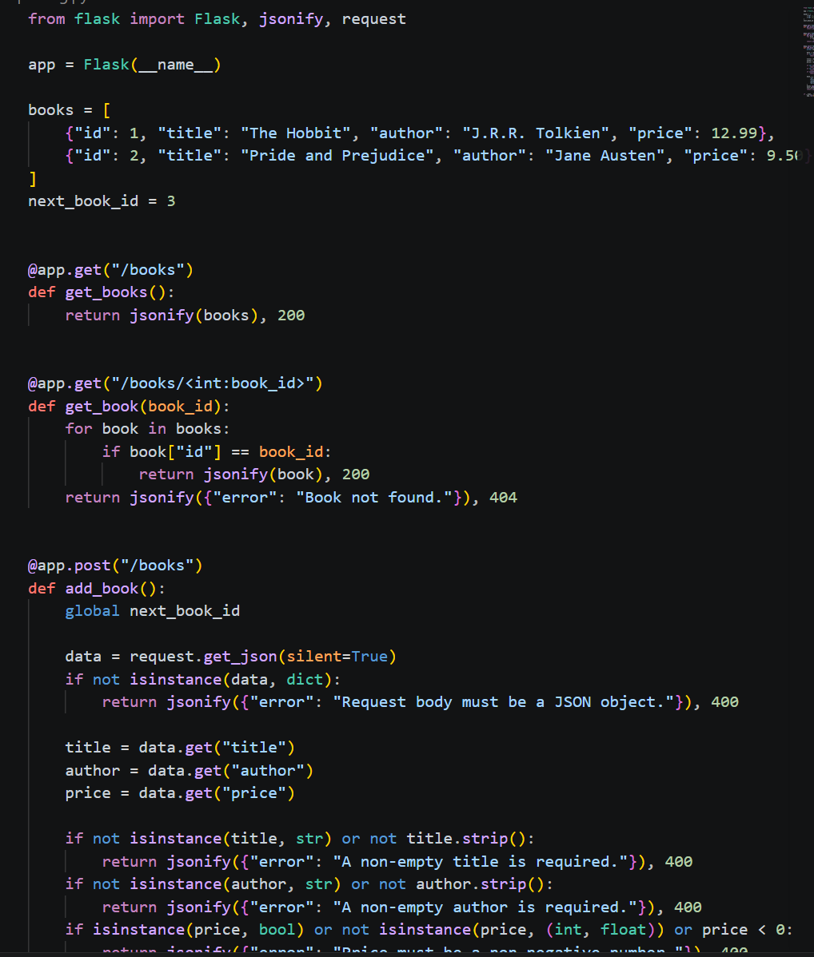
4.OUTPUT:
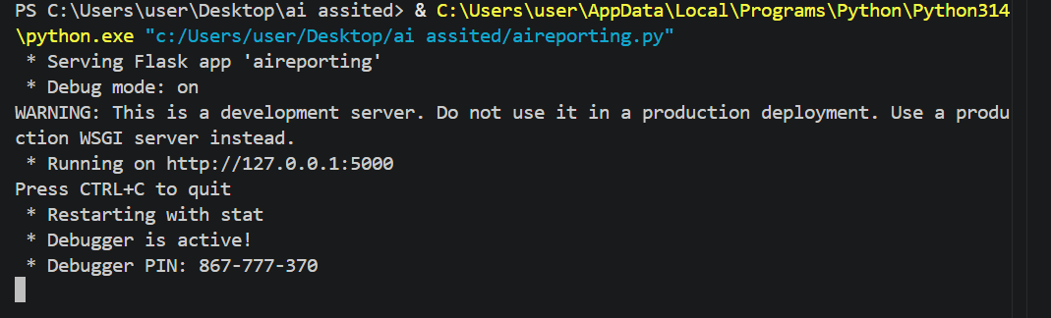
5.OBSERVATION:
Both APIs return data in JSON format. They can list records and add new ones; the bookstore API can also find a book by ID.

