 | SR UNIVERSITY  Campus Warangal
 | Program: II - B. Tech (CS& AI) Batch:
 | Name: D.SAI VISHWANATH Reg. No: 2503A52443
 | Department: Computer Science and AI Semester: I
 | AI Assisted Coding-Assignment Date:

- Question
Q1 – AI-Assisted Bubble Sort Analysis
Problem / Starter Code:
numbers = [64, 34, 25, 12, 22, 11, 90]
# TODO:
# Implement Bubble Sort in ascending order.
# Count comparisons and swaps.
# Display the sorted list.
Student Tasks:
• Implement Bubble Sort.
• Use AI to explain one complete pass of Bubble Sort.
• Count comparisons and swaps.
• Test at least three input lists.
• Ask AI about an early-exit optimisation.
• Compare the original and improved versions.

- Prompt
I’m writing the actual Bubble Sort solution in the current file with comparison and swap counting, early-exit optimization, and test cases so it matches the assignment requirements.

- Code
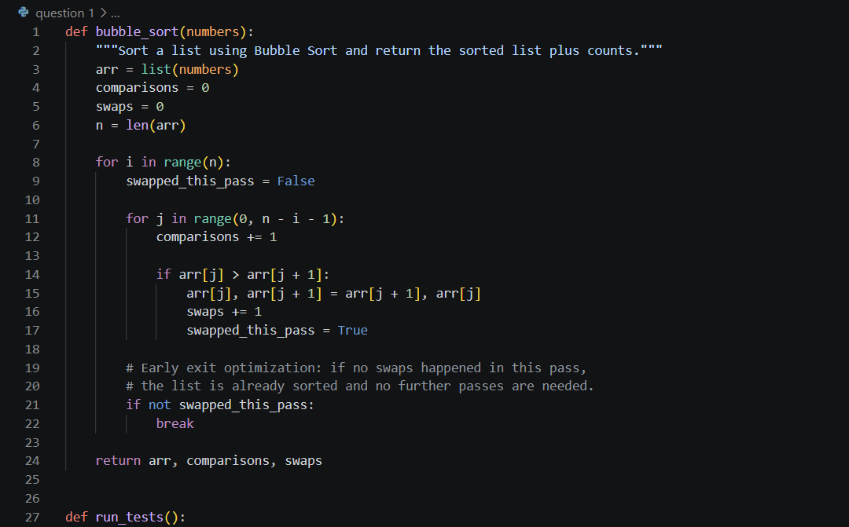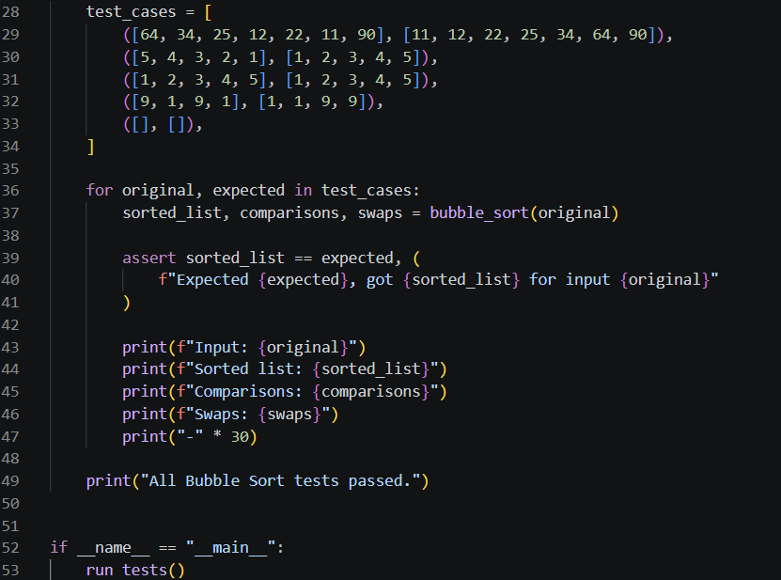
- Output
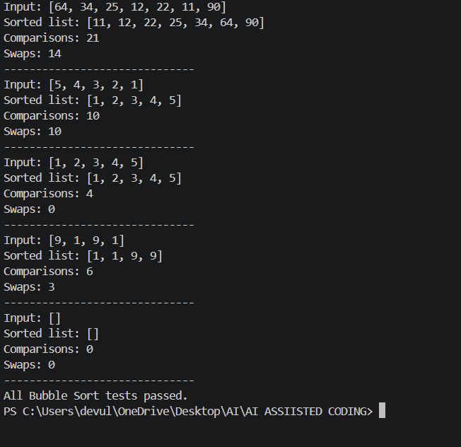
- Observation
This Bubble Sort program works by repeatedly comparing adjacent numbers and swapping them when they are in the wrong order, while also counting the number of comparisons and swaps made. It includes an early-exit optimization so that if a pass does not perform any swaps, the list is already sorted and the algorithm stops immediately, making it more efficient for nearly sorted data. Overall, the code correctly sorts the list, tracks performance details, and demonstrates the basic concept and behavior of Bubble Sort in a simple and clear way.

Q2 – Linear Search vs Binary Search
Problem / Starter Code:
numbers = [5, 12, 18, 23, 31, 45, 56, 72, 89]
target = 45

# TODO:
# Implement Linear Search.
# Implement Binary Search.
# Compare the number of comparisons.
Student Tasks:
• Implement Linear Search and Binary Search.
• Use AI to explain why Binary Search requires sorted data.
• Count comparisons for both algorithms.
• Test first, middle, last and absent elements.
• Compare the results and explain suitable use cases.
• Use AI to suggest a valid optimisation.

2. Prompt
Explain why Binary Search requires sorted data, compare Linear Search and Binary Search for the list [5, 12, 18, 23, 31, 45, 56, 72, 89], and count the number of comparisons for the first, middle, last, and absent elements. Show how the code works, explain the results, and suggest a valid optimization for the search process.

3. Code

