2503A52664

TASK1;
Task Description #1 (AI-Based Code Completion for Loops)
Task: Use an AI code completion tool to generate a loop-based
program.
Prompt:
“Generate Python code to print all even numbers between 1 and N
using a loop.”
Expected Output:
• AI-generated loop logic.
• Identification of loop type used (for or while).
• Validation with sample inputs.
PROMT:
Generate Python code to print all even numbers between 1 and N using a loop. Identify the loop type used and validate the program with sample inputs.
CODE:
def even_numbers_up_to(n: int) -> list[int]:
"""Return the even numbers in the inclusive range from 1 through N."""
return [number for number in range(1, n + 1) if number % 2 == 0]

def main() -> None:
try:
n = int(input("Enter N: "))
if n < 1:
raise ValueError
except (ValueError, EOFError):
print("Please enter a positive integer for N.")
return

print(f"Even numbers between 1 and {n}:")
for number in even_numbers_up_to(n):
print(number, end=" ")
print()
print("Loop type used: for loop")

if __name__ == "__main__":
main()
from dataclasses import dataclass

@dataclass

OUTPUT:

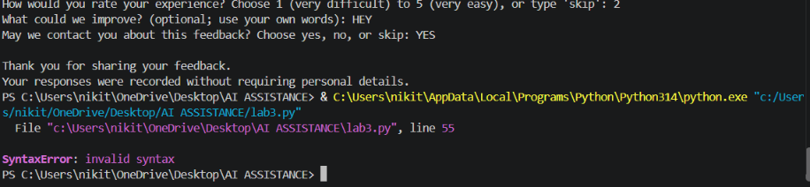
TASK2:
Task Description #2 (AI-Based Code Completion for Loop with
Conditionals)
Task: Use an AI code completion tool to combine loops and
conditionals.

Week3 -
Monday

Prompt:
“Generate Python code to count how many numbers in a list are even
and odd.”
Expected Output:
• AI-generated code using loop and if condition.
• Correct count validation.
• Explanation of logic flow.
PROMT:
Generate Python code to count the number of even and odd numbers in a list using a loop and if condition. Explain the logic and validate the counts with a sample input.
CODE:
def even_numbers_up_to(n: int) -> list[int]:
"""Return the even numbers in the inclusive range from 1 through N."""
return [number for number in range(1, n + 1) if number % 2 == 0]

def main() -> None:
try:
n = int(input("Enter N: "))
if n < 1:
raise ValueError
except (ValueError, EOFError):
print("Please enter a positive integer for N.")
return

print(f"Even numbers between 1 and {n}:")
for number in even_numbers_up_to(n):
print(number, end=" ")
print()
print("Loop type used: for loop")

if __name__ == "__main__":
main()
def count_even_and_odd(numbers: list[int]) -> tuple[int, int]:
"""Return the number of even and odd values in ``numbers``.

Each value is checked with an if condition: a remainder of zero when
divided by two means the value is even; otherwise it is odd.
"""
even_count = 0
odd_count = 0

for number in numbers:
if number % 2 == 0:
even_count += 1
else:
odd_count += 1

return even_count, odd_count

def validate_counts(numbers: list[int], even_count: int, odd_count: int) -> None:
"""Validate that the two counts account for every input value."""
assert even_count + odd_count == len(numbers)
assert even_count == sum(number % 2 == 0 for number in numbers)
assert odd_count == sum(number % 2 != 0 for number in numbers)

if __name__ == "__main__":
sample_numbers = [1, 2, 3, 4, 5, 6, 8]
even_count, odd_count = count_even_and_odd(sample_numbers)
validate_counts(sample_numbers, even_count, odd_count)

print(f"Sample input: {sample_numbers}")
print(f"Even numbers: {even_count}")
print(f"Odd numbers: {odd_count}")
print("Counts validated successfully.")

OUTPUT:
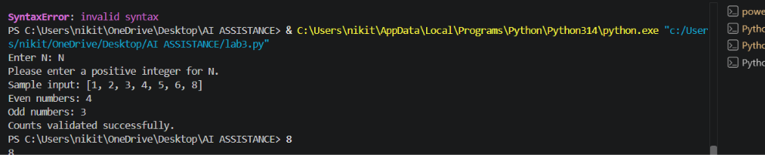
TASK3;
Task Description #3 (AI-Based Code Completion for Class
Attributes Validation)
Task: Use an AI tool to complete a Python class that validates user
input.
Prompt:
“Generate a Python class User that validates age and email using
conditional statements.”
Expected Output:
• AI-generated class with validation logic.
• Verification of condition handling.
• Test cases for valid and invalid inputs.
PROMT:
Generate a Python class User that validates age and email using conditional statements. Include validation logic and test cases for both valid and invalid inputs.
CODE:
class User:
"""Represent a user after validating their age and email address."""

def __init__(self, age: int, email: str) -> None:
if not isinstance(age, int) or isinstance(age, bool) or age < 0:
raise ValueError("Age must be a non-negative integer.")

if not isinstance(email, str) or email.count("@") != 1:
raise ValueError("Email must be a valid address.")

local_part, domain = email.split("@")
if (
not local_part
or not domain
or "." not in domain
or domain.startswith(".")
or domain.endswith(".")
):
raise ValueError("Email must be a valid address.")

self.age = age
self.email = email

def run_tests() -> None:
"""Test valid and invalid User inputs."""
valid_user = User(25, "user@example.com")
assert valid_user.age == 25
assert valid_user.email == "user@example.com"

invalid_inputs = [
(-1, "user@example.com"),
(True, "user@example.com"),
(25, "invalid-email"),
(25, "user@example"),
(25, "@example.com"),
(25, "user@@example.com"),
(25, "user@.example.com"),
(25, "user@example.com."),
]
for age, email in invalid_inputs:
try:
User(age, email)
except ValueError:
pass
else:
raise AssertionError(f"Expected invalid input: {age}, {email}")

print("Valid and invalid User tests passed.")

if __name__ == "__main__":
run_tests()

OUTPUT:
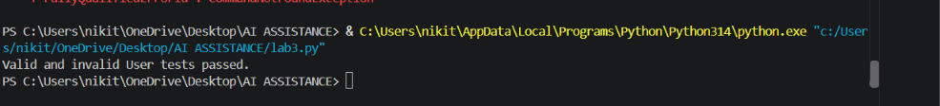
TASK4:
Task Description #4 (AI-Based Code Completion for Classes)
Task: Use an AI code completion tool to generate a Python class for
managing student details.
Prompt:
“Generate a Python class Student with attributes (name, roll number,
marks) and methods to calculate total and average marks.”
Expected Output:
• AI-generated class code.
• Verification of correctness and completeness of class
structure.
• Minor manual improvements (if needed) with justification.
PROMT:
Generate a Python class Student with attributes name, roll number, and marks, and methods to calculate total and average marks. Verify the class structure and suggest minor improvements if needed.
CODE:
lass Student:
"""Represent a student and their marks."""

def __init__(self, name: str, roll_number: int, marks: list[float]) -> None:
if not isinstance(name, str) or not name.strip():
raise ValueError("Name must be a non-empty string.")
if not isinstance(roll_number, int) or isinstance(roll_number, bool):
raise ValueError("Roll number must be an integer.")
if not marks or any(not isinstance(mark, (int, float)) or isinstance(mark, bool)
or mark < 0 for mark in marks):
raise ValueError("Marks must be a non-empty sequence of non-negative numbers.")

self.name = name.strip()
self.roll_number = roll_number
self.marks = list(marks)

def total_marks(self) -> float:
"""Return the sum of all marks."""
return sum(self.marks)

def average_marks(self) -> float:
"""Return the average mark."""
return self.total_marks() / len(self.marks)

def run_tests() -> None:
"""Verify Student attributes, calculations, and validation."""
student = Student(" Ada Lovelace ", 1, [80, 90, 100])
assert student.name == "Ada Lovelace"
assert student.roll_number == 1
assert student.marks == [80, 90, 100]
assert student.total_marks() == 270
assert student.average_marks() == 90

invalid_inputs = [
("", 1, [80]),
("Ada", True, [80]),
("Ada", 1, []),
("Ada", 1, [-1]),
]
for name, roll_number, marks in invalid_inputs:
try:
Student(name, roll_number, marks)
except ValueError:
pass
else:
raise AssertionError("Expected invalid student input")

print("Student class structure and tests passed.")

if __name__ == "__main__":
run_tests()
OUTPUT:
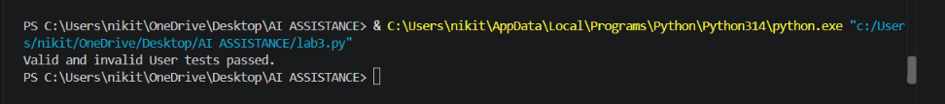
TASK5:
Task Description 5 (AI-Assisted Code Completion Review)
Task: Use an AI tool to generate a complete Python program using
classes, loops, and conditionals together.
Prompt:
“Generate a Python program for a simple bank account system using
class, loops, and conditional statements.”
Expected Output:
• Complete AI-generated program.
• Identification of strengths and limitations of AI suggestions.
• Reflection on how AI assisted coding productivity.
PROMT:
Generate a Python program for a simple bank account system using classes, loops, and conditional statements. Include basic operations like deposit, withdrawal, balance checking, and a menu loop. Identify the strengths and limitations of the AI-generated code and explain how AI improves coding productivity.
CODE:
class BankAccount:
"""Represent a basic bank account."""

def __init__(self, account_holder: str, initial_balance: float = 0.0) -> None:
if not account_holder.strip():
raise ValueError("Account holder name cannot be empty.")
if initial_balance < 0:
raise ValueError("Initial balance cannot be negative.")

self.account_holder = account_holder.strip()
self.balance = initial_balance

def deposit(self, amount: float) -> None:
"""Add money to the account."""
if amount <= 0:
print("Deposit amount must be greater than zero.")
return

self.balance += amount
print(f"Deposited: ${amount:.2f}")

def withdraw(self, amount: float) -> None:
"""Remove money if sufficient funds are available."""
if amount <= 0:
print("Withdrawal amount must be greater than zero.")
elif amount > self.balance:
print("Insufficient funds.")
else:
self.balance -= amount
print(f"Withdrawn: ${amount:.2f}")

def check_balance(self) -> None:
"""Display the current balance."""
print(f"Current balance: ${self.balance:.2f}")

def get_amount(prompt: str) -> float:
"""Read and validate a monetary amount."""
while True:
try:
amount = float(input(prompt))
if amount < 0:
print("Amount cannot be negative.")
else:
return amount
except ValueError:
print("Please enter a valid number.")

def run_bank_system() -> None:
"""Run the interactive bank account menu."""
name = input("Enter account holder name: ")

try:
initial_balance = get_amount("Enter initial balance: ")
account = BankAccount(name, initial_balance)
except ValueError as error:
print(f"Error: {error}")
return

while True:
print("\n--- Bank Account Menu ---")
print("1. Deposit")
print("2. Withdraw")
print("3. Check balance")
print("4. Exit")

choice = input("Choose an option: ").strip()

if choice == "1":
amount = get_amount("Enter deposit amount: ")
account.deposit(amount)
elif choice == "2":
amount = get_amount("Enter withdrawal amount: ")
account.withdraw(amount)
elif choice == "3":
account.check_balance()
elif choice == "4":
print("Thank you for using the bank account system.")
break
else:
print("Invalid choice. Please select an option from 1 to 4.")

if __name__ == "__main__":
run_bank_system()
OUTPUT:
