AI ASSISTED CODING
Experiment 2: Exploring Additional AI Coding Tools beyond Copilot – Gemini (Colab) and Cursor AI

NAME : T.SAI CHARAN
ROLL NO : 2503A52687
BATCH : 23
Task 1: Statistical Summary for Survey Data

- Scenario:
You are a data analyst intern working with survey responses stored as numerical lists.

- Task:
Use Google Gemini in Colab to generate a Python function that reads a list of numbers and calculates the mean, minimum, and maximum values.

- Expected Output:
  - Correct Python function
  - Output shown in Colab
  - Screenshot of Gemini prompt and result

Prompt:-
generate an python code which reads a set of numbers and find out the mean and maximum and minimum number of the list
CODE:-
# List of numbers
numbers = [10, 20, 30, 40, 50]

# Calculate mean
mean = sum(numbers) / len(numbers)

# Find maximum and minimum
maximum = max(numbers)
minimum = min(numbers)

# Display results
print("List:", numbers)
print("Mean:", mean)
print("Maximum:", maximum)
print("Minimum:", minimum)

OUTPUT:-
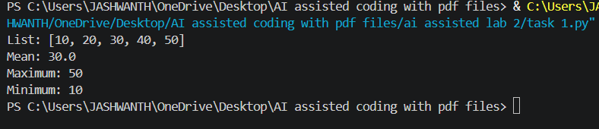
Task 2: Armstrong Number – AI Comparison

- Scenario:
You are evaluating AI tools for numeric validation logic.

- Task:
Generate an Armstrong number checker using Gemini and GitHub Copilot.
Compare their outputs, logic style, and clarity.

- Expected Output:
  - Side-by-side comparison table
  - Screenshots of prompts and generated code

PROMPT:-
GENERATE AN PYTHON CODE TO CHECK AN AMSTRONG NUMBER
CODE OF VS CODE:-
number = int(input("Enter a number: "))
digits = str(abs(number))
power = len(digits)
armstrong_sum = sum(int(digit) ** power for digit in digits)

if number >= 0 and armstrong_sum == number:
print(f"{number} is an Armstrong number.")
else:
print(f"{number} is not an Armstrong number.")
OUTPUT:-
Enter a number: 121
121 is not an Armstrong number.

Enter a number: 153
153 is an Armstrong number.

CODE OF COLAB:-
# Enter a number
num = int(input("Enter a number: "))

# Store the original number
original = num

# Find the number of digits
digits = len(str(num))

# Calculate the sum of powers
sum = 0
while num > 0:
digit = num % 10
sum = sum + digit ** digits
num = num // 10

# Check Armstrong number
if sum == original:
print(original, "is an Armstrong number")
else:
print(original, "is not an Armstrong number")
OUTPUT:-
Enter a number: 153
153 is an Armstrong number.

Enter a number: 121
121 is not an Armstrong number.

Task 3: Leap Year Validation Using Cursor AI

- Scenario:
You are validating a calendar module for a backend system.

- Task:
Use Cursor AI to generate a Python program that checks whether a given year is a leap year.
Use at least two different prompts and observe changes in code.

- Expected Output:
  - Two versions of code
  - Sample inputs/outputs
  - Brief comparison

Prompt:-
generate a Python program that checks whether a given year is a leap year.
Code:-
year = int(input("Enter a year: "))

if year % 400 == 0 or (year % 4 == 0 and year % 100 != 0):
print(f"{year} is a leap year.")
else:
print(f"{year} is not a leap year.")

output:-
Enter a year: 2015
2015 is not a leap year.

Enter a year: 2016
2016 is a leap year.

Task 4: Student Logic + AI Refactoring (Odd/Even Sum)
Scenario:
Company policy requires developers to write logic before using AI.
Task:
Write a Python program that calculates the sum of odd and even numbers in a tuple, then refactor it using any AI tool.
Expected Output:
  - Original code
  - Refactored code
  - Explanation of improvements
Prompt:-
Write a Python program that calculates the sum of odd and even numbers in a tuple.
Code:-
numbers = (1, 2, 3, 4, 5, 6, 7, 8, 9, 10)

odd_sum = sum(number for number in numbers if number % 2 != 0)
even_sum = sum(number for number in numbers if number % 2 == 0)

print("Sum of odd numbers:", odd_sum)
print("Sum of even numbers:", even_sum)
OUTPUT:-
Sum of odd numbers: 25
Sum of even numbers: 30

