AI ASSISTED CODING
Experiment 3: Prompt Engineering – Improving Prompts and Context Management

NAME : T. SAI CHARAN
ROLL NO : 2503A52687
BATCH : 23

Experiment – Prompt Engineering Techniques
Task Description
Design and refine prompts using different prompting strategies to generate Python programs for basic computational problems.

Question 1: Zero-Shot Prompting (Palindrome Number Program)
Write a zero-shot prompt (without providing any examples) to generate a Python function that checks whether a given number is a palindrome.
Task:
- Record the AI-generated code.
- Test the code with multiple inputs.
Identify any logical errors or missing edge-case handling.

Prompt:-
generate a Python function that checks whether a given number is a palindrome.

Code:-
def is_palindrome(number):
"""Return True if the given number reads the same forwards and backwards."""

text = str(number)
return text == text[::-1]

print(is_palindrome(123))
output:-
False

print(is_palindrome(121))
True

Question 2: One-Shot Prompting (Factorial Calculation)
Write a one-shot prompt by providing one input-output example and ask the AI to generate a Python function to compute the factorial of a given number.
Example:
Input: 5 → Output: 120
Task:
- Compare the generated code with a zero-shot solution.
- Examine improvements in clarity and correctness.

Prompt:-
generate a Python function to compute the factorial of a given number.
Example:
Input: 5 → Output: 120

Code:-
def factorial(n):
result = 1 for i in range(1, n + 1):
result = result * i
return result
print(factorial(5))
output:-120
print(factorial(6))
720

Question 3: Few-Shot Prompting (Armstrong Number Check)
Write a few-shot prompt by providing multiple input-output examples to guide the AI in generating a Python function to check whether a given number is an Armstrong number.
Examples:
- Input: 153 → Output: Armstrong Number
- Input: 370 → Output: Armstrong Number
- Input: 123 → Output: Not an Armstrong Number
Task:
- Analyze how multiple examples influence code structure and accuracy.
- Test the function with boundary values and invalid inputs.

PROMPT:-
generate a Python function to check whether a given number is an Armstrong number. For example
Input: 153 → Output: Armstrong Number
Input: 370 → Output: Armstrong Number
Input: 123 → Output: Not an Armstrong Number

CODE:-
def is_armstrong(number):
digits = str(number)
power = len(digits)
total = 0

for digit in digits:
total += int(digit) ** power

return total == number
print("Armstrong Number" if is_armstrong(123) else "Not an Armstrong Number")
OUTPUT:-
Not an Armstrong Number
print("Armstrong Number" if is_armstrong(153) else "Not an Armstrong Number")

Armstrong Number
Question 4: Context-Managed Prompting (Optimized Number Classification)
Design a context-managed prompt with clear instructions and constraints to generate an optimized Python program that classifies a number as prime, composite, or neither.
Task:
- Ensure proper input validation.
- Optimize the logic for efficiency.
- Compare the output with earlier prompting strategies.
Prompt:-
generate an python code which takes an number as input and checks weather the given number is prime number or composite number or neither

CODE:-
def check_number(n):
if n <= 1:
return "Neither Prime nor Composite"

for i in range(2, n):
if n % i == 0:
return "Composite Number"

return "Prime Number"
# Take input from the user
number = int(input("Enter a number: "))
print(check_number(number))
output:-
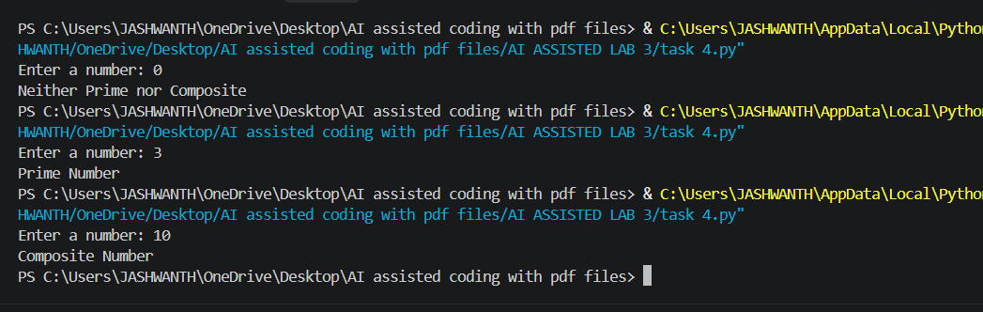

Question 5: Zero-Shot Prompting (Perfect Number Check)
Write a zero-shot prompt (without providing any examples) to generate a Python function that checks whether a given number is a perfect number.
Task:
- Record the AI-generated code.
- Test the program with multiple inputs.
- Identify any missing conditions or inefficiencies in the logic.

Prompt:-
generate a Python function that checks whether a given number is a perfect number.
CODE:-
def is_perfect(number):
if number <= 0:
return False

total = 0

for i in range(1, number):
if number % i == 0:
total += i

return total == number

# Take input from the user
number = int(input("Enter a number: "))

if is_perfect(number):
print("Perfect Number")
else:
print("Not a Perfect Number")
output:-
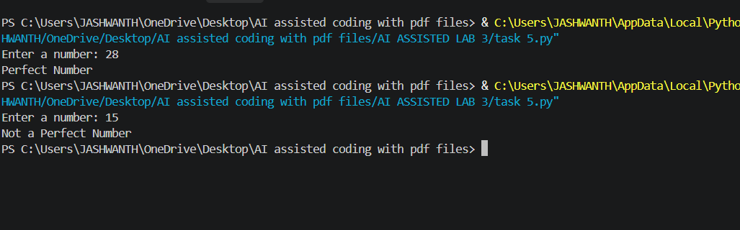
Question 6: Few-Shot Prompting (Even or Odd Classification with Validation)
Write a few-shot prompt by providing multiple input-output examples to guide the AI in generating a Python program that determines whether a given number is even or odd, including proper input validation.
Examples:
- Input: 8 → Output: Even
- Input: 15 → Output: Odd
- Input: 0 → Output: Even
Task:
- Analyze how examples improve input handling and output clarity.
Test the program with negative numbers and non-integer inputs
Prompt:-
generate a Python program that determines whether a given number is even or odd, including proper input validation. Examples: Input: 8 → Output: Even Input: 15 → Output: Odd Input: 0 → Output: Even
CODE:-
def check_even_odd():
while True:
try:
number = int(input("Enter a number: "))

if number % 2 == 0:
print("Even")
else:
print("Odd")

break

except ValueError:
print("Invalid input! Please enter a valid integer.")
check_even_odd()
OUTPUT:-
