AI ASSISTED CODING (ASSIGNMENT-11.1)

Name: G. Siri Priya
Roll No: 2503A52718
Batch: 24

Q1
Task: Use AI to generate a Stack class with push, pop, peek, and is_empty
methods.
Sample Input Code:
class Stack:
pass
Prompt: generate a code on Stack class with push, pop, peek, and is_empty
methods.
Code:
class Stack:
def __init__(self):
self.items = []
def push(self, item):
self.items.append(item)
def pop(self):
if self.is_empty():
return None
return self.items.pop()
def peek(self):
if self.is_empty():
return None
return self.items[-1]

def is_empty(self):
return len(self.items) == 0
stack = Stack()
stack.push(10)
stack.push(20)
print("Top element:", stack.peek())
print("Popped element:", stack.pop())
print("Is stack empty?", stack.is_empty())
Output:
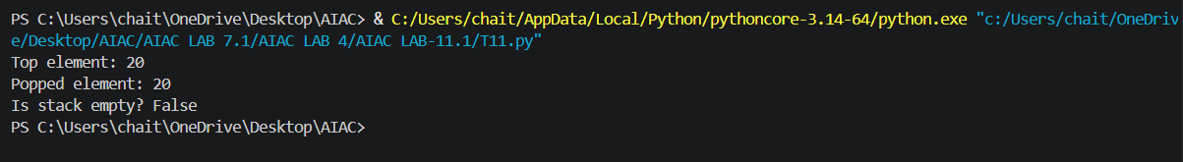

Q2
Task: Use AI to implement a Queue using Python lists.
Sample Input Code:
class Queue:
pass
Prompt: generate a code to implement a Queue using python list.
Code:
class Queue:
def __init__(self):
self._items = []
def enqueue(self, item):
"""Add an item to the rear of the queue."""
self._items.append(item)
def dequeue(self):

if self.is_empty():
return None
return self._items.pop(0)
def peek(self):
if self.is_empty():
return None
return self._items[0]
def is_empty(self):
return len(self._items) == 0
if __name__ == "__main__":
queue = Queue()
print("Is queue empty?", queue.is_empty())
queue.enqueue(10)
queue.enqueue(20)
queue.enqueue(30)
print("Queue after enqueueing 10, 20, 30:", queue._items)
print("Front item:", queue.peek())
print("Dequeued item:")
print(queue.dequeue())
print("Front item after dequeue:", queue.peek())
print("Is queue empty?", queue.is_empty())
output:
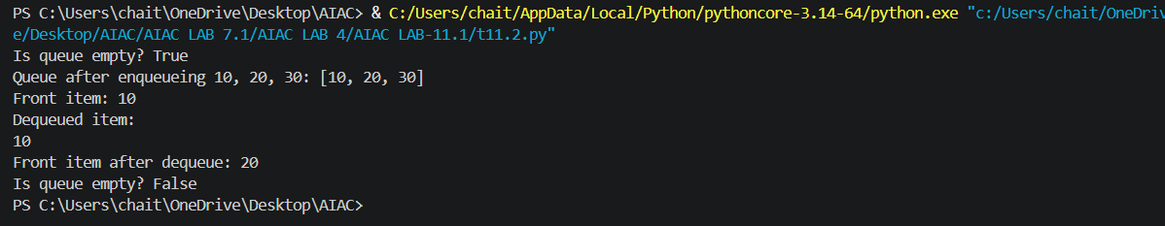
Q3
Task: Use AI to generate a Singly Linked List with insert and display
methods.
Sample Input Code:
class Node:
pass
class LinkedList:
pass
Prompt: generate a code on singly linked list with insert and display methods.
Code:
class Node:
def __init__(self, data):
self.data = data
self.next = None
class LinkedList:
def __init__(self):
self.head = None
def insert(self, data):
new_node = Node(data)
if self.head is None:
self.head = new_node
return
current = self.head
while current.next is not None:
current = current.next
current.next = new_node
def display(self):
current = self.head
values = []

while current is not None:
values.append(str(current.data))
current = current.next
print(" -> ".join(values) if values else "The list is empty.")
if __name__ == "__main__":
linked_list = LinkedList()
linked_list.insert(10)
linked_list.insert(20)
linked_list.insert(30)
print("Linked list:")
linked_list.display()
ouput:
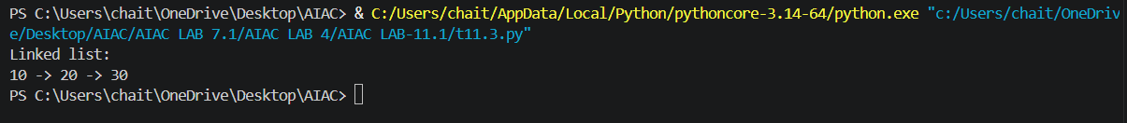
Q4
Task: Use AI to create a BST with insert and in-order traversal methods.
Sample Input Code:
class BST:
pass
Prompt: generate a code on BST with insert and in-order traversal methods.
Code:
class Node:
def __init__(self, data):
self.data = data
self.left = None
self.right = None
class BST:
def __init__(self):
self.root = None
def insert(self, data):
"""Insert a value into the tree."""
self.root = self._insert(self.root, data)
def _insert(self, node, data):
if node is None:
return Node(data)
if data < node.data:
node.left = self._insert(node.left, data)
elif data > node.data:
node.right = self._insert(node.right, data)
return node
def in_order(self):
values = []
self._in_order(self.root, values)
return values
def _in_order(self, node, values):
if node is not None:
self._in_order(node.left, values)
values.append(node.data)
self._in_order(node.right, values)
if __name__ == "__main__":
bst = BST()
for value in (50, 30, 70, 20, 40, 60, 80):
bst.insert(value)
print("In-order traversal:", bst.in_order())
output:
Q5
Task: Use AI to implement a priority queue using Python’s heapq
module.
Sample Input Code:
class PriorityQueue:
pass
Prompt: generate a code to implement a priority queue using Python’s heapq
module.
Code:
import heapq

class PriorityQueue:
def __init__(self):
self._items = []

def insert(self, item):
"""Add an item to the priority queue."""
heapq.heappush(self._items, item)

def remove(self):
"""Remove and return the item with the highest priority."""
return heapq.heappop(self._items)

def peek(self):
"""Return the highest-priority item without removing it."""
return self._items[0]

def is_empty(self):
return len(self._items) == 0

if __name__ == "__main__":
queue = PriorityQueue()
for item in (5, 1, 3, 2, 4):
queue.insert(item)

print("Priority order:", end=" ")
while not queue.is_empty():
print(queue.remove(), end=" ")
output:
Q6
Task:Use AI to implement a double-ended queue using
collections.deque.
Sample Input Code:
class DequeDS:
prompt: generate a code to implement a double-ended queue using
collections.deque.
code:
from collections import deque
class DoubleEndedQueue:
"""A double-ended queue (deque)."""

def __init__(self):
"""Create an empty deque."""
self._items = deque()

def add_front(self, item):
"""Add an item to the front of the deque."""
self._items.appendleft(item)

def add_rear(self, item):
"""Add an item to the rear of the deque."""
self._items.append(item)

def remove_front(self):
"""Remove and return the front item, or None if empty."""
if self.is_empty():
return None
return self._items.popleft()

def remove_rear(self):
"""Remove and return the rear item, or None if empty."""
if self.is_empty():
return None
return self._items.pop()

def is_empty(self):
"""Return True when the deque has no items."""
return len(self._items) == 0

if __name__ == "__main__":
queue = DoubleEndedQueue()

queue.add_rear(10)
queue.add_rear(20)
queue.add_front(5)
print("Deque after adding 10, 20 at the rear and 5 at the front:", queue._items)
print("Removed from front:", queue.remove_front())
print("Removed from rear:", queue.remove_rear())
print("Deque after removals:", queue._items)
print("Is deque empty?", queue.is_empty())
output:
