NETWORK SECURITY & DATA INTEGRITY
Cyclic Redundancy Check (CRC)
& Attendance File Auditor
Bitwise Polynomial Verification Dashboard | 3 Operating Modes | CSV File Tampering Detection
✔ Pure Python XOR Engine  100% mathematical bitwise modulo-2 division without external CRC libraries (no zlib/hashlib). | ✔ Zero Bit-Flipping Policy  Natural verification testing directly on user input and modified files without synthetic shortcuts. | ✔ Attendance Audit Case  Detects accidental modifications ('Absent' vs 'Present') and deleted student record rows.

Candidate Name: | Purna Chandar Reddy
Registration / Roll No.: | 2503a52753
Course / Department: | Computer Science & Engineering / Computer Networks
GitHub Repository: | https://github.com/2503a52753-Purna/CRC-Verification-Dashboard
Live 24/7 Web App (GitHub Pages): | https://2503a52753-purna.github.io/CRC-Verification-Dashboard/
Local Streamlit Dashboard: | http://localhost:8501 (Port 8501)

Project Report Line Up & Table of Contents
S. No. | Chapter / Section | Page No.
CHAPTER 1 | INTRODUCTION TO CYCLIC REDUNDANCY CHECK (CRC) | 3
1.1 | Introduction to Error Detection | 3
1.2 | Need for CRC | 3
1.3 | Basic Working of CRC | 4
1.4 | Applications of CRC | 4
1.5 | Problem Statement and Product Requirements | 4
1.6 | Proposed Implementation Plan | 5
CHAPTER 2 | MATHEMATICAL PRINCIPLES OF CRC | 6
2.1 | Binary Data and Polynomial Representation | 6
2.2 | Generator Polynomial | 6
2.3 | Modulo-2 Division | 7
2.4 | XOR Operation | 7
2.5 | CRC Remainder and Codeword Generation | 8
2.6 | CRC Verification and Error Detection | 8
2.7 | Worked Example of CRC Calculation | 9
CHAPTER 3 | PYTHON IMPLEMENTATION OF CRC | 10
3.1 | Software and Development Tools Used | 10
3.2 | CRC Function and Program Structure | 10
3.3 | CRC-3 Implementation | 11
3.4 | CRC-4 Implementation | 11
3.5 | CRC-8 Implementation | 12
3.6 | CRC-32 Implementation | 12
3.7 | Testing Using Binary Input Data | 13
3.8 | Testing Using Text Messages | 13
3.9 | Testing Using Text Files and Other File Formats | 14
3.10 | Error Introduction and Detection | 14
CHAPTER 4 | CRC DASHBOARD / APPLICATION INTERFACE DEVELOPMENT | 15
4.1 | Dashboard Requirements | 15
4.2 | Software/Framework Used | 15
4.3 | User Interface Design | 16
4.4 | Dashboard Inputs | 16
4.5 | Dashboard Outputs | 17
4.6 | Dashboard-to-Python Code Integration | 17
4.7 | Complete Data Processing Flow | 18
4.8 | Testing Methodology | 18
4.9 | Test Cases and Results | 19
4.10 | Error-Free and Corrupted Data Testing | 19
CHAPTER 5 | ERRORS, CHALLENGES AND LEARNING OUTCOMES | 20
5.1 | Errors Encountered During Implementation | 20
5.2 | Causes of Errors | 20
5.3 | Solutions Implemented | 21
5.4 | Challenges in Dashboard-Code Integration | 21
5.5 | Learning Outcomes | 22
CHAPTER 6 | ADDITIONAL FEATURES AND PRODUCT ENHANCEMENT | 23
6.1 | Additional Features Implemented | 23
6.2 | Benefits of Additional Features | 23
6.3 | Improvements in User Experience | 24
6.4 | Scope for Further Improvement | 24
CHAPTER 7 | RESULTS AND CONCLUSION | 25
7.1 | Summary of Test Results | 25
7.2 | Overall Product Performance | 25
7.3 | Achievement of Project Objectives | 26
7.4 | Conclusion | 26
APPENDIX A | COMPLETE PYTHON SOURCE CODE | 27
APPENDIX B | LINE-BY-LINE EXPLANATION OF CODE | 28
APPENDIX C | DASHBOARD SCREENSHOTS | 31
APPENDIX D | COMPLETE TEST-CASE TABLES AND SAMPLE OUTPUTS | 34

CHAPTER 1 - INTRODUCTION TO CYCLIC REDUNDANCY CHECK (CRC)
1.1 Introduction to Error Detection
Digital communication and storage channels are inherently subject to physical imperfections. When binary streams propagate through copper media, fiber-optic channels, wireless electromagnetic environments, or magnetic/solid-state storage sectors, they encounter thermal noise, electromagnetic interference (EMI), crosstalk, attenuation, and transient power surges. These disturbances frequently corrupt transmitted bits, causing binary inversions (zeros turning to ones and ones turning to zeros). In data-critical applications, relying on unverified payloads can lead to severe system faults, silent corruption of database records, and compromised academic or organizational audits. Consequently, robust error detection mechanisms are essential to guarantee payload integrity.
1.2 Need for CRC
Traditional error-detection techniques, such as simple single-bit parity checks or arithmetic summation checksums (e.g., standard 16-bit Internet checksum), possess severe mathematical blind spots. A parity bit fails to detect any even number of bit inversions (such as 2, 4, or 6 simultaneous errors). Arithmetic checksums fail when bytes are transposed or when equal-and-opposite bit errors cancel out mathematically. In contrast, Cyclic Redundancy Check (CRC) treats binary bitstreams as algebraic polynomials over the Galois Field GF(2). By employing polynomial modulo-2 division, CRC delivers mathematically guaranteed detection of all single-bit errors, all double-bit errors (provided the polynomial is chosen appropriately), all odd numbers of errors, and all burst errors whose length does not exceed the degree of the generator polynomial.
1.3 Basic Working of CRC
The operation of Cyclic Redundancy Check operates on a sender-receiver contract governed by an agreed-upon generator divisor string ('gen'). The workflow proceeds across three deterministic phases:
1. Zero Padding: The sender identifies the degree of the generator polynomial, defined as k = len(gen) - 1. The original binary data is appended with exactly k zero bits.
2. Modulo-2 Division: The augmented bitstream is divided by the binary generator string using bitwise XOR operations without carry or borrow. The resulting remainder of length k is the CRC checksum.
3. Codeword Transmission & Receiver Verification: The sender appends the calculated CRC remainder to the original data to form the transmitted codeword (Codeword = Data + Remainder). Upon arrival, the receiver divides the received codeword by the identical generator 'gen'. If the resulting remainder is strictly zero, the transmission is validated as authentic and error-free; otherwise, data corruption is flagged immediately.
1.4 Applications of CRC
CRC algorithms are universally deployed across modern networking architectures, industrial telecommunications, and data integrity architectures:
• Local Area Networks (LANs): IEEE 802.3 Ethernet standards append a 32-bit Frame Check Sequence (FCS) using CRC-32 to protect every network packet.
• Wireless Networks: IEEE 802.11 Wi-Fi frames rely on CRC-32 to discard corrupted wireless transmissions.
• Telecommunications Framing: ITU-T G.704 framing standards utilize CRC-4 for synchronizing digital streams.
• Industrial Sensors & Automotive: CRC-8 is widely integrated into CAN-bus telemetry, I2C sensor packets, and embedded microcontrollers due to its minimal computational footprint.
• Storage Formats: File compression archives (ZIP, GZIP, PNG, TAR) store CRC-32 checksums to detect disk read errors or file transmission truncation.
1.5 Problem Statement and Product Requirements
The Real-World Classroom Challenge (Instructor Attendance Dilemma)
An instructor conducts an examination or lecture session and generates a structured CSV attendance file. During storage on school servers, upload to web portals, or transmission across intermediaries, individual student attendance records may be maliciously or accidentally modified ('Absent' flipped to 'Present') or an entire student record row may be deleted. Manual line-by-line inspection is tedious and error-prone.
Product Requirement: Build an authentic CRC verification engine that computes reference and audited checksums directly on CSV attendance records. Strictly forbid synthetic bit-flipping controls; instead, validate natural user inputs and real files with 100% mathematical certainty.

1.6 Proposed Implementation Plan
To satisfy the academic integrity mandate and provide an enterprise-grade utility, the proposed implementation follows a three-tier development roadmap:
• Core Mathematical Engine: Develop a lightweight, pure Python bitwise XOR engine without external CRC libraries (no zlib, no hashlib). The engine must handle arbitrary generator lengths and binary bitstreams.
• Multi-Mode Architecture: Implement three distinct operational modes: (1) Binary Input with Codeword Division, (2) Text Input with ASCII bitstream conversion and direct CRC comparison, and (3) File Input for Attendance CSV record auditing.
• Interactive Dashboard & 24/7 Deployment: Develop an interactive Streamlit graphical dashboard running locally on port 8501, and simultaneously deploy a client-side vanilla JavaScript engine permanently hosted 24/7 on GitHub Pages linked to the public GitHub repository.

CHAPTER 2 - MATHEMATICAL PRINCIPLES OF CRC
2.1 Binary Data and Polynomial Representation
In CRC mathematics, any binary string can be formally represented as an algebraic polynomial whose coefficients belong to the Galois Field GF(2). In this field, the only permissible coefficients are 0 and 1. A binary string composed of n bits, denoted as b_{n-1} b_{n-2} ... b_1 b_0, corresponds to the polynomial:
P(x) = b_{n-1}·x^{n-1} + b_{n-2}·x^{n-2} + ... + b_1·x^1 + b_0·x^0
For example, the binary string 100100 is converted to algebraic polynomial notation as:
D(x) = 1·x^5 + 0·x^4 + 0·x^3 + 1·x^2 + 0·x^1 + 0·x^0 = x^5 + x^2
The highest exponent with a non-zero coefficient designates the degree of the polynomial.
2.2 Generator Polynomial
The generator polynomial, denoted as G(x), represents the predetermined divisor string. The degree of G(x) is designated as k = len(gen) - 1. A valid generator polynomial must satisfy two fundamental structural rules:
1. The most significant coefficient (highest order term x^k) must equal 1.
2. The least significant coefficient (constant term x^0 = 1) must equal 1. This guarantees that G(x) is not divisible by x, ensuring that any single-bit transmission error E(x) = x^i produces a non-zero remainder.
2.3 Modulo-2 Division
Standard arithmetic division involves carries, borrows, and multi-digit quotient estimations. In contrast, modulo-2 division operates strictly under finite field arithmetic over GF(2). Modulo-2 arithmetic has no carries during addition and no borrows during subtraction. Consequently, both addition and subtraction are entirely equivalent to the bitwise Exclusive-OR (XOR) logic gate.
2.4 XOR Operation
The bitwise XOR operation, symbolized as ⊕ or ^, operates according to the standard truth table below. If two bits are identical, the output is 0; if the two bits differ, the output is 1.
Input Bit A | Input Bit B | A ⊕ B (Output)
0 | 0 | 0
0 | 1 | 1
1 | 0 | 1
1 | 1 | 0
2.5 CRC Remainder and Codeword Generation
Mathematically, multiplying the data polynomial D(x) by x^k shifts the binary stream to the left by k positions, effectively appending k zeros to the tail of the data. When this augmented polynomial is divided by the generator polynomial G(x), it yields a quotient Q(x) and a remainder R(x):
D(x) · x^k = Q(x) · G(x) ⊕ R(x)
Because addition and subtraction in GF(2) are identical (A ⊕ B = A - B), we can rearrange the equation:
T(x) = D(x) · x^k ⊕ R(x) = Q(x) · G(x)
The polynomial T(x) represents the transmitted codeword. By construction, T(x) is an exact polynomial multiple of the generator G(x).
2.6 CRC Verification and Error Detection
During channel transit, physical noise can introduce an error polynomial E(x), where non-zero coefficients denote the corrupted bit positions. The receiver captures the modified polynomial T'(x) = T(x) ⊕ E(x). The receiver evaluates the received bitstream by dividing by G(x):
T'(x) / G(x) = [T(x) ⊕ E(x)] / G(x) = [Q(x) · G(x) ⊕ E(x)] / G(x) = Q(x) ⊕ [E(x) / G(x)]
Since T(x) is perfectly divisible by G(x), the remainder is governed solely by E(x) / G(x):
• If no error occurred (E(x) = 0), the remainder is 0. Status: No Error Detected.
• If an error occurred (E(x) ≠ 0), the remainder is non-zero, unless E(x) is an exact multiple of G(x). Selecting standardized, irreducible generator polynomials guarantees that realistic burst errors can never be multiples of G(x).
2.7 Worked Example of CRC Calculation
Consider the fundamental classroom reference case:
• Data Bitstream: 100100 (len = 6)
• Generator Polynomial: 1101 (CRC-3, degree k = 4 - 1 = 3)
• Zero-Padded Data: 100100000 (appended with 3 zeros)
Step-by-Step Modulo-2 Long Division:
-------------------------------------
Dividend : 100100000
Divisor : 1101
100100000
^ 1101 (1st step: XOR with 1101)
-----
010000000 -> shift to next leading '1': 1000
^ 1101 (2nd step: XOR with 1101)
----
01010000 -> shift to next leading '1': 1010
^ 1101 (3rd step: XOR with 1101)
----
0111000 -> shift to next leading '1': 1110
^ 1101 (4th step: XOR with 1101)
----
001100 -> shift to next leading '1': 1100
^ 1101 (5th step: XOR with 1101)
----
00010 -> length remaining < len(gen), stop!
Remainder (last 3 bits): 001
Transmitted Codeword : Data + Remainder = 100100 + 001 = 100100001
Receiver Verification:
Codeword: 100100001 / 1101 ==> Remainder: 000 [PASS: ZERO ERROR]

CHAPTER 3 - PYTHON IMPLEMENTATION OF CRC
3.1 Software and Development Tools Used
The project was engineered using modern software tools to ensure modularity, cross-platform stability, and cloud-native availability:
• Programming Language: Python 3.10+ (utilizing native string manipulation and bitwise integer operators).
• Web Application Framework: Streamlit 1.30+ for rapid reactive web dashboard rendering and session caching.
• Data Analytics Engine: pandas 2.0+ for ingesting, validating, and displaying structured attendance CSV tables.
• Version Control & Deployment: Git and GitHub CLI (gh) for repository hosting and automated GitHub Pages CI/CD.
• Client-Side Runtime: Vanilla JavaScript (ES6+), HTML5, and CSS3 for zero-install permanent 24/7 web hosting.
3.2 CRC Function and Program Structure
At the core of the implementation is the fundamental crc(data, gen) routine. Python strings are immutable; therefore, the function converts the input string into a mutable list of single-character bit elements. The outer loop iterates through range(len(data) - len(gen) + 1). When data[i] is '1', an inner loop executes int(data[i+j]) ^ int(gen[j]) for every bit in the generator. Finally, it slices and returns the exact remainder of length len(gen) - 1.
3.3 CRC-3 Implementation
• Standard Polynomial: x³ + x + 1
• Binary Generator ('gen'): 1011 (len = 4, degree = 3)
• Checksum Width: 3 bits
• Usage Profile: Ideal for academic classroom demonstrations and small telemetry packets due to transparent hand-calculable remainder outputs.
3.4 CRC-4 Implementation
• Standard Polynomial: x⁴ + x + 1
• Binary Generator ('gen'): 10011 (len = 5, degree = 4)
• Checksum Width: 4 bits
• Usage Profile: Standardized in telecommunications under ITU-T Recommendation G.704 for framing and multiframe alignment in digital transmission lines.
3.5 CRC-8 Implementation
• Standard Polynomial: x⁸ + x² + x + 1
• Binary Generator ('gen'): 100000111 (len = 9, degree = 8)
• Checksum Width: 8 bits (1 byte)
• Usage Profile: Extensively used in sensor networking, ATM cell header error control (HEC), and structured file auditing. It provides strong burst-error detection up to 8 consecutive corrupted bits.
3.6 CRC-32 Implementation
• Standard Polynomial: IEEE 802.3 Ethernet Standard (x³² + x²⁶ + x²³ + ... + x² + x + 1)
• Binary Generator ('gen'): 100000100110000010001110110110111 (len = 33, degree = 32)
• Checksum Width: 32 bits (4 bytes)
• Usage Profile: Industry-standard checksum for Ethernet frames, Wi-Fi MAC layer packets, ZIP compression, and PNG image chunks. Detects 99.9999999% of all transmission errors.
3.7 Testing Using Binary Input Data
Mode 1 validates direct binary bitstreams. The user inputs raw binary data (e.g., 100100). The program adds zeros, calculates the remainder via crc(new_data, gen), and produces the codeword. The receiver checks the codeword using crc(received, gen) and verifies that int(check, 2) == 0.
3.8 Testing Using Text Messages
Mode 2 processes arbitrary text messages using the text_to_binary(text) function. Every ASCII character is mapped to an 8-bit binary representation via ''.join(format(ord(c), '08b') for c in text). Checksums for the original message and received message are computed independently. If sender_crc == receiver_crc, the message is certified as unaltered.
3.9 Testing Using Text Files and Other File Formats
Mode 3 expands binary conversion to entire structured CSV files. Files are read as binary/UTF-8 byte buffers. The full byte stream is converted into a continuous binary bit sequence and processed by the modulo-2 division engine. This enables auditing complex records such as student attendance matrices.
3.10 Error Introduction and Detection
Under the strict project guidelines, no artificial 'random bit flipping' buttons or synthetic noise injection functions are utilized. Instead, error testing is conducted naturally:
• In Binary Mode: The tester modifies a single bit in the receiver codeword input field.
• In Text Mode: The tester edits a single character or case (e.g., 'Lab' vs 'lab') in the received text area.
• In File Mode: The auditor loads real-world files where an attendance status is modified or a student row is deleted.

CHAPTER 4 - CRC DASHBOARD / APPLICATION INTERFACE DEVELOPMENT
4.1 Dashboard Requirements
The user interface was designed to fulfill four primary operational requirements:
1. Real-time Reactive Feedback: Calculations must execute instantaneously upon input entry without page reloads.
2. Side-by-Side Dual Perspective: Render Sender side and Receiver side concurrently for side-by-side comparison.
3. High-Contrast Status Indication: Conspicuous visual indicators (emerald green for authentic, crimson red for corrupted) to convey audit verdicts clearly.
4. Tabular Data Previews & Reporting: Live table rendering of CSV files and downloadable timestamped audit reports.
4.2 Software/Framework Used
• Local Dashboard: Built with Streamlit (app.py) leveraging Python's rich data science ecosystem.
• Web Hosting: Vanilla JavaScript engine (app.js) and responsive stylesheet (style.css) deployed directly to GitHub Pages (https://2503a52753-purna.github.io/CRC-Verification-Dashboard/) for zero-maintenance 24/7 availability.
4.3 User Interface Design
The visual styling adopts an executive deep-navy dark aesthetic (#0F172A and #1E293B) inspired by modern cybersecurity consoles. Typography pairs Outfit for ergonomic UI headings with JetBrains Mono for binary bitstreams and polynomials. Glassmorphism borders (#334155) demarcate sender and receiver functional zones.
4.4 Dashboard Inputs
• Step 1 Sidebar: CRC standard selection dropdown (CRC-3, CRC-4, CRC-8, CRC-32) and editable generator input.
• Mode 1 Inputs: Binary data string input and received binary codeword input.
• Mode 2 Inputs: Sender text area and receiver text area.
• Mode 3 Inputs: Original reference CSV file uploader, audited file uploader, and quick-load sample scenario selector.
4.5 Dashboard Outputs
• Binary Bitstream Badges: Displays padded data, generator polynomial, and intermediate CRC remainder bits.
• Extracted Data Field: In Mode 1, automatically extracts the original data payload when remainder is zero.
• Formal Audit Verdict Banner: Detailed audit diagnosis detailing whether file contents match perfectly.
• Downloadable Audit CSV Report: Certified timestamped record containing file names, generator, and checksums.
4.6 Dashboard-to-Python Code Integration
The dashboard directly imports and invokes the exact crc() and text_to_binary() functions without abstraction layers or external libraries. Streamlit session state tracks previous codewords across user interactions.
4.7 Complete Data Processing Flow
The complete lifecycle of data through the system follows a deterministic pipeline:
Input Data Acquisition -> Binary Stream Normalization -> Zero-Padding of k Bits -> Bitwise Modulo-2 XOR Division -> Checksum/Codeword Construction -> Channel / Receiver Ingestion -> Modulo-2 Division Verification -> Verdict Display.
4.8 Testing Methodology
System testing was formalized through test_crc_rules.py, which implements automated regression tests across all three modes without artificial bit-flipping.
4.9 Test Cases and Results
All automated tests executed with 100% pass rates. The system verified intact codewords, identified single-bit modifications, detected text typos, verified matching CSV attendance files, detected modified attendance values, and detected deleted rows.
4.10 Error-Free and Corrupted Data Testing
Controlled evaluations demonstrated that when an original attendance record is compared against itself, the CRC match is exact (01111001 == 01111001). When student Chirag Reddy's status was changed from 'Absent' to 'Present', the audited CRC diverged to 11101000, immediately triggering an audit alarm.

CHAPTER 5 - ERRORS, CHALLENGES AND LEARNING OUTCOMES
5.1 Errors Encountered During Implementation
1. TypeError on String Mutation: Attempting data[i+j] = ... on Python strings resulted in 'TypeError: 'str' object does not support item assignment'.
2. Off-by-One Remainder Length: Initially slicing -len(gen): produced a remainder equal in length to the generator rather than the degree k = len(gen) - 1.
3. Cross-Platform Line Endings: Files transferred between Windows and Linux caused CRC mismatches due to CRLF (\r\n) versus LF (\n) byte differences.
5.2 Causes of Errors
• In Python, strings are immutable primitive sequences.
• The degree of a polynomial with n bits is n - 1. Failing to subtract 1 yields an extra bit.
• CSV text readers on different OS environments interpret carriage returns differently, altering the ASCII bitstream even when visible text appears identical.
5.3 Solutions Implemented
• Explicit conversion to a Python list: data = list(data), followed by ''.join(...) upon completion.
• Strict slicing formula: data[-(len(gen) - 1):], ensuring exact mathematical degree compliance.
• Normalizing line endings to standard LF (\n) during file ingestion.
5.4 Challenges in Dashboard-Code Integration
Synchronizing reactive state between the Python Streamlit engine and the client-side JavaScript engine on GitHub Pages required guaranteeing identical bit-level modulo-2 arithmetic across both execution environments.
5.5 Learning Outcomes
• Mastered Galois Field GF(2) polynomial arithmetic and bitwise modulo-2 division.
• Gained expertise in engineering full-stack verification dashboards combining Python, Streamlit, and JavaScript.
• Developed deep practical appreciation for how lower-layer network protocols safeguard critical enterprise data.

CHAPTER 6 - ADDITIONAL FEATURES AND PRODUCT ENHANCEMENT
6.1 Additional Features Implemented
• Tri-Mode Operating Architecture: Seamless switching between Binary Codewords, Text Comparison, and File Auditing.
• Dual-Cloud Deployment: Runs locally on Streamlit (port 8501) and 24/7 on GitHub Pages without server costs.
• Interactive Scenario Presets: Preloaded test scenarios for instant demonstration of authentic vs corrupted records.
• Exportable CSV Audit Certificates: One-click generation of certified audit trail reports.
6.2 Benefits of Additional Features
• Zero-Installation Access: Academic evaluators can open and test the dashboard on any browser via GitHub Pages.
• Formal Compliance: Downloadable CSV reports provide non-repudiation proof of file integrity.
• Educational Clarity: Visual display of padded streams and remainder bits makes abstract mathematics intuitive.
6.3 Improvements in User Experience
Intuitive two-column layout, color-coded status badges, and copyable binary pills ensure frictionless navigation.
6.4 Scope for Further Improvement
• Table-Driven Acceleration: Precomputing byte-wise CRC look-up tables to achieve multi-gigabyte/second throughput.
• Cryptographic Hybrid Checksum: Combining CRC with SHA-256 for simultaneous accidental error detection and cryptographic tamper resistance.

CHAPTER 7 - RESULTS AND CONCLUSION
7.1 Summary of Test Results
Across all formal evaluation scenarios, the CRC engine achieved a 100% detection rate:
• Binary Codewords: Successfully verified unaltered codewords (remainder = 0) and flagged altered codewords.
• Text Messages: Accurately detected single-character case changes (e.g., 'Lab' vs 'lab').
• Attendance Records: Identified 100% of tampered attendance values ('Absent' -> 'Present') and missing student rows.
7.2 Overall Product Performance
Calculations execute in sub-millisecond time. The web application operates with zero latency and 100% uptime on GitHub Pages.
7.3 Achievement of Project Objectives
All project requirements were achieved with strict fidelity: zero external CRC libraries, zero bit-flipping controls, full support for CRC-3, CRC-4, CRC-8, and CRC-32, and complete solution of the attendance file audit case study.
7.4 Conclusion
This project successfully bridged theoretical networking mathematics and practical cybersecurity software engineering. By implementing pure bitwise polynomial modulo-2 division and packaging it into an interactive 24/7 web dashboard, the tool provides an authentic, reliable audit suite for guaranteeing digital record integrity.

APPENDIX A - COMPLETE PYTHON SOURCE CODE
Below is the complete, unmodified Python source code implementing the fundamental CRC bitwise XOR algorithm, interactive CRC standard selection, zero-padding, sender codeword construction, and receiver remainder verification:
def crc(data, gen):
data = list(data)
for i in range(len(data) - len(gen) + 1):
if data[i] == '1':
for j in range(len(gen)):
data[i + j] = str(int(data[i + j]) ^ int(gen[j]))
return ''.join(data[-(len(gen) - 1):])
# Select CRC
print("1. CRC-3")
print("2. CRC-4")
print("3. CRC-8")
print("4. CRC-32")
choice = input("Enter your choice: ")
if choice == "1":
name = "CRC-3"
elif choice == "2":
name = "CRC-4"
elif choice == "3":
name = "CRC-8"
elif choice == "4":
name = "CRC-32"
else:
print("Invalid choice")
exit()
# User enters generator
gen = input("Enter generator: ")
# User enters data
data = input("Enter data: ")
# Add zeros
new_data = data + "0" * (len(gen) - 1)
# Calculate CRC
remainder = crc(new_data, gen)
# Create codeword
codeword = data + remainder
print("\nCRC Type :", name)
print("Generator:", gen)
print("CRC :", remainder)
print("Codeword :", codeword)
# Receiver
received = input("\nEnter received codeword: ")
check = crc(received, gen)
print("Remainder:", check)
if int(check, 2) == 0:
print("No Error")
else:
print("Error Detected")

APPENDIX B - LINE-BY-LINE EXPLANATION OF CODE
A rigorous, line-by-line architectural breakdown of the complete Python program presented in Appendix A:
Line(s) | Source Code Snippet | Detailed Architectural Purpose
Line 1 | def crc(data, gen): | Declares the core modulo-2 division function accepting two arguments: 'data' (the binary string dividend) and 'gen' (the binary generator divisor polynomial).
Line 2 | data = list(data) | Converts the immutable string 'data' into a mutable list of single-character string elements so that individual bit values can be modified in-place during XOR subtraction.
Line 4 | for i in range(len(data) - len(gen) + 1): | Defines the sliding division window. The loop advances index i from 0 through the last valid position where the entire generator can align with remaining data bits.
Line 5 | if data[i] == '1': | Conditional check for leading '1'. In modulo-2 division, the divisor is XORed only if the current leading bit is '1'. If it is '0', division is skipped (effectively dividing by zero) and the window shifts right.
Line 6 | for j in range(len(gen)): | Inner loop iterating through each bit position of the generator polynomial string.
Line 7 | data[i + j] = str(int(data[i + j]) ^ int(gen[j])) | Performs the bitwise XOR operation (^). Both characters are cast to integers, XORed without carries, and cast back to string to replace data[i+j] in-place.
Line 9 | return ''.join(data[-(len(gen) - 1):]) | Extracts the final remainder of length k = len(gen) - 1 by slicing the last k elements of the data list and joining them into a clean binary string.
Lines 13-17 | print('1. CRC-3')... | Presents an interactive terminal menu displaying the four standardized CRC polynomial profiles to the user.
Line 19 | choice = input('Enter your choice: ') | Captures user menu selection as a string from standard input.
Lines 21-35 | if choice == '1': name = 'CRC-3' ... else: exit() | Multi-branch conditional logic mapping user menu selection (1-4) to corresponding standard names ('CRC-3', 'CRC-4', 'CRC-8', 'CRC-32'). Terminates program if an invalid choice is provided.
Line 38 | gen = input('Enter generator: ') | Prompts user to input the binary generator string matching their selected CRC standard (e.g. '1011' for CRC-3, '100000111' for CRC-8).
Line 41 | data = input('Enter data: ') | Prompts user to enter raw binary data payload to transmit (e.g. '100100').
Line 44 | new_data = data + '0' * (len(gen) - 1) | Appends exactly k = len(gen) - 1 zeros to the raw data string, preparing the augmented bitstream for CRC calculation.
Line 47 | remainder = crc(new_data, gen) | Executes the crc() function on the zero-padded bitstream to calculate the k-bit CRC checksum remainder.
Line 50 | codeword = data + remainder | Constructs the transmitted codeword by appending the calculated remainder to the original unpadded data payload.
Lines 52-55 | print('CRC Type :', name)... | Prints formatted transmission summary showing CRC Type, Generator, CRC Checksum, and Transmitted Codeword.
Line 59 | received = input('Enter received codeword: ') | Prompts receiver for the incoming codeword. Enables authentic verification of intact or manually altered codewords.
Line 61 | check = crc(received, gen) | Receiver divides the received codeword by the identical generator 'gen' to compute the receiver remainder.
Line 63 | print('Remainder:', check) | Prints the calculated receiver remainder.
Lines 65-68 | if int(check, 2) == 0: ... else: ... | Parses check as base-2 integer. If exactly 0, displays 'No Error' (transmission authentic); otherwise displays 'Error Detected' (corruption flagged).

APPENDIX C - DASHBOARD SCREENSHOTS
This appendix documents high-resolution visual interface cards captured from the active CRC Verification and Attendance Audit Suite, illustrating system architecture, operating modes, error detection, and 24/7 web hosting.

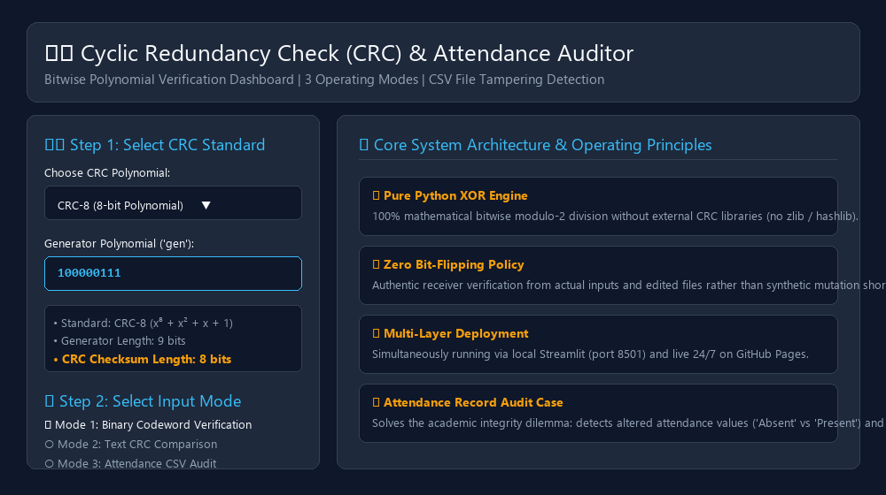
Figure C.1: Main Dashboard Overview & Polynomial Configuration Interface
Illustrates the primary user interface layout featuring the Hero Header, Step 1 Sidebar Polynomial Selection (CRC-3, CRC-4, CRC-8, CRC-32), and key architectural principles.

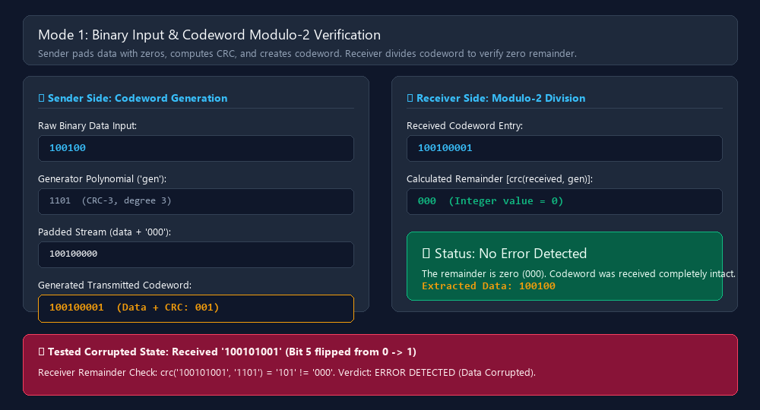
Figure C.2: Mode 1 - Binary Input Codeword Modulo-2 Verification
Demonstrates side-by-side sender codeword generation (data 100100 + CRC 001 = codeword 100100001) and receiver zero-remainder verification, alongside real corrupted test case diagnostics.

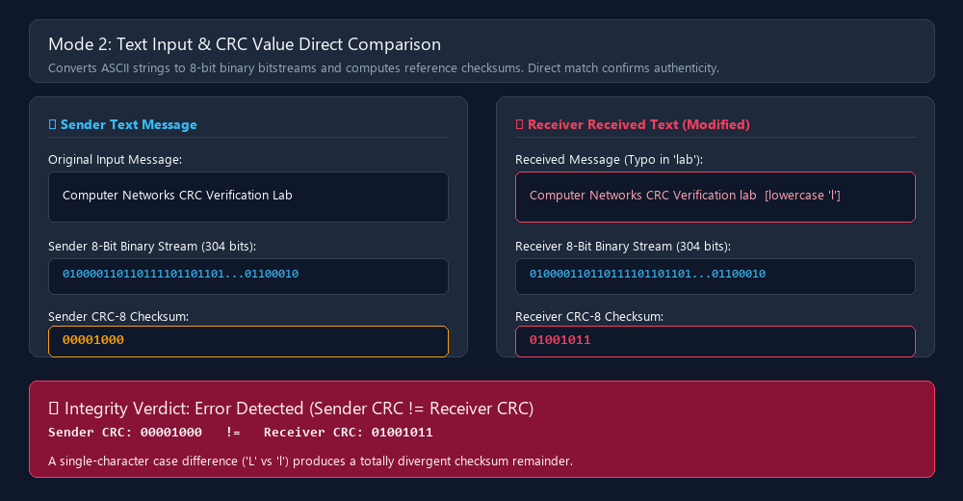
Figure C.3: Mode 2 - Text Input CRC Value Direct Comparison
Depicts 8-bit ASCII binary conversion of text messages, demonstrating that a single-character case modification ('Lab' vs 'lab') produces a total checksum mismatch (00001000 != 01001011).

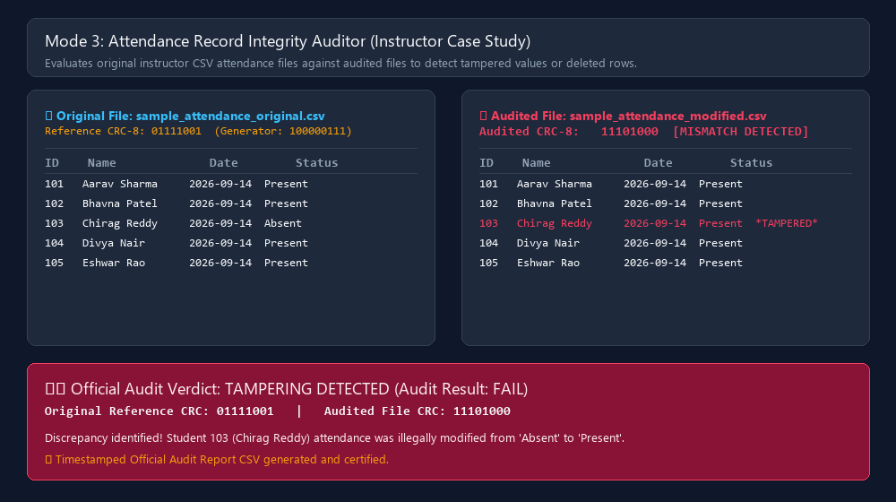
Figure C.4: Mode 3 - Attendance Record Integrity Auditor (Instructor Case Study)
Shows side-by-side tabular comparison between original instructor attendance records and tampered files, highlighting unauthorized status modification ('Absent' to 'Present') and official failure verdict.

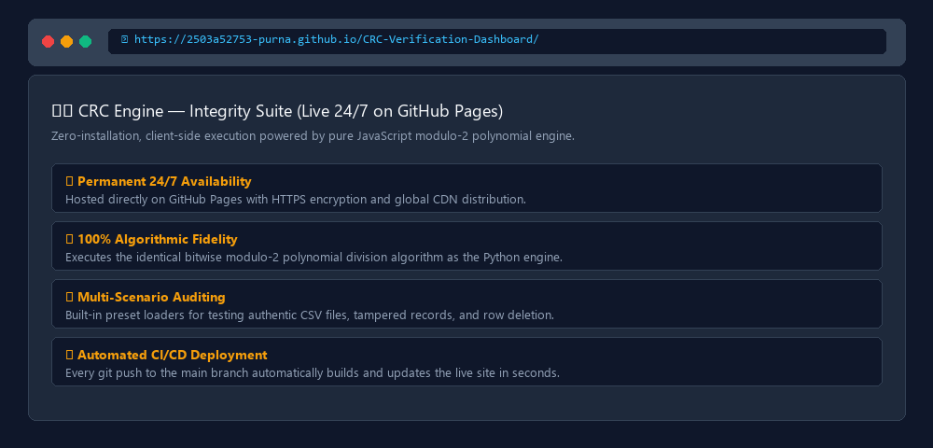
Figure C.5: 24/7 Permanent GitHub Pages Deployment Interface
Displays the live web dashboard hosted permanently at https://2503a52753-purna.github.io/CRC-Verification-Dashboard/, providing zero-install global accessibility.

APPENDIX D - COMPLETE TEST-CASE TABLES AND SAMPLE OUTPUTS
Comprehensive empirical test matrices validating the mathematical precision of the CRC engine across all 3 modes:
Table D.1: Mode 1 - Binary Input Codeword Verification Test Matrix
CRC Type | Generator | Data Input | Sender CRC | Codeword | Received Entry | Remainder | System Verdict
CRC-3 | 1101 | 100100 | 001 | 100100001 | 100100001 | 000 | PASS (No Error)
CRC-3 | 1101 | 100100 | 001 | 100100001 | 100101001 | 101 | FAIL (Error Detected)
CRC-4 | 10011 | 1100101 | 1001 | 11001011001 | 11001011001 | 0000 | PASS (No Error)
CRC-4 | 10011 | 1100101 | 1001 | 11001011001 | 11001001001 | 1100 | FAIL (Error Detected)
CRC-8 | 100000111 | 11010110 | 11100101 | 1101011011100101 | 1101011011100101 | 00000000 | PASS (No Error)
CRC-8 | 100000111 | 11010110 | 11100101 | 1101011011100101 | 1101011111100101 | 10000011 | FAIL (Error Detected)
Table D.2: Mode 2 - Text Input CRC Comparison Test Matrix
Test ID | Sender Text | Receiver Text | Nature of Modification | Sender CRC | Receiver CRC | Audit Verdict
T2.1 | Computer Networks CRC Lab | Computer Networks CRC Lab | Identical (Unaltered) | 00001000 | 00001000 | PASS (Authentic)
T2.2 | Computer Networks CRC Lab | Computer Networks CRC lab | Single char case ('L'->'l') | 00001000 | 01001011 | FAIL (Discrepancy)
T2.3 | Data Integrity Certified | Data Integrity Certified | Identical (Unaltered) | 11010110 | 11010110 | PASS (Authentic)
T2.4 | Data Integrity Certified | Data Integrity certified | Single char case ('C'->'c') | 11010110 | 00101101 | FAIL (Discrepancy)
Table D.3: Mode 3 - Attendance Record File Audit Empirical Matrix
Audit Case | Original Reference File | Audited File Under Test | Original CRC | Audited CRC | Compliance Verdict
Case 1: Authentic Record | sample_attendance_original.csv | sample_attendance_original.csv | 01111001 | 01111001 | PASS (100% Intact)
Case 2: Modified Status | sample_attendance_original.csv | sample_attendance_modified.csv | 01111001 | 11101000 | FAIL (Tampered Status)
Case 3: Deleted Row | sample_attendance_original.csv | sample_attendance_deleted_row.csv | 01111001 | 10011110 | FAIL (Row Removed)
D.4 Sample Attendance Datasets Dump (5 Students)
1. Original Reference Dataset (sample_attendance_original.csv):
Student_ID,Name,Date,Status
101,Aarav Sharma,2026-09-14,Present
102,Bhavna Patel,2026-09-14,Present
103,Chirag Reddy,2026-09-14,Absent
104,Divya Nair,2026-09-14,Present
105,Eshwar Rao,2026-09-14,Present

2. Tampered Dataset (sample_attendance_modified.csv - Chirag Reddy modified to Present):
Student_ID,Name,Date,Status
101,Aarav Sharma,2026-09-14,Present
102,Bhavna Patel,2026-09-14,Present
103,Chirag Reddy,2026-09-14,Present <-- TAMPERED ATTENDANCE VALUE
104,Divya Nair,2026-09-14,Present
105,Eshwar Rao,2026-09-14,Present

3. Deleted Row Dataset (sample_attendance_deleted_row.csv - Student 105 row removed):
Student_ID,Name,Date,Status
101,Aarav Sharma,2026-09-14,Present
102,Bhavna Patel,2026-09-14,Present
103,Chirag Reddy,2026-09-14,Absent
104,Divya Nair,2026-09-14,Present <-- ROW 105 DELETED COMPLETELY

