SE&SD LAB-ASSIGNMENT -2
Name : R.BHANU TEJA
HALL TICKET: 2503A52L22
BATCH : 16
USER diagram:

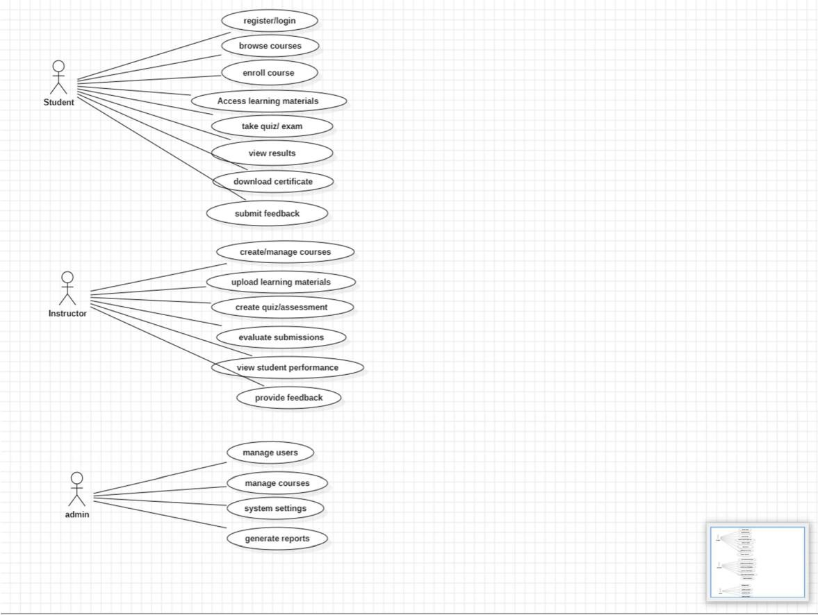

Class diagram:

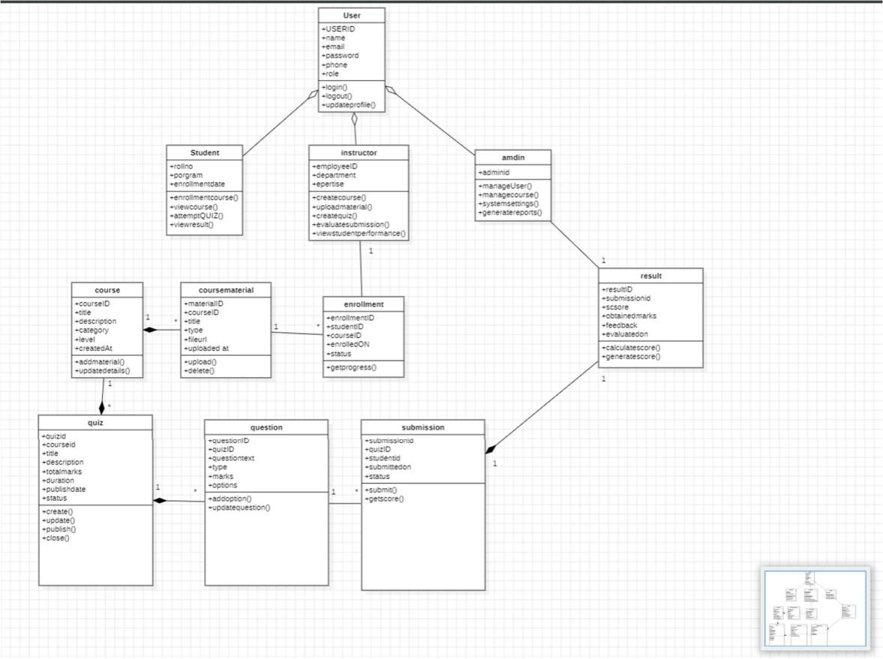

Activity Diagram:
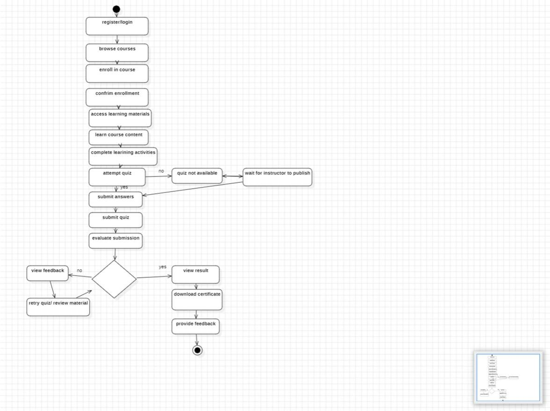
Sequence diagram:
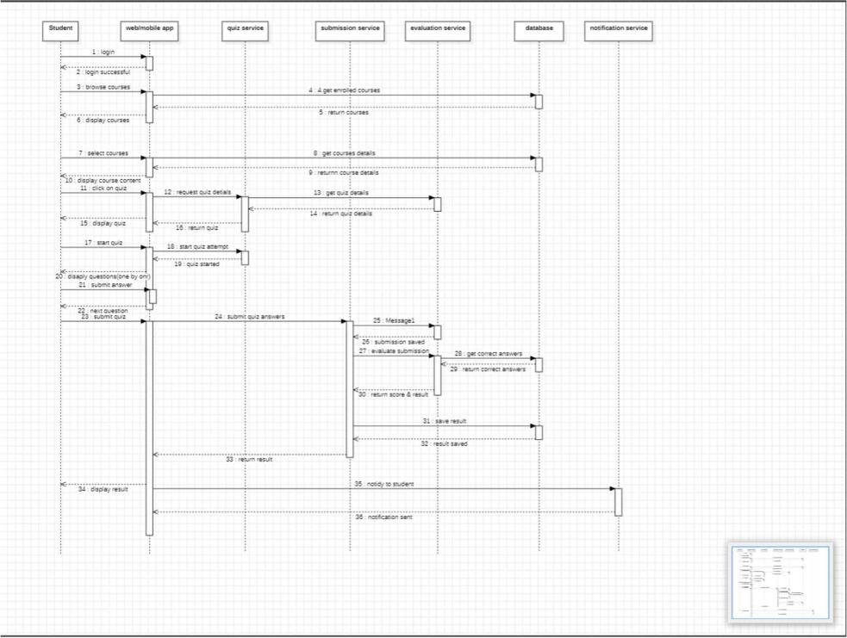

STATECHART DIAGRAM:



