Course Code: AIPP
Assignment No: 3
Done by: 2503B05203 (M.Tech)
Name: B Subhash Chandra

SCHOOL OF COMPUTER SCIENCE AND ARTIFICIAL INTELLIGENCE |  |  |  |  | DEPARTMENT OF COMPUTER SCIENCE ENGINEERING
Program Name: M. Tech/MCA |  |  |  | Assignment Type: Lab |  |  | AcademicYear:2025-2026
Course Coordinator Name |  |  |  | Venkataramana Veeramsetty
Course Code |  |  | 24CS002PC215 | Course Title |  | AI Assisted Problem Solving Using Python
Year/Sem |  |  | I/I | Regulation |  | R24
Date and Day  of Assignment |  |  | Week1 - Tuesday | Time(s)
Duration |  |  | 2 Hours | Applicable to  Batches |  | M. Tech/MCA
AssignmentNumber:03.3(Present assignment number)/24(Total number of assignments)
 | Q.No. | Question |  |  |  |  |  | ExpectedTime  to complete
 | 1 | Application for TGNPDCL  Objective: Build an application using Python program for TGNPDCL, to generate the bill based on energy consumption and type of customer with the help of AI tools.  Build a python application as per below instructions  - Read all the required data like PU,CU and Type of customer  - Calculate bill amount based on number of units consumed, type of customer and other charges  - Finally print the values of EC(Energy Charges),FC(Fixed Charges),CC(Customer Char-ges),ED(Electricity Duty Charges),bill as per expected output  Requirements:  - VS Code with Github Copilot and/or Google Colab with Gemini  - Students should bring power bill from their home  Deliverables:  - Print energy bill for given inputs and verify with bill taken by students |  |  |  |  |  | Week2 - Wednesday

Objective:
To develop a Python program that calculates the electricity bill for TGNPDCL customers
based on energy consumption and customer type using AI tools such as GitHub Copilot.

Problem Statement:
The program reads previous and current meter readings (PU, CU) and the type of customer.
It calculates energy charges (EC), fixed charges (FC), customer charges (CC), electricity
duty (ED), and displays the total bill amount similar to a real TGNPDCL power bill.
Code: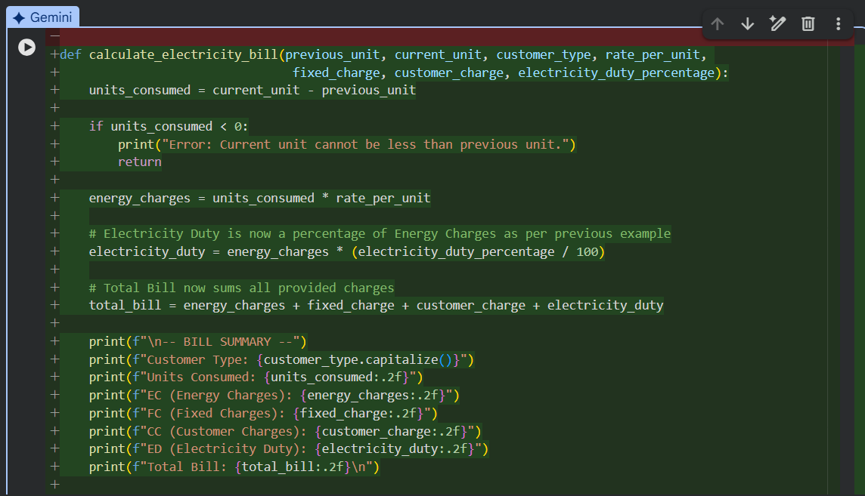 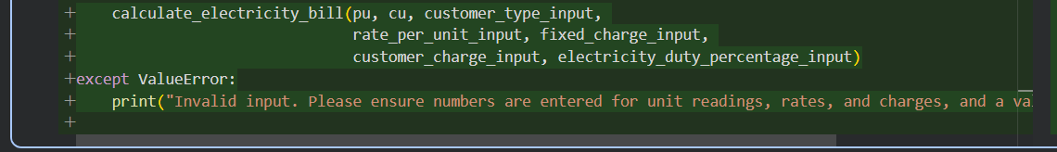

Code Explanation:
This Python code defines a function calculate_electricity-bill that computes an electricity bill based on several inputs, and then the main part of the script guides a user through providing those inputs to generate a bill.
Let's break down the code:
- calculate_electricity_bill Function Definition:
  - This function takes seven arguments: previous_unit, current_unit, customer_type, rate_per_unit, fixed_charge, customer_charge, and electricity_duty_percentage.
  - It first calculates units_consumed by subtracting previous_unit from current_unit.
  - There's an error check: if units_consumed is negative, it prints an error message and stops.
  - energy_charges are calculated by multiplying units_consumed by the rate_per_unit.
  - electricity_duty is calculated as a percentage of energy_charges, using the electricity_duty_percentage provided.
  - The total_bill is the sum of energy_charges, fixed_charge, customer_charge, and electricity_duty.
  - Finally, it prints a formatted "BILL SUMMARY" displaying all these calculated values, along with the customer_type and units_consumed.
- Main Application Block (--- Application Start ---):
  - It starts by printing a welcome message: "Welcome to the TGNPDCL Bill Generator!".
  - It uses a try-except ValueError block to handle potential issues with user input (e.g., entering text when a number is expected).
  - Inside the try block, it prompts the user to enter:
    - Previous Unit Reading (PU)
    - Current Unit Reading (CU)
    - Type of Customer (Domestic/Commercial)
    - Rate per Unit
    - Fixed Charge
    - Customer Charge
    - Electricity Duty (as a percentage)
  - All these inputs are then passed as arguments to the calculate_electricity_bill function to compute and display the bill.
  - If any input causes a ValueError (e.g., non-numeric input for a number field), the except block catches it and prints an "Invalid input" error message.

Code Output:

