Course Code: AIPP
Assignment No: 9
Done by: 2503B05203 (M.Tech)
Name: B Subhash Chandra

SCHOOL OF COMPUTER SCIENCE AND ARTIFICIAL INTELLIGENCE |  |  |  |  | DEPARTMENT OF COMPUTER SCIENCE ENGINEERING
ProgramName:M. Tech |  |  |  | Assignment Type: Lab |  |  | AcademicYear:2025-2026
CourseCoordinatorName |  |  |  | Venkataramana Veeramsetty
rCourseCode |  |  | 24CS002PC215 | CourseTitle |  | AI Assisted Problem Solving Using Python
Year/Sem |  |  | II/I | Regulation |  | R24
Date and Day  of Assignment |  |  | 10.11.2025 | Time(s)
Duration |  |  | 2 Hours | Applicableto  Batches
AssignmentNumber:9.3(Present assignment number)/24(Total number of assignments)
 | Q.No. | Question |  |  |  |  |  | ExpectedTime  to complete
 | 1 | Lab 9: Documentation Generation: Automatic documentation and code comments  Lab Objectives:  - To understand the importance of documentation and code comments in software development.  - To explore how AI-assisted coding tools can generate meaningful documentation and inline comments.  - To practice generating function-level and module-level docstrings automatically.  - To evaluate the quality, accuracy, and limitations of AI-generated documentation.  - To develop a small automated tool for documentation generation in Python..  Lab Outcomes (LOs):  After completing this lab, students will be able to:  - Apply AI-assisted coding tools to generate docstrings and inline comments for Python code.  - Critically analyze AI-generated documentation for correctness, completeness, and readability.  - Create structured documentation (function-level, module-level) following standard formats.  - Design and implement a mini documentation generator tool to automate code commenting and docstring creation.  Task Description#1 Basic Docstring Generation  - Write python function to return sum of even and odd numbers in the given list.  - Incorporate manual docstring in code with Google Style  - Use an AI-assisted tool (e.g., Copilot, Cursor AI) to generate a docstring describing the function.  - Compare the AI-generated docstring with your manually written one.  Prompt:  - I already wrote my own docstrings and comments. Don’t change them. Just create a new set of AI-generated docstrings and comments along with function separately for comparison in the same file.  Process:  - To generate Docstrings right-click -> generate -> generate Docs  Manual Code and Docstrings:  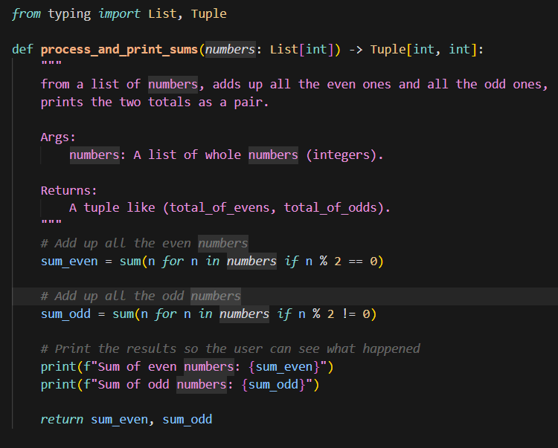  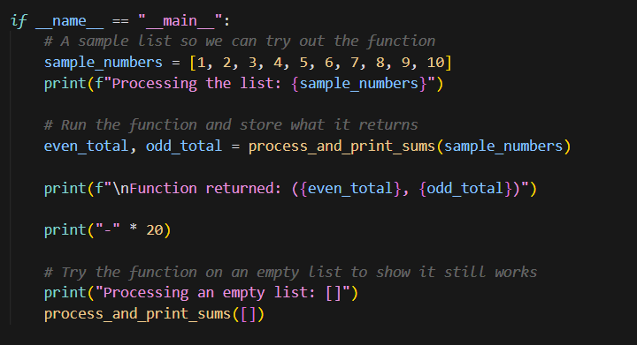  AI Generated DocString:  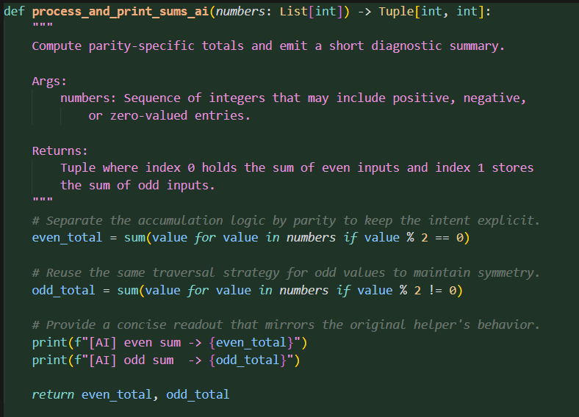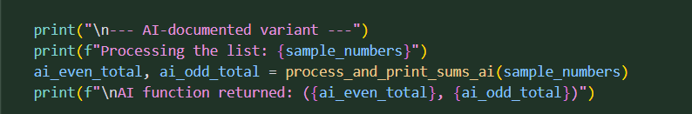  Expected Outcome#1: Students understand how AI can produce function-level documentation.  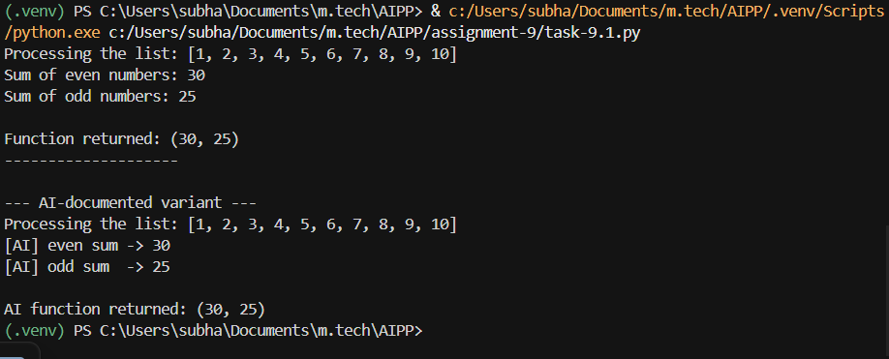  Comparison:  - The manual docstring shows a casual, beginner-friendly style with minimal technical terms.  - The AI-generated docstring uses more formal and precise language with clearer structure.  - The manual version focuses mainly on the basic function behavior, while the AI version adds contextual details.  - The AI docstring demonstrates more technical vocabulary and justification of the implementation.  - Overall, the manual docstring is suited for introductory learning, whereas the AI version is better for detailed technical documentation.  Conclusion:  - AI generates docstrings automatically based on code which is better then manual  Task Description#2 Automatic Inline Comments  - Write python program for sru_student class with attributes like name, roll no., hostel_status and fee_update method and display_details method.  - Write comments manually for each line/code block  - Ask an AI tool to add inline comments explaining each line/step.  - Compare the AI-generated comments with your manually written one.  Prompt:  - I already wrote my own docstrings and comments. Don’t change them. Just create a new set of AI-generated inline comments along with function separately for comparison in the same file.  Process:  - To generate Docstrings right-click -> generate -> generate Docs  - To generate comment enter prompt: write comments for the code where it is required  Manual Code:  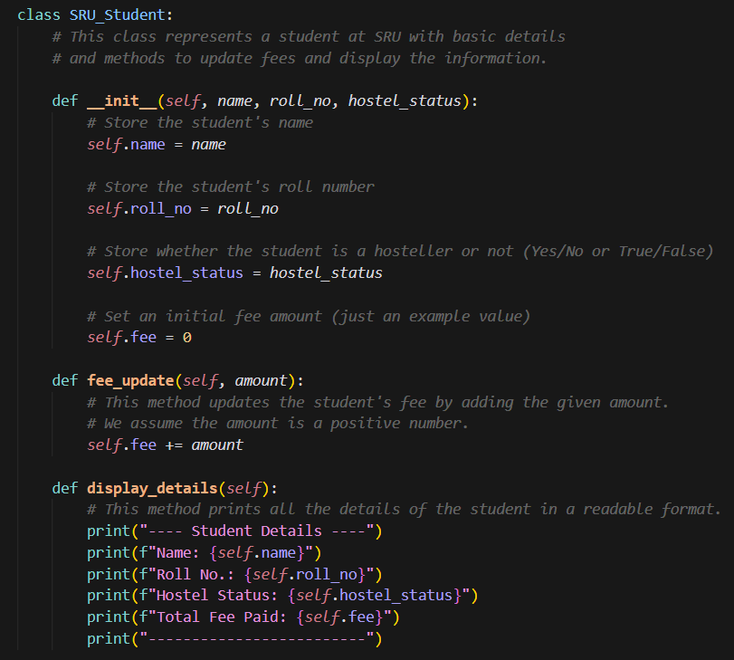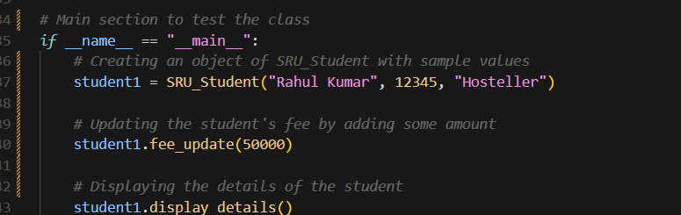  AI Generated Comments:  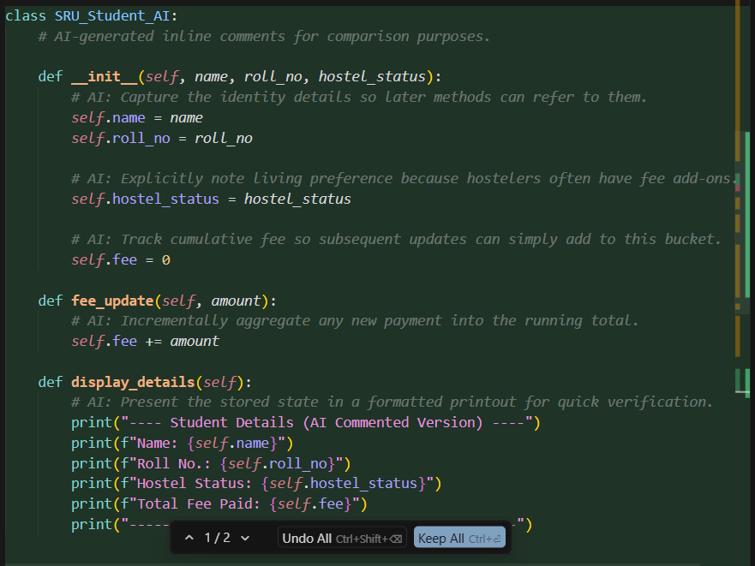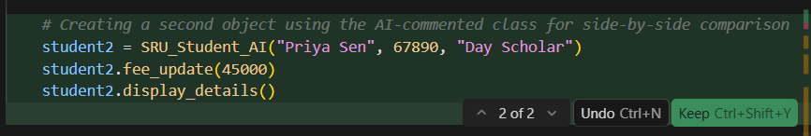  Expected Output#2: Students critically analyze AI-generated code comments.  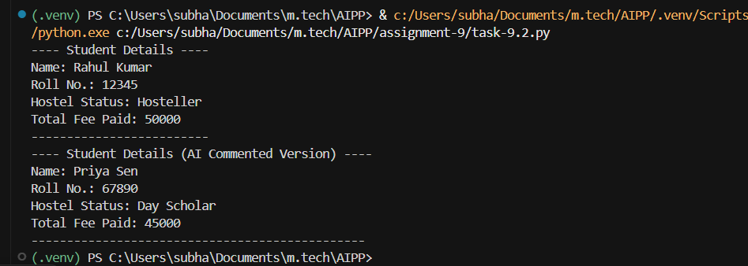  Comparison:  - The manual comments are straightforward and beginner-friendly, focusing mainly on what each line or block of code does. They describe actions in simple terms such as storing values, updating fees, or printing details, making them easy for new learners to understand.  - In contrast, the AI-generated comments take a more technical and descriptive approach. Instead of only explaining what the code does, the AI comments also highlight the purpose and reasoning behind certain operations—for example, mentioning cumulative fee tracking or the relevance of hostel status. This makes the AI version more detailed and context-aware, but also slightly more advanced in tone.  Conclusion:  - The manual comments are ideal for basic understanding, while the AI comments provide deeper insight into the intent and design of the code. AI style is better for better technical explanation.  Task Description#3  - Write a Python script with 3–4 functions (e.g., calculator: add, subtract, multiply, divide).  - Incorporate manual docstring in code with NumPy Style  - Use AI assistance to generate a module-level docstring + individual function docstrings.  - Compare the AI-generated docstring with your manually written one.  Prompt:  - Write a Python script with 3-4 functions for a simple calculator. The functions should include:  - add(a, b): Returns the sum of a and b.  - subtract(a, b): Returns the difference between a and b.  - multiply(a, b): Returns the product of a and b.  - divide(a, b): Returns the quotient of a and b (ensure to handle division by zero).  - Incorporate manual docstrings in the code using the NumPy style. Use AI assistance to generate the module-level docstring and individual function docstrings to clearly explain the purpose and usage of the functions.  Manual Code with Docstrings:  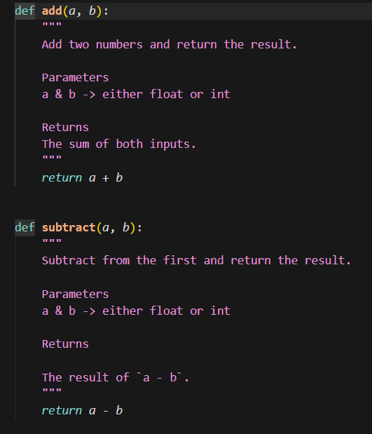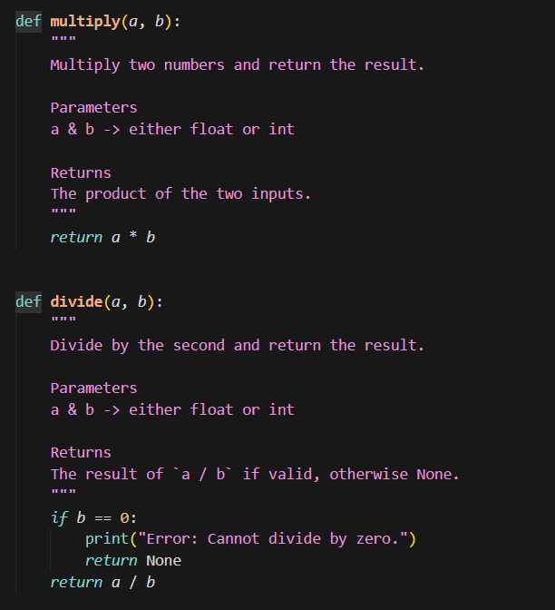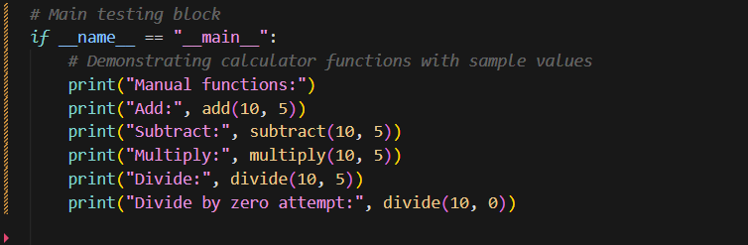  AI-generated Code and Docstrings:  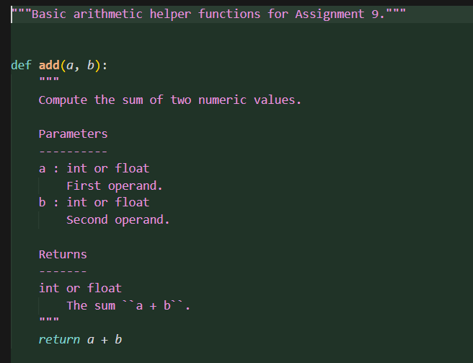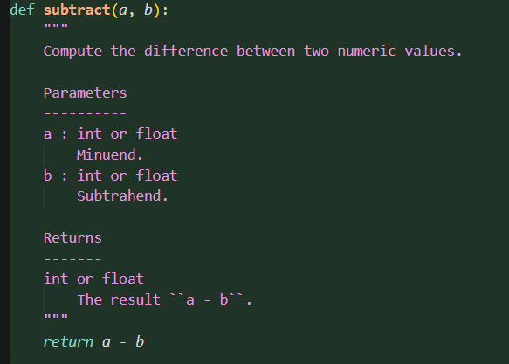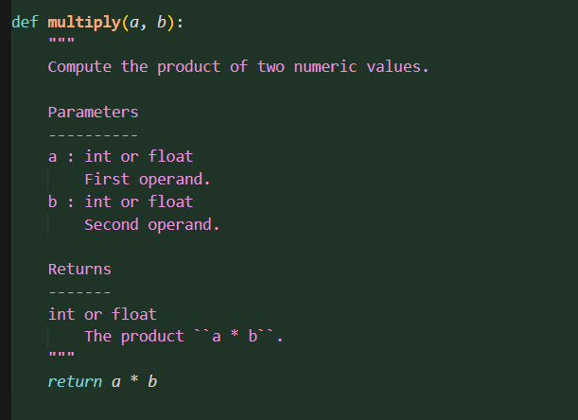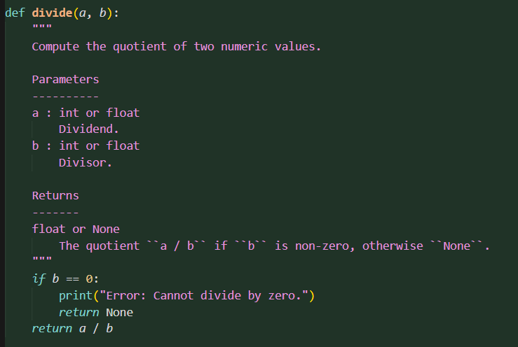  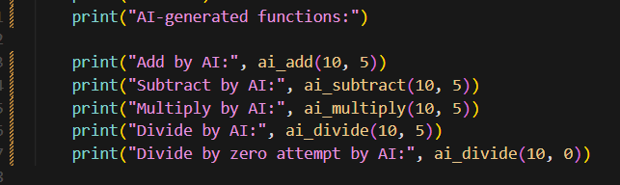  Expected Output#3: Students learn structured documentation for multi-function scripts  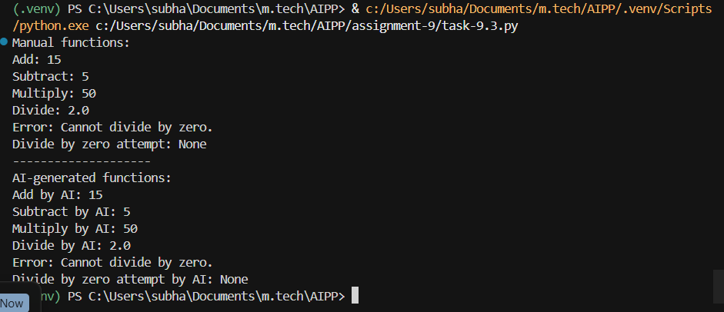  comparison:  - The manual docstrings are simple and easy to understand.  - They explain what each function does, the parameters, and the return values in plain language. This style is good for beginners because it is clear and short.  - The AI-generated docstrings use the NumPy style, which is more structured. They clearly show the parameters, their types, and the return values in a formal format.  - This makes the functions easier to understand for other programmers and useful for professional code.  .  Lab conclusion:  - Docstrings: Provide structured documentation for functions, classes, and modules, explaining purpose, parameters, and return values. Accessible via help() and aid in auto documentation generation.  - Comments: Explain specific lines or sections of code, offering context or clarifying logic. Help developers understand the reasoning behind the code.  - AI can generate docstrings and comments by analyzing code and automatically creating clear descriptions of functions, parameters, and logic, improving code readability and documentation efficiency.  Push documentation whole workspace as .md file in GitHub Repository  Note: Report should be submitted a word document for all tasks in a single document with prompts, comments & code explanation, and output and if required, screenshots |  |  |  |  |  | Week4 - Wednesday

