Course Code: AIPP
Assignment No: 17
Done by: 2503B05203 (M.Tech)
Name: B Subhash Chandra

SCHOOLOFCOMPUTER SCIENCE AND ARTIFICIAL INTELLIGENCE |  |  |  |  | DEPARTMENTOFCOMPUTER SCIENCE ENGINEERING
ProgramName:M. Tech/MSC/MCA |  |  |  | AssignmentType: Lab |  |  | AcademicYear:2025-2026
CourseCoordinatorName |  |  |  | Venkataramana Veeramsetty
CourseCode |  |  |  | CourseTitle |  | AI Assisted Coding
Year/Sem |  |  | I/I | Regulation |  | R25
DateandDay  of Assignment |  |  |  | Time(s)
Duration |  |  | 2 Hours | Applicableto  Batches
AssignmentNumber:17.3(Presentassignmentnumber)/24(Totalnumberofassignments)
 | Q.No. | Question |  |  |  |  |  | ExpectedTime  to complete
 | 1 | Lab 17 – AI for Data Processing: Data Cleaning and Preprocessing Scripts  Lab Objectives:  - Learn how to clean raw datasets using AI-assisted Python scripting.  - Apply preprocessing techniques such as handling missing values, encoding categorical data, and normalization.  - Automate repetitive data-cleaning tasks with AI-generated code.  - Understand how preprocessing impacts model performance.  Task 1 – Social Media Data Cleaning  Task: Clean raw social media posts dataset.  Instructions:  - Remove stopwords, punctuation, and special symbols from post text.  - Handle missing values in likes and shares columns.  - Convert timestamp to datetime and extract features (hour, weekday).  - Detect and remove spam/duplicate posts.  Expected Output: A cleaned dataset with structured features for sentiment/engagement analysis.  "Load the dataset from the file path  C:\Users\subha\Documents\m.tech\AIPP\assignment-17/movie_reviews-1.csv.  Clean the raw movie reviews data by performing the following steps:  – Remove stopwords, punctuation, and special symbols from the review text.  – Handle missing values in all numerical columns (e.g., rating, likes, shares).  – Convert any date or timestamp column to datetime format and extract features such as hour and weekday if applicable.  – Detect and remove spam or duplicate reviews.  After cleaning, return the processed dataset and display the first few rows."  Load and inspect the original data  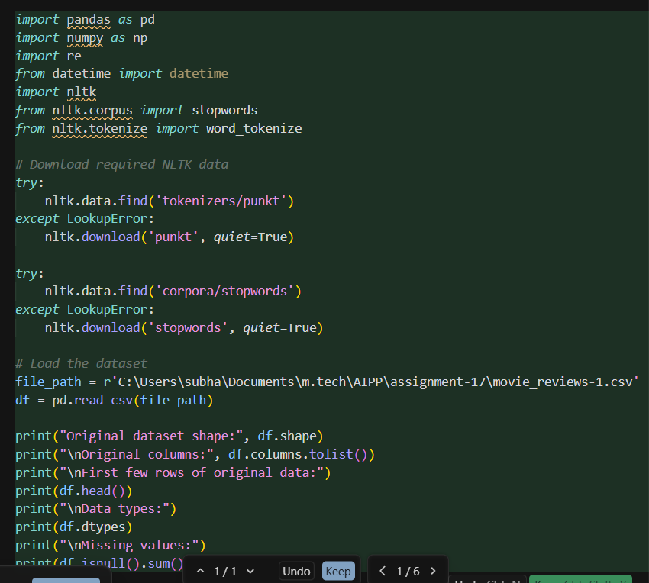  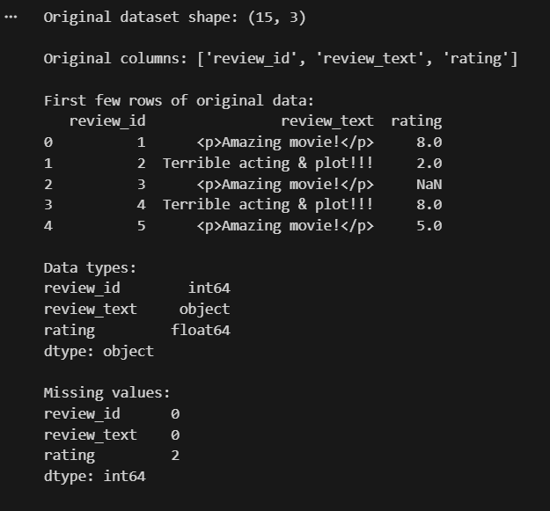  Clean the review text  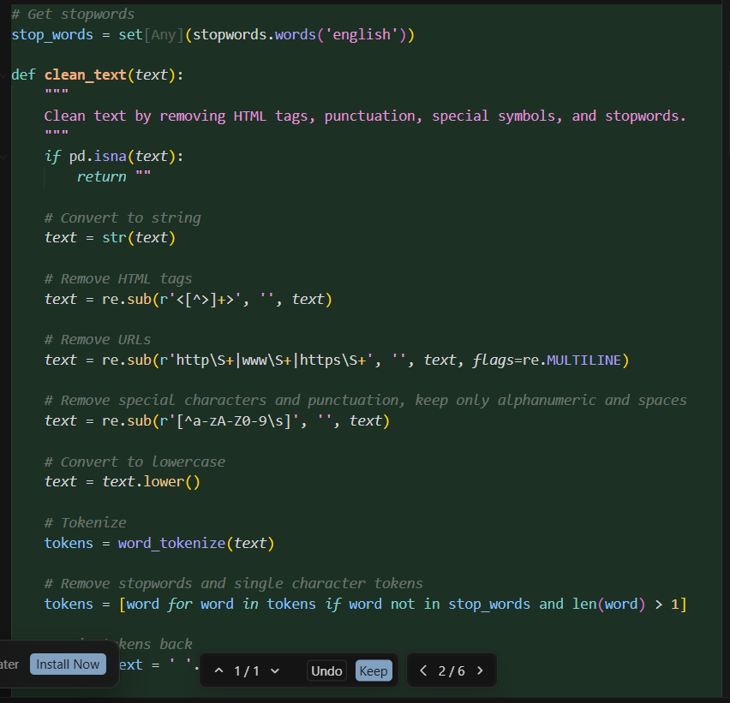  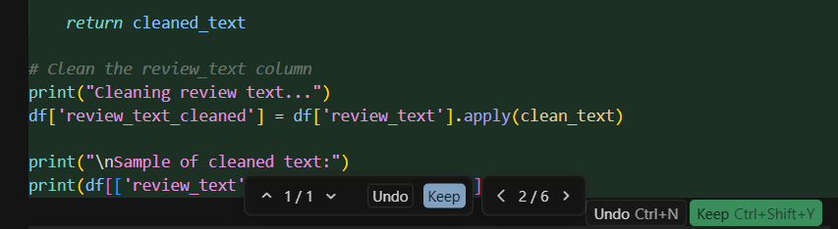  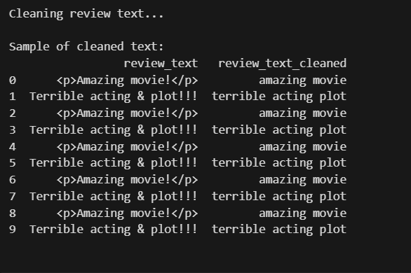  Handle missing values in numerical columns  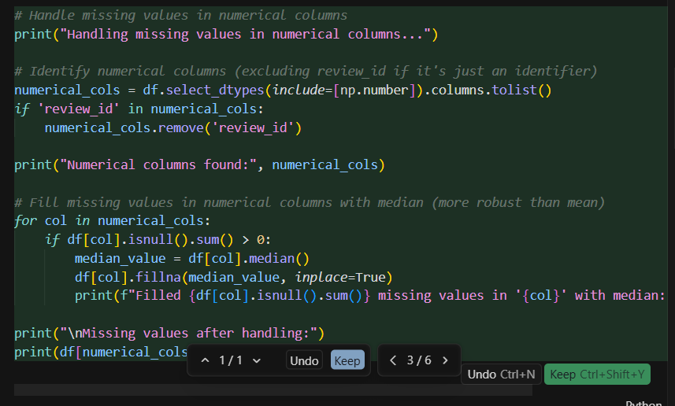  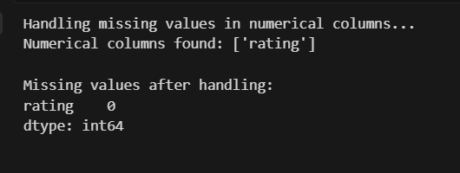  Process date/timestamp columns  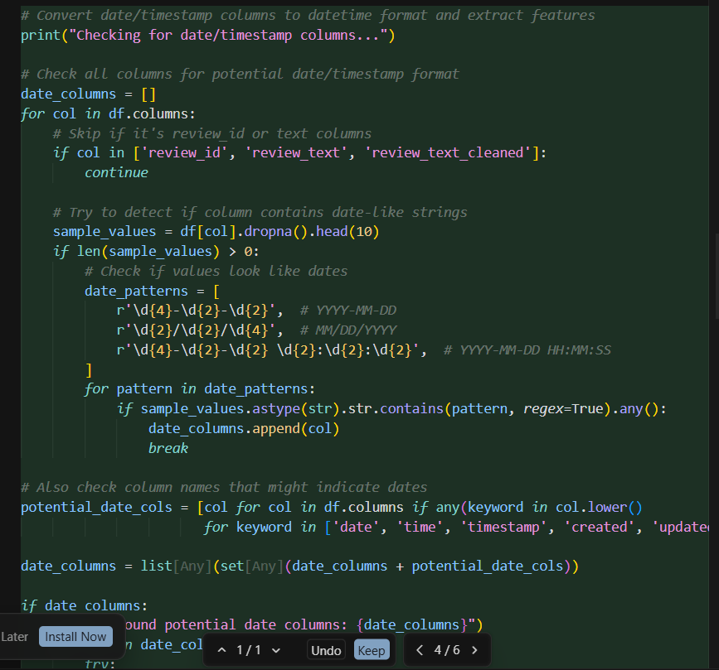  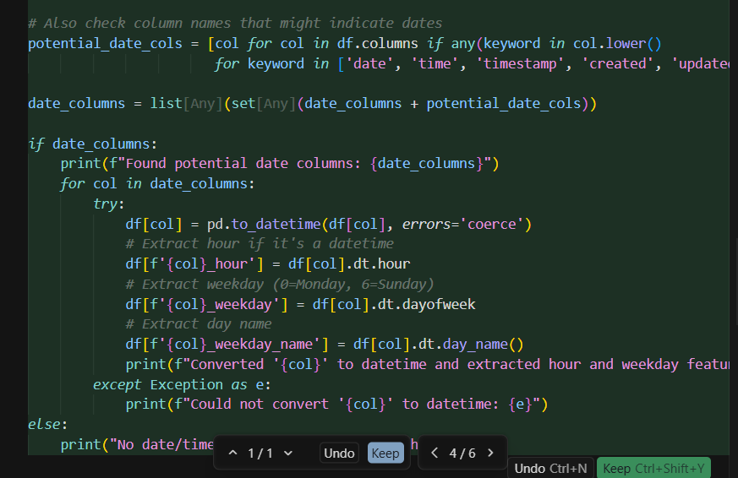  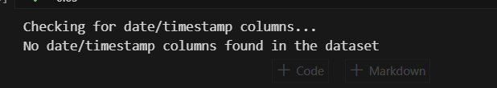  Detect and remove duplicates and spam  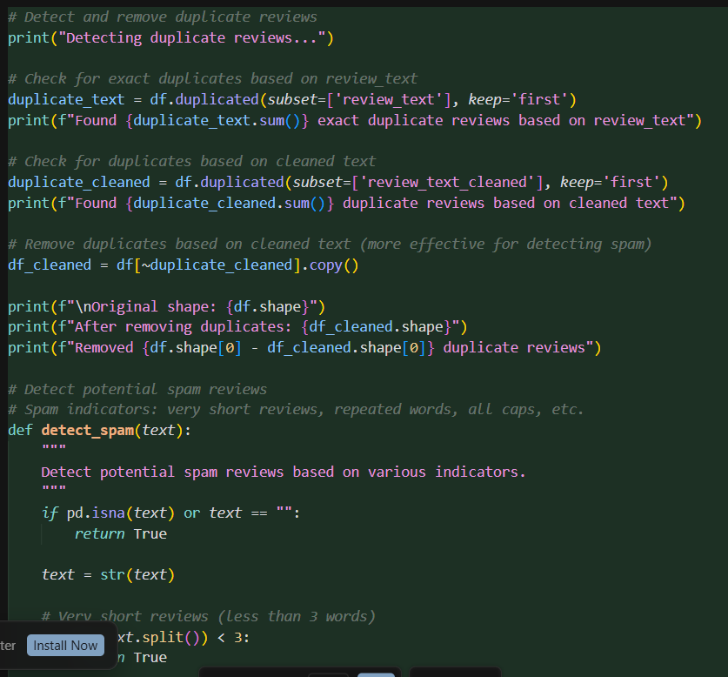  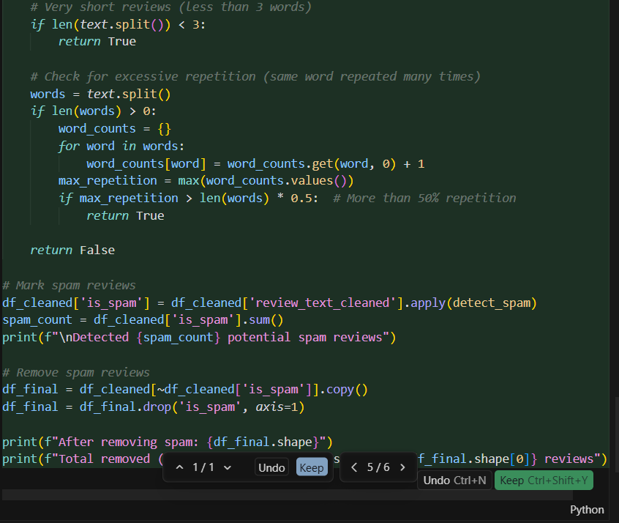  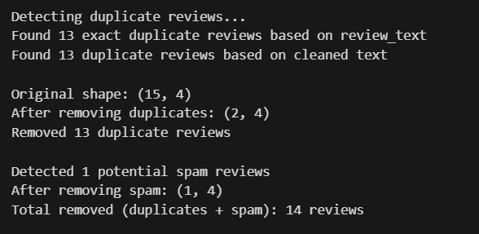  Display the final processed dataset  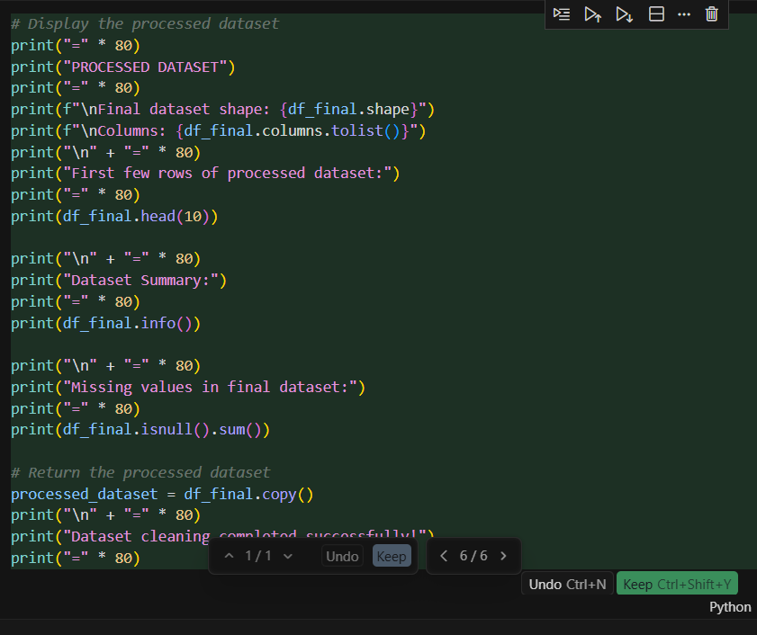  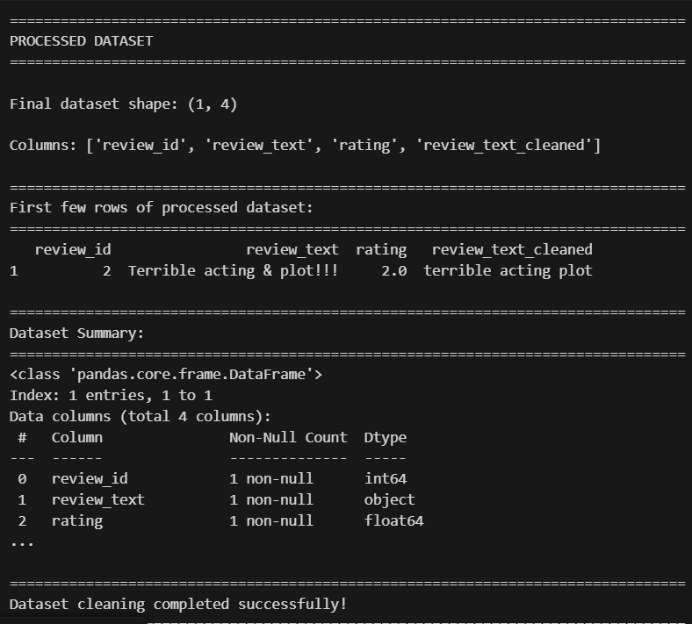  Task 2 – Financial Data Preprocessing  Task: Preprocess a stock market dataset.  Instructions:  - Handle missing values in closing_price and volume.  - Create lag features (1-day, 7-day returns).  - Normalize volume column using log-scaling.  - Detect outliers in closing_price using IQR method.  Expected Output: A time-series dataset ready for forecasting models.  "Preprocess a stock market dataset with the following steps:  – Handle missing values in closing_price and volume (impute or fill).  – Create lag features: 1-day return and 7-day return.  – Normalize the volume column using log-scaling.  – Detect and flag/remove outliers in closing_price using the IQR method.  Produce a cleaned, feature-enhanced time-series dataset ready for forecasting models."  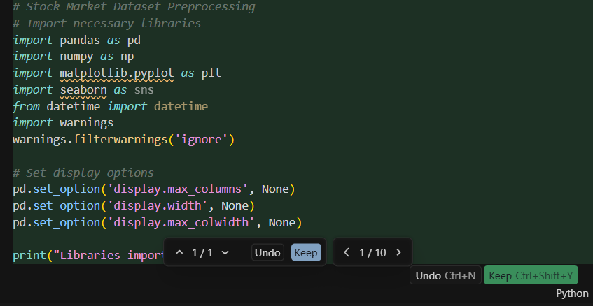  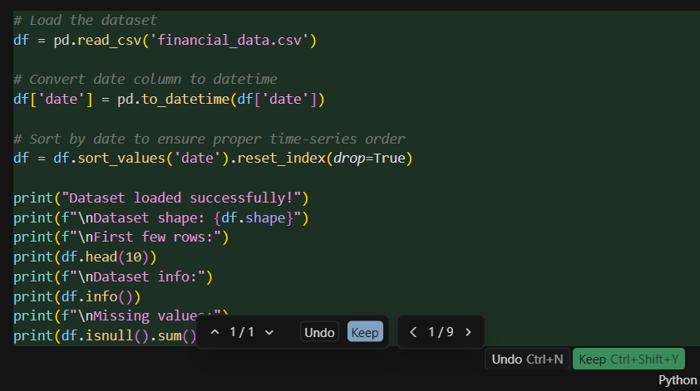  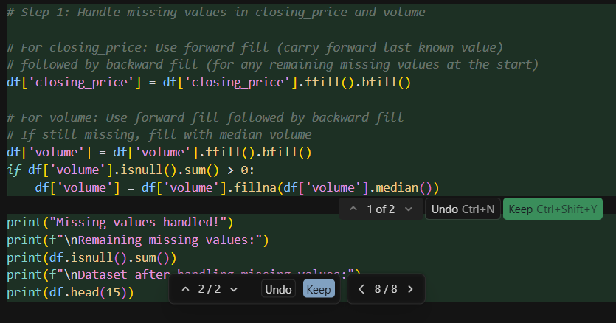  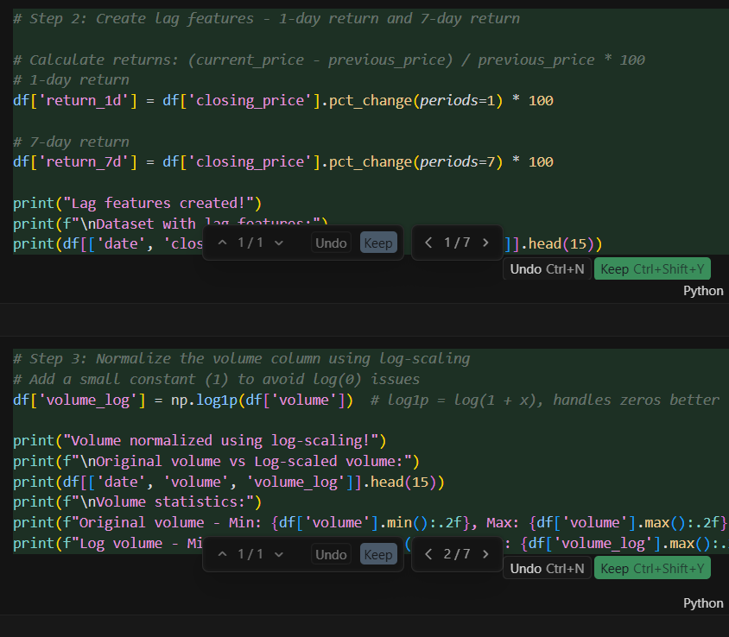  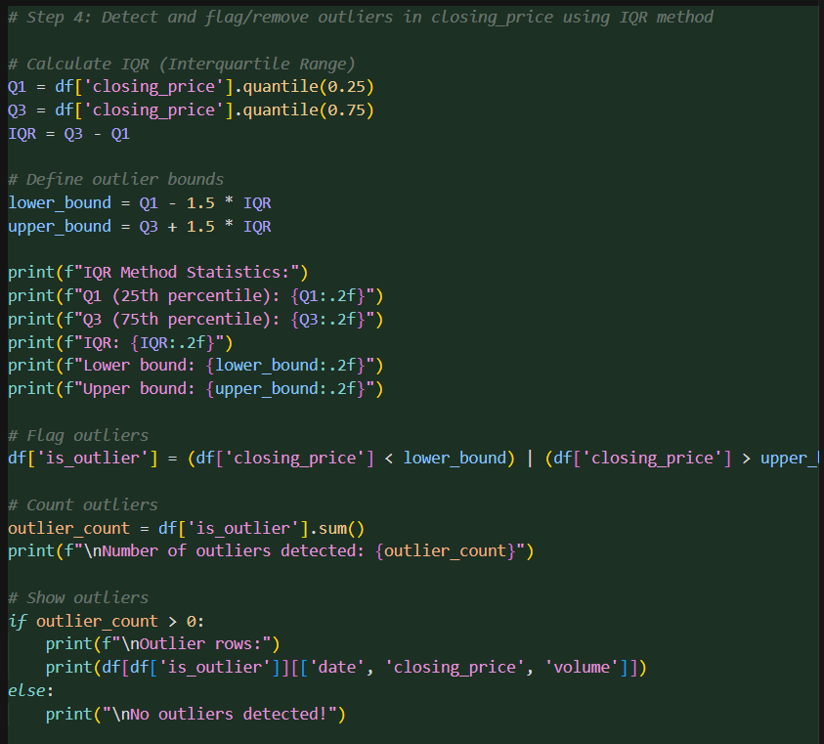  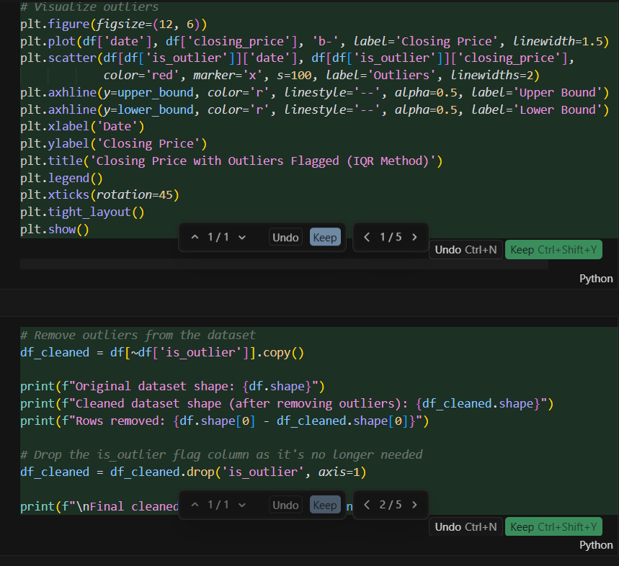  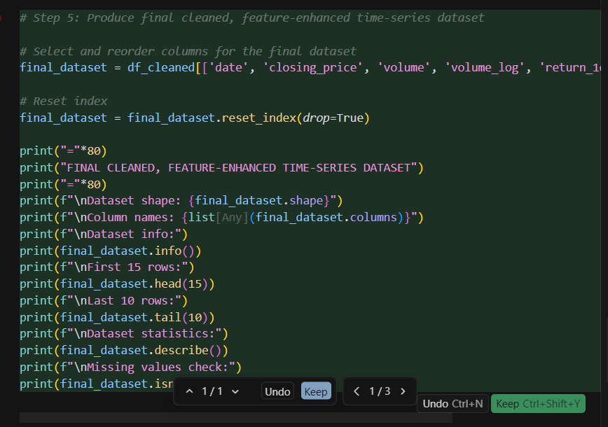  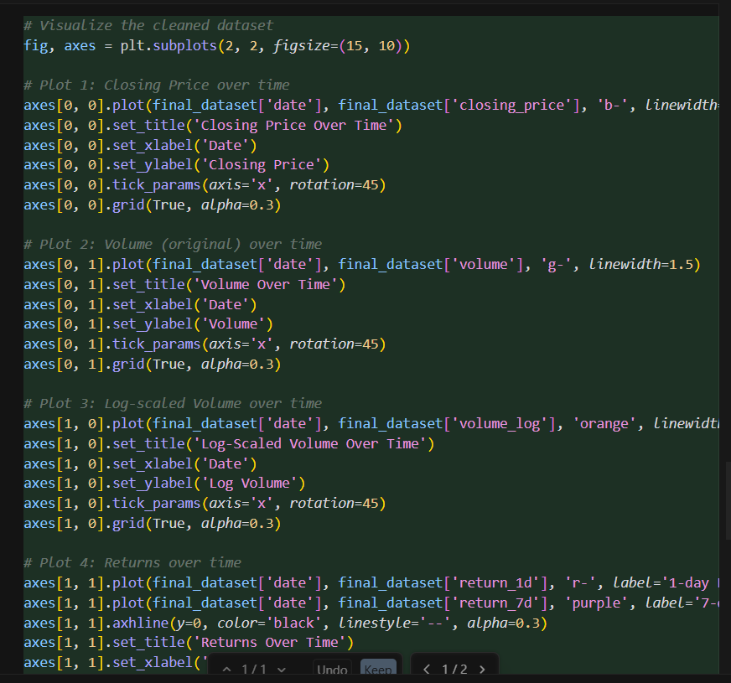  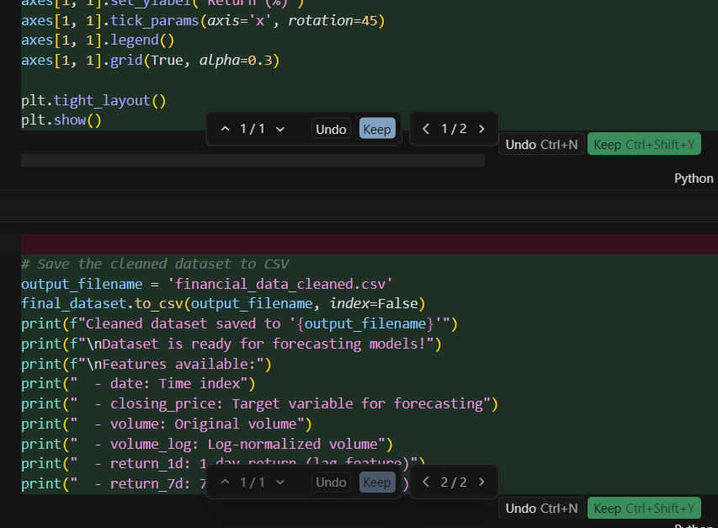  Task 3 – IoT Sensor Data Preparation  Task: Clean and preprocess IoT temperature and humidity logs.  Instructions:  - Handle missing values using forward fill.  - Remove sensor drift (apply rolling mean).  - Normalize readings using standard scaling.  - Encode categorical sensor IDs.  Expected Output: A structured dataset optimized for anomaly detection.  Prompt:  "Clean and preprocess an IoT temperature and humidity logs dataset with the following steps:  – Handle missing values using forward fill.  – Remove sensor drift by applying a rolling mean smoothing technique.  – Normalize temperature and humidity readings using standard scaling.  – Encode categorical sensor IDs.  Return a structured dataset optimized for anomaly detection  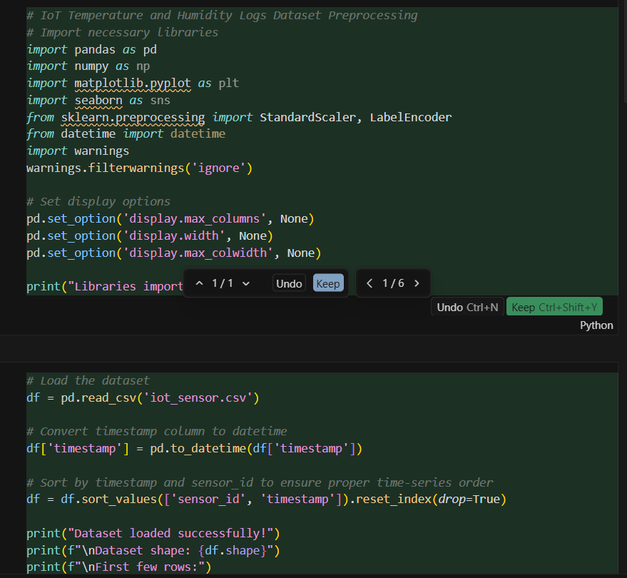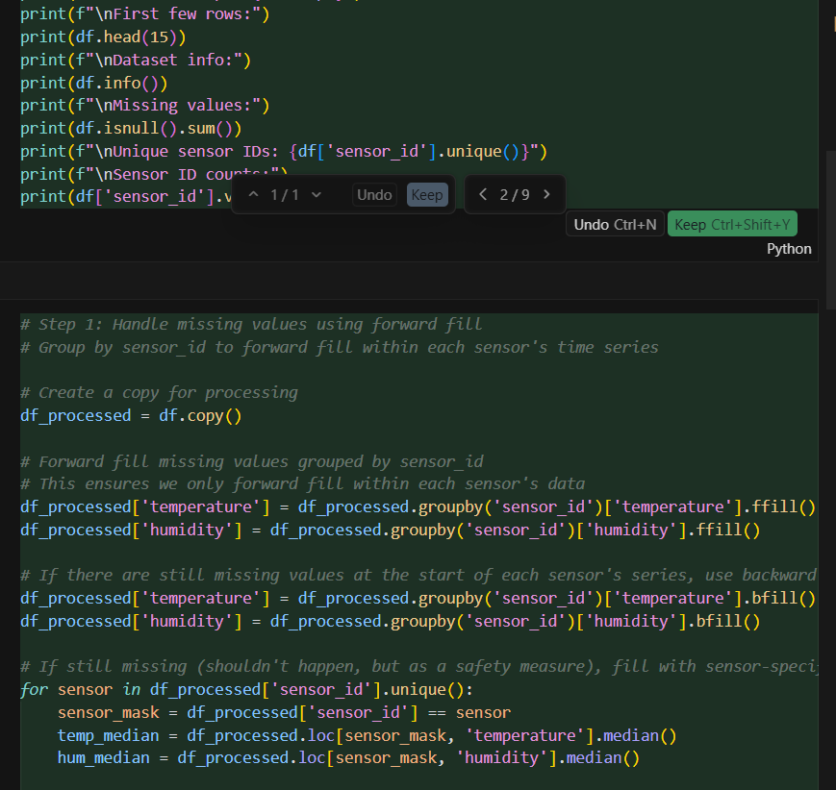  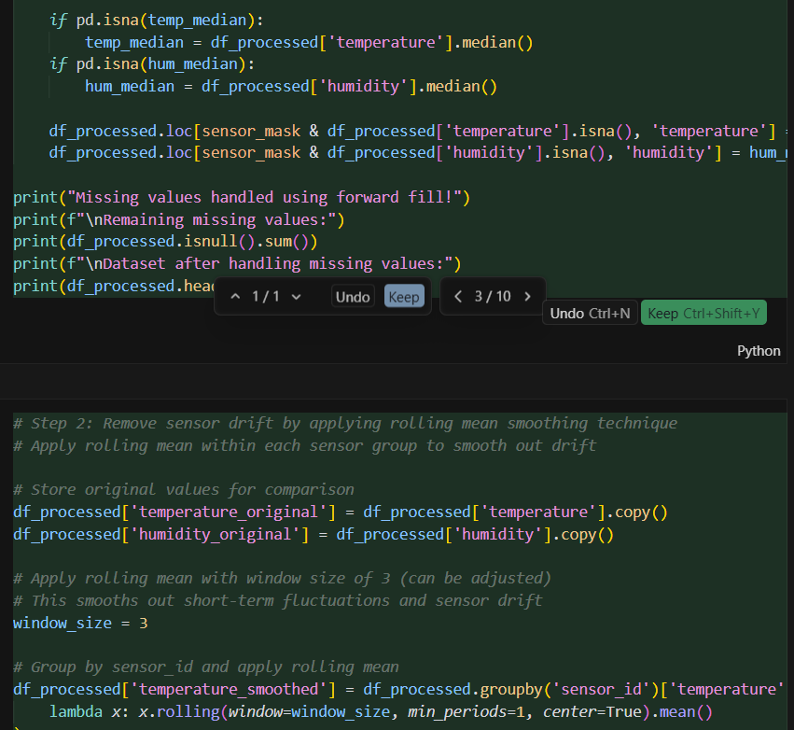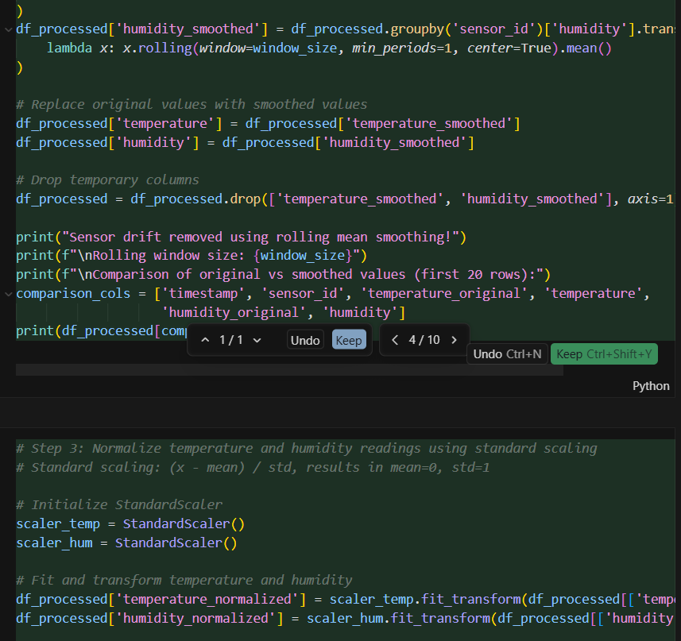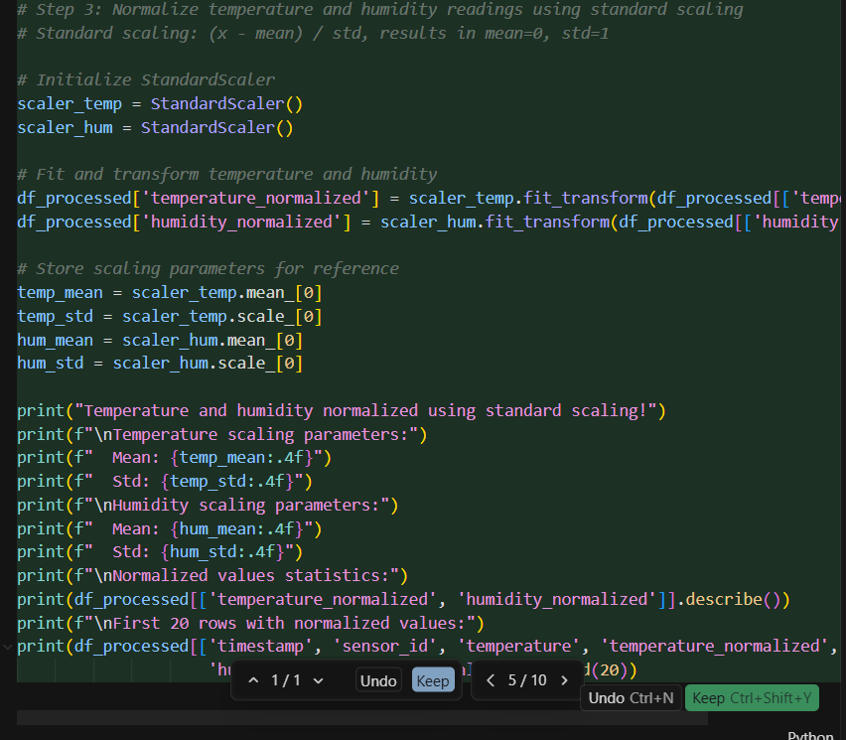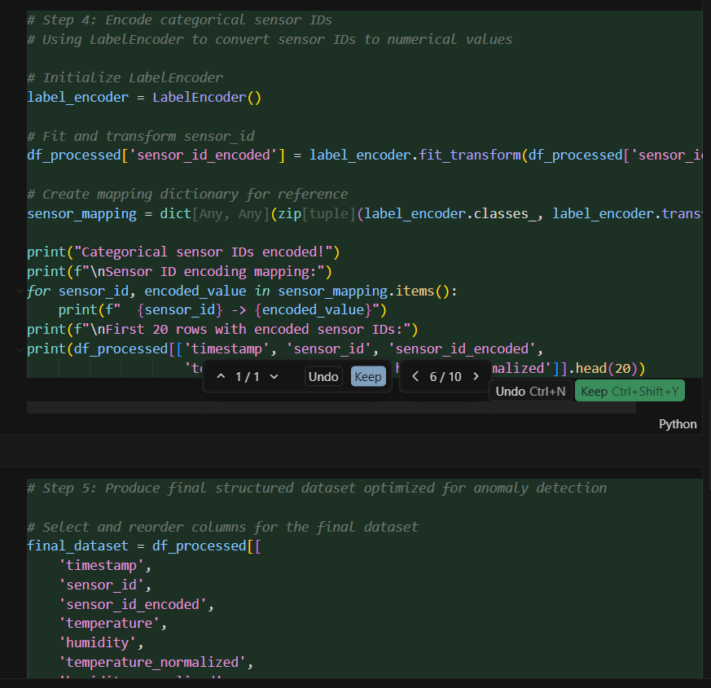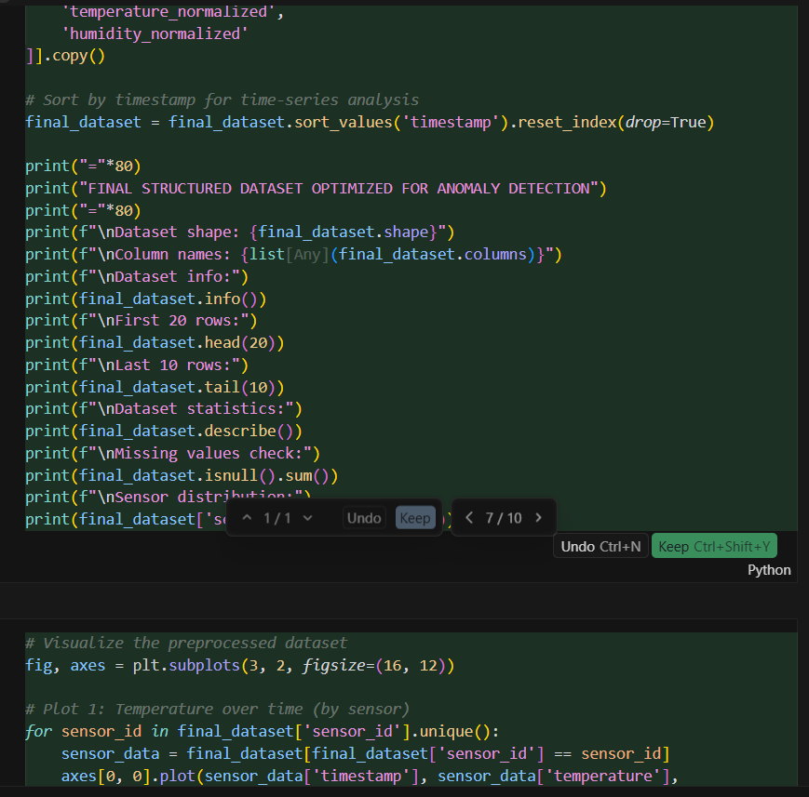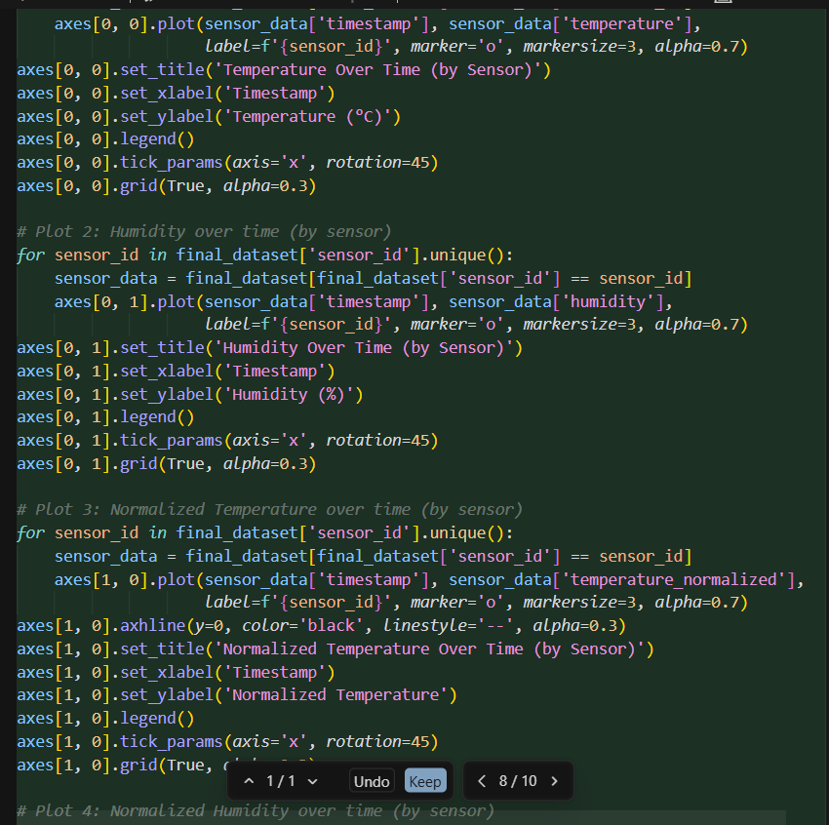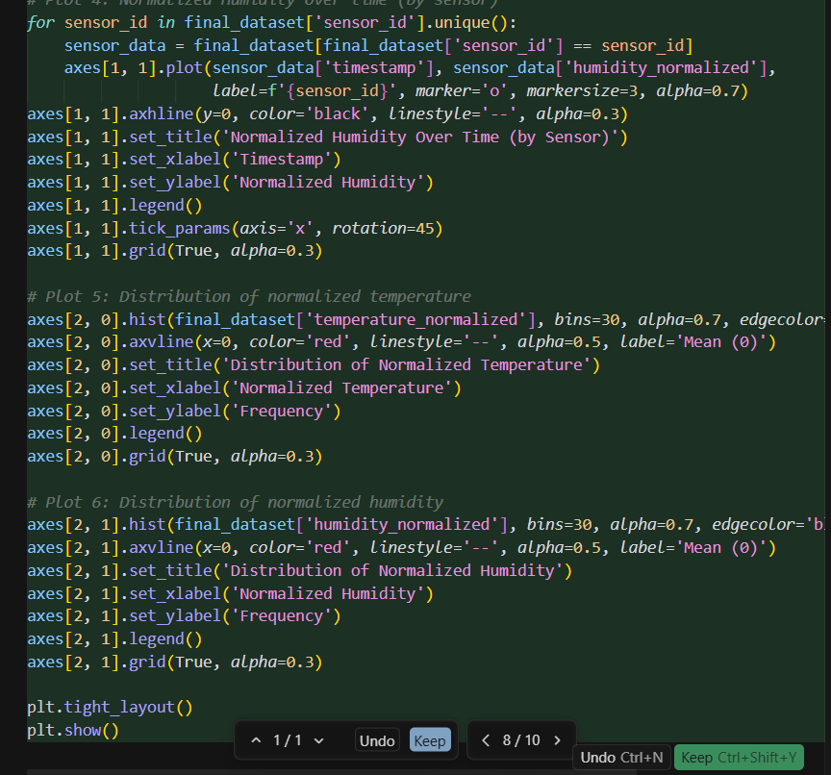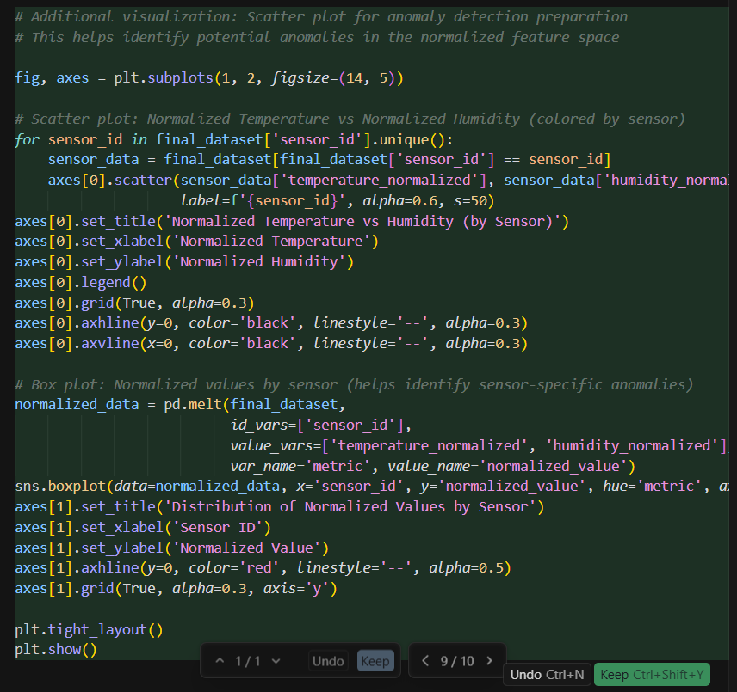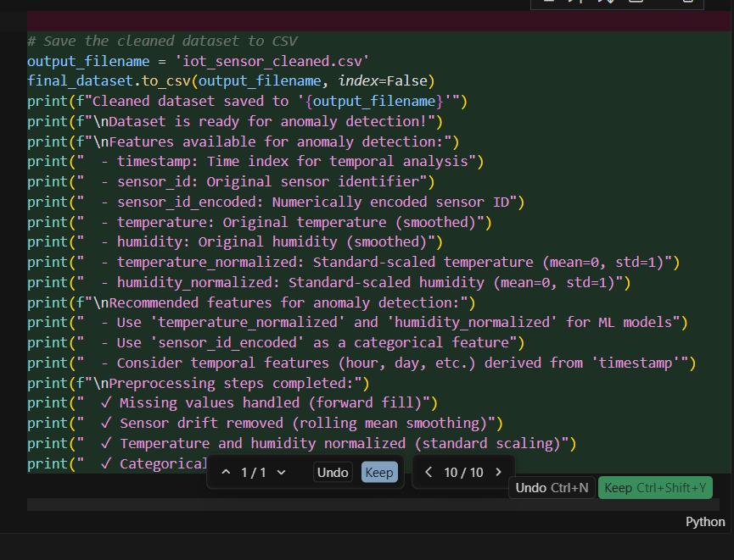  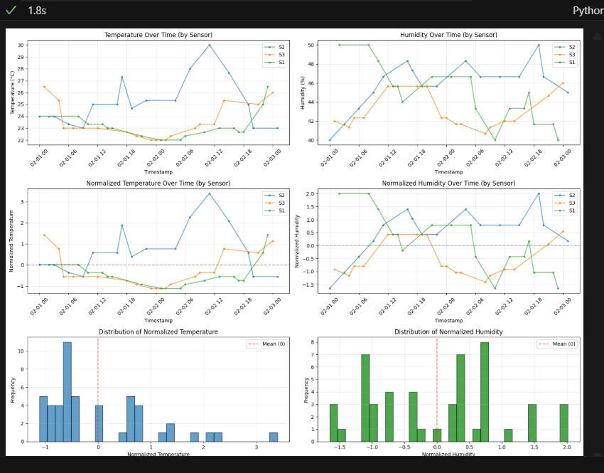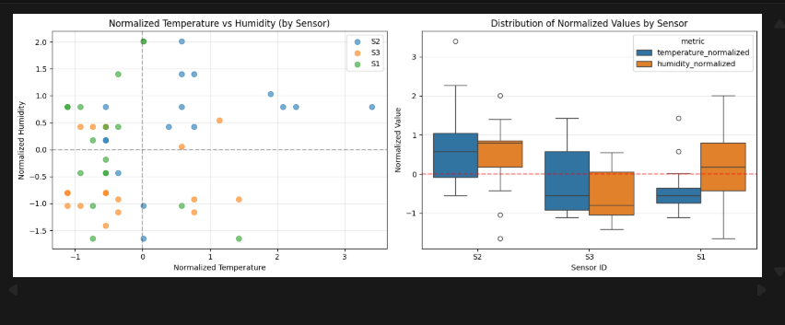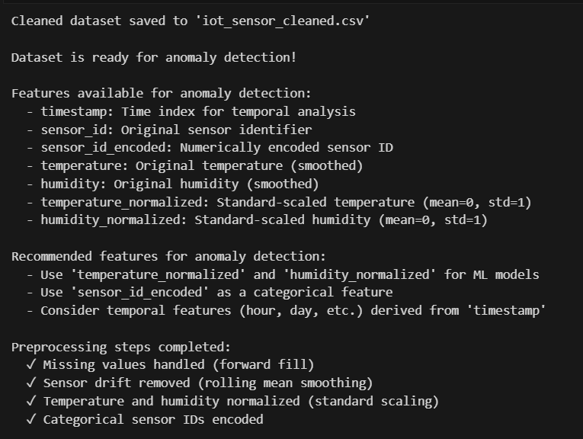  Task 4 – Real-Time Application: Movie Reviews Data Cleaning  Task: A streaming platform wants to analyze customer reviews.  Instructions:  - Standardize text (lowercase, remove HTML tags).  - Tokenize and encode reviews using AI-assisted methods (TF-IDF or embeddings).  - Handle missing ratings (fill with median).  - Normalize ratings (0–10 → 0–1 scale).  - Generate a before vs after summary report.  Expected Output: A cleaned dataset ready for sentiment classification.  Prompt:  Clean and preprocess a movie reviews dataset with the following steps:  – Standardize review text by lowercasing and removing HTML tags.  – Tokenize and encode the reviews using an AI-assisted method such as TF-IDF or embeddings.  – Handle missing ratings by filling them with the median value.  – Normalize ratings from a 0–10 scale to a 0–1 scale.  – Produce a before-vs-after summary report showing key improvements and transformations.  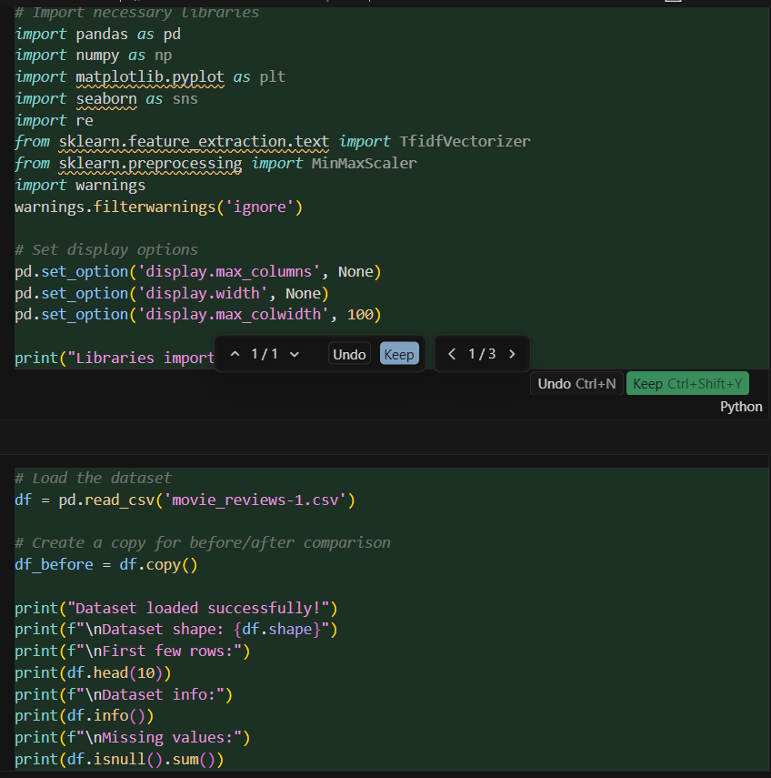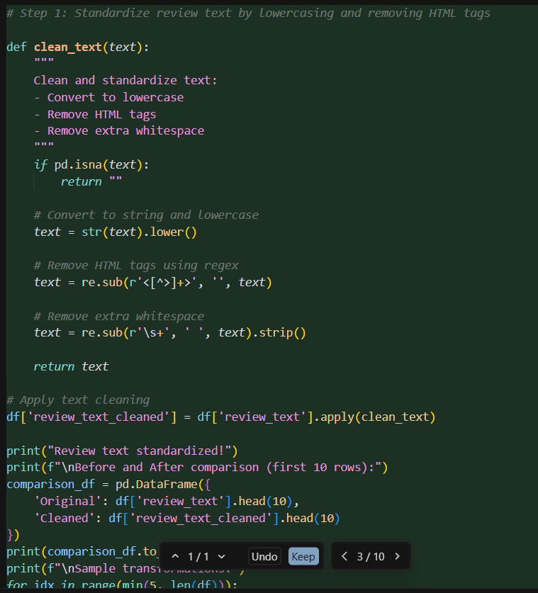  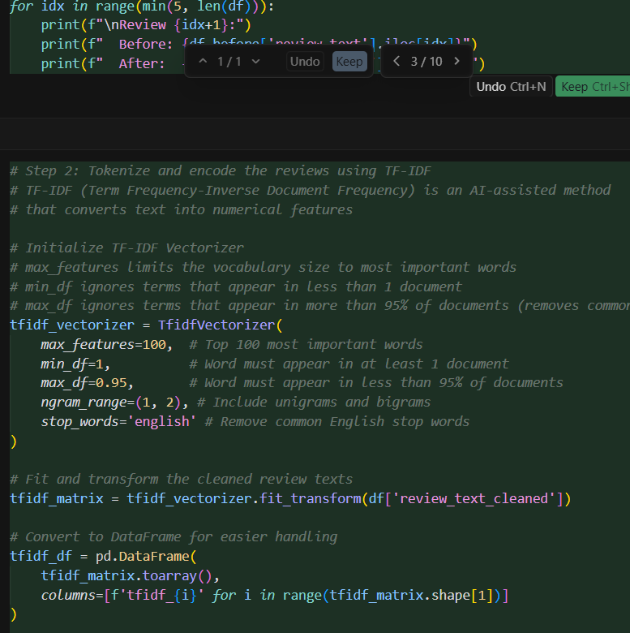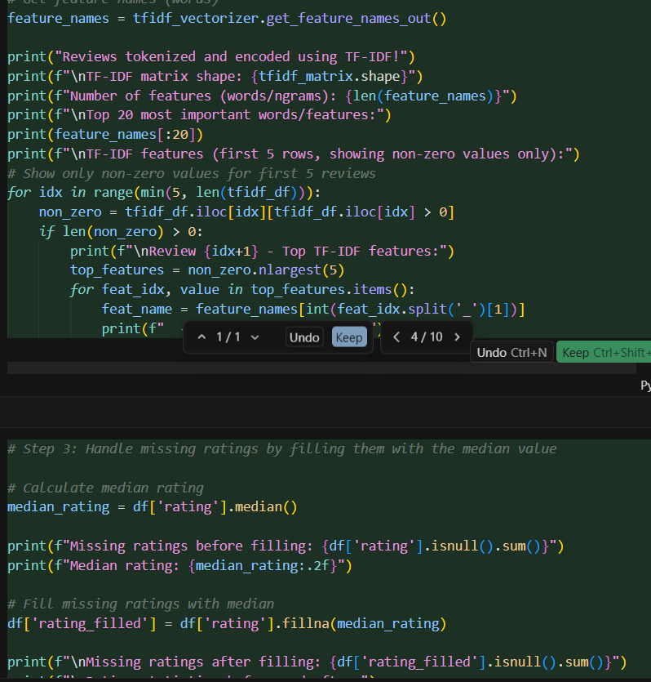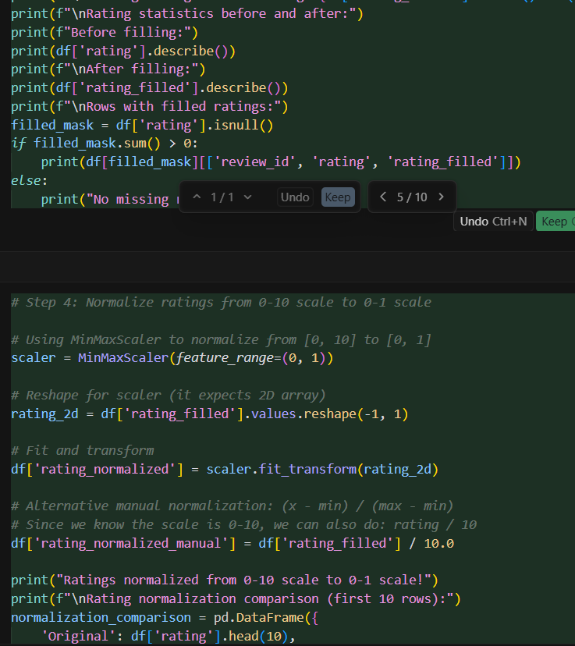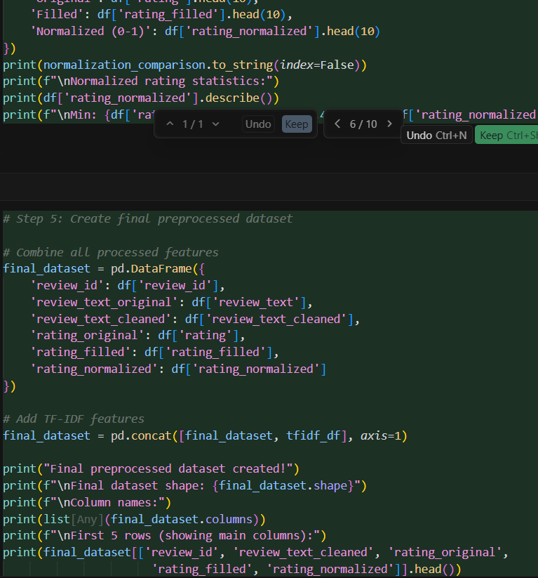  ✅ Deliverables (For All Tasks)  - AI-generated prompts for code and test case generation.  - At least 3 assert test cases for each task.  - AI-generated initial code and execution screenshots.  - Analysis of whether code passes all tests.  - Improved final version with inline comments and explanations.  - Compiled report (Word/PDF) with prompts, test cases, assertions, code, and output. |  |  |  |  |  | Week9 - Monday

