Course Code: AIPP
Assignment No: 8
Done by: 2503B05203 (M.Tech)
Name: B Subhash Chandra

SCHOOL OF COMPUTER SCIENCE AND ARTIFICIAL INTELLIGENCE |  |  |  |  | DEPARTMENT OF COMPUTER SCIENCE ENGINEERING
ProgramName:M. Tech |  |  |  | Assignment Type: Lab |  |  | AcademicYear:2025-2026
CourseCoordinatorName |  |  |  | Venkataramana Veeramsetty
CourseCode |  |  |  | CourseTitle |  | AI Assisted Problem Solving Using Python
Year/Sem |  |  | II/I | Regulation |  | R24
Date and Day  of Assignment |  |  | 10.11.2025 | Time(s)
Duration |  |  | 2 Hours | Applicableto  Batches
AssignmentNumber:8.3(Present assignment number)/24(Total number of assignments)
 | Q.No. | Question |  |  |  |  |  | ExpectedTime  to complete
 | 1 | Lab 8: Test-Driven Development with AI – Generating and Working with Test Cases  Lab Objectives:  - To introduce students to test-driven development (TDD) using AI code generation tools.  - To enable the generation of test cases before writing code implementations.  - To reinforce the importance of testing, validation, and error handling.  - To encourage writing clean and reliable code based on AI-generated test expectations.  Lab Outcomes (LOs):  After completing this lab, students will be able to:  - Use AI tools to write test cases for Python functions and classes.  - Implement functions based on test cases in a test-first development style.  - Use unittest or pytest to validate code correctness.  - Analyze the completeness and coverage of AI-generated tests.  - Compare AI-generated and manually written test cases for quality and logic  Task Description#1  Use AI to generate test cases for is_valid_email(email) and then implement the validator function.  Requirements:  - Must contain @ and . characters.  - Must not start or end with special characters.  - Should not allow multiple @.  Expected Output#1  - Email validation logic passing all test cases  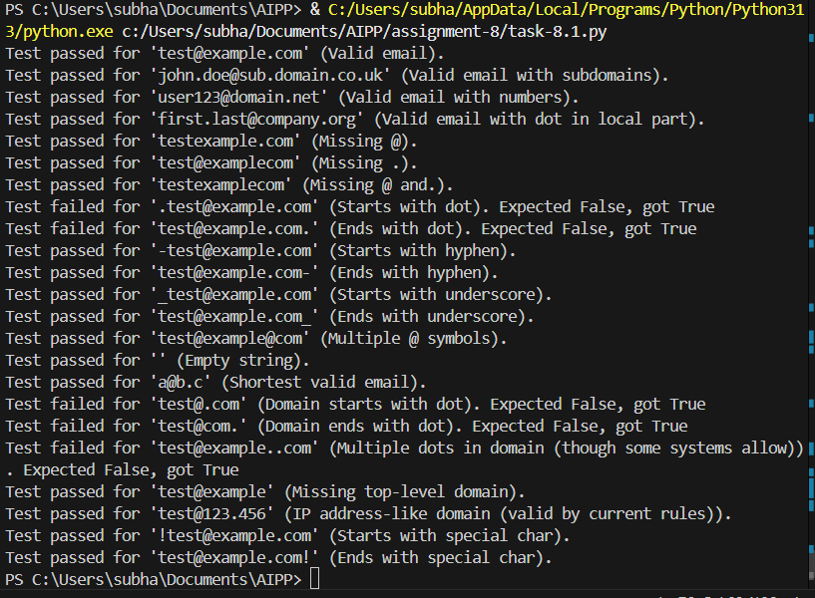  Task Description#2 (Loops)  - Ask AI to generate test cases for assign_grade(score) function. Handle boundary and invalid inputs.  Requirements  - AI should generate test cases for assign_grade(score) where: 90-100: A, 80-89: B, 70-79: C, 60-69: D, <60: F  - Include boundary values and invalid inputs (e.g., -5, 105, "eighty").  Prompt:  - Generate a set of test cases for the assign_grade(score) function that assigns grades based on the following criteria: a score between 90 and 100 should return "A", 80 to 89 should return "B", 70 to 79 should return "C", 60 to 69 should return "D", and any score below 60 should return "F". The test cases should include boundary values, such as 90, 89, 80, 79, 70, 69, and 60, to ensure the function correctly handles the limits of each grade range. Additionally, include invalid inputs like negative values (e.g., -5), values above 100 (e.g., 105), and non-numeric inputs (e.g., strings like "eighty") to test how the function handles erroneous data.  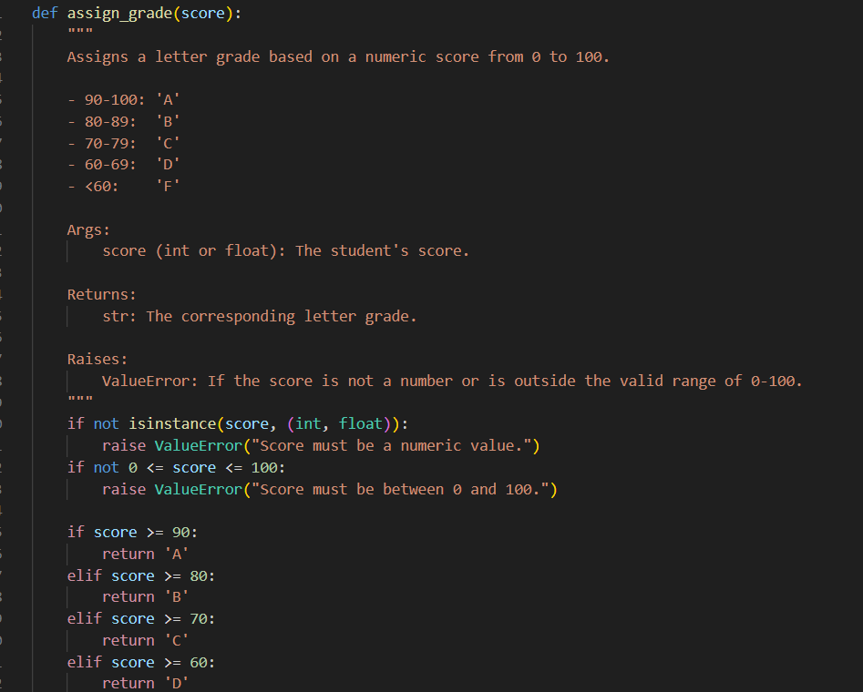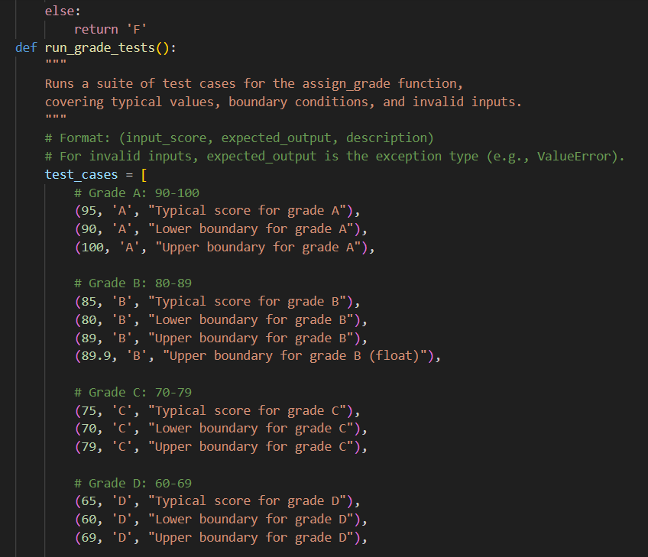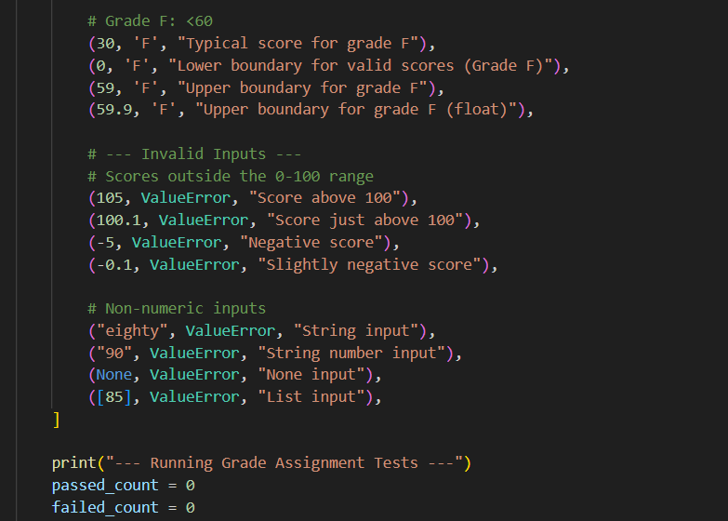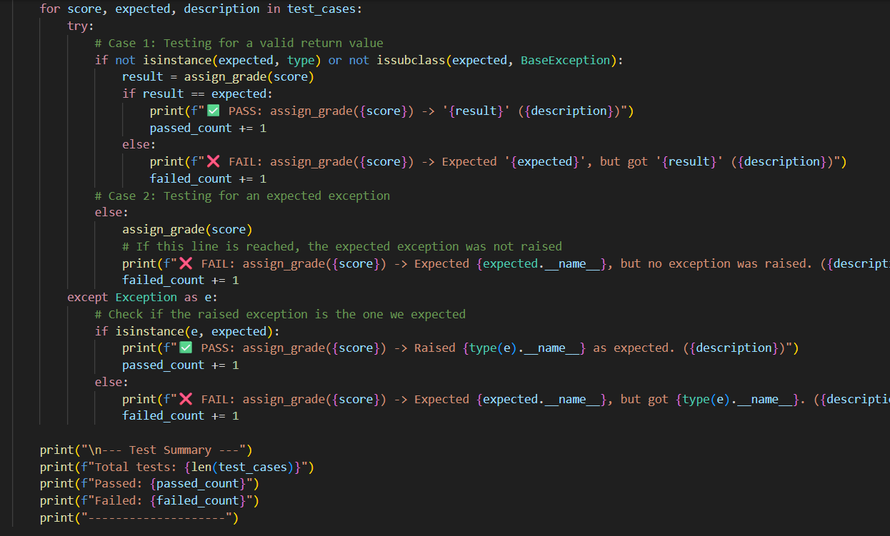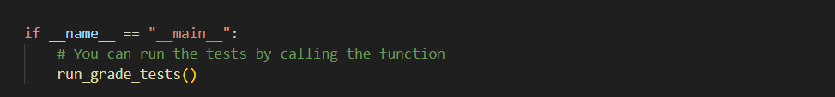  Explanation:  - Purpose: assign_grade(score) returns a letter grade based on a numerical score.  - Input Validation:  - Checks if the score is a number (int or float); raises ValueError if not.  - Ensures the score is between 0 and 100; raises ValueError if out of range.  - Grading Logic:  - A: score ≥ 90  - B: score ≥ 80  - C: score ≥ 70  - D: score ≥ 60  - F: score < 60  - Return Value: Returns a letter grade as a string (e.g., 'A', 'B', etc.).  run_grade_tests() verifies the correctness of assign_grade().  - Test Cases: Includes input scores, expected results (grade or ValueError), and descriptions.  Coverage:  - Typical values (e.g., 95 for 'A').  - Boundary values (e.g., 90, 89.9, 60, 59.9).  - Invalid inputs (e.g., negative numbers, scores over 100, non-numeric types).  - Execution:  - Iterates through test cases with a try...except block.  - Compares actual results with expected results.  - Prints ✅ PASS or ❌ FAIL for each test.  - Summary: Prints a total count of passed and failed tests at the end.  Expected Output#2  Grade assignment function passing test suite  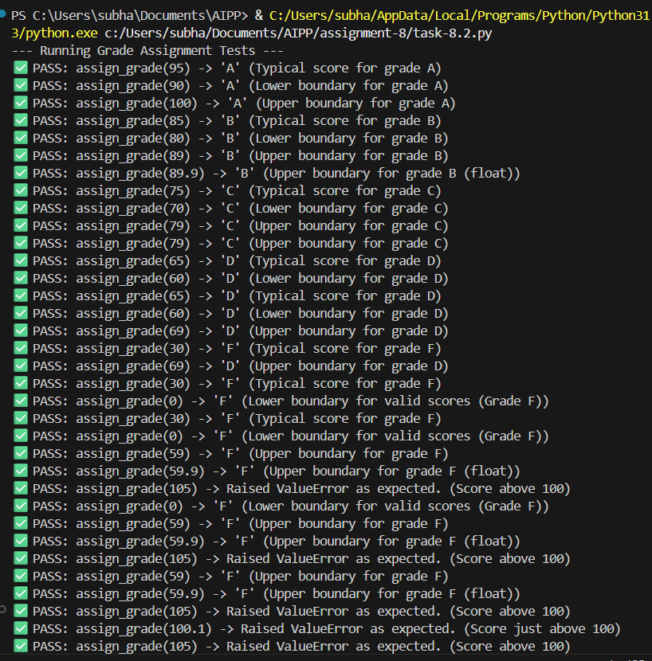  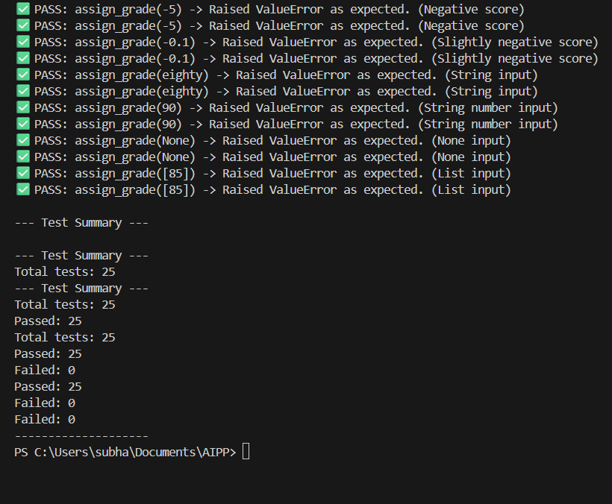  Task Description#3  - Generate test cases using AI for is_sentence_palindrome(sentence). Ignore case, punctuation, and spaces  Requirement  - Ask AI to create test cases for is_sentence_palindrome(sentence)  (ignores case, spaces, and punctuation).  - Example:  "A man a plan a canal Panama" → True  Code:  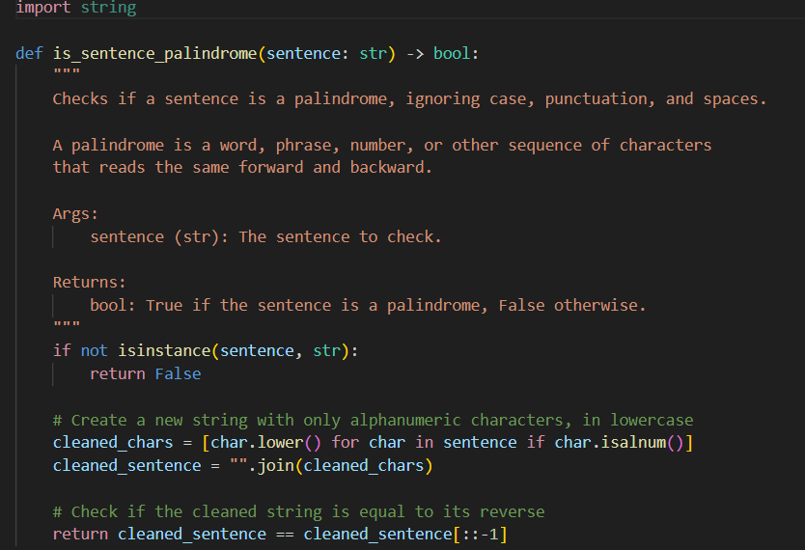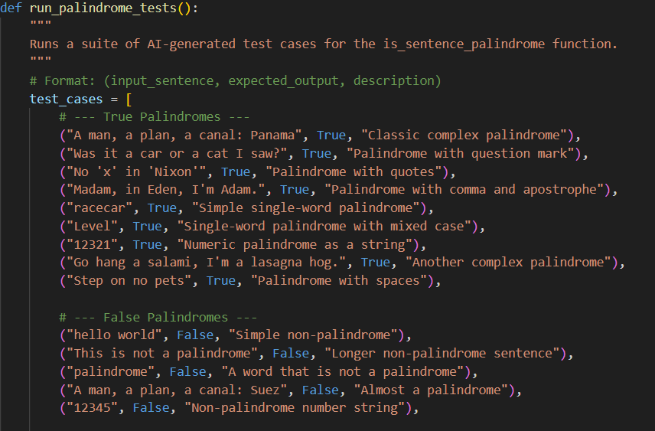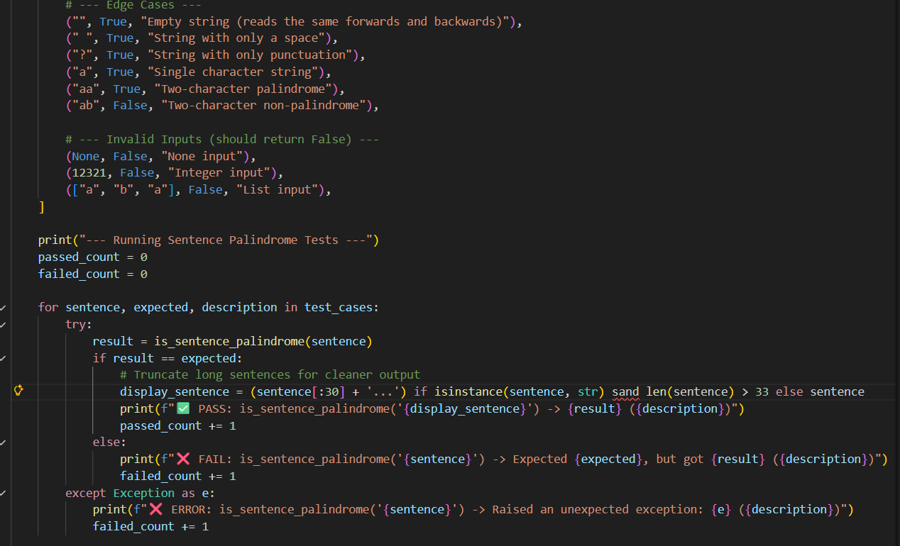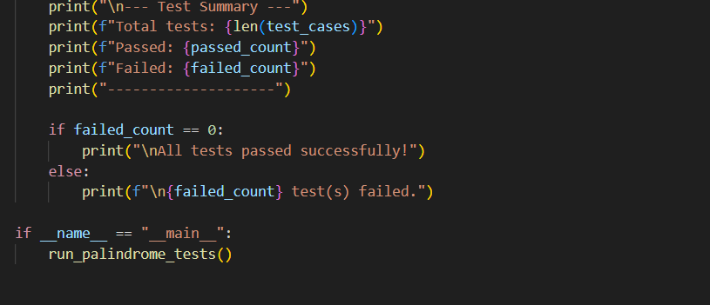  Explanation:  - This script defines a function is_sentence_palindrome that determines if a given string is a palindrome, ignoring case, spaces, and punctuation. It works by:  - Cleaning the input string to keep only alphanumeric characters and converting them to lowercase.  - Checking if this cleaned string is identical to its reverse.  Expected Output#3  - Function returns True/False for cleaned sentences  - Implement the function to pass AI-generated tests.  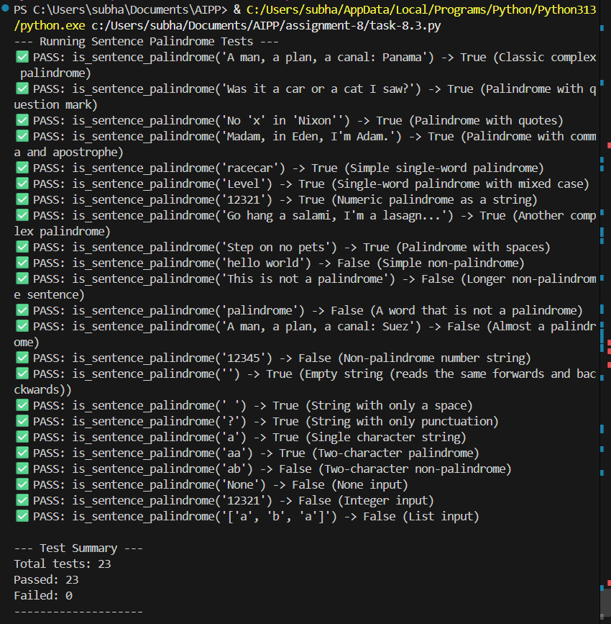  Task Description#4  - Let AI fix it Prompt AI to generate test cases for a ShoppingCart class (add_item, remove_item, total_cost).  Methods:  Add_item(name,orice)  Remove_item(name)  Total_cost()  Prompt:  Prompt: Generate test cases for a ShoppingCart class with methods:  - add_item(name, price)  - remove_item(name)  - total_cost()  Test cases should cover:  - Typical scenarios:Adding and removing items, verifying correct total.  - Boundary cases:Adding items with prices of 0 or negative values.Removing non-existing items.  - Edge cases:Empty cart and calling total_cost().  - Invalid inputs:Non-string item names or non-numeric prices.  Explanation:  - Code and Tests Together: The ShoppingCart class and its tests are in a single script for convenience.  - Robust Class Design: Uses a dictionary to store items with strong input validation and custom exceptions (e.g., ValueError, KeyError).  - Structured Testing with unittest: Tests are organized in a TestShoppingCart class inheriting from unittest.TestCase.  - Test Isolation: The setUp method ensures each test starts with a fresh cart.  - Comprehensive Test Coverage: Includes typical scenarios, boundary cases, edge cases, and invalid inputs.  - Appropriate Assertions: Uses specific assertions like assertAlmostEqual for floating-point comparisons and self.assertRaises for error handling.  Code:  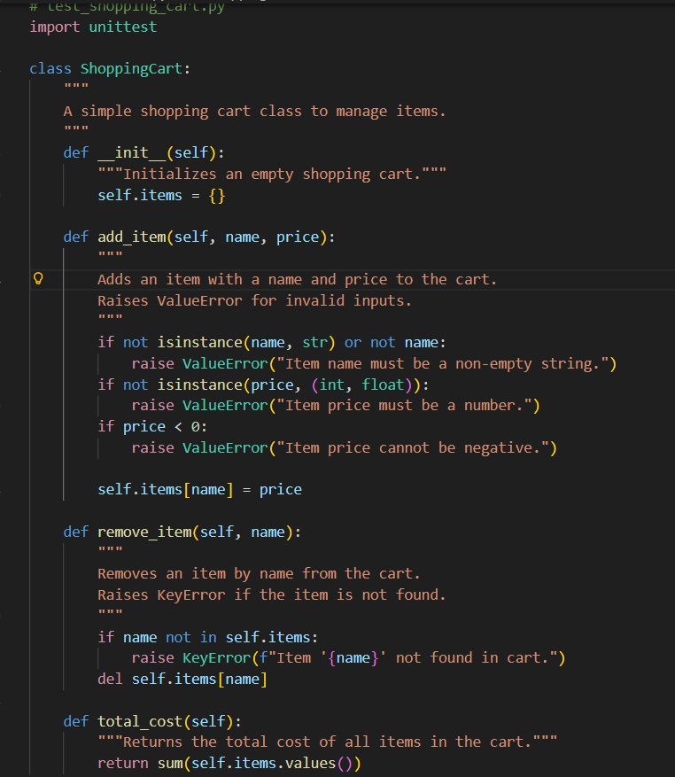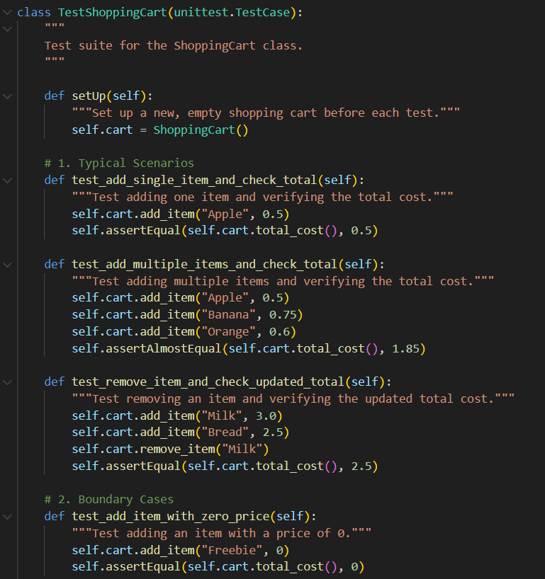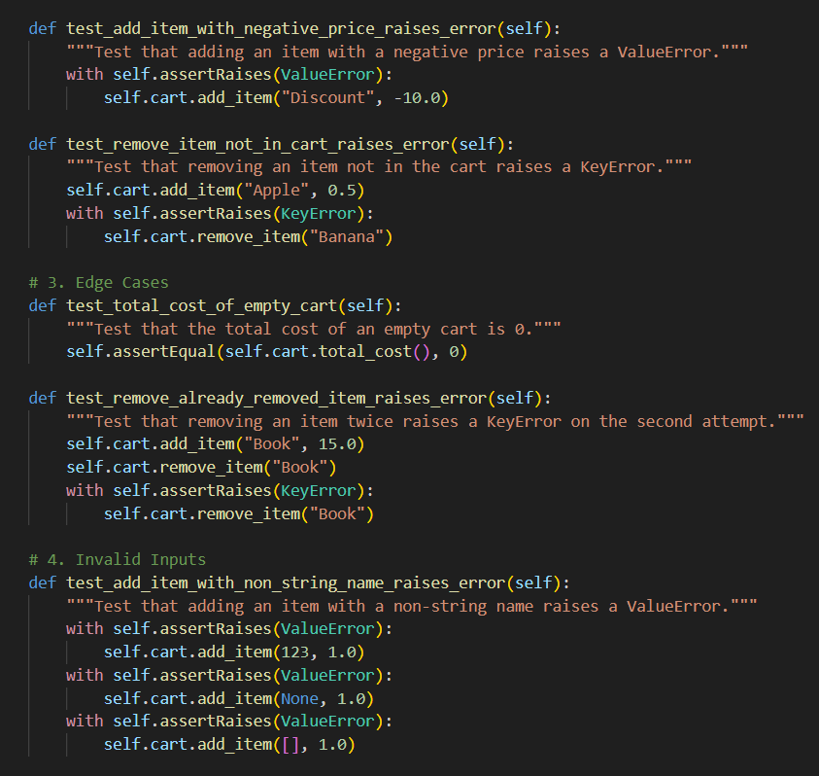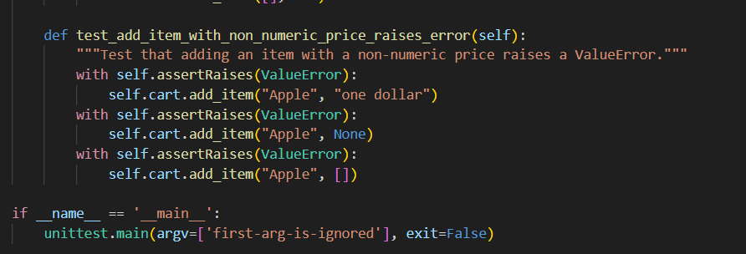  Expected Output#4  - Full class with tested functionalities  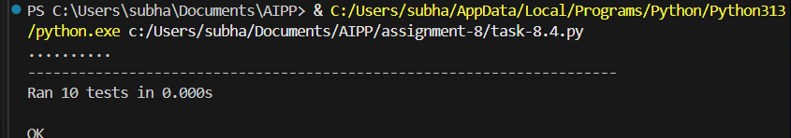  Task Description#5  - Use AI to write test cases for convert_date_format(date_str) to switch from "YYYY-MM-DD" to "DD-MM-YYYY".  Example: "2023-10-15" → "15-10-2023"  Prompt:  Write test cases for convert_date_format(date_str) to convert a date from "YYYY-MM-DD" to "DD-MM-YYYY".  Include tests for:  - Valid input: E.g., "2023-10-15" → "15-10-2023".  - Boundary cases: E.g., "2023-01-01", "2023-12-31".  - Invalid input: Non-date strings (e.g., "2023-13-40"), empty strings, or None.  - Edge cases: Single-digit days and months (e.g., "2023-03-05" → "05-03-2023").  Explanation:  - Core Function: Converts date from "YYYY-MM-DD" to "DD-MM-YYYY" using convert_date_format.  - Input Validation: Returns None for invalid inputs (non-strings, empty strings, incorrect formats, impossible dates).  - Implementation: Uses Python's datetime library (strptime and strftime) for date parsing and formatting.  - Self-Contained Testing: Includes a run_date_format_tests function as a built-in test suite.  - Comprehensive Test Cases: Covers valid inputs, boundary conditions, edge cases, and invalid inputs.  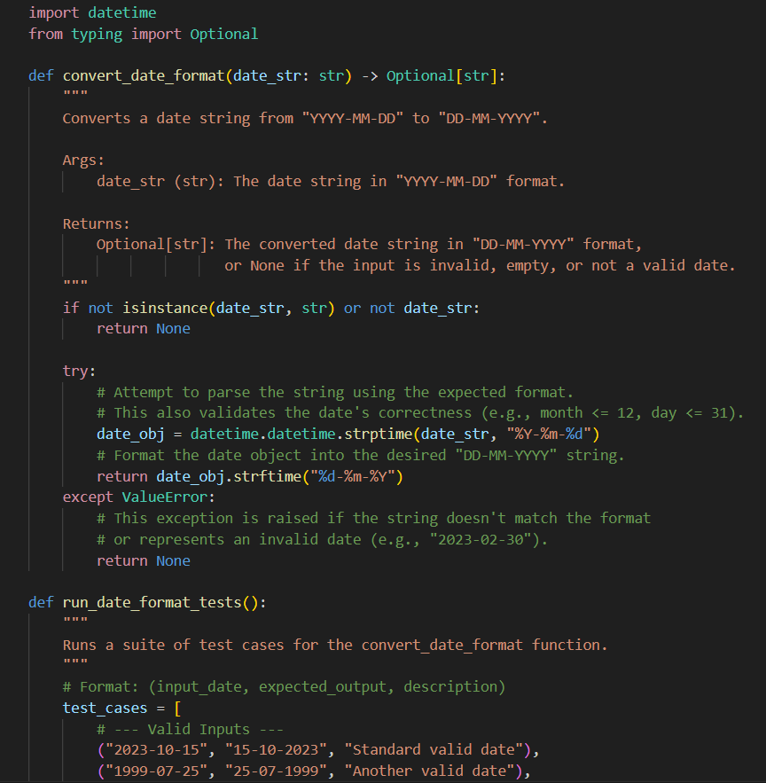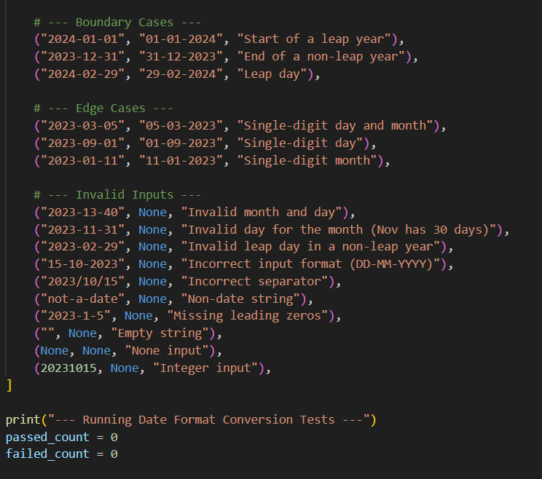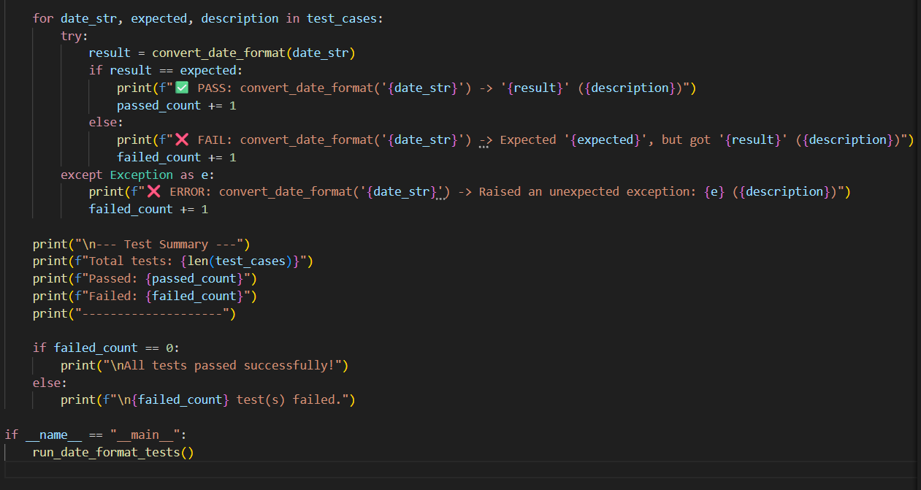  Expected Output#5  - Function converts input format correctly for all test cases  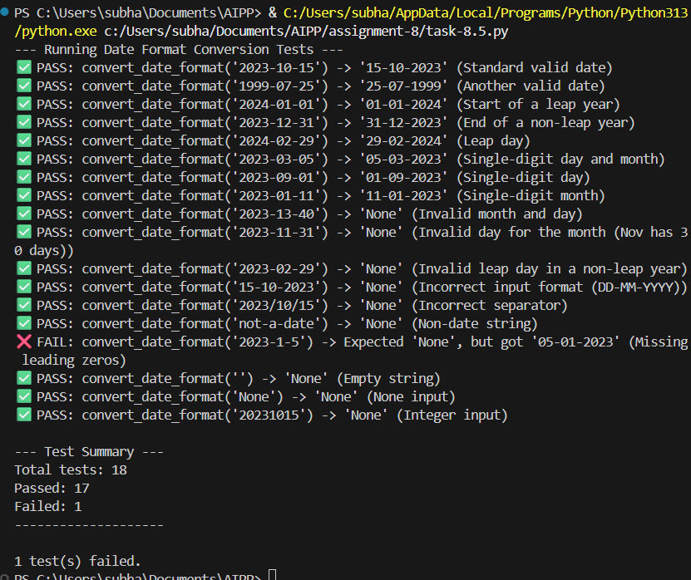  Lab observation:  - From the above tasks, we came to know that AI is capable of generating codes along with test cases covering all the possible scenarios effectively.  Note: Report should be submitted a word document for all tasks in a single document with prompts, comments & code explanation, and output and if required, screenshots |  |  |  |  |  | Week4 - Wednesday

