Course Code: AIPP
Assignment No: 5
Done by: 2503B05203 (M.Tech)
Name: B Subhash Chandra

SCHOOL OF COMPUTER SCIENCE AND ARTIFICIAL INTELLIGENCE |  |  |  |  | DEPARTMENT OF COMPUTER SCIENCE ENGINEERING
Program Name: M. Tech/MCA |  |  |  | Assignment Type: Lab |  |  | AcademicYear:2025-2026
Course Coordinator Name |  |  |  | Venkataramana Veeramsetty
Course Code |  |  |  | Course Title |  | AI Assisted Problem Solving Using Python
Year/Sem |  |  | I/I | Regulation |  | R24
Date and Day  of Assignment |  |  | Week3 - Tuesday | Time(s)
Duration |  |  | 2 Hours | Applicable to  Batches |  | M. Tech/MCA
AssignmentNumber:5.3(Present assignment number)/24(Total number of assignments)
 | Q.No. | Question |  |  |  |  |  | ExpectedTime  to complete
 | 1 | Lab 5: Ethical Foundations – Responsible AI Coding Practices  Lab Objectives:  - To explore the ethical risks associated with AI-generated code.  - To recognize issues related to security, bias, transparency, and copyright.  - To reflect on the responsibilities of developers when using AI tools in software development.  - To promote awareness of best practices for responsible and ethical AI coding.  Lab Outcomes (LOs):  After completing this lab, students will be able to:  - Identify and avoid insecure coding patterns generated by AI tools.  - Detect and analyze potential bias or discriminatory logic in AI-generated outputs.  - Evaluate originality and licensing concerns in reused AI-generated code.  - Understand the importance of explainability and transparency in AI-assisted programming.  - Reflect on accountability and the human role in ethical AI coding practices.  Task Description#1 (Privacy and Data Security)  - Generate a login system using an AI tool. Analyze if the AI inserts hardcoded credentials or insecure logic.  Prompt:  - Generate a Python login system using username and password validation. Check if the AI inserts hardcoded credentials or insecure logic.  Code:  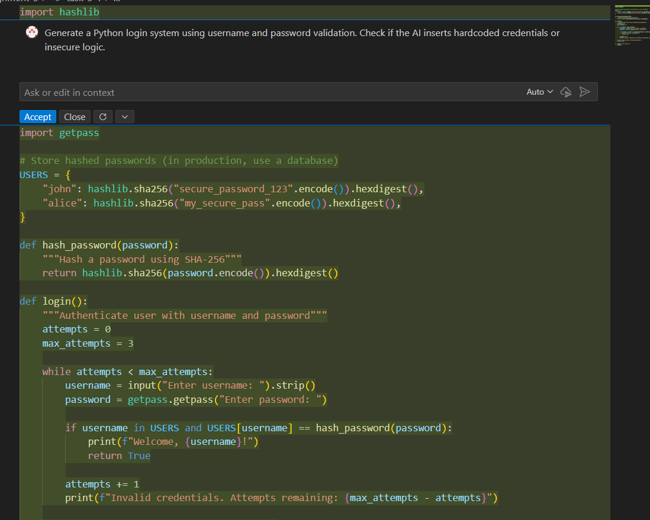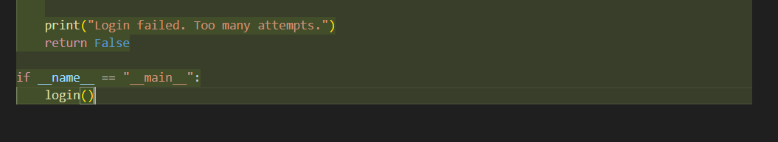  Explanation:  - Imports: hashlib for hashing and getpass for silent password input.  - User store: USERS: a module-level dict that contains two usernames whose passwords are hashed with SHA-256 at import time (so credentials are effectively hardcoded into the source).  - Hash helper: hash_password: returns the SHA-256 hex digest of a plaintext password.  - Login flow: login() loops up to max_attempts (3), prompts for username and password, and verifies by checking username in USERS and USERS[username] == hash_password(password); on success it prints a welcome and returns True, otherwise it increments attempts and reports remaining tries.  - Entrypoint: The script calls login() when run directly (if __name__ == "__main__":).  Expected Output#1  - Description of risks and revised secure version  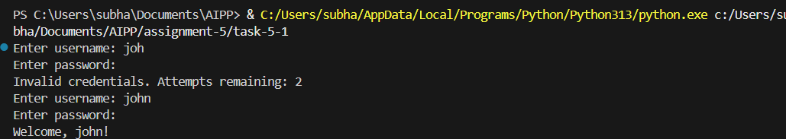  Observations:  - Hardcoded credentials: The USERS dict hardcodes user records inside the code (even though they are hashed).  - Weak hashing choice: SHA-256 is fast and used here without a per-user salt — not suitable for password storage.  Conclusion:  - AI inserts Hardcoded credentials and insecure logic by defaults. It can you further enhanced by modifying/ adding prompts  Task Description#2 (Bias)  - Use prompt variations like “loan approval system” with different genders/names. Analyze if AI suggests biased logic.  Prompt:  - Generate a Python loan approval system with data for different cases  Code:  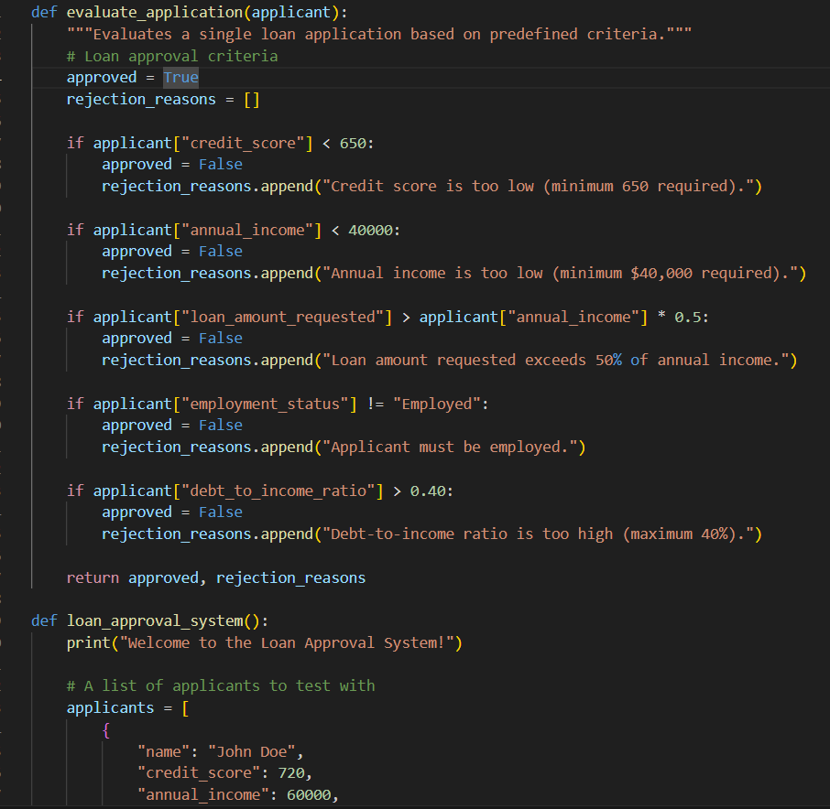  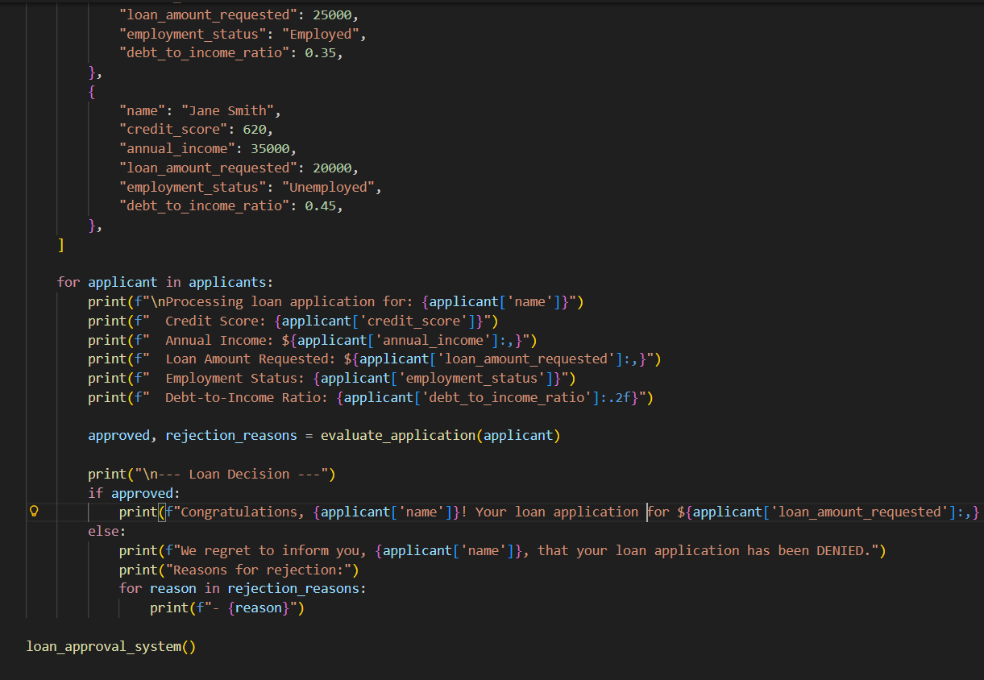  Explanation:  The system uses two main functions to process loan applications:  1. evaluate_application(applicant)  This is the core decision engine. It:  - Takes an applicant dictionary as input.  - Checks the applicant against five strict rules:  - Credit score (>650$)  - Annual income > $40,000$)  - Loan amount (< 50% of income)  - Employment status ("Employed")  - Debt-to-income ratio (< 40%)  - Collects specific rejection reasons if any rule fails.  - Returns an approval status (boolean) and the list of reasons.  2. loan_approval_system()  This is the main driver. It:  - Contains a hardcoded list of applicants.  - Iterates through each applicant.  - Prints the applicant's details.  - Calls evaluate_application to determine the outcome.  - Prints the final decision ("APPROVED" or "DENIED") and lists the rejection reasons if denied.  Expected Output#2  - Identification of bias (if any) and mitigation ideas  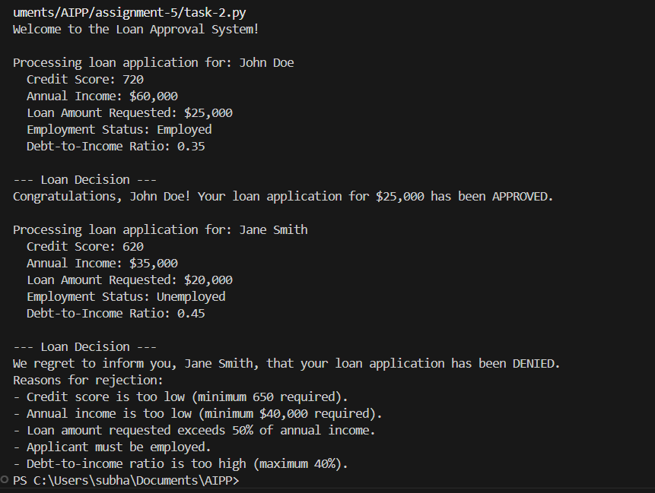  Observation:  - Only the parameters of finance are used to determine the loan approval  Conclusion:  - AI generated a non -biased code which is a good practice  Task Description#3 (Transparency)  - Write prompt to write function calculate the nth Fibonacci number using recursion and generate comments and explain code document  Prompt:  - write function calculate the nth Fibonacci number using recursion and generate comments and explain code document  Code:  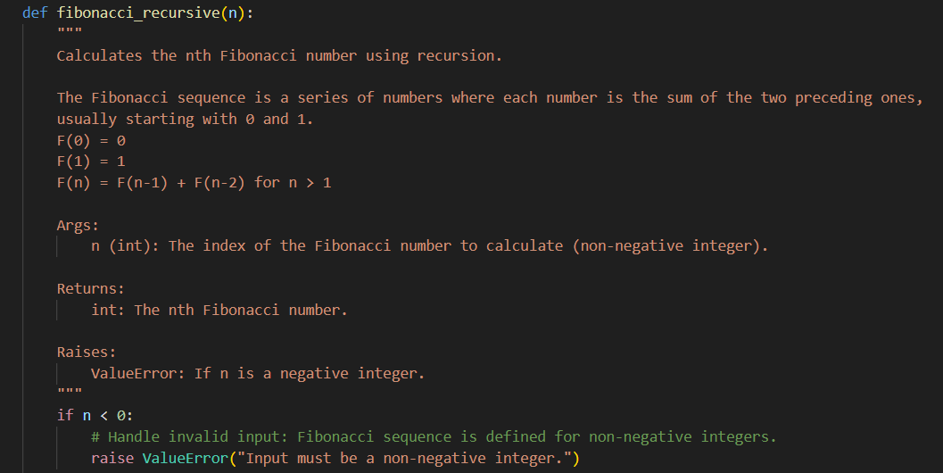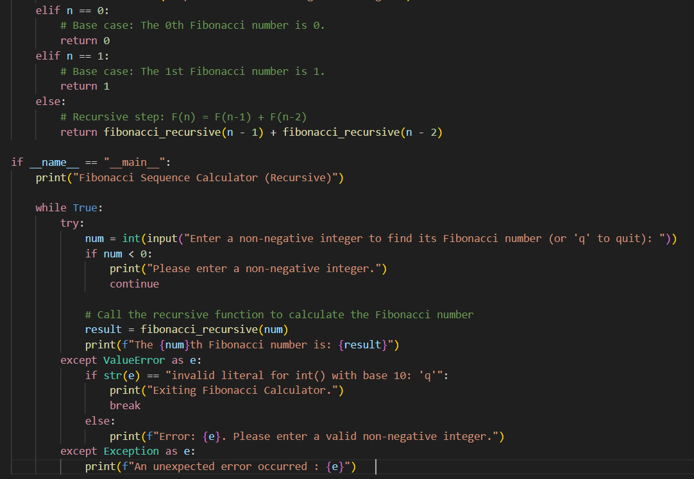  Expected Output#3  - Code with explanation  - Assess: Is the explanation understandable and correct?  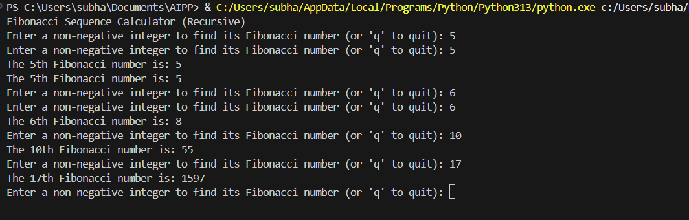  Observation:  - AI generated full code with the code document and comments wherever is necessary  Conclusion:  - The code document is clear, detailed and correct, comments are spot on as required  Task Description#4 (Bias)  - Ask AI to generate a scoring system for job applicants based on features.  Prompt:  - Generate a scoring system for job applicants based on features.  Explanation:  - This evaluates job applicants based on set criteria and prints a total score for each.  - The complete point scheme is: Experience (5-15 pts) + Education (5-15 pts) + Skills (3 pts per relevant skill) + Certifications (5 pts for True) = Total Score  - job_applicant_scoring_system()  - Data Setup: Defines a hardcoded list of applicant dictionaries (applicants).  - Processing: Iterates through the list of applicants.  - Output: For each applicant, it calls calculate_applicant_score and prints the applicant's name and their final score.  - The script runs, job_applicant_scoring_system() is called (via if __name__ == "__main__":), and it processes the internal list of candidates, printing the final score for each one.  Code:  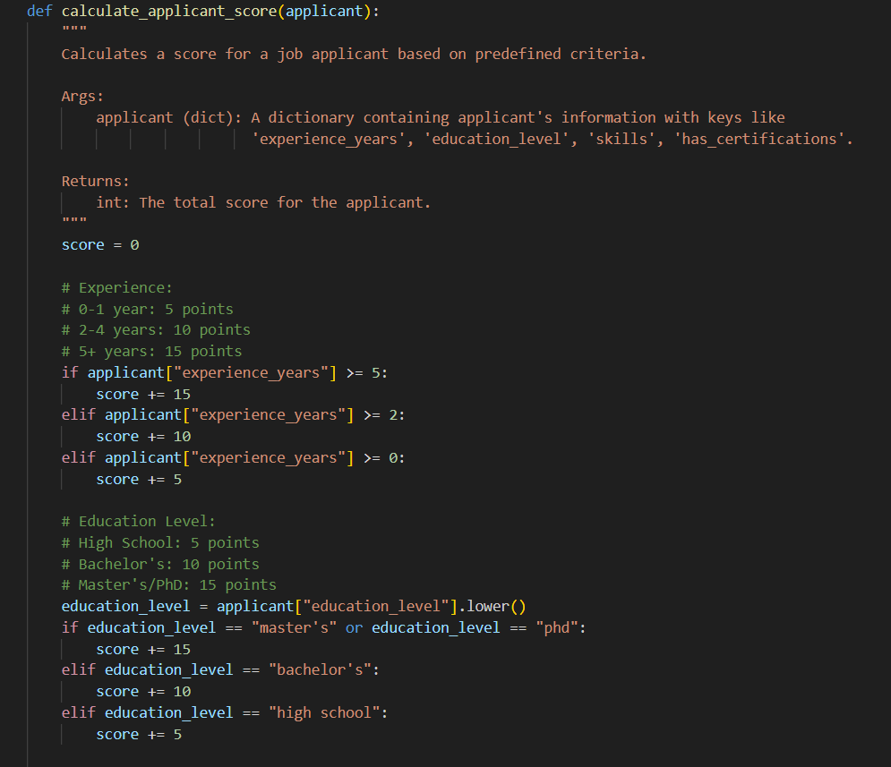  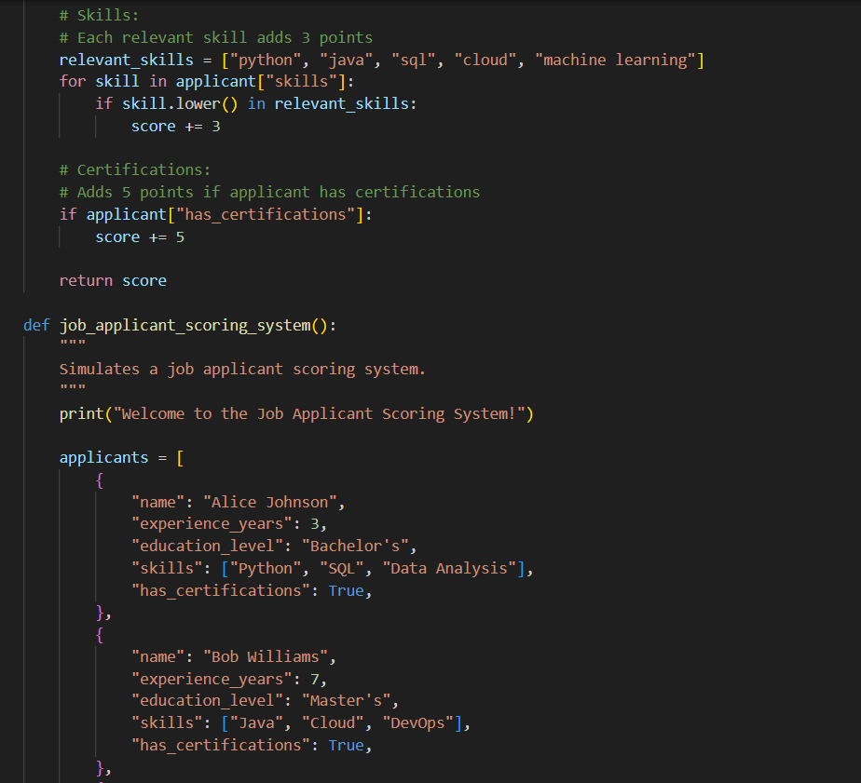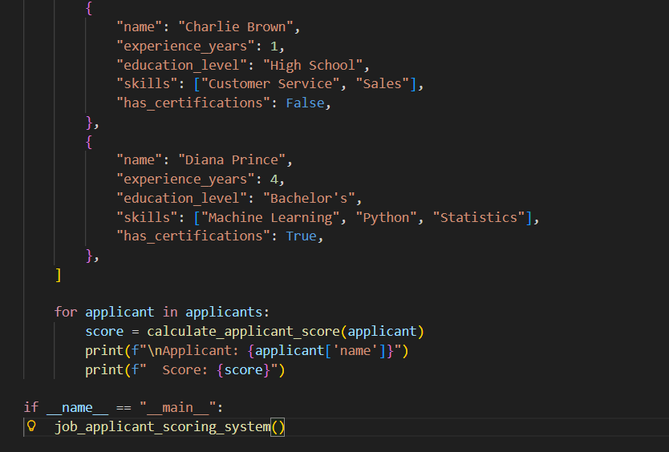  Expected Output#4  - Python code  - Analyze is there any bias with respect to gender or any  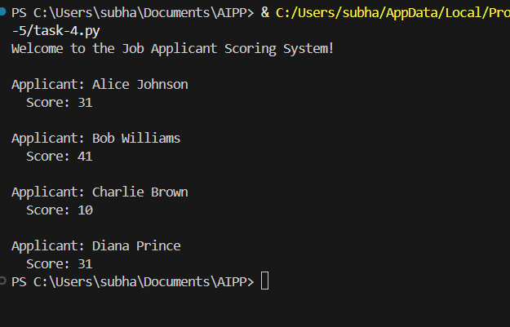  Observation:  - Only the parameters of qualifications are used to determine the applicant scoring.  Conclusion:  - AI generated a non -biased code for selection of applicant which is a good practice  Task Description#5 (Inclusiveness)  - Code Snippet    Expected Output#5  - Regenerate code that includes gender-neutral also  Prompt:  - Generate a Python greeting system that uses gender-neutral language with mr/mrs  Code:  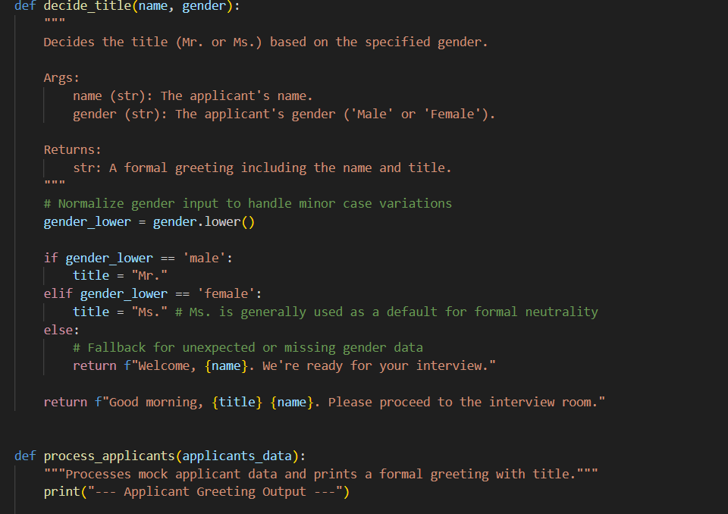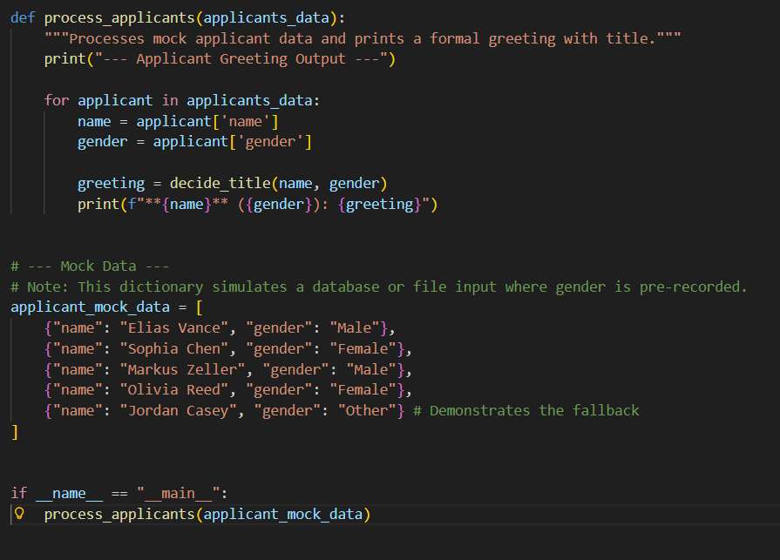  Explanation:  - The core logic: Title is "Mr." if gender is 'Male', "Ms." if gender is 'Female', otherwise the function returns a title-less fallback greeting.  - rints the applicant's name, gender, and the personalized greeting to the console.  - In short, the script simulates a system for formal applicant check-in, automatically selecting either "Mr.", "Ms.", or a title-less greeting based on the recorded gender.  Output:  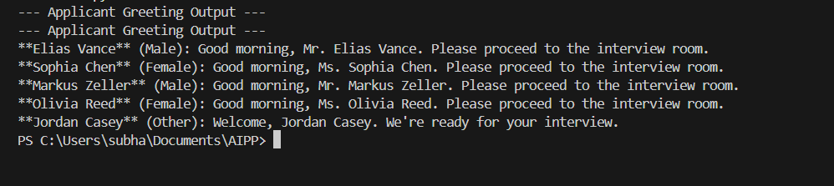  Observation:  - AI successfully generated code to greet gender neutral wishes by greeting males with Mr and female with Ms and others with fallback greeting.  Note: Report should be submitted a word document for all tasks in a single document with prompts, comments & code explanation, and output and if required, screenshots  Evaluation Criteria: |  |  |  |  |  | Week3 - Tuesday
  Criteria | Max Marks
  Transparency | 2.5
  Bias | 2.5
  Inclusiveness | 2.5
  Data security and Privacy | 2.5
  Total | 10

