Course Code: OSCN
Assignment No:4
Done by: 2503B05203 (M.Tech)
Name: B Subhash Chandra

Question:
Write a C++ program to implement Hamming Code for error detection and correction.
Requirements:
- Accept a binary data string as input.
- Determine the number of redundant bits required.
- Insert the redundant bits into appropriate positions (1, 2, 4, 8, …).
- Calculate and set the parity bits using even parity logic.
- Display the final data packet (data bits + redundant bits) to be transmitted.
- Simulate the receiver side to:
  - Recalculate parity bits.
  - Detect if there is any single-bit error.
  - Display the position of the erroneous bit or confirm no error if data is correct.
CODE:
#include <iostream>
#include <string>
#include <algorithm>
using namespace std;
class hamming{
public:
string data; //it is the raw data received
int m , r = 0; // n is the length of raw data and r is the number of redundant bits
char * msg; // it will store the all bits (data + redundant). We made it dynamic because at compile time we dont know how much redundant bits will be there, we will initialize memory to it once we know the number of redundant bits.
hamming(string data){
this->data = data;
//reversing the data received
reverse(data.begin(),data.end());
m = data.size();
int power = 1;

//finding the number of redundant bits and storing them in r
while(power < (m + r + 1)){
r++;
power*=2;
}
//Allocating memory to our dynamic msg array(Note we are using one based indexing).
msg = new char[m+r+1];
int curr = 0;

//initializing the msg with data bits and for redundant bits, an initial value of n
for(int i = 1 ; i <= m+r ; i++){
if(i & (i-1)){
msg[i] = data[curr++];
}
else msg[i] = 'n';
}
//function call to set the redundant bits
setRedundantBits();
}
//function to show the whole msg
void showmsg(){
cout << "the data packet to be sent is : ";
for(int i = m+r ; i >= 1 ; i--){
cout << msg[i] << " ";
}
cout << endl;
}
void setRedundantBits(){
//for first redundant bit, check all those data bits at index where the first bit of index is set(1) similarly for second redundant bit, check all those data bits at index where the second bit of index is set(1), similarly for third redundant bit check all those data bits at index where the third bit of index is set to 1 and so on.
int bit = 0;
//outer loop runs for redundant bits (1 ,2 ,4 ,8 ....)
for(int i = 1 ; i <= m+r ; i*=2){
int count = 0;
//inner loop runs for data bits
for(int j = i+1 ; j<=m+r ; j++){
// checking if the data bit corresponds to our redundant bit or not using bit manipulation
if(j & (1 << bit)){
if(msg[j] == '1') count++; // counting the number of ones in corresponding data bits
}
}
//setting up redundant bits
if(count & 1) msg[i] = '1';
else msg[i] = '0';
//increasing the bit position.
bit++;
}
//showing up the message to be sent(data + redundant)
showmsg();
}
void receiver(){
//this ans will store the redundant bits, if they were right then according to even parity they will store 0 else if some error was made in a bit it will store 1
string ans = "";
int bit = 0;
//this loop corresponds to the logic used in set redundant bits function
for(int i = 1 ; i <= m+r ; i*=2){
int count = 0;
for(int j = i+1 ; j<=m+r ; j++){
if(j & (1 << bit)){
if(msg[j] == '1') count++;
}
}
//incrementing the ans variable with the parity of redundant bit
// if it was right then add 0 else 1
if(count & 1){
if(msg[i] == '1') ans.push_back('0');
else ans.push_back('1');
}
else{
if(msg[i]=='0') ans.push_back('0');
else ans.push_back('1');
}
bit++;
}
// if the ans had any occurrence of 1 then there is some fault
if(ans.find('1') != string::npos){
int power = 1;
int wrongbit = 0;
//evaluating the binary expression of ans variable
for(int i = 0 ; i < ans.size() ; i++){
if(ans[i]=='1') wrongbit+=power;
power*=2;
}
cout << "bit number " << wrongbit << " is wrong and having error " << endl;
}
// if the ans dont have any occurrence of 1 then it is correct
else{
cout << "correct data packet received " << endl;
}
}
};
int main(){
string data = "1011001";
hamming h(data);
// manipulating any ith data bit to check if receiver is detecting a error in that bit. If you eliminate the following line then correct code will be sent to receiver following that no error is received

//h.msg[i] == '0' ? h.msg[i] = '1' : h.msg[i] = '0';

h.receiver();
return 0;
}
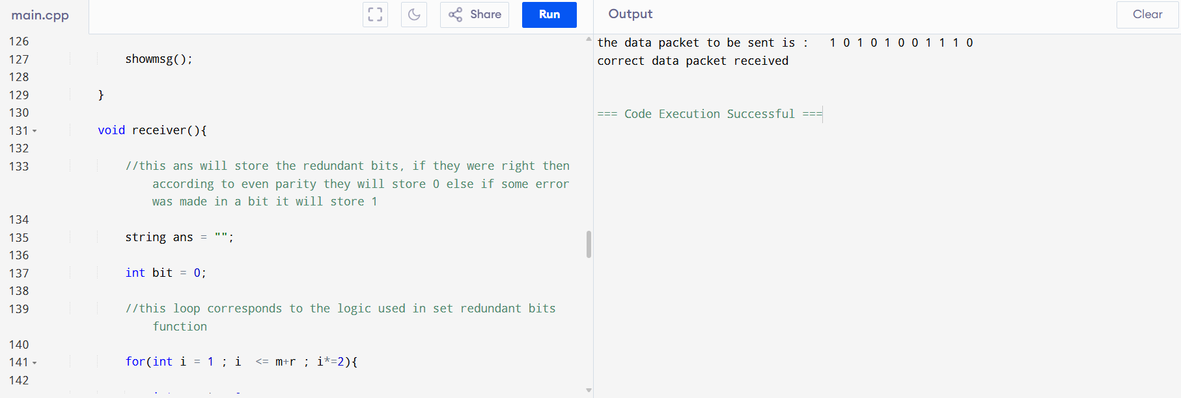
OUTPUT:
