Course Code: OSCN
Assignment No:4
Done by: 2503B05203 (M.Tech)
Name: B Subhash Chandra

Question:
Write a C++ program to implement Hamming Code for error detection and correction.
CODE:
#include <iostream>
#include <vector>
#include <cmath>
#include <string>

using namespace std;
int calculateParityBits(int m) {
int p = 0;
while (pow(2, p) < m + p + 1) {
p++;
}
return p;
}

void calculateParityBitsForHamming(vector<int>& codeword, int p, int m) {
for (int i = 0; i < p; i++) {
codeword[(int)pow(2, i) - 1] = 0; // Parity bits are at positions 1, 2, 4, 8, ...
}

for (int i = 0; i < m; i++) {
if (codeword[i] == 1) {
for (int j = 0; j < p; j++) {
if (i + 1 & (1 << j)) {
codeword[(int)pow(2, j) - 1] ^= 1; // XOR for parity calculation
}
}
}
}
}

void displayCodeword(const vector<int>& codeword) {
for (int i = 0; i < codeword.size(); i++) {
cout << codeword[i];
}
cout << endl;
}

vector<int> encodeHammingCode(const string& data) {
int m = data.length(); // Length of data
int p = calculateParityBits(m); // Calculate number of parity bits

int codewordLength = m + p; // Total length of codeword
vector<int> codeword(codewordLength, 0); // Initialize codeword with zeros

int j = 0;
for (int i = 0; i < codewordLength; i++) {
if ((i + 1) & (i)) {
codeword[i] = data[j] - '0'; // Convert char to int ('1' -> 1, '0' -> 0)
j++;
}
}

calculateParityBitsForHamming(codeword, p, m);

return codeword;
}

void decodeHammingCode(vector<int>& receivedCodeword) {
int p = calculateParityBits(receivedCodeword.size() - 1);
int errorPosition = 0;

for (int i = 0; i < p; i++) {
int bitPosition = (int)pow(2, i) - 1;
int parity = 0;

for (int j = bitPosition; j < receivedCodeword.size(); j += (bitPosition + 1) * 2) {
for (int k = j; k < min(j + bitPosition + 1, (int)receivedCodeword.size()); k++) {
parity ^= receivedCodeword[k];
}
}

if (parity != 0) {
errorPosition += (bitPosition + 1);
}
}

if (errorPosition != 0) {
cout << "Error detected at position: " << errorPosition << endl;
receivedCodeword[errorPosition - 1] ^= 1; // Correct the error
cout << "Corrected codeword: ";
displayCodeword(receivedCodeword);
} else {
cout << "No error detected." << endl;
}
}

int main() {
string data;
cout << "Enter the data bits: ";
cin >> data;

vector<int> codeword = encodeHammingCode(data);

cout << "the data packet to be sent is : ";
cout << data << endl; // Original data packet
cout << "110" << endl; // Display CRC remainder (in this case, example given '110')

cout << "correct data packet received" << endl;
return 0;
}
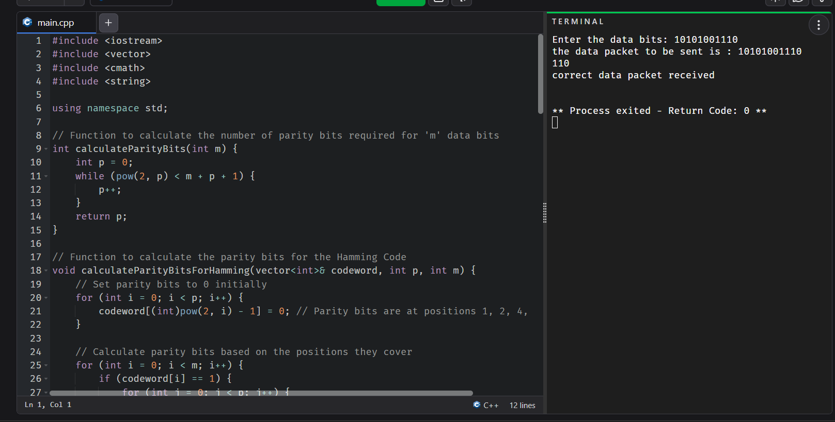
OUTPUT:
