Assignment No: 2
Done by: 2503B05203 (M.Tech)
Name: B Subhash Chandra

Question 1:
Write a C++ program to implement Dijkstra’s Single Source Shortest Path Algorithm for a given weighted, undirected graph using an adjacency matrix representation.
- Problem Setup
- We have 9 vertices (0 to 8).
#include <iostream>
#include <climits>
using namespace std;

void dijkstra(int V, int graph[][9], int src) {
int dist[V];
bool sptSet[V];

for (int i = 0; i < V; i++) {
dist[i] = INT_MAX;
sptSet[i] = false;
}

dist[src] = 0;

for (int count = 0; count < V - 1; count++) {
int u = -1;
for (int i = 0; i < V; i++) {
if (!sptSet[i] && (u == -1 || dist[i] < dist[u])) {
u = i;
}
}

sptSet[u] = true;

for (int v = 0; v < V; v++) {
if (graph[u][v] != 0 && !sptSet[v] && dist[u] + graph[u][v] < dist[v]) {
dist[v] = dist[u] + graph[u][v];
}
}
}

for (int i = 0; i < V; i++) {
cout << "Distance from source to " << i << " is " << dist[i] << endl;
}
}

int main() {
int V = 9;
int graph[9][9] = {
{ 0, 4, 0, 0, 0, 0, 0, 8, 0 },
{ 4, 0, 8, 0, 0, 0, 0, 11, 0 },
{ 0, 8, 0, 7, 0, 4, 0, 0, 2 },
{ 0, 0, 7, 0, 9, 14, 0, 0, 0 },
{ 0, 0, 0, 9, 0, 10, 0, 0, 0 },
{ 0, 0, 4, 14, 10, 0, 2, 0, 0 },
{ 0, 0, 0, 0, 0, 2, 0, 1, 6 },
{ 8, 11, 0, 0, 0, 0, 1, 0, 7 },
{ 0, 0, 2, 0, 0, 0, 6, 7, 0 }
};

int src = 0;
dijkstra(V, graph, src);

return 0;
}
Output :
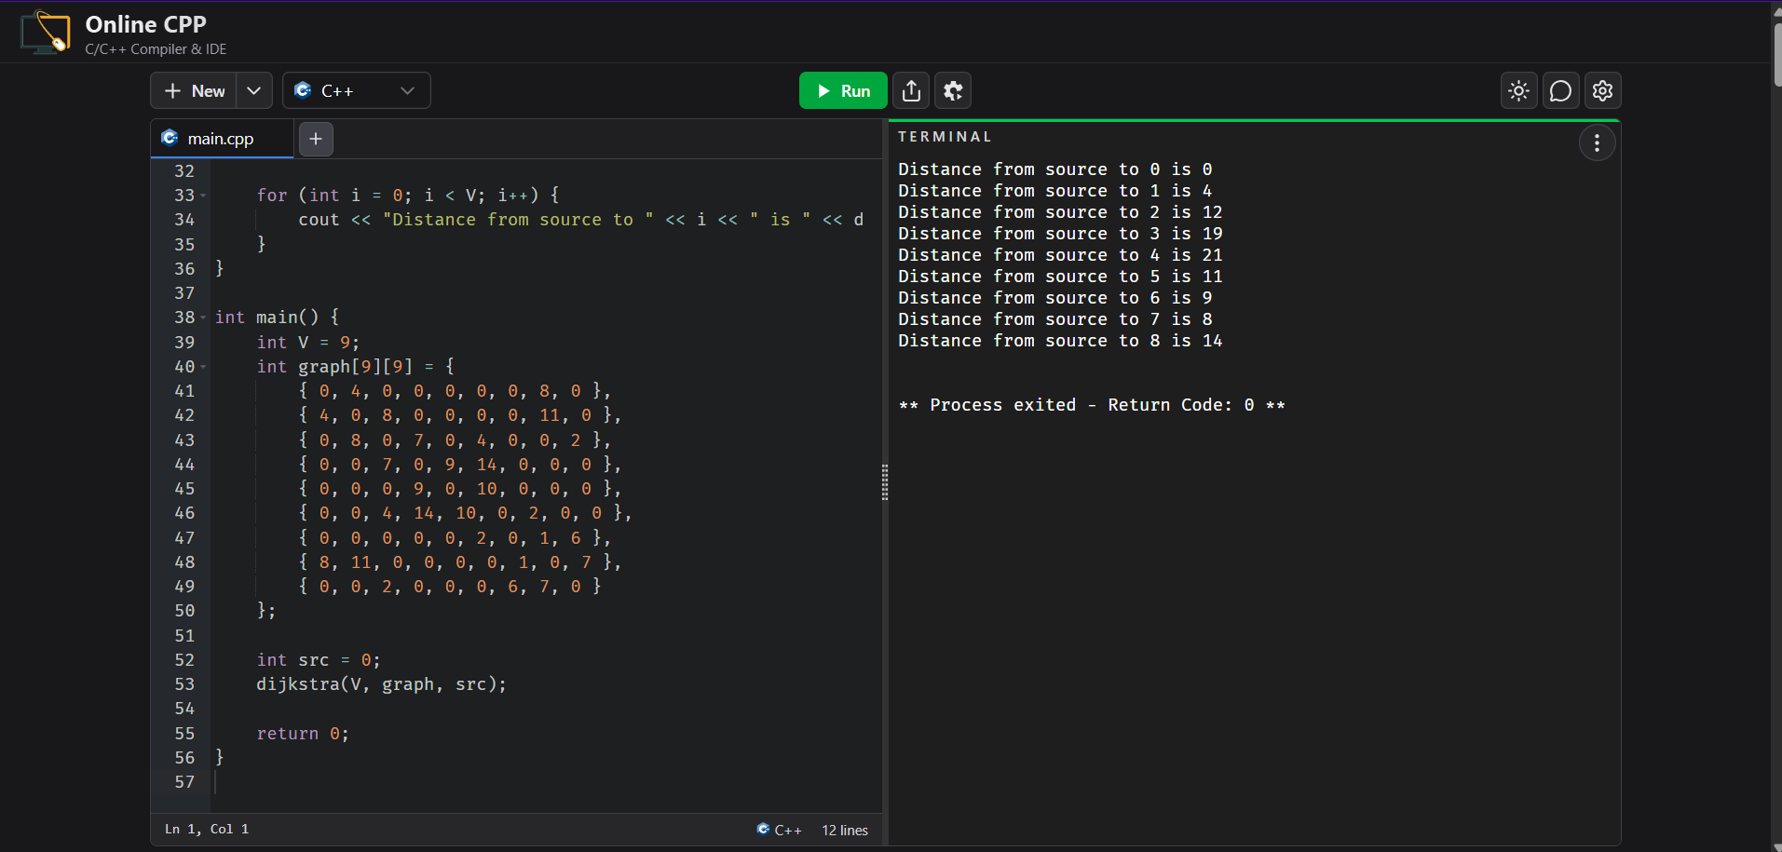
Distance from source to 0 is 0
Distance from source to 1 is 4
Distance from source to 2 is 12
Distance from source to 3 is 19
Distance from source to 4 is 21
Distance from source to 5 is 11
Distance from source to 6 is 9
Distance from source to 7 is 8
Distance from source to 8 is 14

