MODERN OPERATING SYSTEMS AND COMPUTER NETWORKS
ASSIGNMENT-3
Done by: 2503B05203 (M.Tech)
Name: B Subhash Chandra

Task:1
Problem-01:
A bit stream 1101011011 is transmitted using the standard CRC method. The generator polynomial is x4+x+1. What is the actual bit string transmitted?
CODE AND COMPLICATION RESULTS:
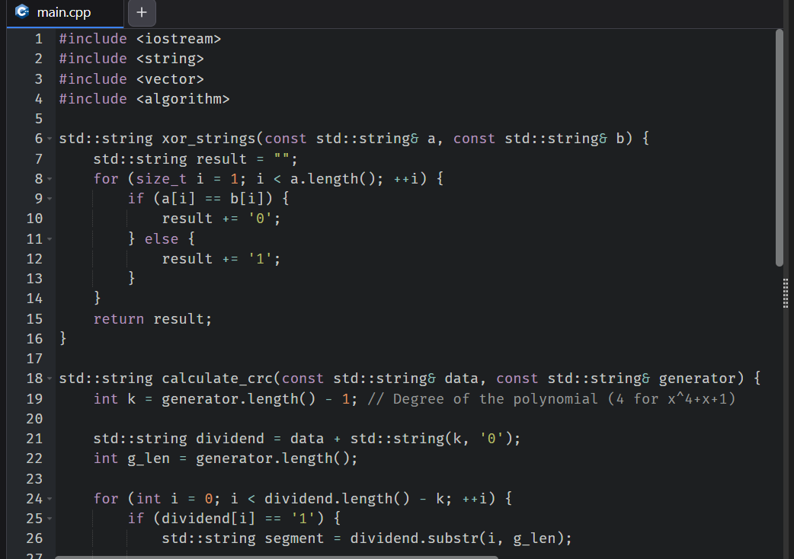
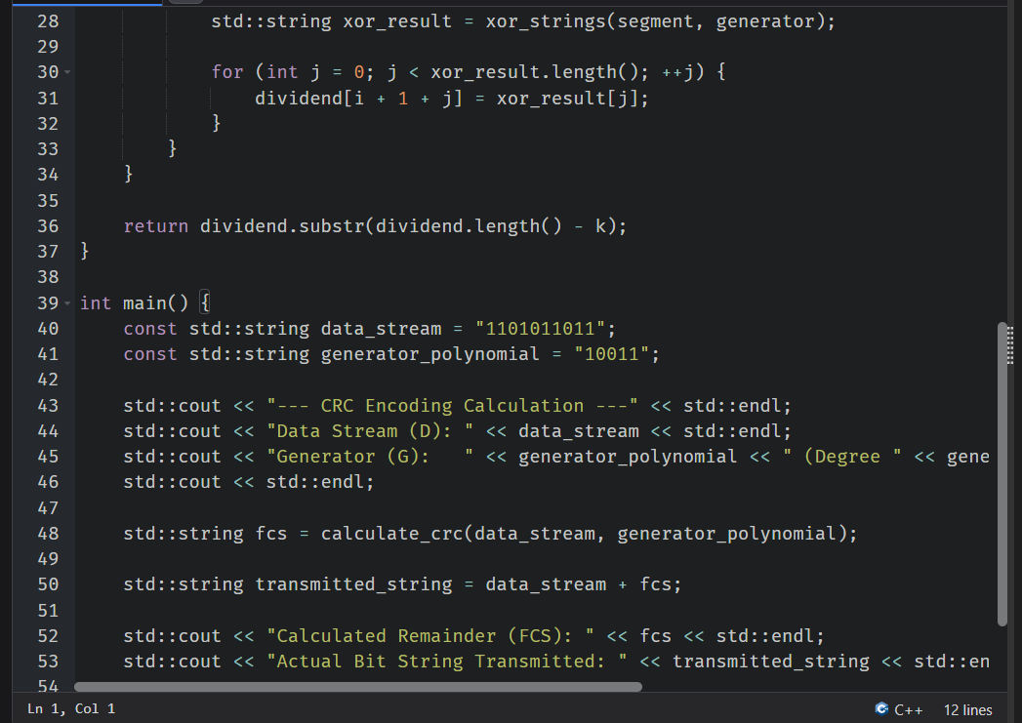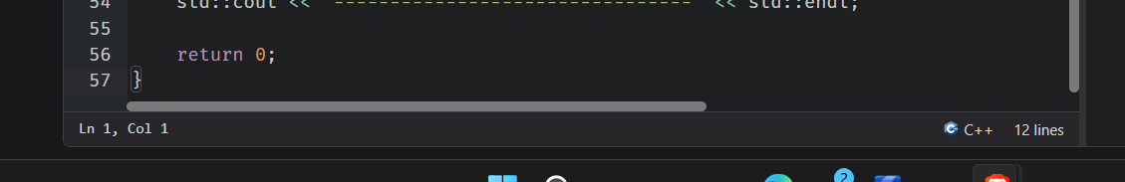

#include <iostream>
#include <string>
#include <vector>
#include <algorithm>

std::string xor_strings(const std::string& a, const std::string& b) {
std::string result = "";
for (size_t i = 1; i < a.length(); ++i) {
if (a[i] == b[i]) {
result += '0';
} else {
result += '1';
}
}
return result;
}

std::string calculate_crc(const std::string& data, const std::string& generator) {
int k = generator.length() - 1; // Degree of the polynomial (4 for x^4+x+1)

std::string dividend = data + std::string(k, '0');
int g_len = generator.length();

for (int i = 0; i < dividend.length() - k; ++i) {
if (dividend[i] == '1') {
std::string segment = dividend.substr(i, g_len);

std::string xor_result = xor_strings(segment, generator);

for (int j = 0; j < xor_result.length(); ++j) {
dividend[i + 1 + j] = xor_result[j];
}
}
}

return dividend.substr(dividend.length() - k);
}

int main() {
const std::string data_stream = "1101011011";
const std::string generator_polynomial = "10011";

std::cout << "--- CRC Encoding Calculation ---" << std::endl;
std::cout << "Data Stream (D): " << data_stream << std::endl;
std::cout << "Generator (G): " << generator_polynomial << " (Degree " << generator_polynomial.length() - 1 << ")" << std::endl;
std::cout << std::endl;

std::string fcs = calculate_crc(data_stream, generator_polynomial);

std::string transmitted_string = data_stream + fcs;

std::cout << "Calculated Remainder (FCS): " << fcs << std::endl;
std::cout << "Actual Bit String Transmitted: " << transmitted_string << std::endl;
std::cout << "--------------------------------" << std::endl;

return 0;
}

Output:
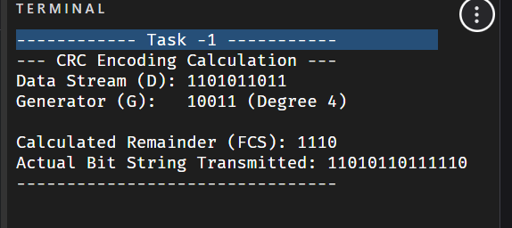

Task:2
Problem-02:
A bit stream 10011101 is transmitted using the standard CRC method. The generator polynomial is x³+1.

- What is the actual bit string transmitted?
- Suppose the third bit from the left is inverted during transmission. How will receiver detect this error?
CODE AND COMPILATION RESULTS:
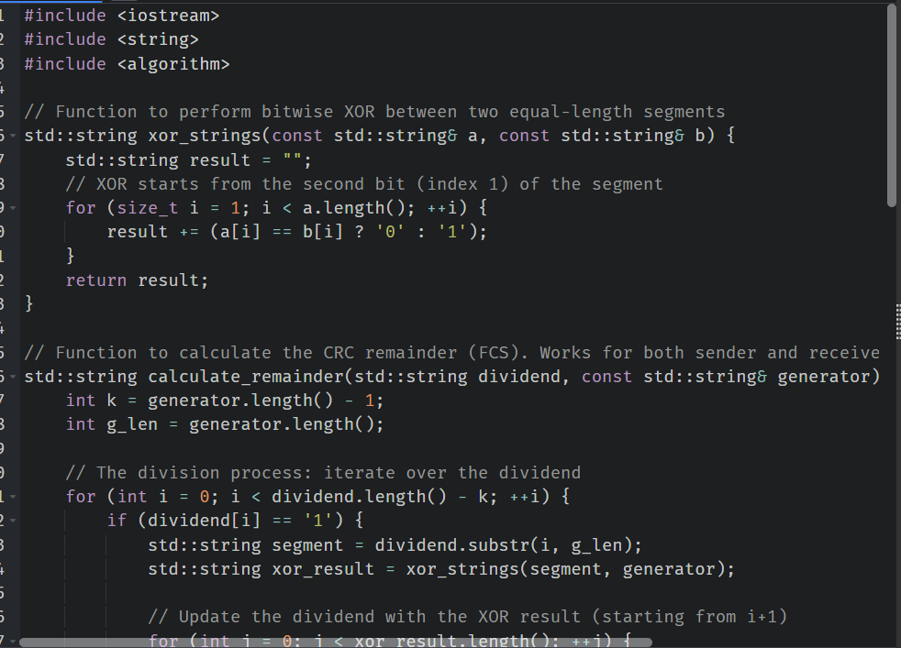
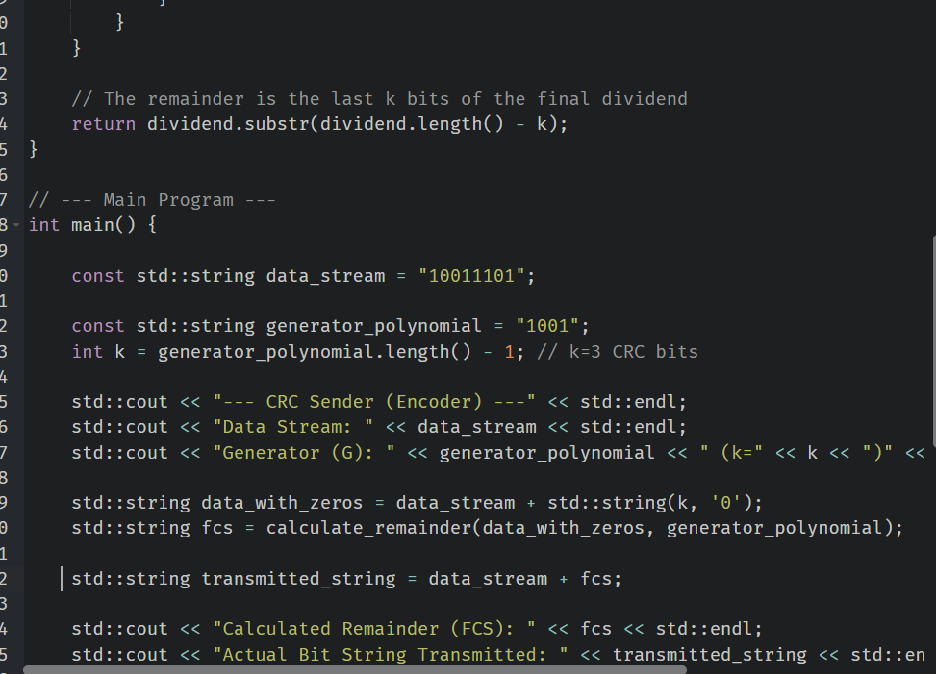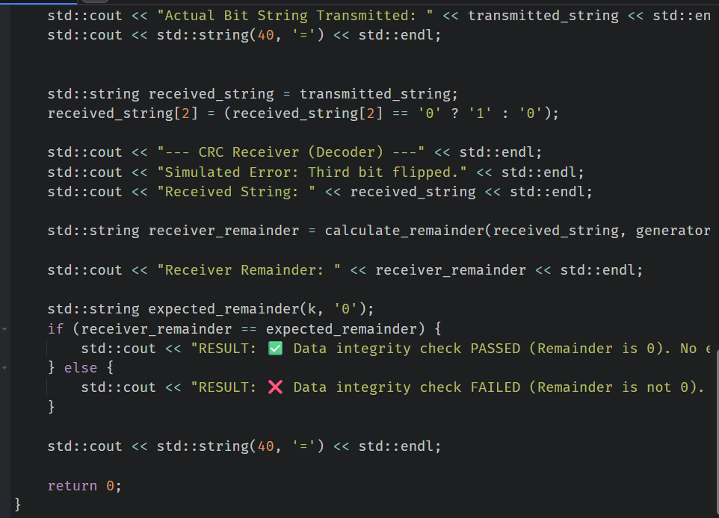

Code:
#include <iostream>
#include <string>
#include <algorithm>

// Function to perform bitwise XOR between two equal-length segments
std::string xor_strings(const std::string& a, const std::string& b) {
std::string result = "";
// XOR starts from the second bit (index 1) of the segment
for (size_t i = 1; i < a.length(); ++i) {
result += (a[i] == b[i] ? '0' : '1');
}
return result;
}

// Function to calculate the CRC remainder (FCS). Works for both sender and receiver.
std::string calculate_remainder(std::string dividend, const std::string& generator) {
int k = generator.length() - 1;
int g_len = generator.length();

// The division process: iterate over the dividend
for (int i = 0; i < dividend.length() - k; ++i) {
if (dividend[i] == '1') {
std::string segment = dividend.substr(i, g_len);
std::string xor_result = xor_strings(segment, generator);

// Update the dividend with the XOR result (starting from i+1)
for (int j = 0; j < xor_result.length(); ++j) {
dividend[i + 1 + j] = xor_result[j];
}
}
}

// The remainder is the last k bits of the final dividend
return dividend.substr(dividend.length() - k);
}

// --- Main Program ---
int main() {

const std::string data_stream = "10011101";

const std::string generator_polynomial = "1001";
int k = generator_polynomial.length() - 1; // k=3 CRC bits

std::cout << "--- CRC Sender (Encoder) ---" << std::endl;
std::cout << "Data Stream: " << data_stream << std::endl;
std::cout << "Generator (G): " << generator_polynomial << " (k=" << k << ")" << std::endl;

std::string data_with_zeros = data_stream + std::string(k, '0');
std::string fcs = calculate_remainder(data_with_zeros, generator_polynomial);

std::string transmitted_string = data_stream + fcs;

std::cout << "Calculated Remainder (FCS): " << fcs << std::endl;
std::cout << "Actual Bit String Transmitted: " << transmitted_string << std::endl;
std::cout << std::string(40, '=') << std::endl;

std::string received_string = transmitted_string;
received_string[2] = (received_string[2] == '0' ? '1' : '0');

std::cout << "--- CRC Receiver (Decoder) ---" << std::endl;
std::cout << "Simulated Error: Third bit flipped." << std::endl;
std::cout << "Received String: " << received_string << std::endl;

std::string receiver_remainder = calculate_remainder(received_string, generator_polynomial);

std::cout << "Receiver Remainder: " << receiver_remainder << std::endl;

std::string expected_remainder(k, '0');
if (receiver_remainder == expected_remainder) {
std::cout << "RESULT: ✅ Data integrity check PASSED (Remainder is 0). No error detected." << std::endl;
} else {
std::cout << "RESULT: ❌ Data integrity check FAILED (Remainder is not 0). Error detected!" << std::endl;
}

std::cout << std::string(40, '=') << std::endl;

return 0;
}

Output:
