TUTORIAL – 8
Test Case Management and Defect Tracking Using TestLink and Bugzilla
Aim
To apply defect management, test case management, and test execution report generation using Bugzilla and TestLink workflows.
Description
Software testing tools are used to organize test cases, execute tests, record results, and manage software defects. TestLink supports test case management and execution, while Bugzilla supports defect reporting and tracking. In this practical, the login functionality of the SauceDemo website is tested using different valid and invalid inputs.
Website Used
SauceDemo: https://www.saucedemo.com/
Valid Username: standard_user
Valid Password: secret_sauce

- Login Page
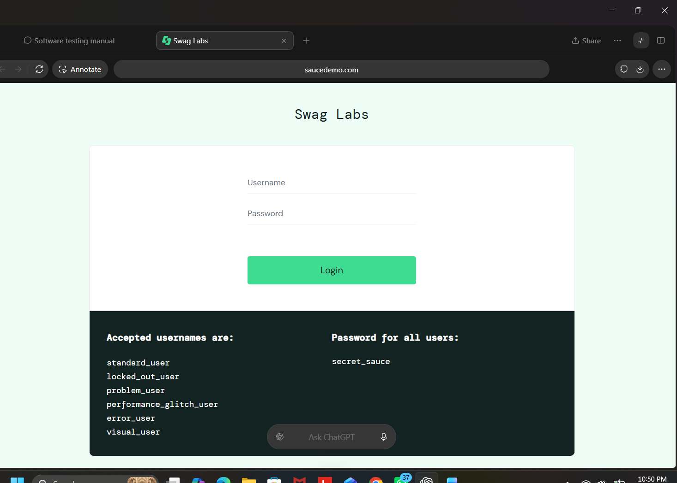

2. Valid Login Test
Test Case ID: TC_LOGIN_01
Test Scenario: Login with valid credentials
Test Data:
Username: standard_user
Password: secret_sauce
Expected Result: User should successfully log in and the Products page should be displayed.
Actual Result: User successfully logged in
Status: Pass
Screenshot:

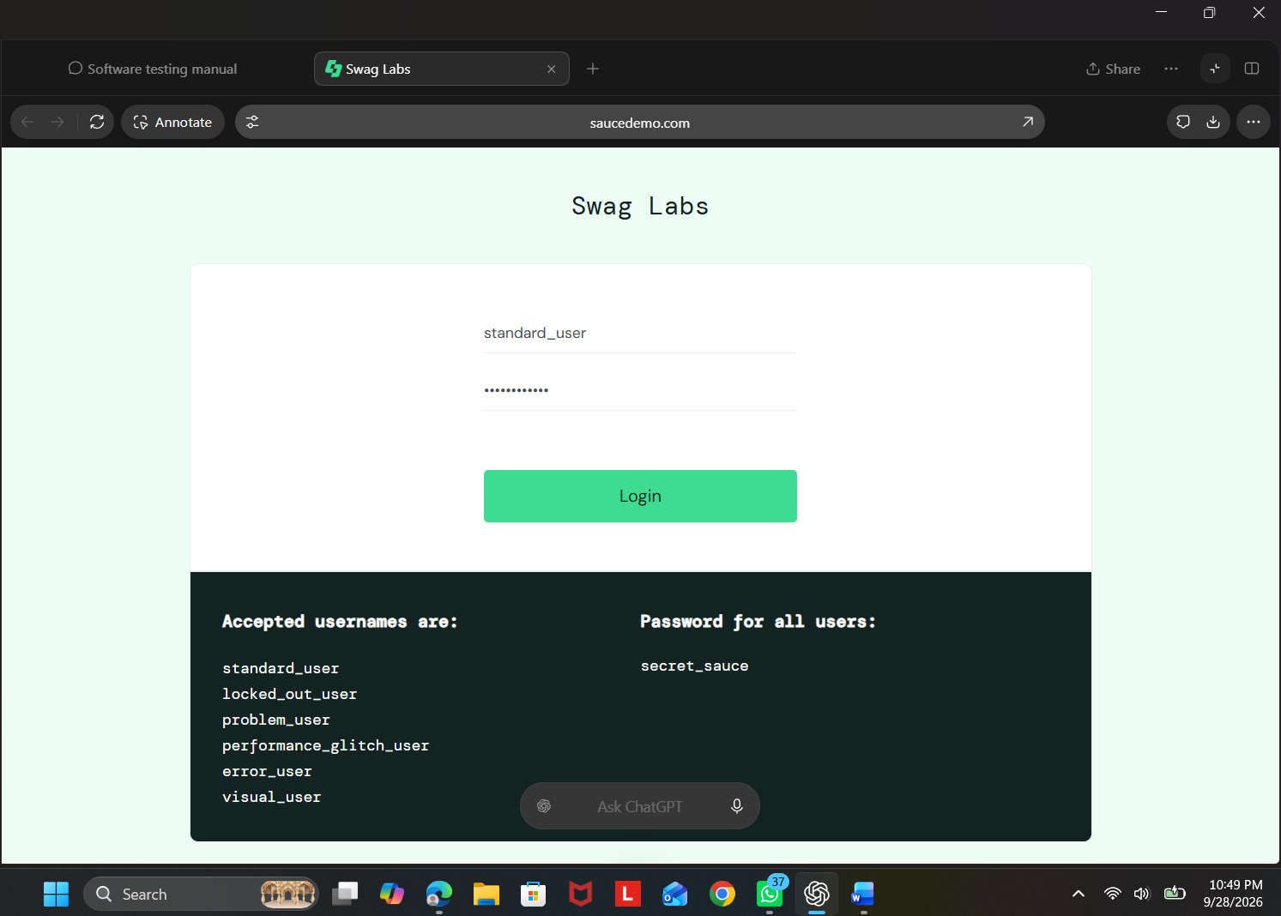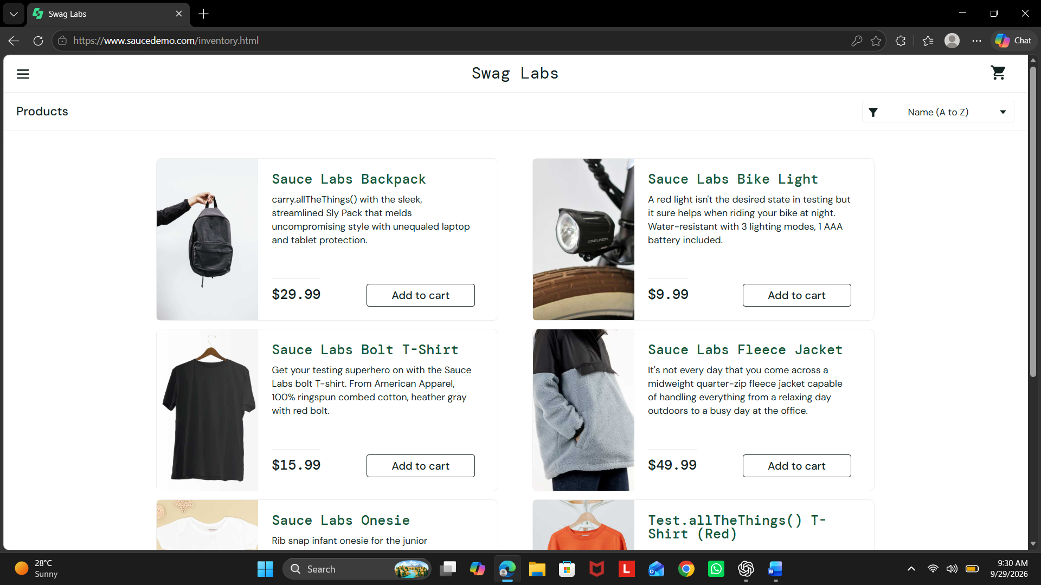

3. Invalid Username Test
Test Case ID: TC_LOGIN_02
Test Scenario: Login with invalid username
Test Data:
Username: invalid_user
Password: secret_sauce
Expected Result: Login should be rejected and an error message should be displayed.
Actual Result: Login was rejected and an error message was displayed.
Status: Pass
Screenshot:
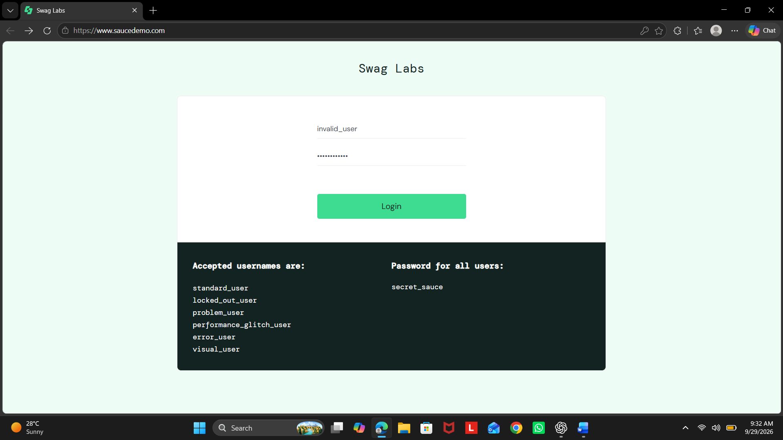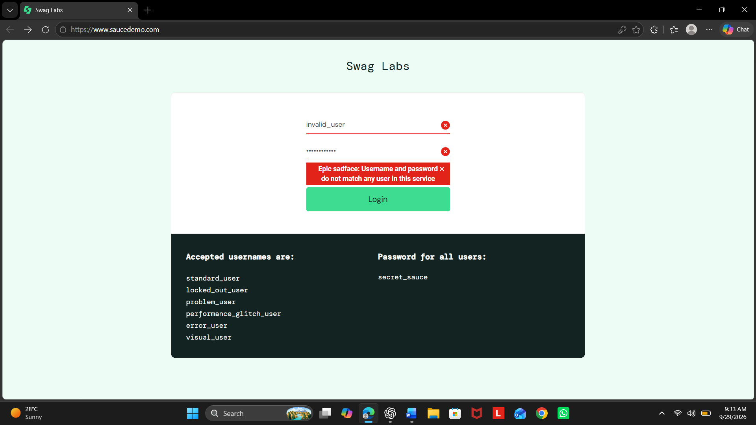

4. Invalid Password Test
Test Case ID: TC_LOGIN_03
Test Scenario: Login with invalid password
Test Data:
Username: standard_user
Password: wrong123
Expected Result: Login should be rejected and an error message should be displayed.
Actual Result: Login was rejected and an error message was displayed.
Status: Pass
Screenshot:
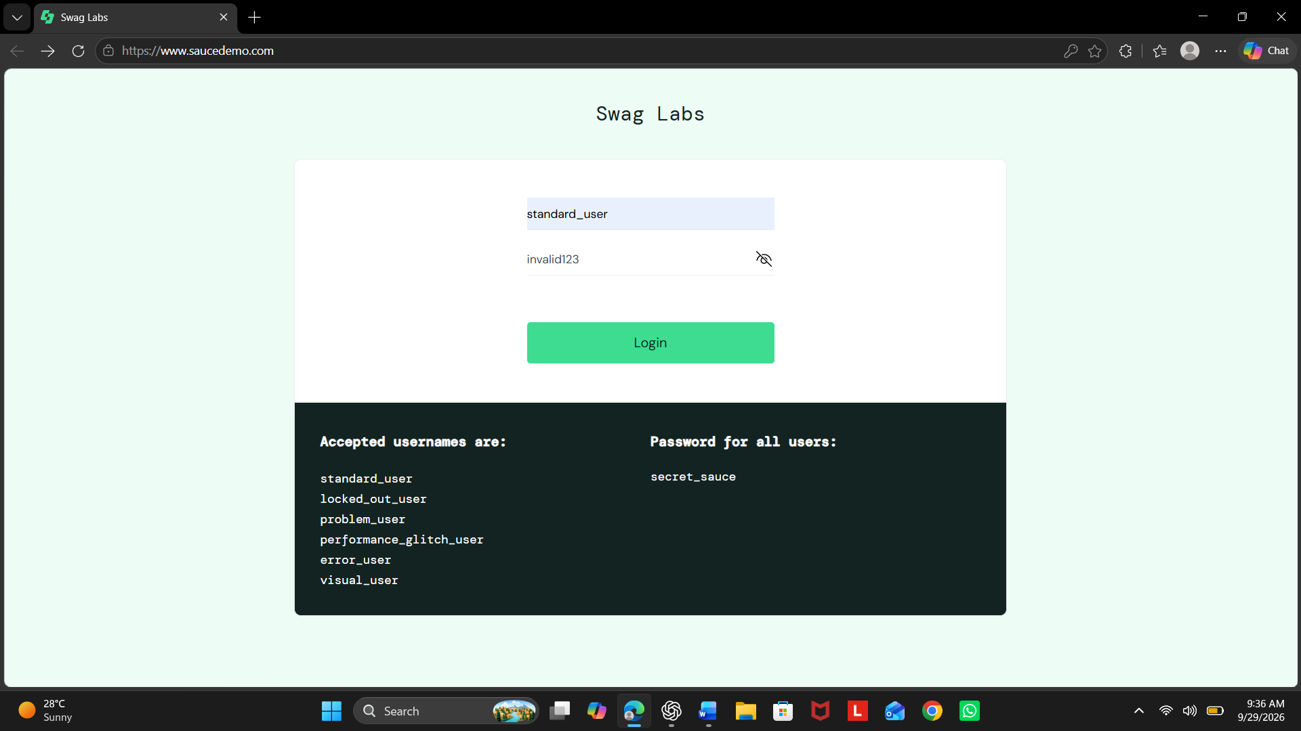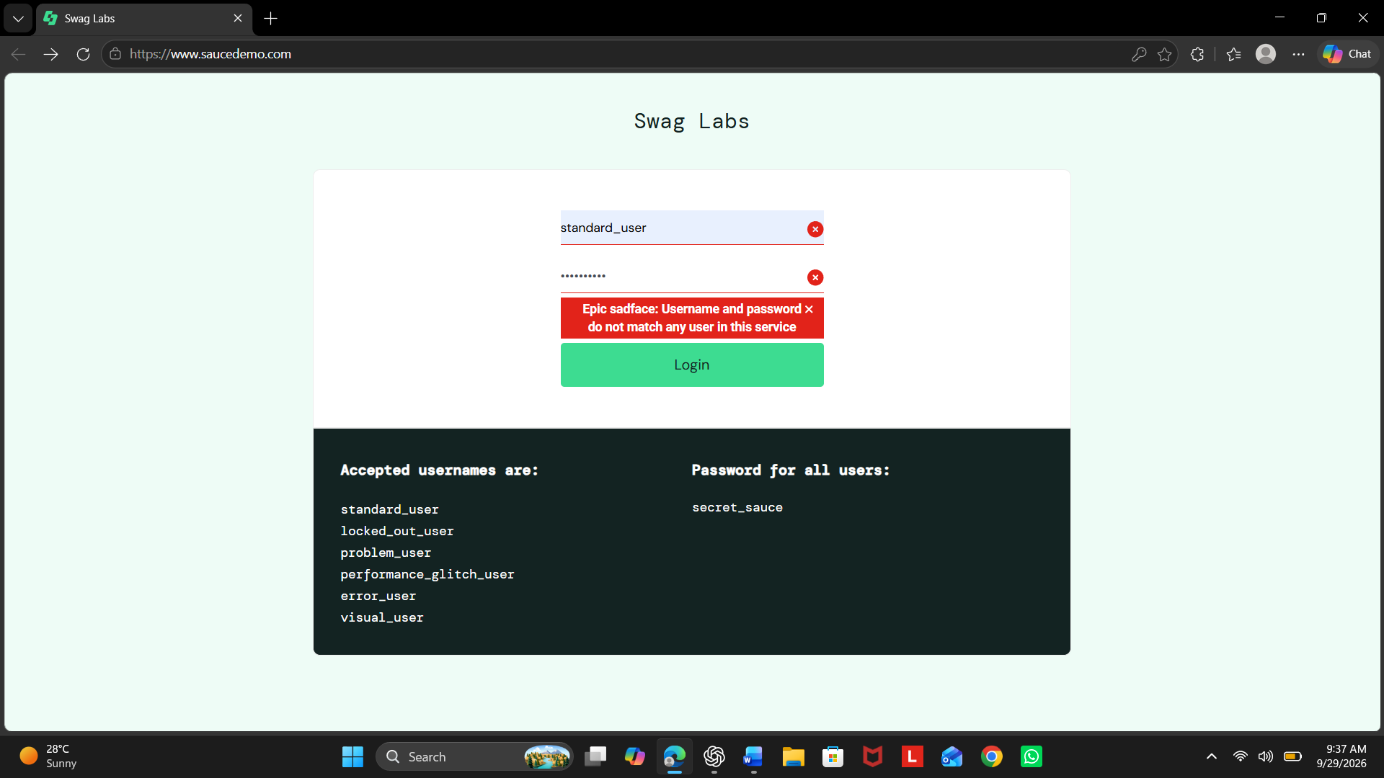

5. Blank Credentials Test
Test Case ID: TC_LOGIN_04
Test Scenario: Login with blank credentials
Expected Result: The application should not allow login and should display a validation/error message.
Actual Result: Login was not allowed and an error message was displayed.
Status: Pass
Screenshot:
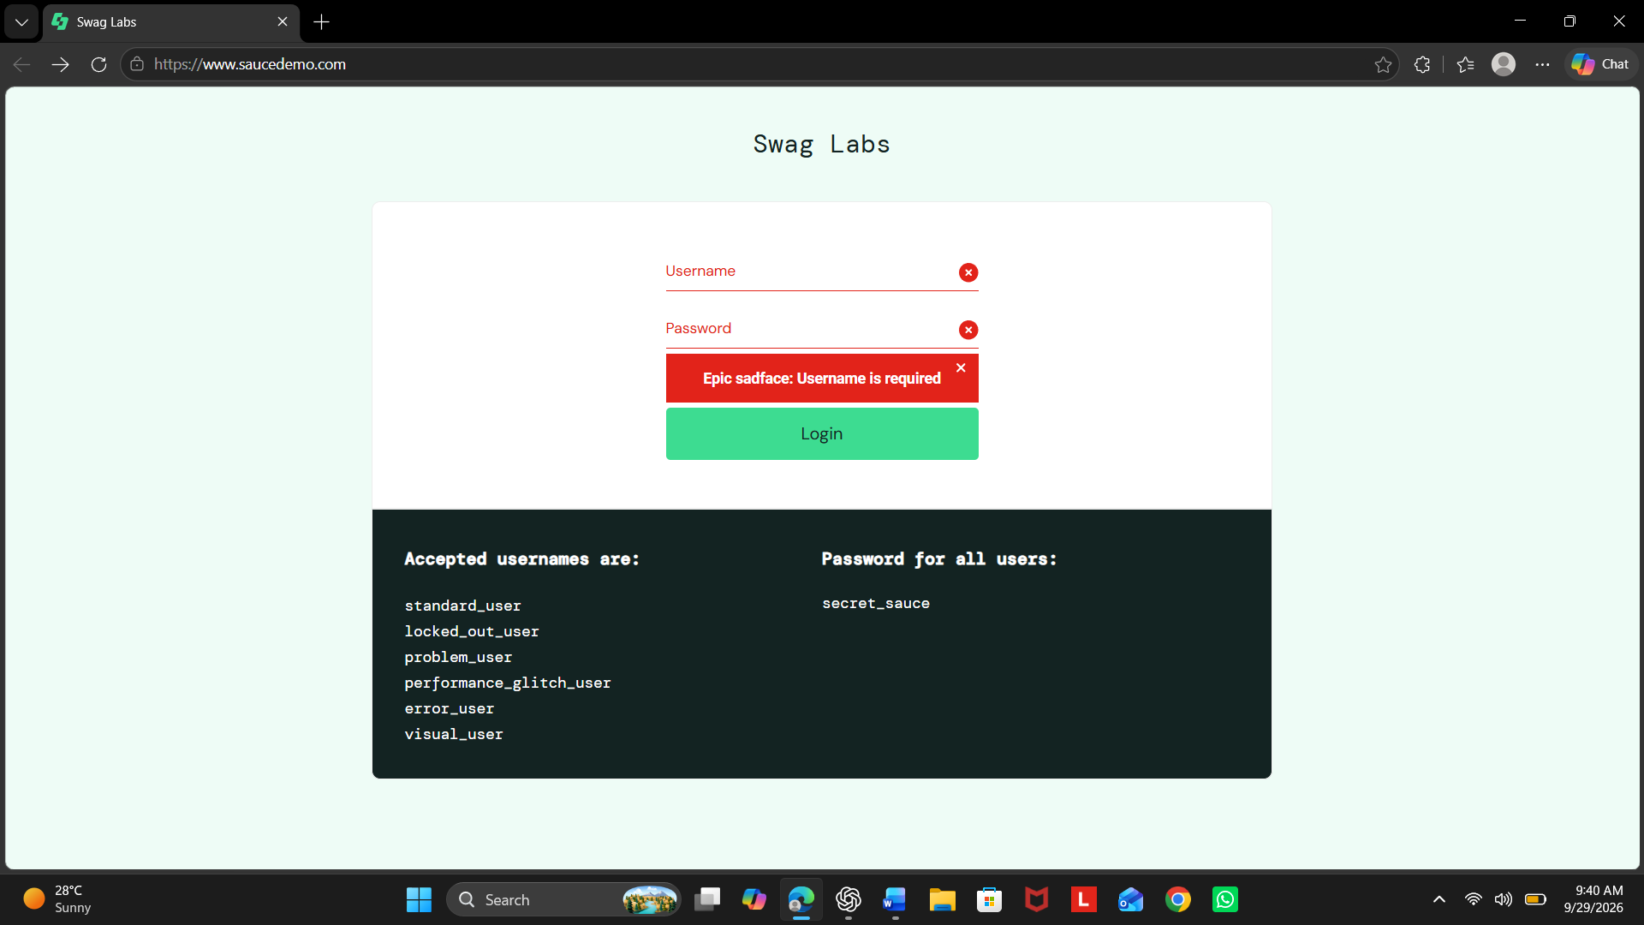

6. Add Product to Cart Test
Test Case ID: TC_CART_01
Test Scenario: Add a product to the shopping cart
Test Data: Sauce Labs Backpack
Expected Result: Selected product should be added to the cart.
Actual Result: Product was successfully added to the cart.
Status: Pass
Screenshot:
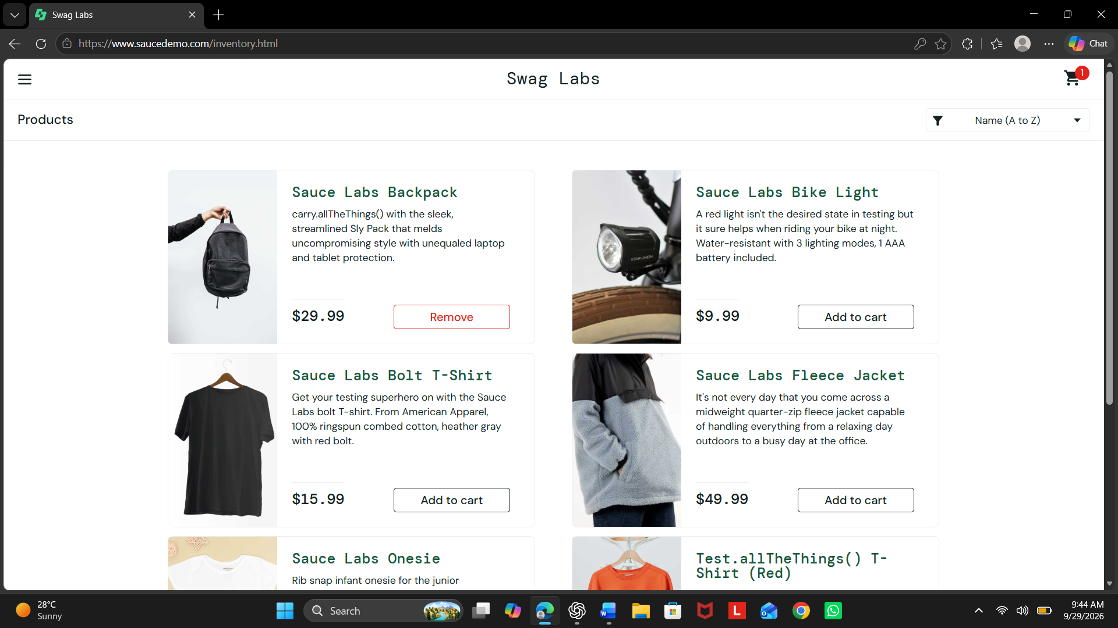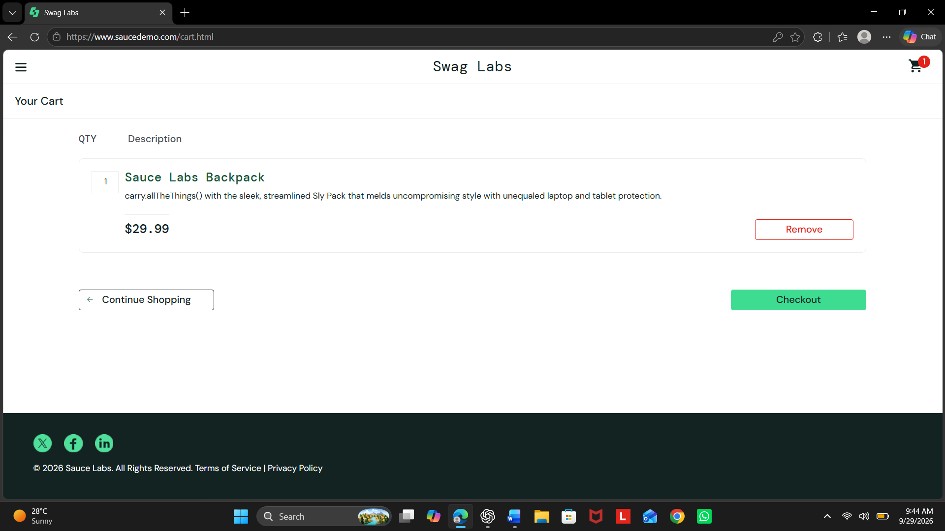

7. Remove Product from Cart Test
Test Case ID: TC_CART_02
Test Scenario: Remove an added product from the cart
Test Data: Sauce Labs Backpack
Expected Result: Selected product should be removed from the cart.
Actual Result: Product was successfully removed from the cart.
Status: Pass
Screenshot:
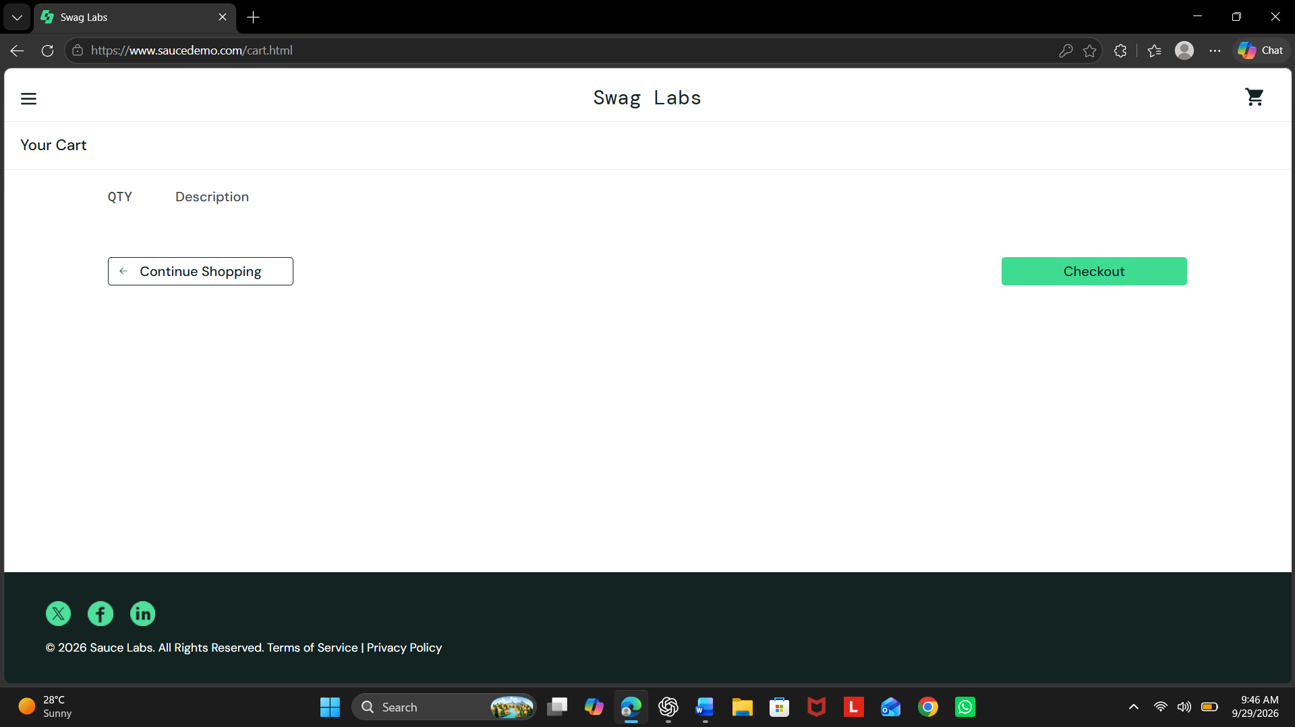

8. Product Sorting Test
Test Case ID: TC_PRODUCT_01
Test Scenario: Sort products by price from low to high
Test Data: Price (low to high)
Expected Result: Products should be arranged from lowest to highest price.
Actual Result: Products were displayed in ascending price order.
Status: Pass
Screenshot:
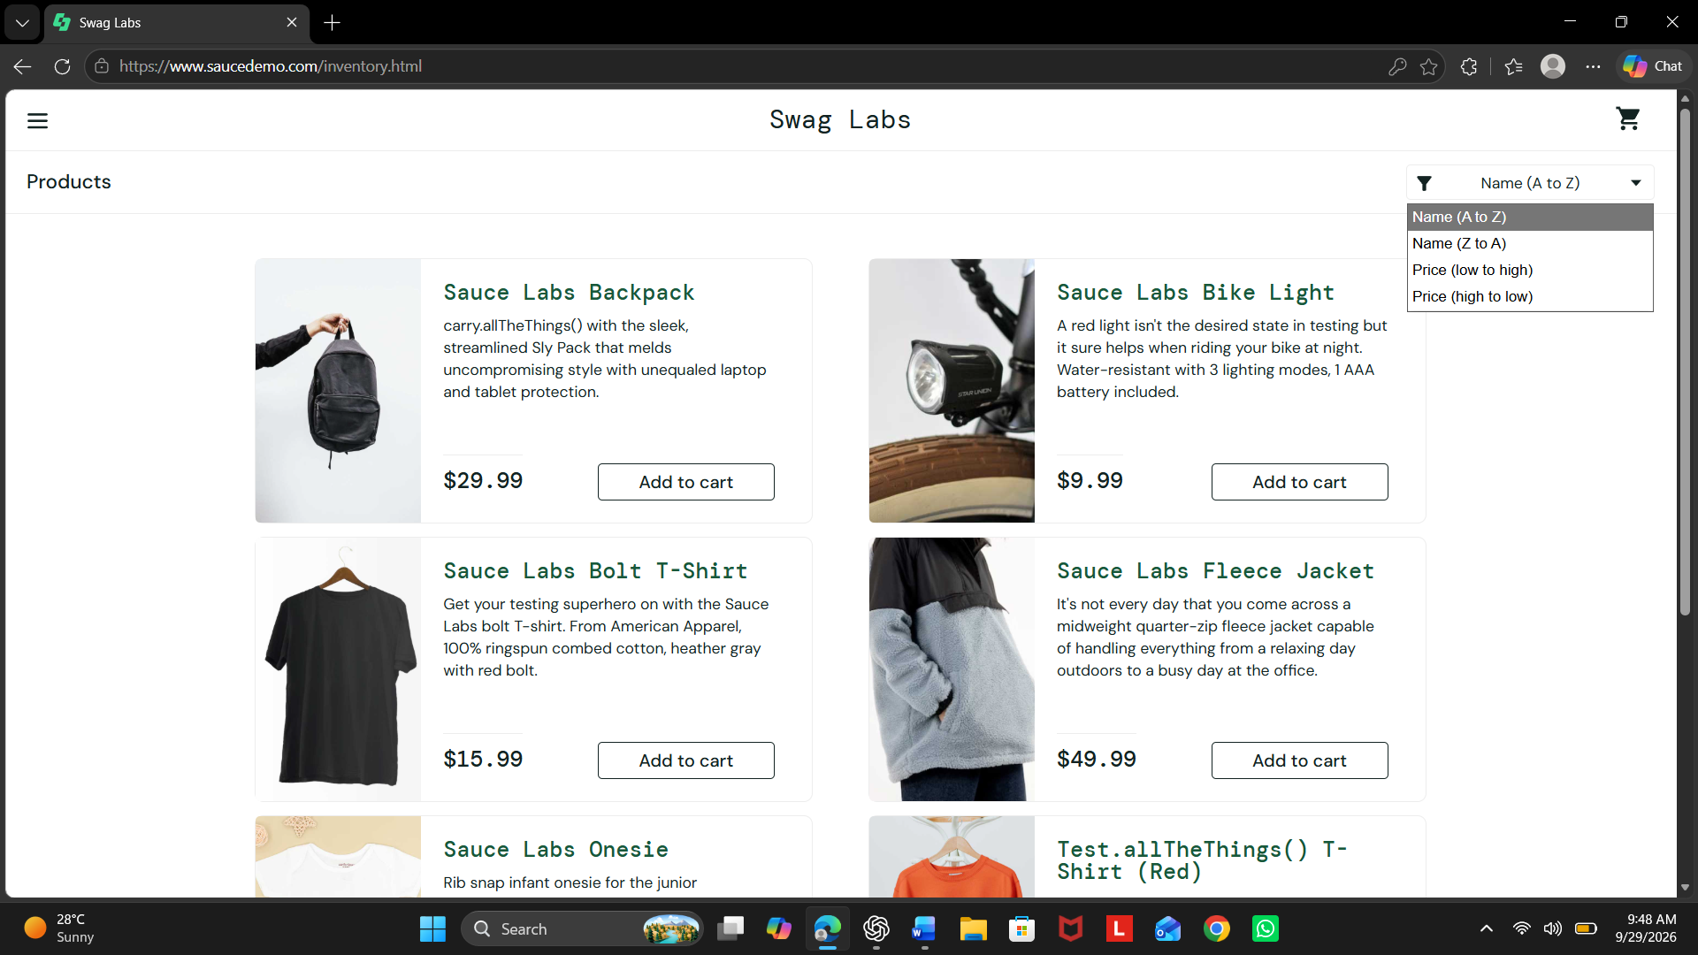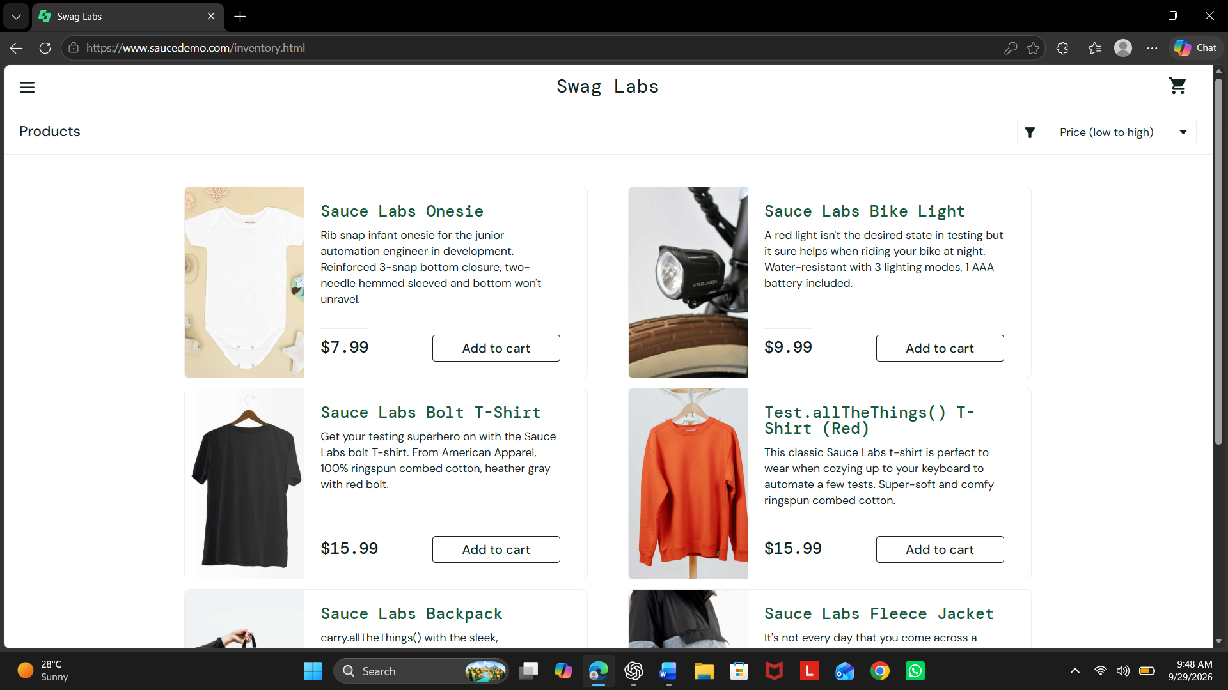

9. Logout Test
Test Case ID: TC_LOGOUT_01
Test Scenario: Logout from the application
Expected Result: User should be logged out and redirected to the login page.
Actual Result: User was successfully logged out and the login page was displayed.
Status: Pass
Screenshot:
