SOFTWARE TESTING TUTORIAL
SAUCEDEMO LOGIN TESTING USING SELENIUM

1. Aim
To analyze and automate the login functionality of the SauceDemo website using Python and Selenium WebDriver, including valid login, invalid credentials, empty fields, and locked-out account scenarios.

2. Software and Tools Required
Programming Language | Python
IDE | PyCharm
Automation Tool | Selenium WebDriver
Browser | Google Chrome
Website Under Test | https://www.saucedemo.com/

3. Test Website Credentials
Website: https://www.saucedemo.com/
Valid username: standard_user
Password: secret_sauce
Locked-out test username: locked_out_user

4. Prompt
Analyze the following software requirement for the SauceDemo website:
“A registered user should be able to log in using a valid username and password.
Invalid credentials should be rejected and an appropriate error message should be displayed.”
Generate positive and negative test cases, test data, expected results, regression test cases, possible defect-prone areas, and Selenium Python automation code suitable for PyCharm using Google Chrome.

5. Python Source Code
The script performs login tests, validates the resulting page or error message, prints test outcomes, and saves screenshots in the current working directory.
from pathlib import Path
from selenium import webdriver
from selenium.webdriver.common.by import By
from selenium.webdriver.support.ui import WebDriverWait
from selenium.webdriver.support import expected_conditions as EC
URL = "https://www.saucedemo.com/"
SCREENSHOT_DIR = Path("screenshots")
SCREENSHOT_DIR.mkdir(exist_ok=True)
driver = webdriver.Chrome()
driver.maximize_window()
wait = WebDriverWait(driver, 10)
def capture(name):
"""Save a screenshot of the current browser page."""
driver.save_screenshot(str(SCREENSHOT_DIR / f"{name}.png"))
def login(username, password):
"""Open SauceDemo and submit the provided credentials."""
driver.get(URL)
wait.until(
EC.visibility_of_element_located((By.ID, "user-name"))
).send_keys(username)
driver.find_element(By.ID, "password").send_keys(password)
driver.find_element(By.ID, "login-button").click()
def check_error(expected_text, screenshot_name):
"""Verify the login error message."""
error = wait.until(
EC.visibility_of_element_located(
(By.CSS_SELECTOR, "[data-test='error']")
)
)
assert expected_text.lower() in error.text.lower(), (
f"Expected '{expected_text}', but received '{error.text}'"
)
capture(screenshot_name)
def test_valid_login():
login("standard_user", "secret_sauce")
wait.until(EC.url_contains("/inventory.html"))
heading = wait.until(
EC.visibility_of_element_located((By.CLASS_NAME, "title"))
)
assert heading.text == "Products"
capture("valid_login_products")
print("TC01 PASS - Valid login")
def test_invalid_username():
login("wrong_user", "secret_sauce")
check_error("do not match any user", "invalid_username_error")
print("TC02 PASS - Invalid username rejected")
def test_invalid_password():
login("standard_user", "wrong_password")
check_error("do not match any user", "invalid_password_error")
print("TC03 PASS - Invalid password rejected")
def test_empty_username():
login("", "secret_sauce")
check_error("Username is required", "empty_username_error")
print("TC04 PASS - Empty username rejected")
def test_empty_password():
login("standard_user", "")
check_error("Password is required", "empty_password_error")
print("TC05 PASS - Empty password rejected")
def test_locked_out_user():
login("locked_out_user", "secret_sauce")
check_error("locked out", "locked_out_user_error")
print("TC06 PASS - Locked-out user rejected")
try:
driver.get(URL)
capture("saucedemo_login_page")
print("SauceDemo login page opened")
test_valid_login()
test_invalid_username()
test_invalid_password()
test_empty_username()
test_empty_password()
test_locked_out_user()
print("All login test cases completed.")
finally:
driver.quit()

6. Screenshots
☐ SauceDemo login page 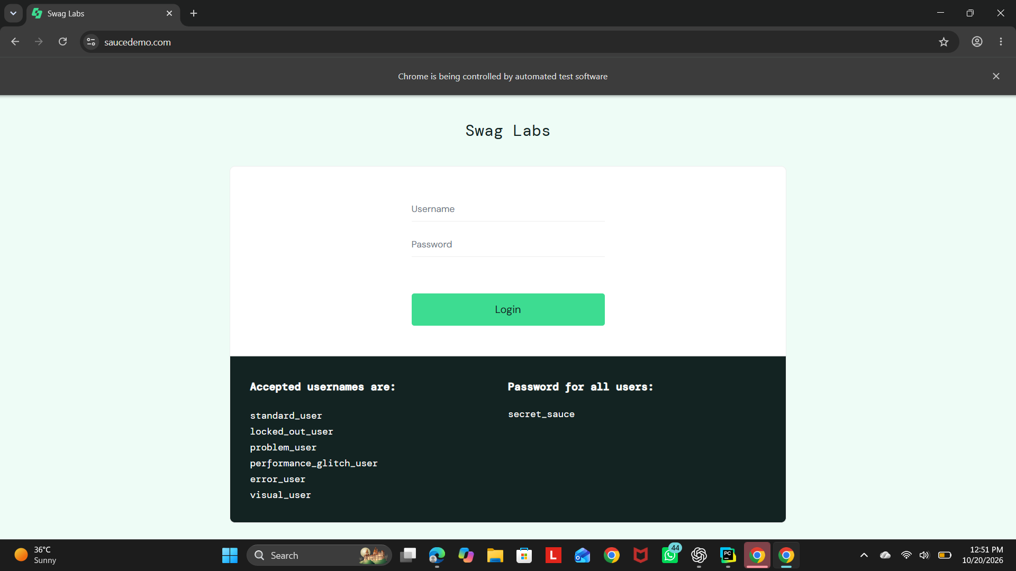
☐ Products page after successful login
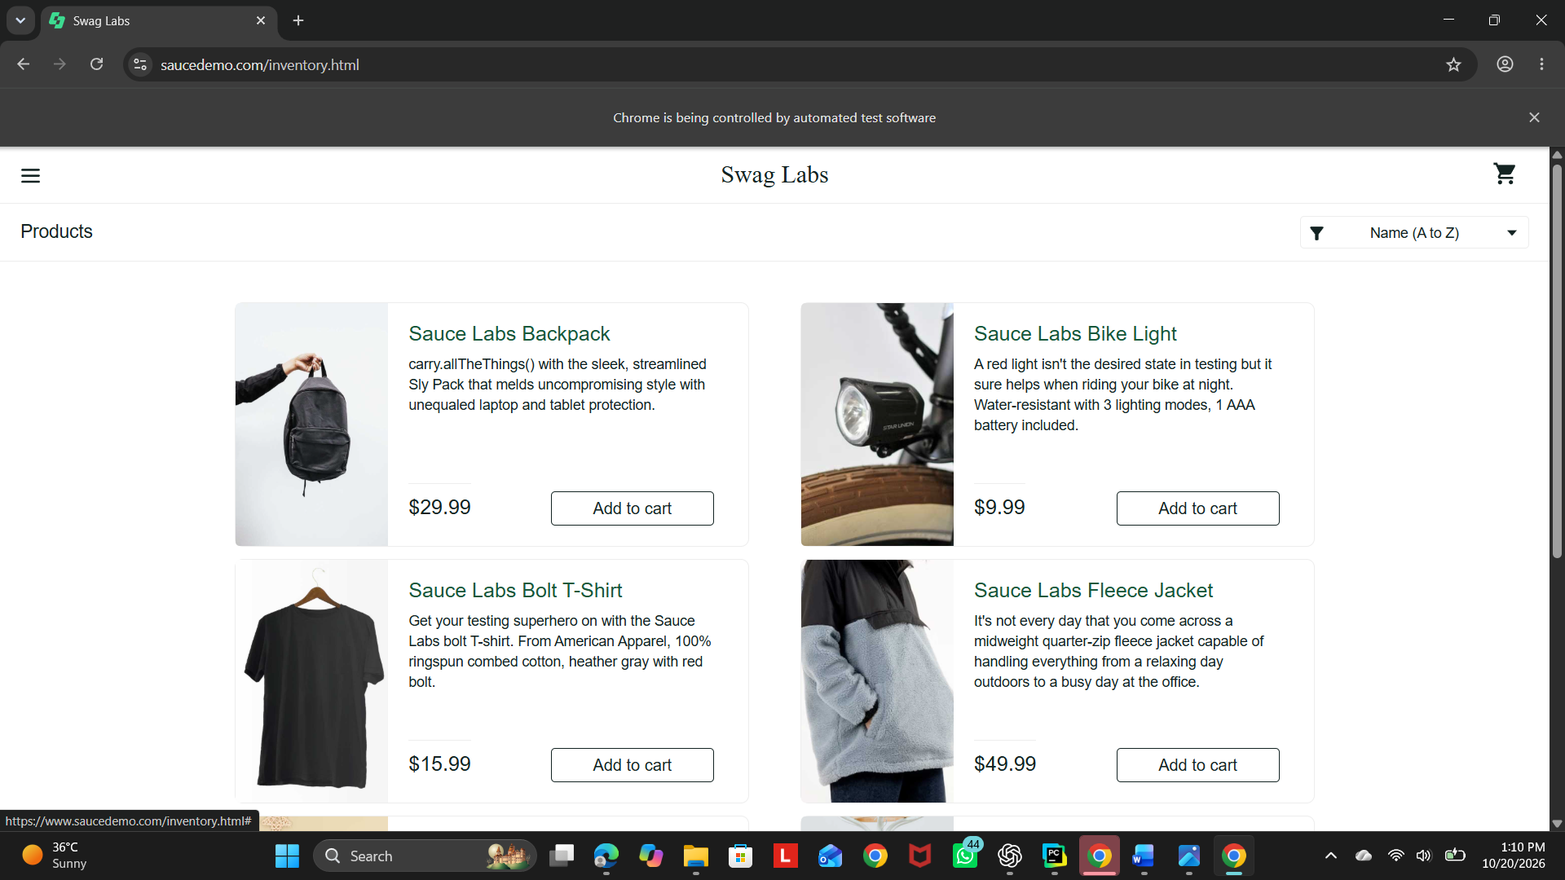
☐ Invalid username error message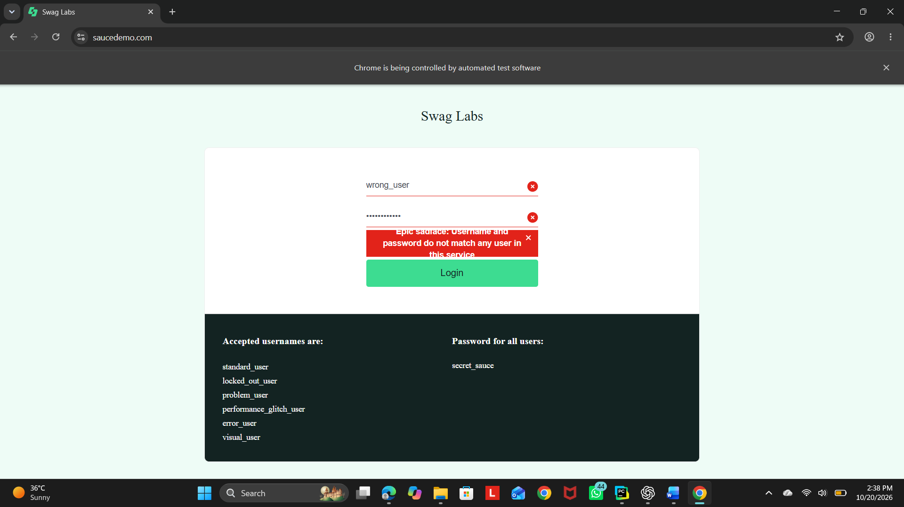

☐ Invalid password error message
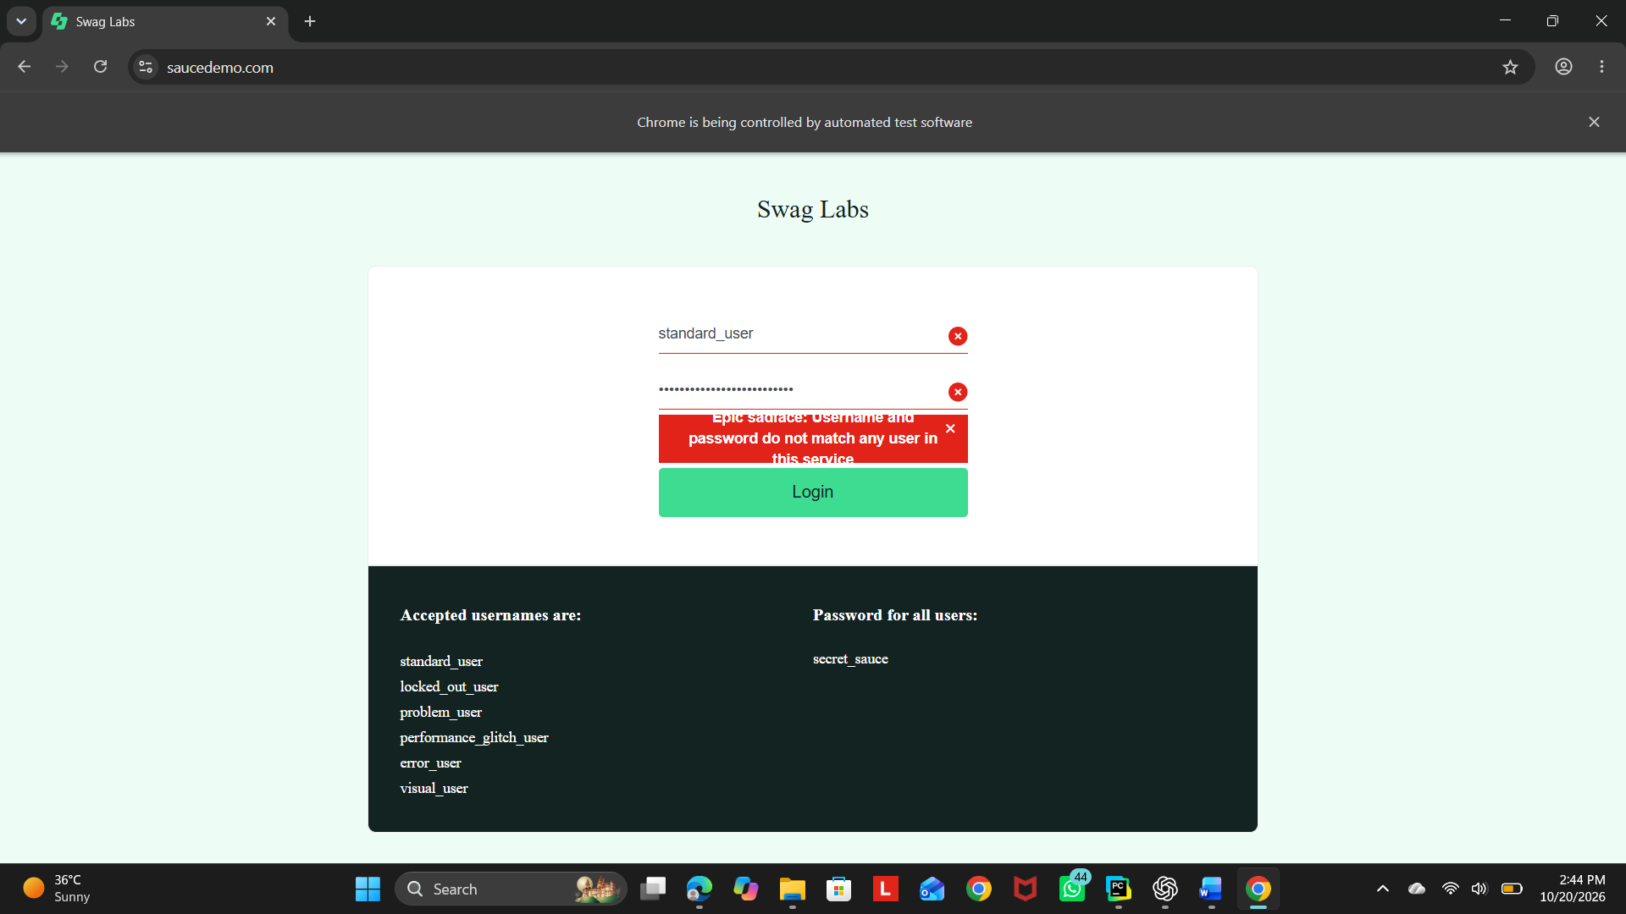
☐ Empty username error message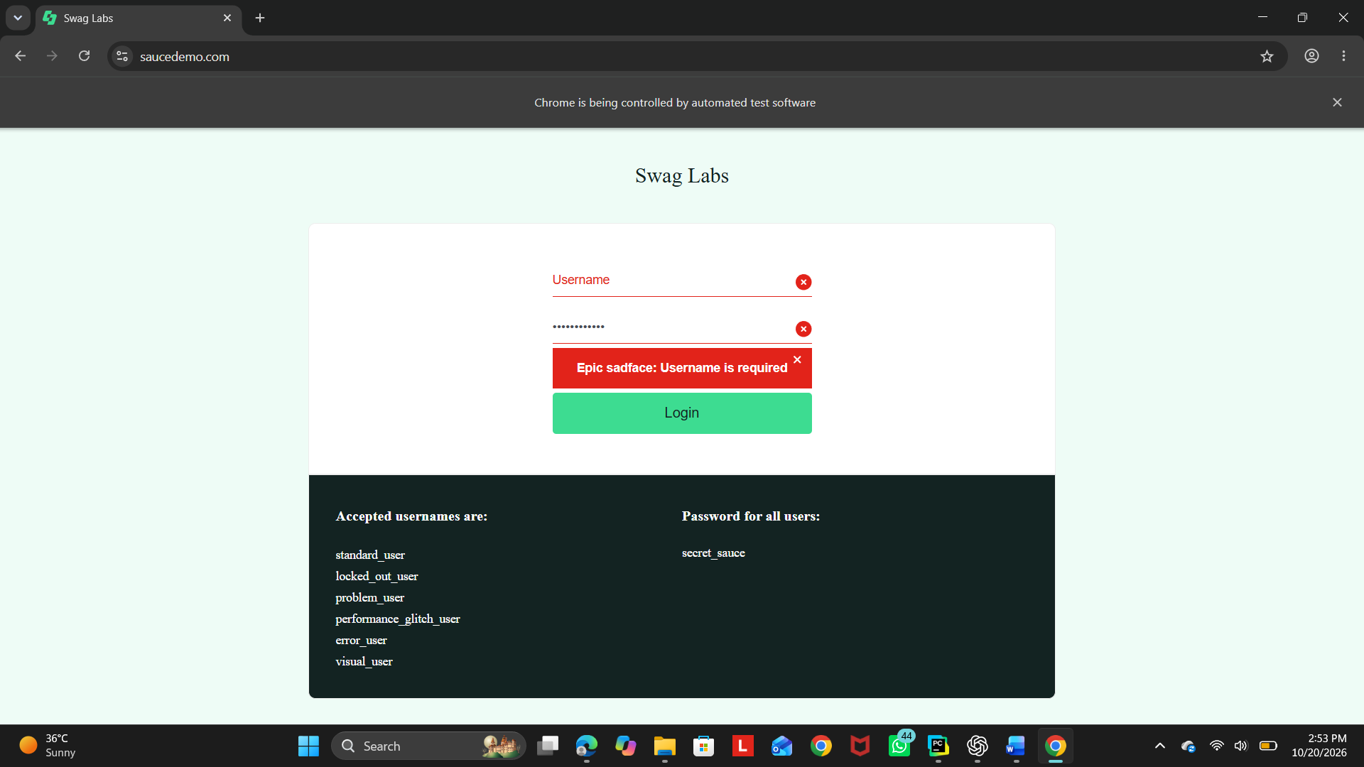
☐ Empty password error message
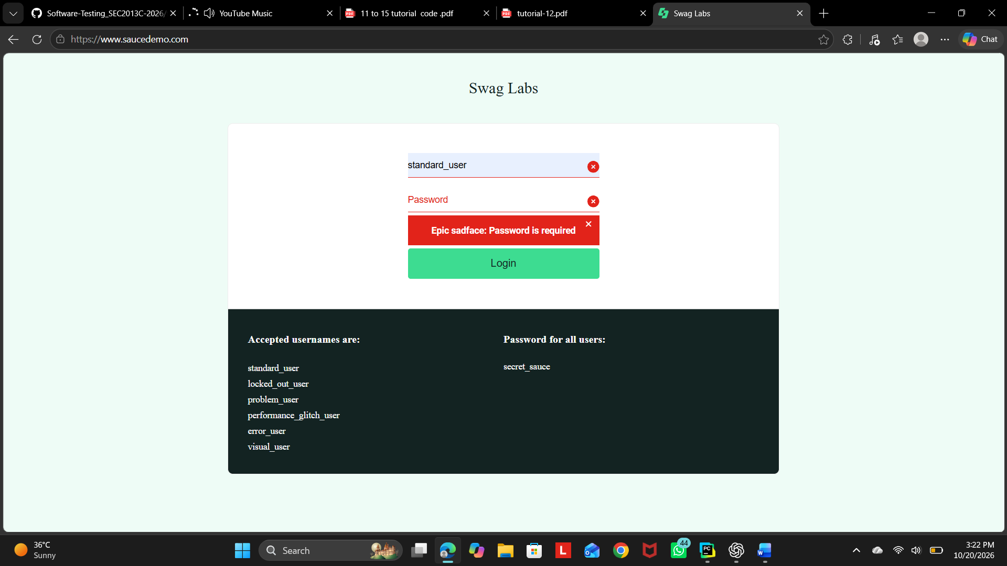
☐ Locked-out user error message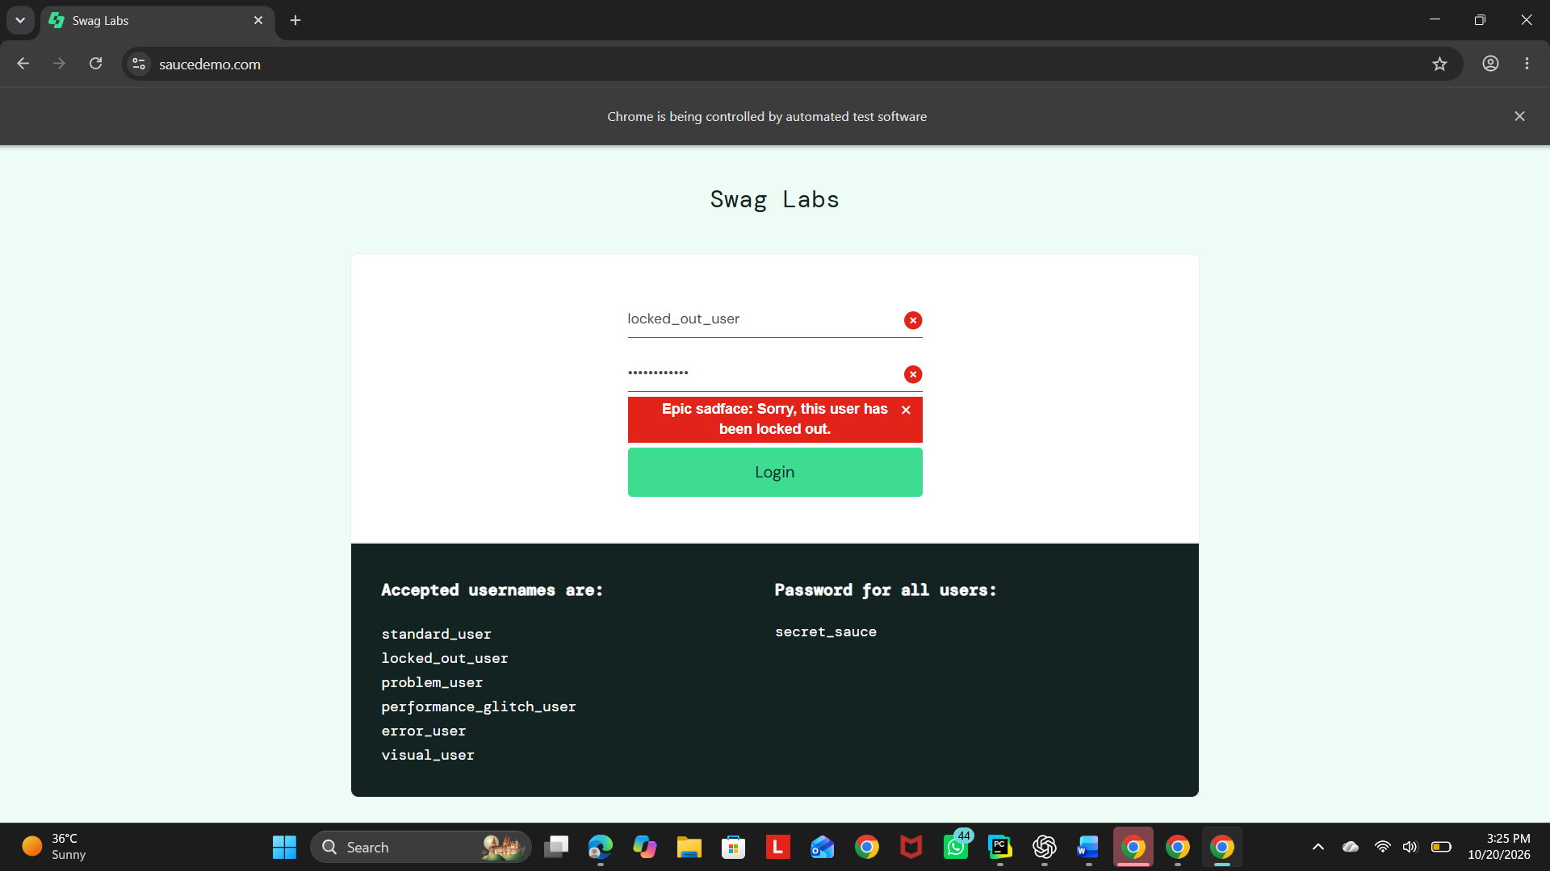

☐ PyCharm console showing PASS messages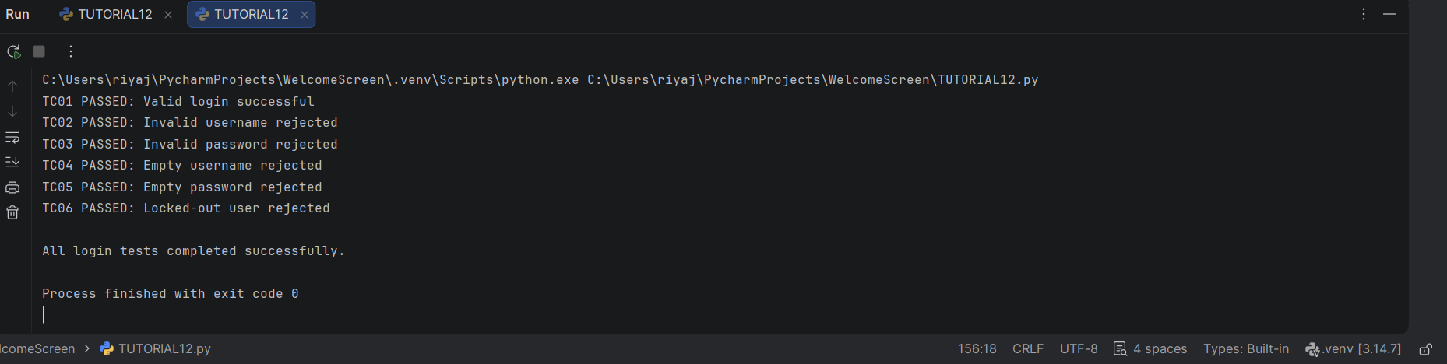

7. Conclusion
The SauceDemo login requirement was addressed using Selenium WebDriver with Python. The automation script verifies successful login with valid credentials and confirms that invalid usernames, invalid passwords, empty required fields, and a locked-out account are rejected with appropriate error messages. Screenshots are saved during execution to provide evidence of the application behavior. The test results should be confirmed by running the script in the local PyCharm and Google Chrome environment.

