TUTORIAL – 11
PYTHON AUTOMATION TESTING USING SELENIUM
Website: SauceDemo

1. Aim
To analyze automation testing in Python for website navigation, forms, multi-page workflows, links, and regression testing scenarios.

2. Software and Tools Required
SDLC Model | Agile
Programming Language | Python
IDE | PyCharm
Automation Tool | Selenium WebDriver
Browser | Google Chrome
Website Under Test | https://www.saucedemo.com/

3. Test Website Credentials
Website: https://www.saucedemo.com/
Username: standard_user
Password: secret_sauce
These are the demo credentials used by the SauceDemo practice website.

4. Test Scenarios
Test Case ID | Test Scenario | Expected / Observed Result | Status
TC-11-01 | Open website | SauceDemo login page opens in Chrome. | Pass
TC-11-02 | Valid login | User reaches the Products/Inventory page. | Pass
TC-11-03 | Product selection | Sauce Labs Backpack is added to the cart. | Pass
TC-11-04 | Open cart | Cart page opens successfully. | Pass
TC-11-05 | Checkout form | First name, last name, and postal code are entered. | Pass
TC-11-06 | Multi-page validation | Checkout overview page is reached and validated. | Pass

5. Python Source Code
The time.sleep() pauses below give time to capture screenshots manually while the browser remains open.
from selenium import webdriver
from selenium.webdriver.common.by import By
from selenium.webdriver.support.ui import WebDriverWait
from selenium.webdriver.support import expected_conditions as EC
import time
# Step 1: Open Chrome
driver = webdriver.Chrome()
# Step 2: Maximize browser
driver.maximize_window()
# Step 3: Create explicit wait
wait = WebDriverWait(driver, 10)
try:
# Step 4: Open website
driver.get("https://www.saucedemo.com/")
print("Website opened successfully")
time.sleep(10) # Screenshot: Login page
# Step 5: Enter username
username = wait.until(
EC.visibility_of_element_located((By.ID, "user-name"))
)
username.send_keys("standard_user")
# Step 6: Enter password
password = driver.find_element(By.ID, "password")
password.send_keys("secret_sauce")
# Step 7: Click Login
driver.find_element(By.ID, "login-button").click()
# Step 8: Validate Products page
wait.until(EC.url_contains("inventory"))
assert "inventory" in driver.current_url
print("Login Test: PASS")
time.sleep(15) # Screenshot: Products page
# Step 9: Add product
wait.until(
EC.element_to_be_clickable((By.ID, "add-to-cart-sauce-labs-backpack"))
).click()
print("Product Added: PASS")
time.sleep(10) # Screenshot: Product added
# Step 10: Open cart
driver.find_element(By.CLASS_NAME, "shopping_cart_link").click()
assert "cart" in driver.current_url
print("Cart Navigation: PASS")
time.sleep(15) # Screenshot: Cart page
# Step 11: Checkout
driver.find_element(By.ID, "checkout").click()
time.sleep(5)
# Step 12: Fill form
wait.until(
EC.visibility_of_element_located((By.ID, "first-name"))
).send_keys("Student")
driver.find_element(By.ID, "last-name").send_keys("Testing")
driver.find_element(By.ID, "postal-code").send_keys("380001")
time.sleep(10) # Screenshot: Checkout form filled
# Step 13: Continue
driver.find_element(By.ID, "continue").click()
# Step 14: Validate next page
wait.until(EC.url_contains("checkout-step-two"))
assert "checkout-step-two" in driver.current_url
print("Multi-Page Workflow: PASS")
time.sleep(15) # Screenshot: Checkout overview
finally:
# Step 15: Close browser
time.sleep(5)
driver.quit()
print("Tutorial 11 Completed Successfully")

6. Implementation Details
- Chrome is launched using Selenium WebDriver and the browser window is maximized.
- An explicit wait of up to 10 seconds is used for important page elements and URL changes.
- The script opens SauceDemo and enters the valid demo username and password.
- After login, it verifies that the Products/Inventory page is reached.
- The Sauce Labs Backpack is added to the cart, and the cart page is opened.
- The checkout form is filled using Student, Testing, and postal code 380001.
- The script continues to the checkout overview and verifies the checkout-step-two URL.
- Screenshot pauses are added using time.sleep() so screenshots can be captured manually.

7. Test Execution / Expected Console Output
Website opened successfully
Login Test: PASS
Product Added: PASS
Cart Navigation: PASS
Multi-Page Workflow: PASS
Tutorial 11 Completed Successfully

8. Screenshots :
☐ PyCharm project and source code
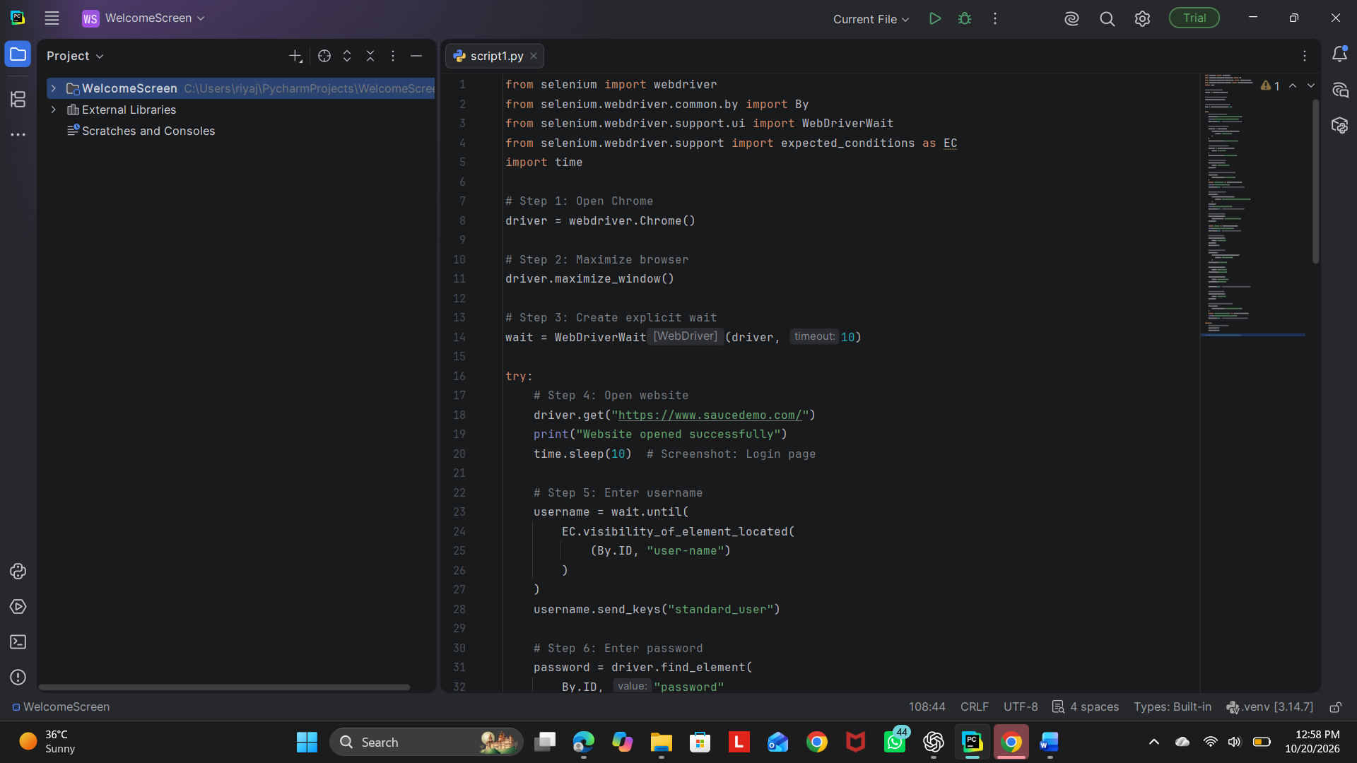
☐ SauceDemo login page
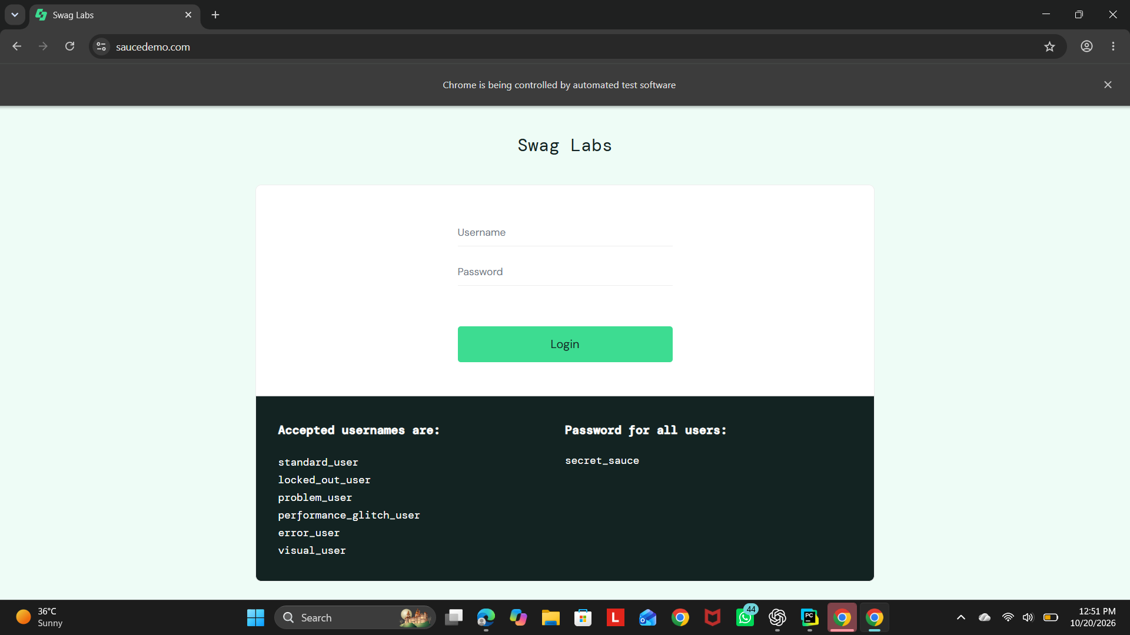
☐ Products page after successful login
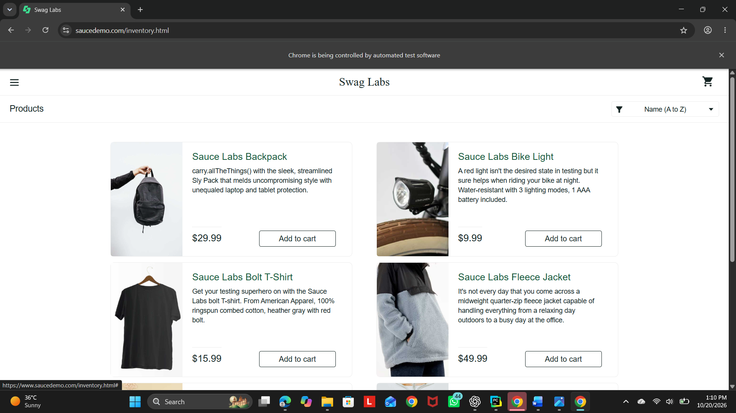
☐ Products page showing the product added to the cart
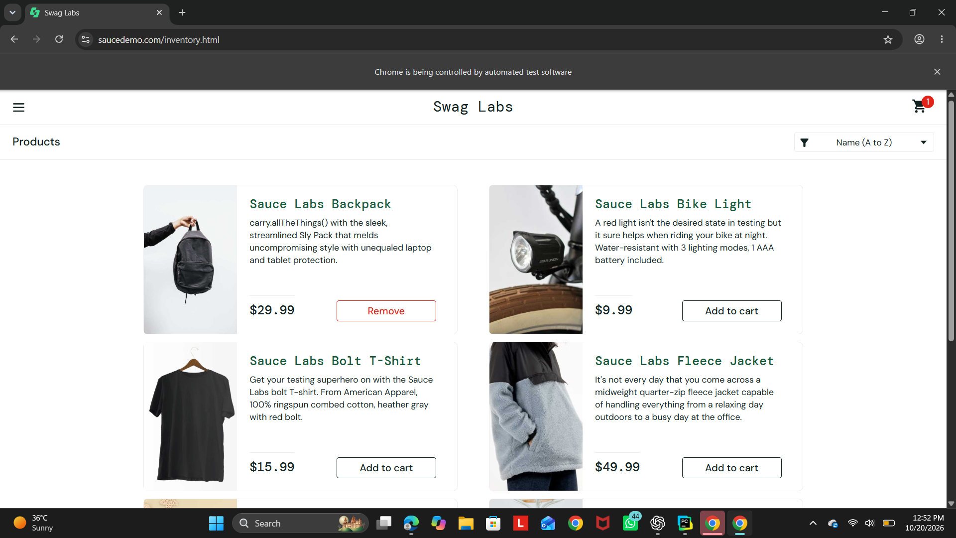
☐ Cart page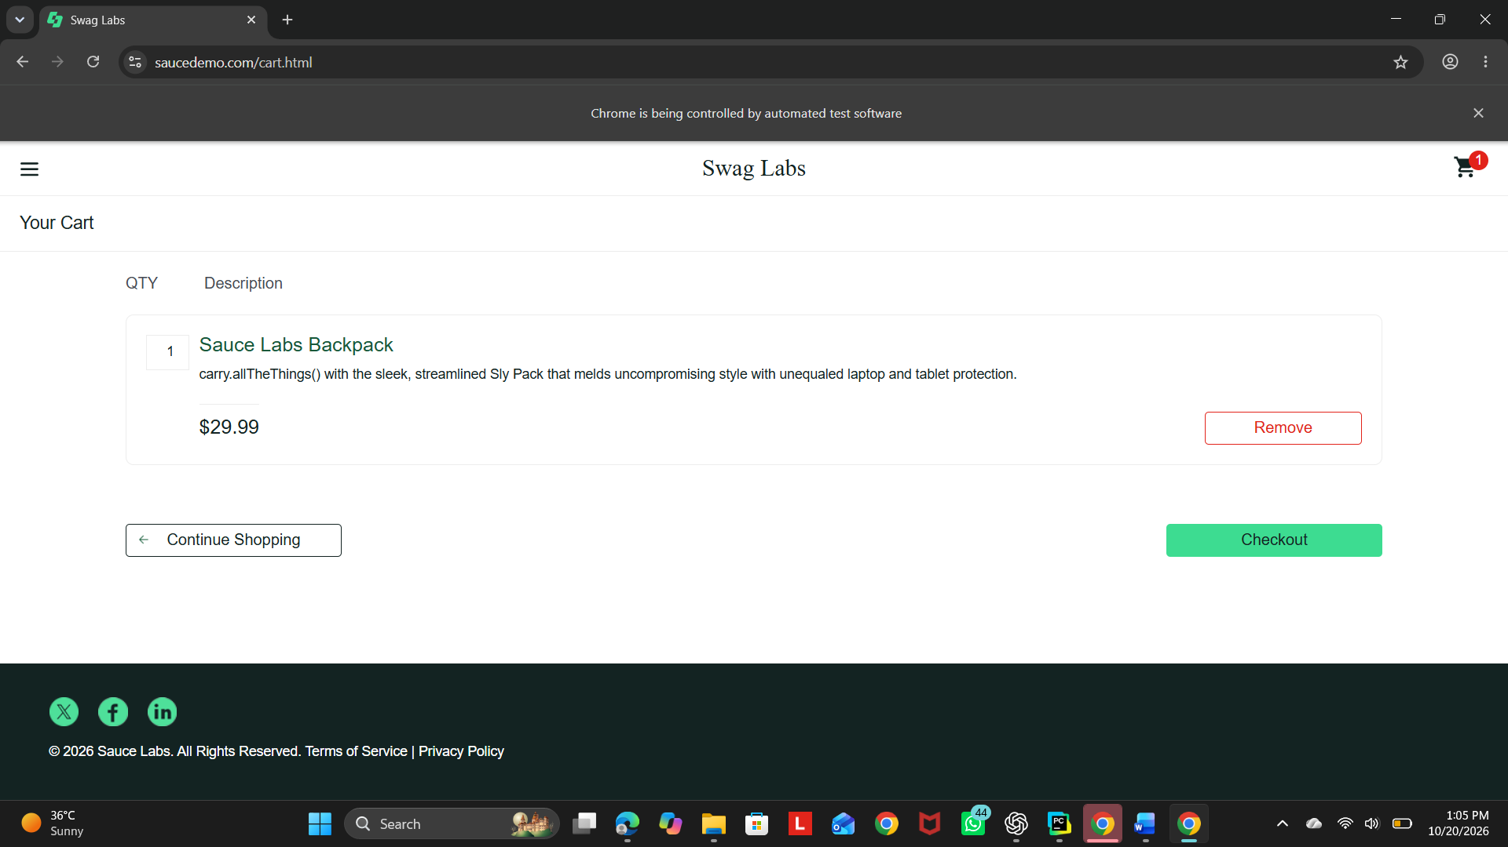
☐ Checkout form filled with test data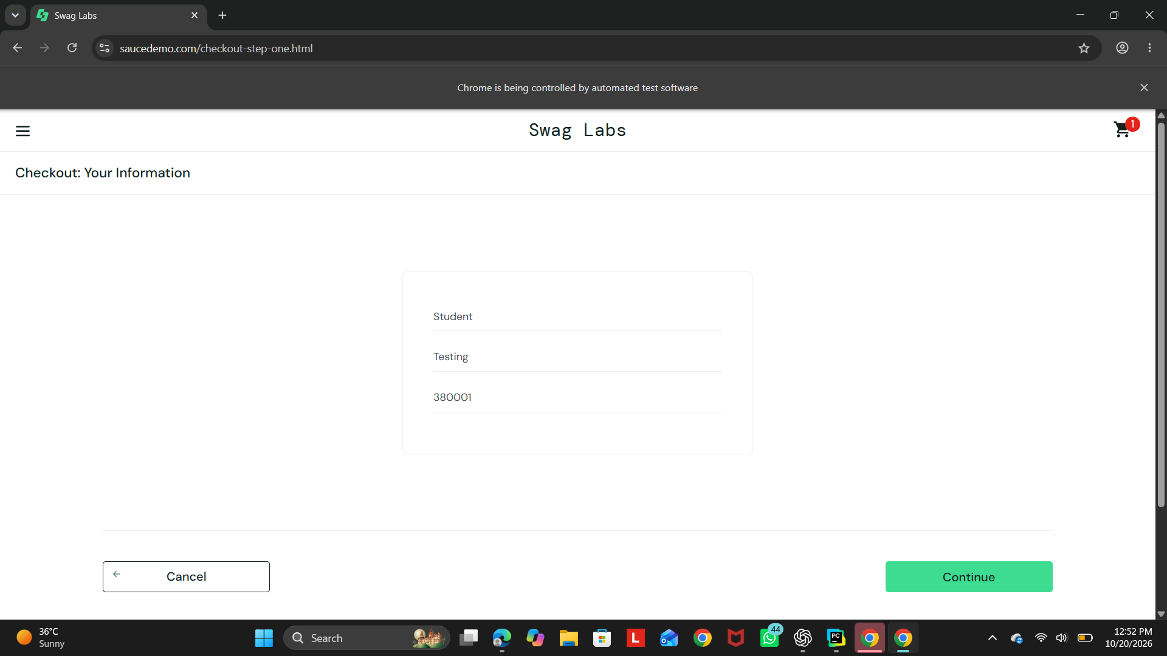
☐ Checkout overview page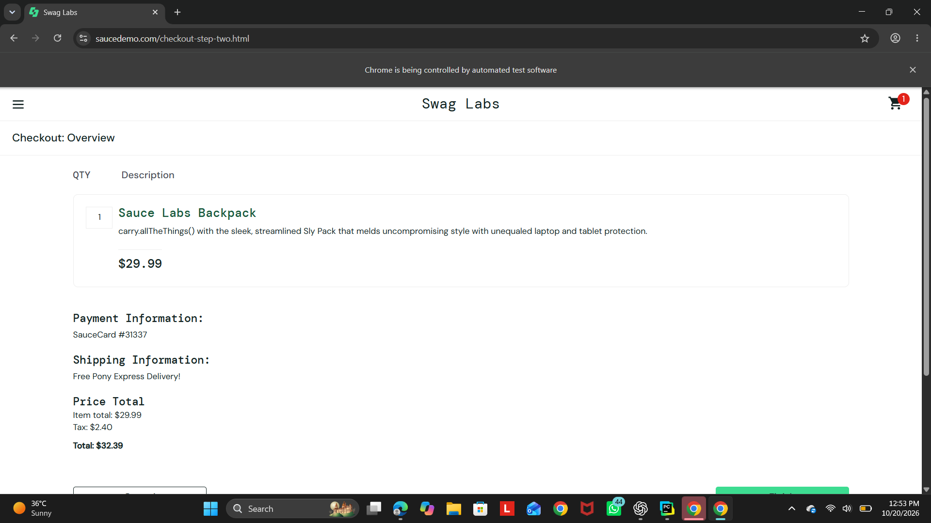
☐ PyCharm console showing PASS messages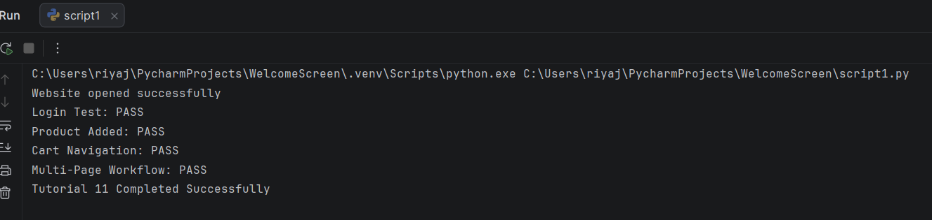

9. Observations
- Chrome was launched through Selenium WebDriver.
- The login form was automated using the demo credentials.
- The product was added to the cart successfully.
- The cart and checkout pages were navigated in sequence.
- The checkout form was completed with the specified test data.
- The multi-page workflow was validated using URL checks and assertions.

10. Conclusion
The Selenium script successfully automates login, product selection, cart navigation, and checkout on the SauceDemo website.

11. Important Note
The test-case statuses above reflect the results listed in the tutorial reference. Run the script in your own environment and confirm the statuses and screenshots against your actual execution. The script reaches the checkout overview; it does not click the final Finish button or verify the order-complete page.

