TUTORIAL – 13
SELENIUM ENVIRONMENT SETUP

Aim
To configure Python, PyCharm, Selenium WebDriver and Google Chrome, and verify the setup by running a basic Selenium program.

Procedure

Step 1: Create a PyCharm Project
Open PyCharm, select New Project, name it SoftwareTesting, and select an available Python interpreter. Create a Python file named tutorial13.py. 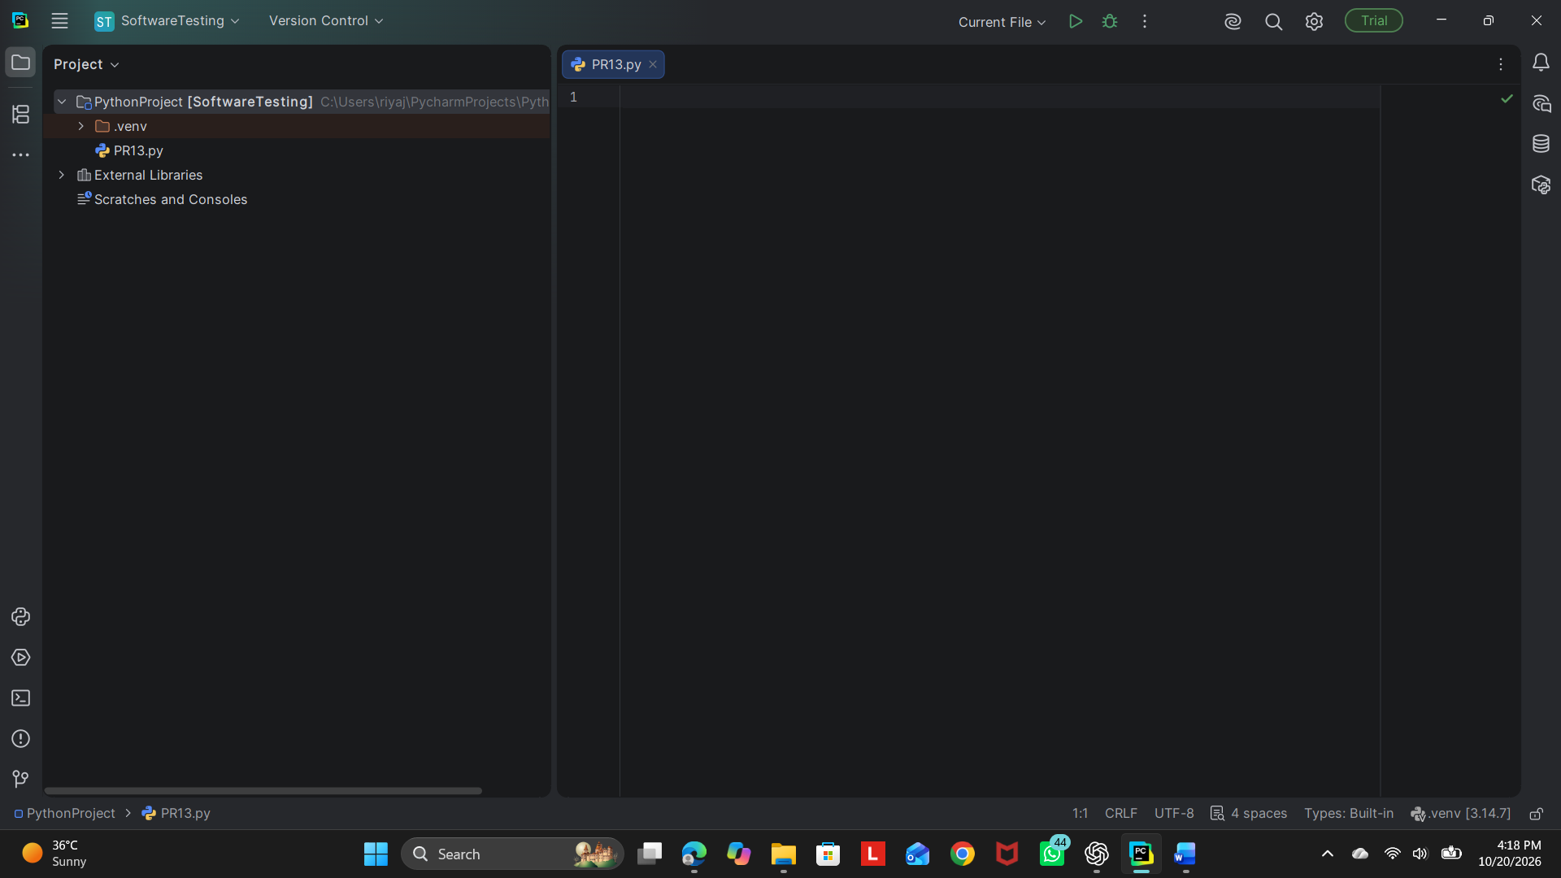

Step 2: Install and Verify Selenium
Open the PyCharm Terminal and run:
python -m pip install selenium
Verify the installation by running:
python -m pip show selenium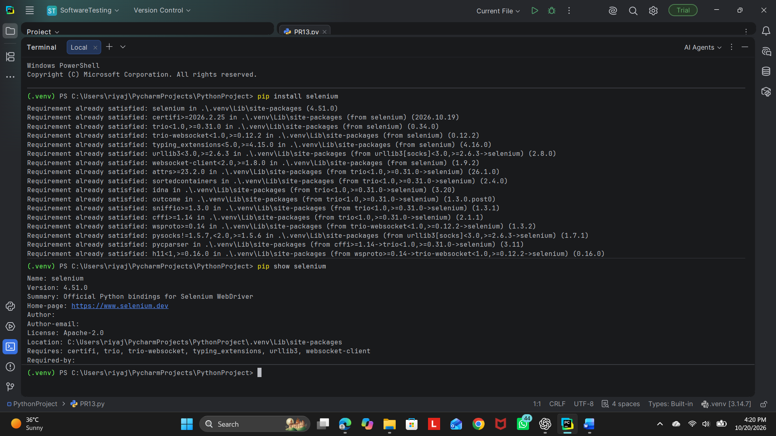

Step 3: Enter the Python Program
Copy the following code into tutorial13.py:
from selenium import webdriver
driver = webdriver.Chrome()
driver.maximize_window()
driver.get("https://www.selenium.dev/")
print("Browser launched successfully")
print("Page Title:", driver.title)
print("Current URL:", driver.current_url)
driver.quit()

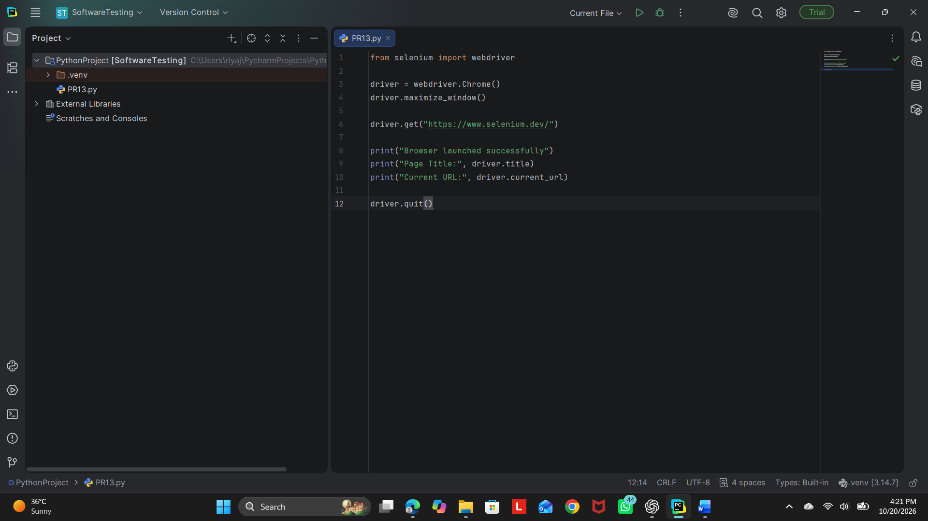

Step 4: Run and Verify the Program
Right-click tutorial13.py and select Run 'tutorial13'. Chrome should open https://www.selenium.dev/. Check the PyCharm console for the browser message, page title and current URL.
Expected console output:
Browser launched successfully
Page Title: Selenium
Current URL: https://www.selenium.dev/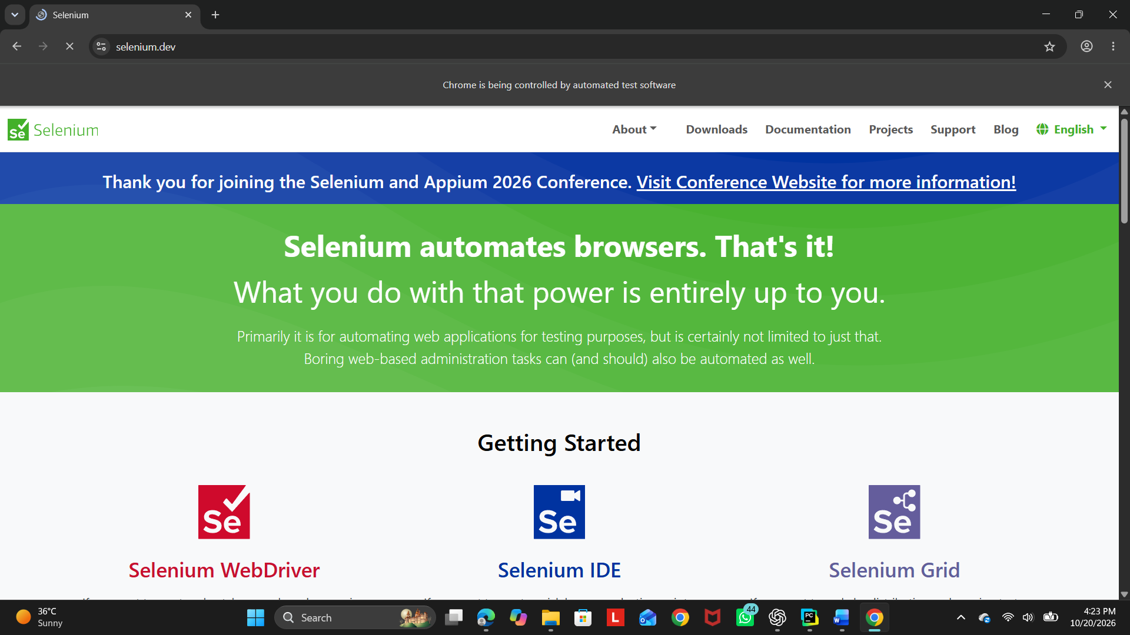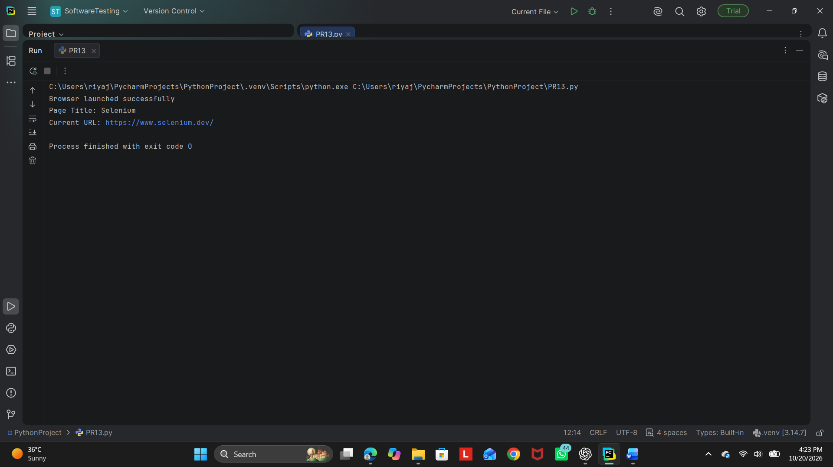

Conclusion
The Selenium environment setup practical demonstrates how to configure Python, PyCharm, Selenium WebDriver and Chrome. The setup is verified by running a Python script that opens the Selenium website and displays its page title and current URL. Record the actual result after executing the program.

