TUTORIAL – 14
SELENIUM WEB AUTOMATION

Aim
To create Selenium automation scripts in Python for browser navigation, form handling, web element interaction and validation testing.

Procedure

Step 1: Create the Python File
Open the SoftwareTesting project in PyCharm. Create a Python file named tutorial14.py.
[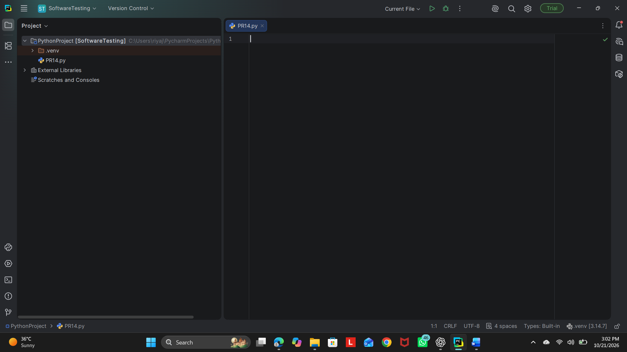

Step 2: Install or Verify Selenium
Open the PyCharm Terminal and run:
python -m pip install selenium
If Selenium is already installed, the terminal will indicate that the requirement is satisfied.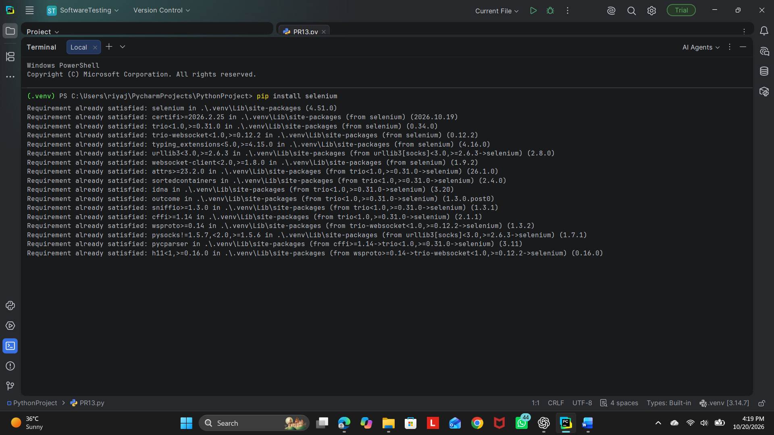

Step 3: Open SauceDemo
Open https://www.saucedemo.com/ in Chrome. Use these test credentials:
Username: standard_user
Password: secret_sauce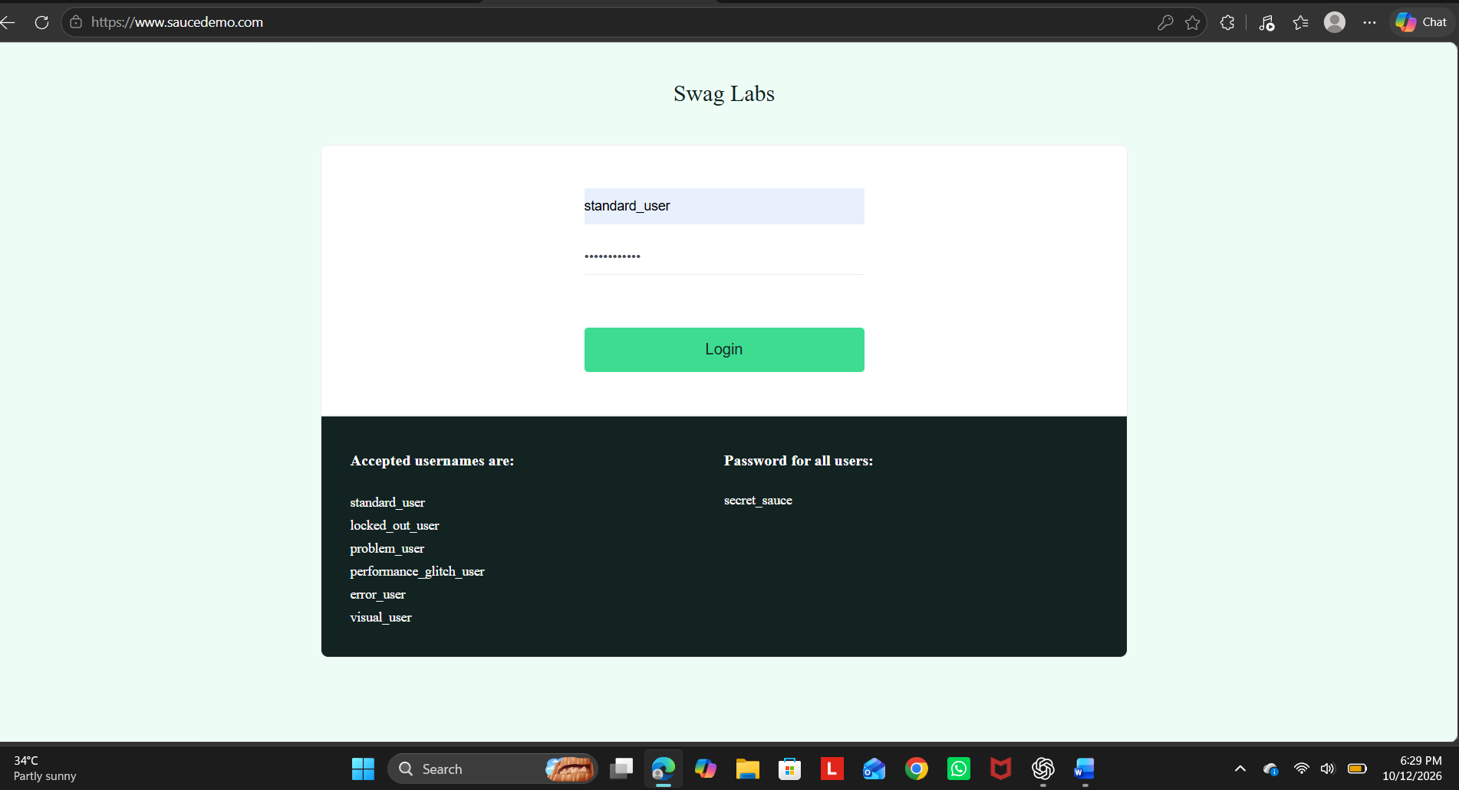

Step 4: Enter the Python Program
Enter the following code in tutorial14.py:
from selenium import webdriver
from selenium.webdriver.common.by import By
from selenium.webdriver.support.ui import WebDriverWait
from selenium.webdriver.support import expected_conditions as EC
driver = webdriver.Chrome()
driver.maximize_window()
wait = WebDriverWait(driver, 10)
try:
driver.get("https://www.saucedemo.com/")
print("Page Title:", driver.title)
wait.until(EC.visibility_of_element_located(
(By.ID, "user-name")
)).send_keys("standard_user")
driver.find_element(By.ID, "password").send_keys("secret_sauce")
driver.find_element(By.ID, "login-button").click()
wait.until(EC.url_contains("inventory"))
assert "inventory" in driver.current_url
print("Login Validation: PASS")
wait.until(EC.element_to_be_clickable(
(By.ID, "add-to-cart-sauce-labs-backpack")
)).click()
print("Product Selection: PASS")
driver.find_element(By.CLASS_NAME, "shopping_cart_link").click()
assert "cart" in driver.current_url
print("Cart Navigation: PASS")
print("All Selenium Tests Passed")
finally:
driver.quit()

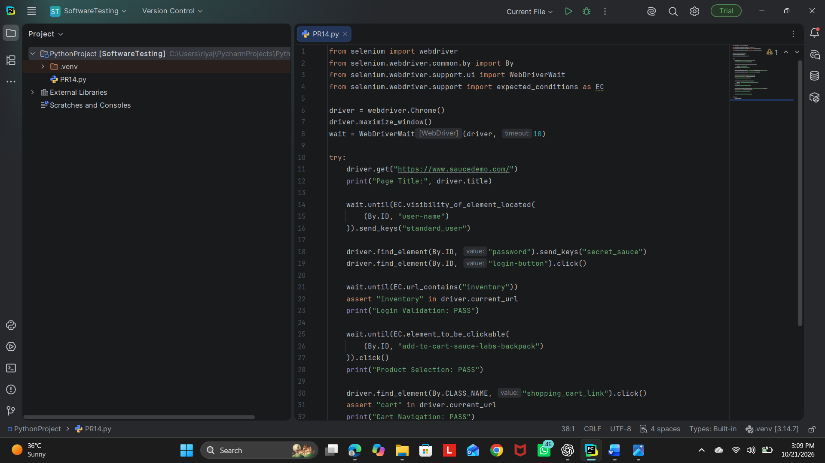

Step 5: Run and Verify
Save the file, right-click inside the editor, and select Run 'tutorial14'. Chrome should log in, add the Sauce Labs Backpack to the cart, and open the cart. 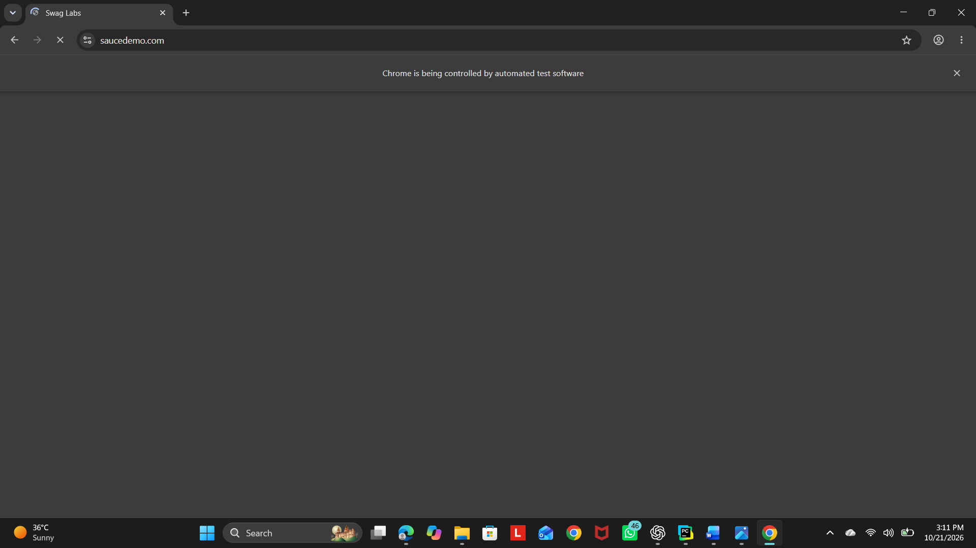
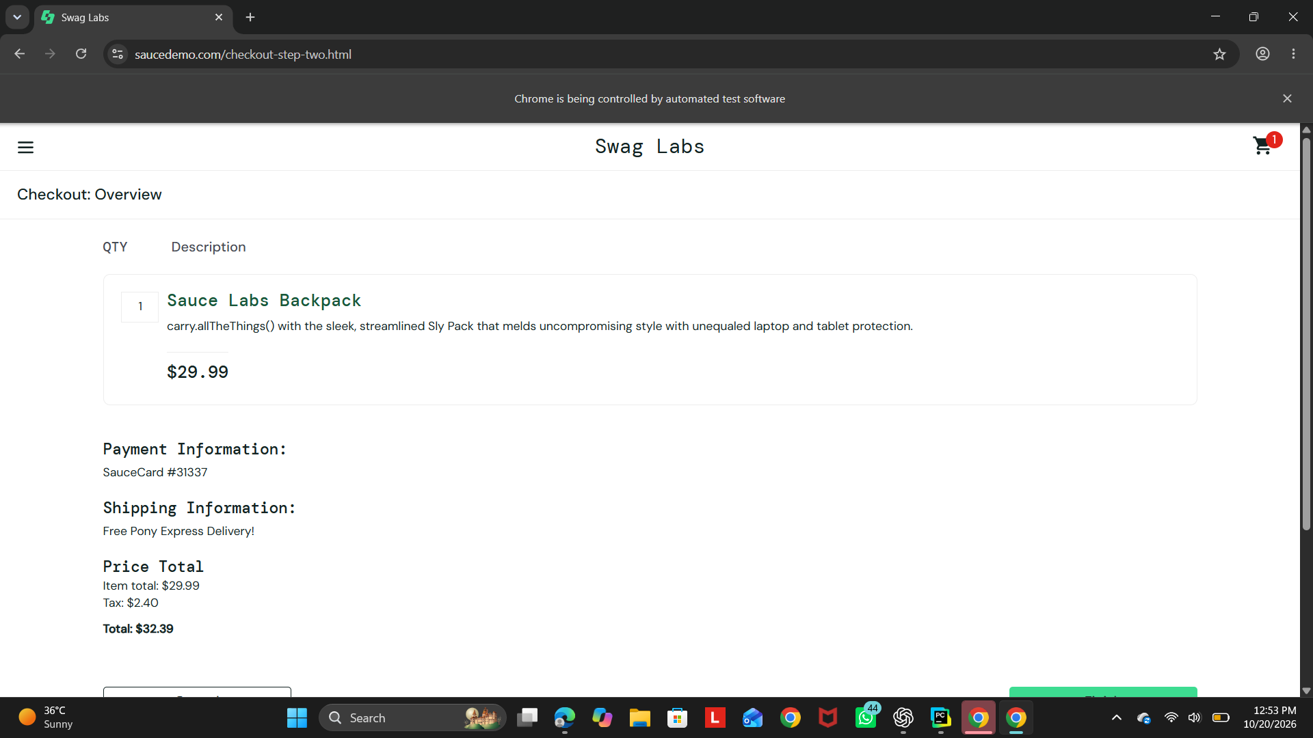
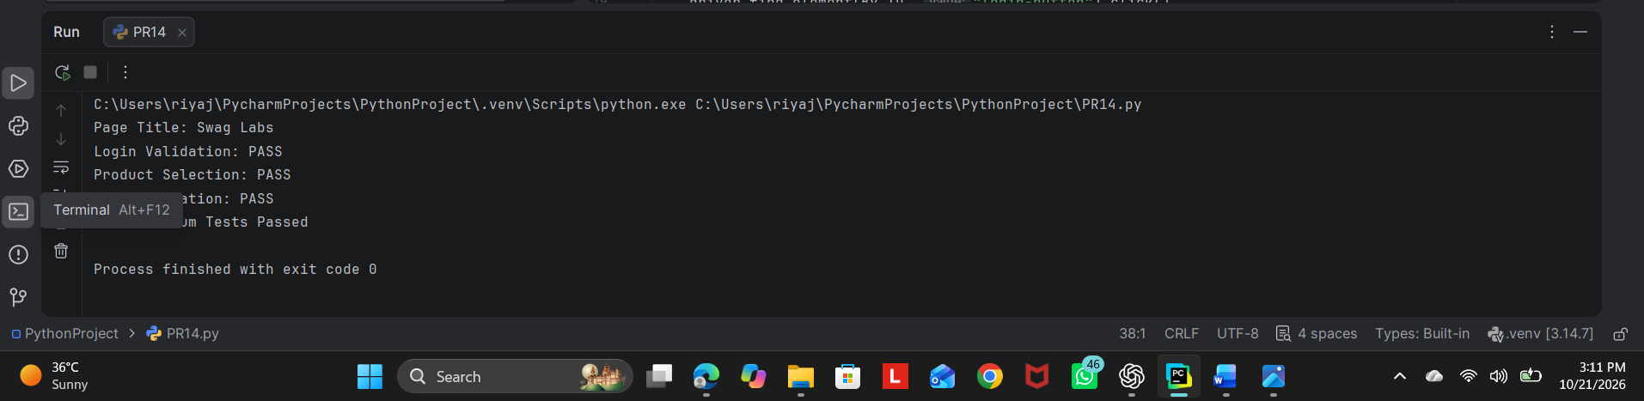

Conclusion
Selenium WebDriver is used to automate browser navigation, login form handling, product selection and cart navigation on SauceDemo. The script uses explicit waits and assertions to validate login and cart navigation. Record the actual result after executing the program.

