TUTORIAL – 15
AUTOMATED LOGIN TESTING
Aim: To automate login functionality, authentication validation, assertions, exception handling, and logout using Selenium WebDriver with Python.
Python Source Code
from selenium import webdriver
from selenium.webdriver.common.by import By
from selenium.webdriver.support.ui import WebDriverWait
from selenium.webdriver.support import expected_conditions as EC

URL = "https://www.saucedemo.com/"
U, P = "standard_user", "secret_sauce"

def run(user, pwd, test):
d = webdriver.Chrome()
w = WebDriverWait(d, 10)
try:
d.get(URL)
d.find_element(By.ID, "user-name").send_keys(user)
d.find_element(By.ID, "password").send_keys(pwd)
d.find_element(By.ID, "login-button").click()

if test == "Valid Login":
w.until(EC.url_contains("inventory"))
assert d.find_element(By.CLASS_NAME, "title").text == "Products"
elif test == "Logout":
w.until(EC.element_to_be_clickable((By.ID, "react-burger-menu-btn"))).click()
w.until(EC.element_to_be_clickable((By.ID, "logout_sidebar_link"))).click()
w.until(EC.visibility_of_element_located((By.ID, "login-button")))
else:
e = w.until(EC.visibility_of_element_located((By.CSS_SELECTOR, "[data-test='error']")))
assert {"Invalid Password": "do not match",
"Invalid Username": "do not match",
"Empty Credentials": "Username is required"}[test] in e.text

print(test + ": PASS")
except Exception as e:
print(test + ": FAIL", e)
finally:
d.quit()

run(U, P, "Valid Login")
run(U, "wrong_password", "Invalid Password")
run("wrong_user", P, "Invalid Username")
run("", "", "Empty Credentials")
run(U, P, "Logout")

Screenshots:
☐ PyCharm source code 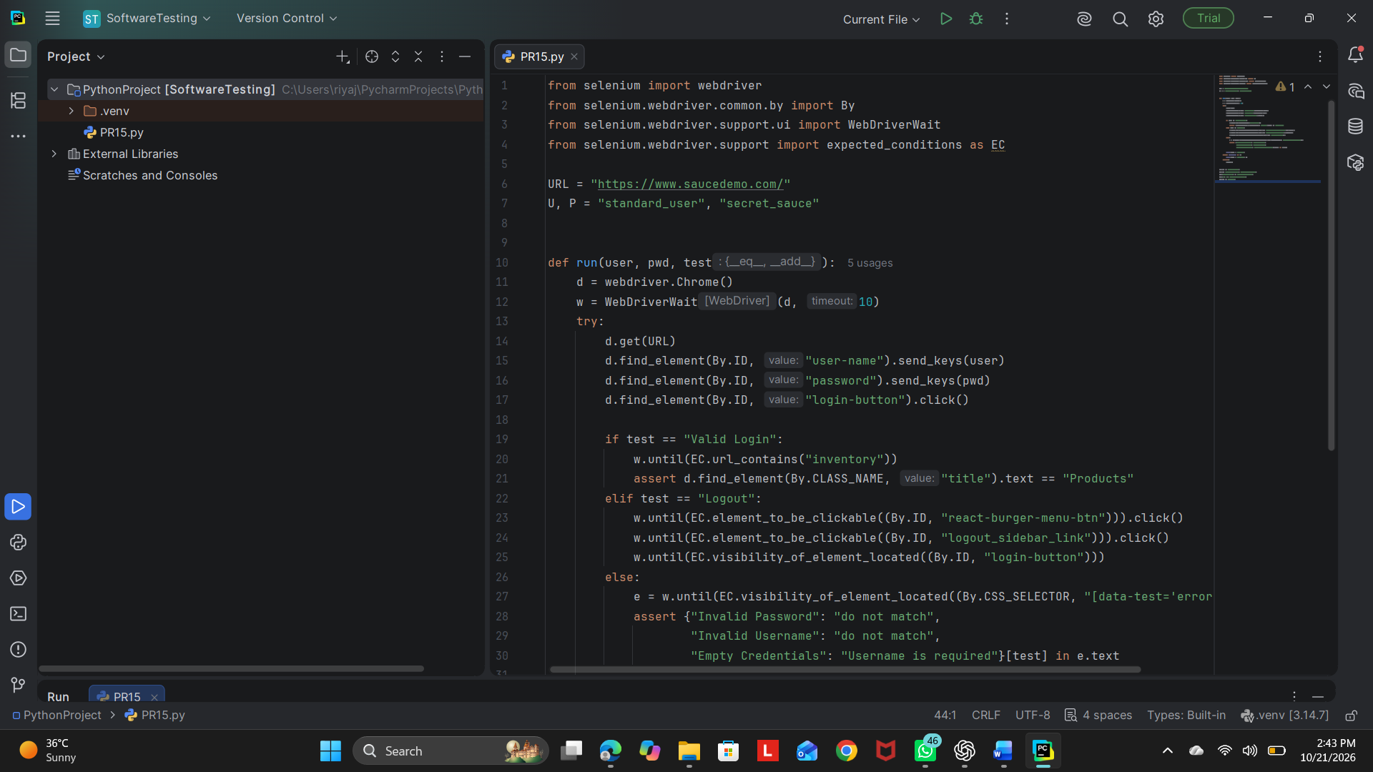

☐ SauceDemo login page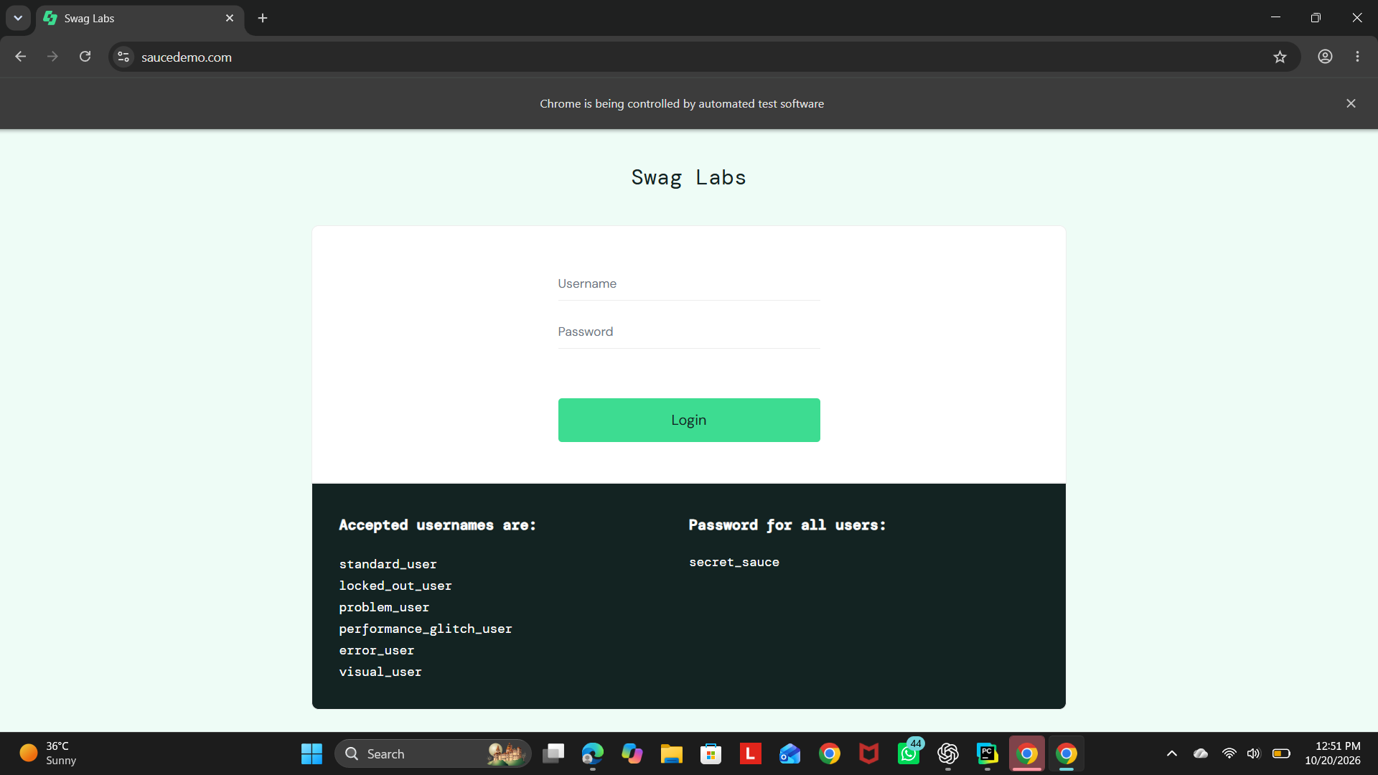

☐ Successful login – Products page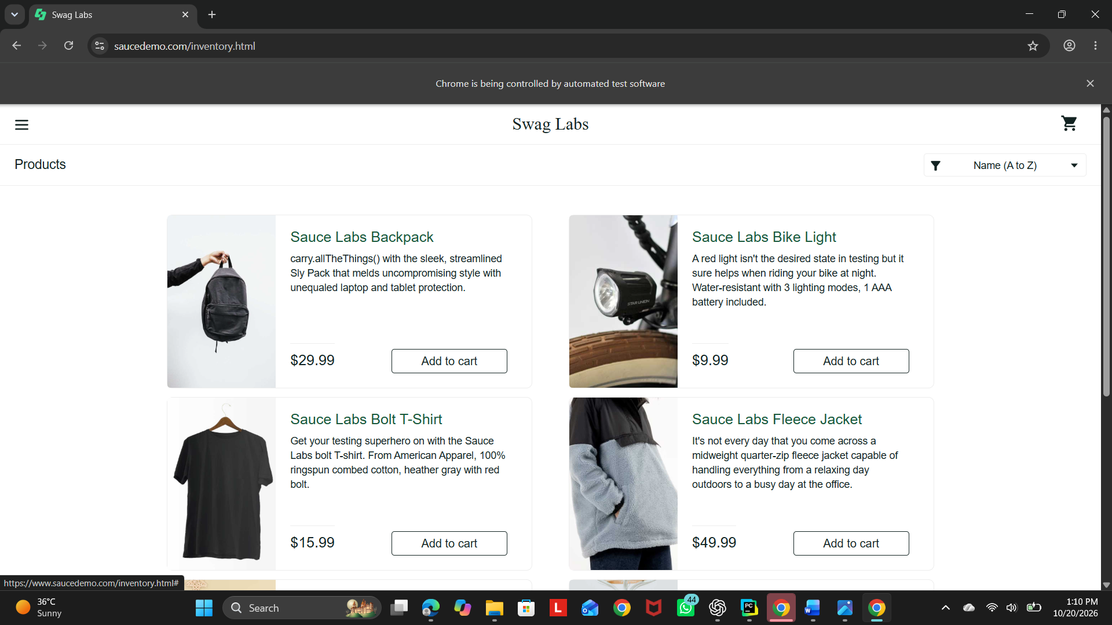

☐ Invalid password error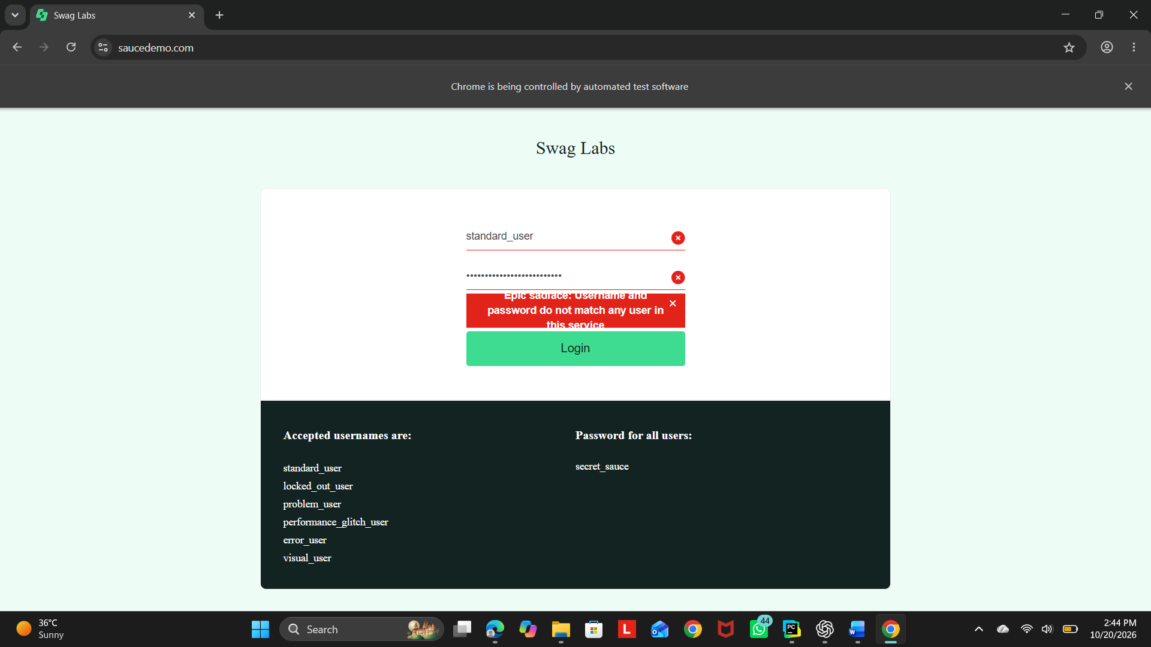

☐ Invalid username error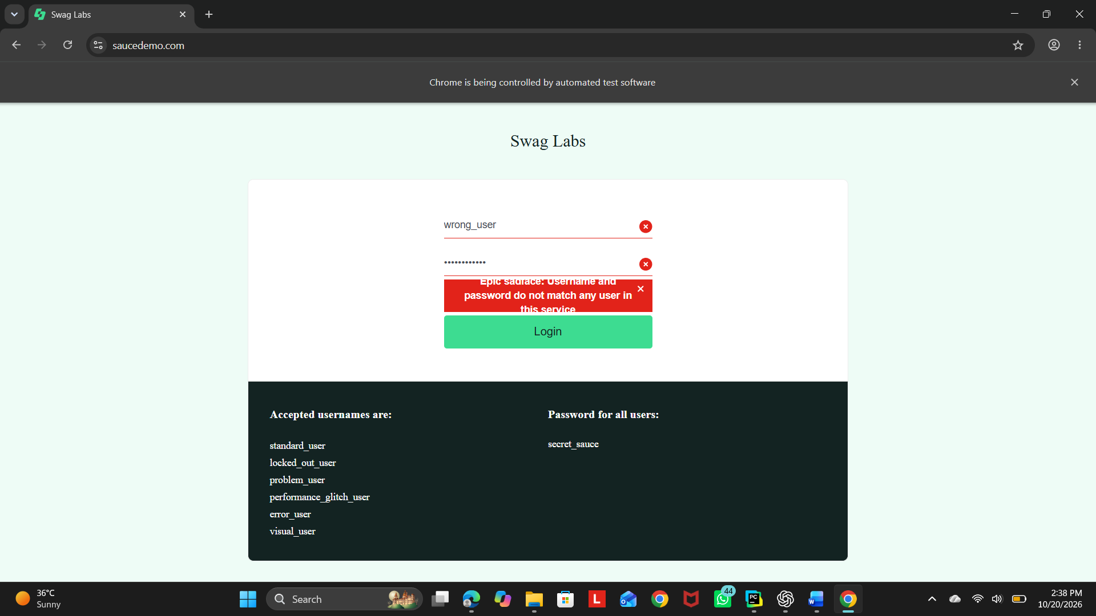

☐ Empty credentials validation 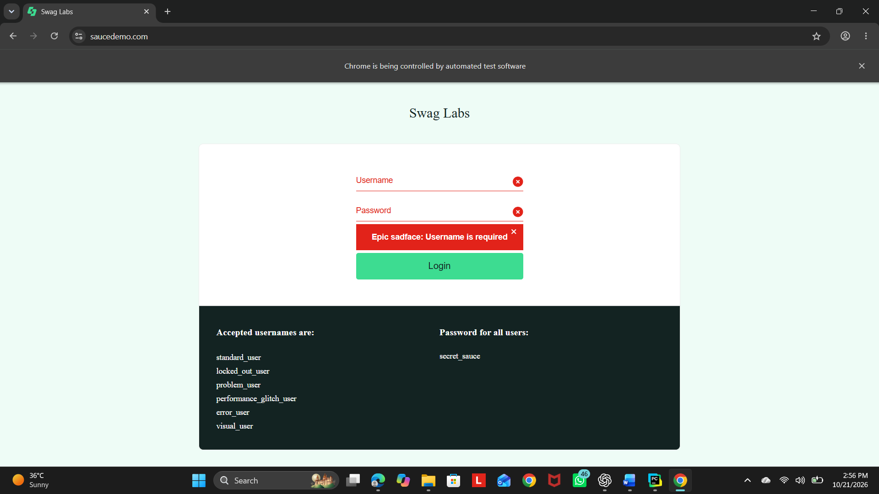

☐ Logout result

☐ PyCharm console output 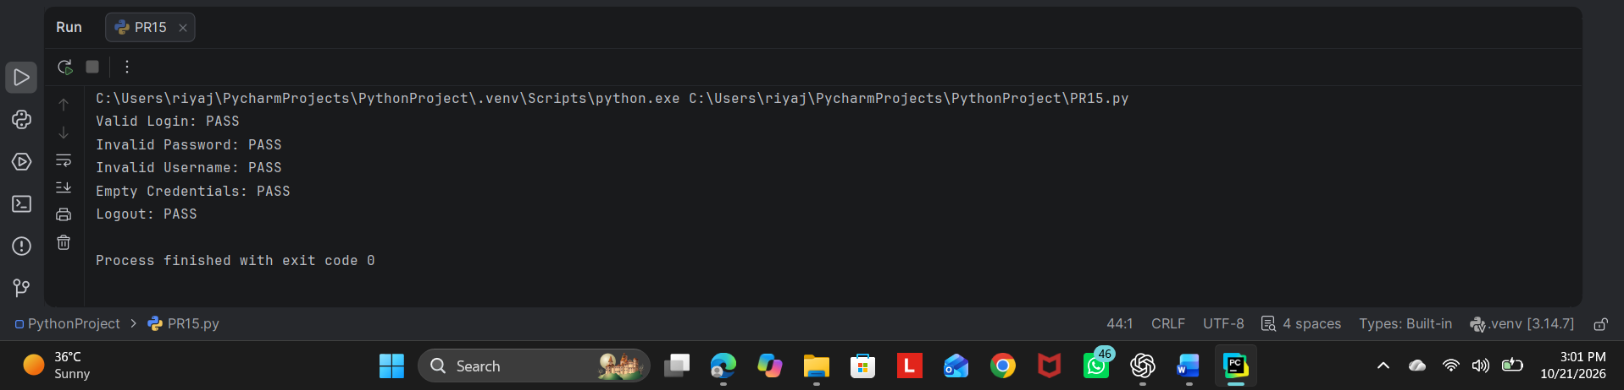

Conclusion
The Selenium script automates five login-related test cases on SauceDemo: valid login, invalid password, invalid username, empty credentials, and logout. Explicit waits and assertions verify expected results, while the console displays each test status.

