TUTORIAL 10
Automation & Regression Analysis

Module Name: OrangeHRM - Automation & Regression Analysis
Test Case ID: orangehrm_ar_01
Tester Name: Riya Dhariwal
Test Case Description: To identify suitable modules for automation and prepare a regression test suite for the OrangeHRM demo website.
Prerequisites: 1. Internet connection.
2. Google Chrome browser.
3. OrangeHRM demo website accessible.
Environment Information: OS: Windows 11
Browser: Google Chrome
Device: Laptop
Website URL: https://opensource-demo.orangehrmlive.com/

TEST CASE EXECUTION
The test case titles, inputs, expected results, actual results, status, and comments below are transcribed from the uploaded Tutorial_10.xlsx workbook. Screenshot placeholders are provided because the Excel workbook does not contain screenshots.

Test Case 001 – Valid Login
Test Case ID: TC001
Input: Username: Admin; Password: admin123
Expected Result: Dashboard is displayed
Steps:
- Open the OrangeHRM demo website.
- Enter valid credentials.
- Click Login.
- Observe the dashboard.
Screenshot: 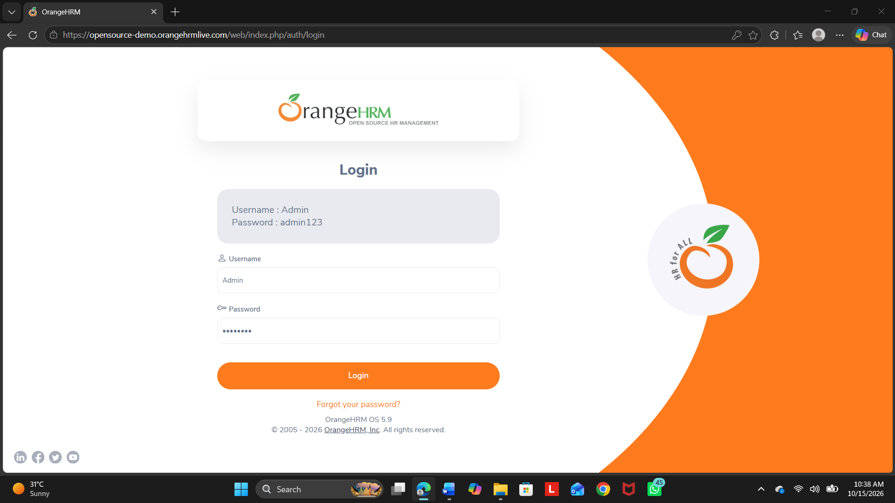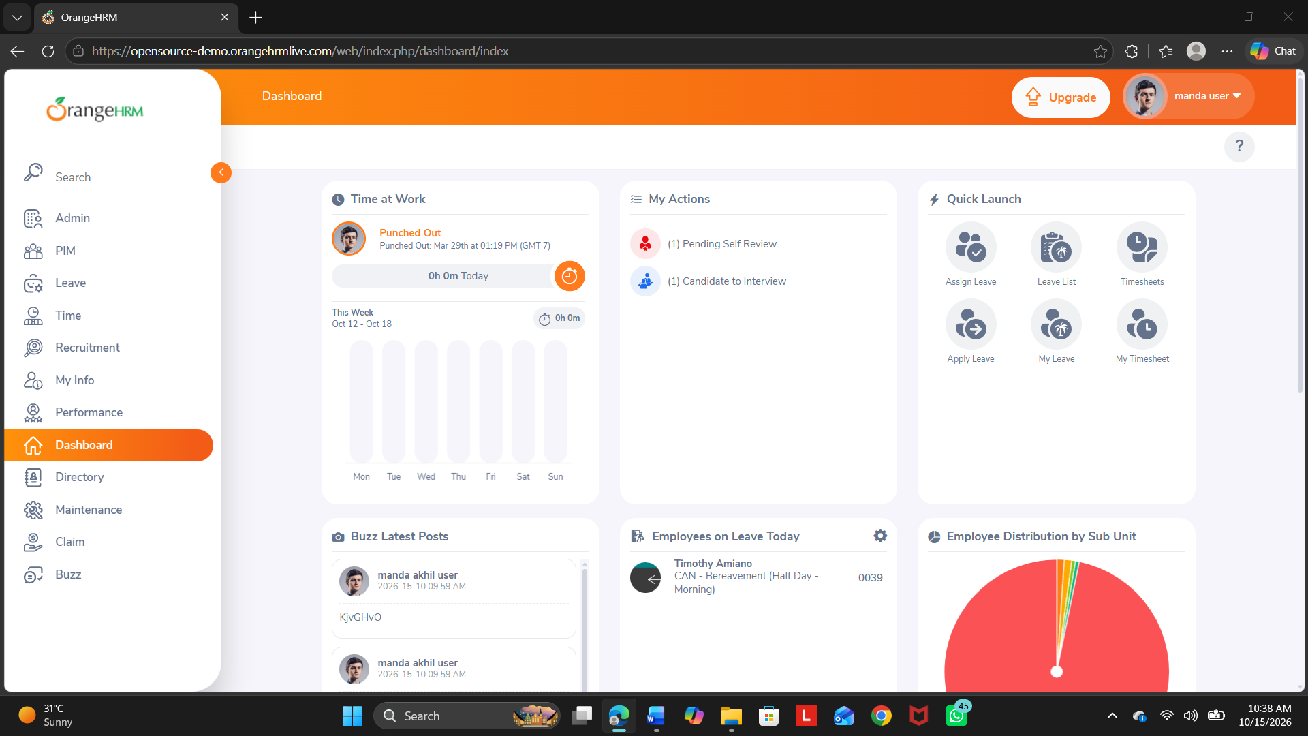
Actual Result: Dashboard displayed
Status: Pass
Comments: Worked

Test Case 002 – Invalid Login
Test Case ID: TC002
Input: Username: InvalidUser; Password: Wrong123
Expected Result: Login is rejected and an error message appears
Steps:
- Open the OrangeHRM demo website.
- Enter the invalid username and password.
- Click Login.
- Observe the error message.
Screenshot: 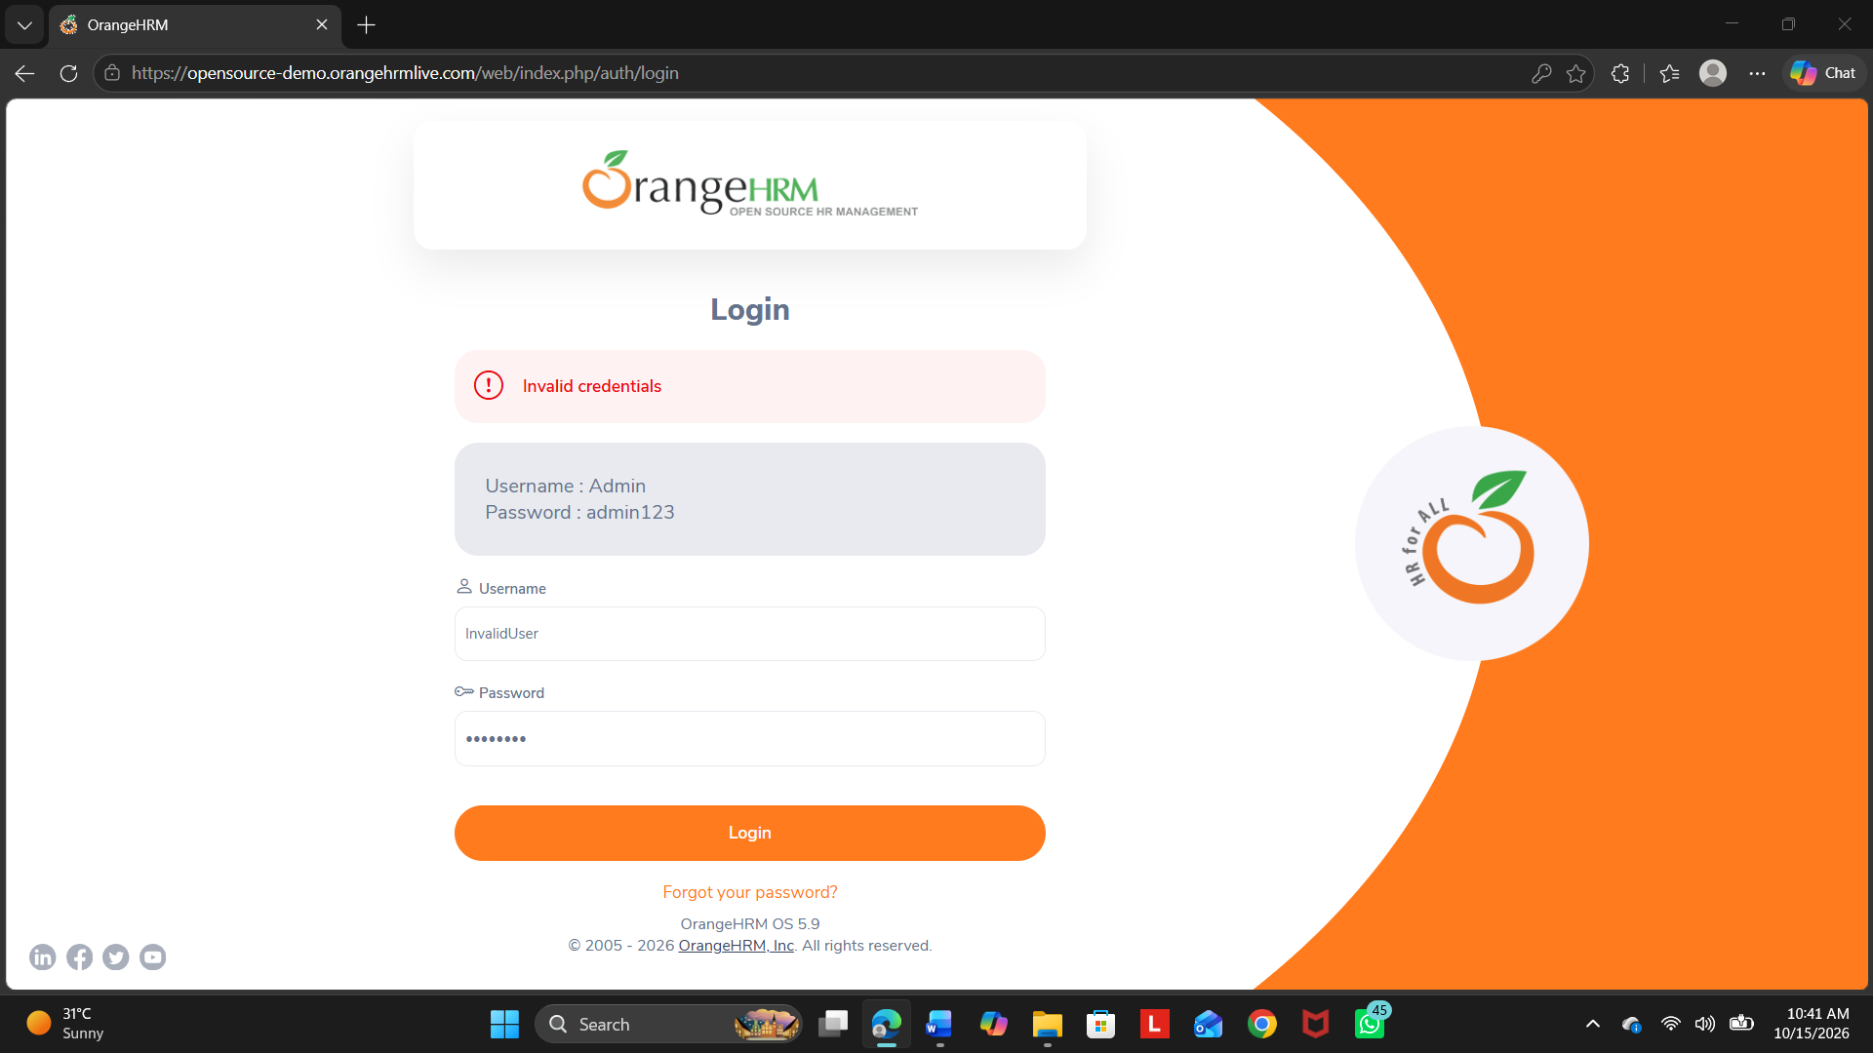
Actual Result: Error message displayed
Status: Pass
Comments: Worked

Test Case 003 – Empty Login Validation
Test Case ID: TC003
Input: Blank username and password
Expected Result: Required-field validation appears
Steps:
- Open the OrangeHRM demo website.
- Leave the username and password fields blank.
- Click Login.
- Observe the required-field validation.
Screenshot: 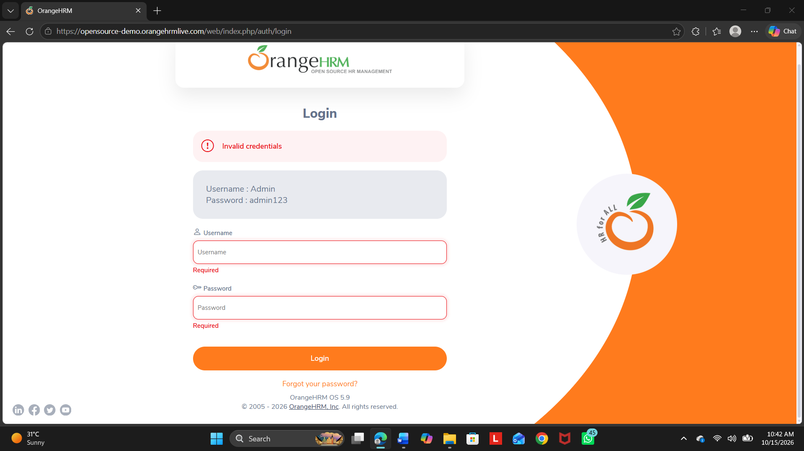
Actual Result: Validation message appeared
Status: Pass
Comments: Worked

Test Case 004 – Dashboard navigation
Test Case ID: TC004
Input: Valid demo credentials
Expected Result: Dashboard page is accessible
Steps:
- Log in using valid demo credentials.
- Open the Dashboard page.
- Verify that the dashboard is accessible.
Screenshot:
Actual Result: Dashboard accessed
Status: Pass
Comments: Worked

Test Case 005 – Employee List Review
Test Case ID: TC005
Input: PIM module
Expected Result: Employee list page is displayed
Steps:
- Log in to the application.
- Open PIM.
- Select Employee List.
- Verify that the employee list page is displayed.
Screenshot: 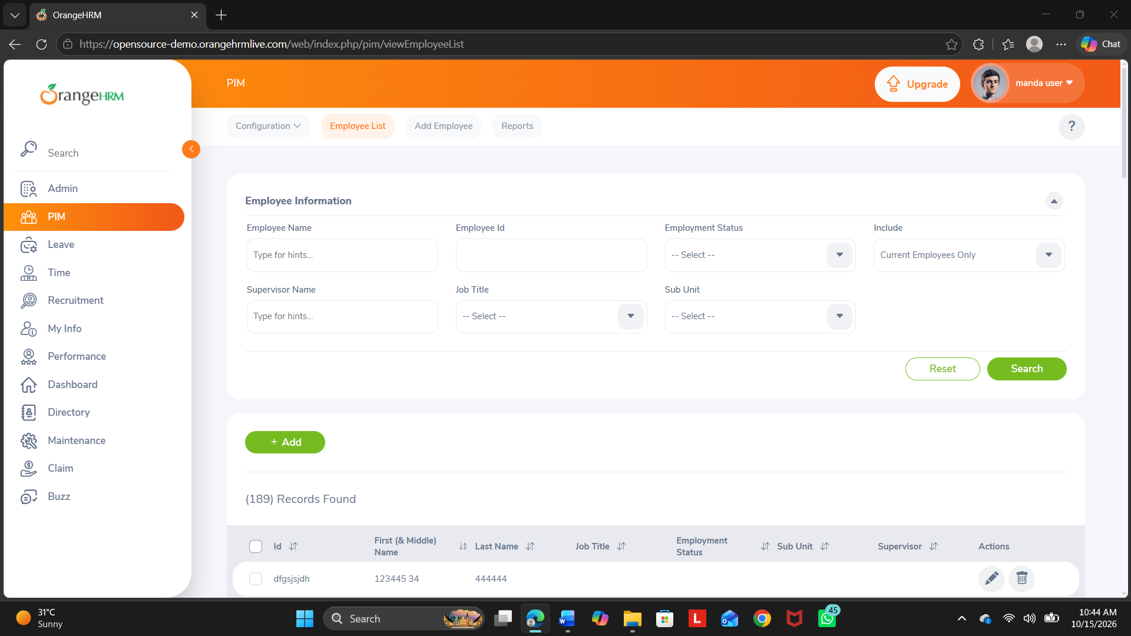
Actual Result: List displayed
Status: Pass
Comments: Worked

Test Case 006 – Employee Search
Test Case ID: TC006
Input: Existing visible employee name/ID
Expected Result: Matching employee record is displayed
Steps:
- Log in to the application.
- Open the employee list.
- Search using an employee name or ID visible in the list.
- Observe the matching records.
Screenshot: 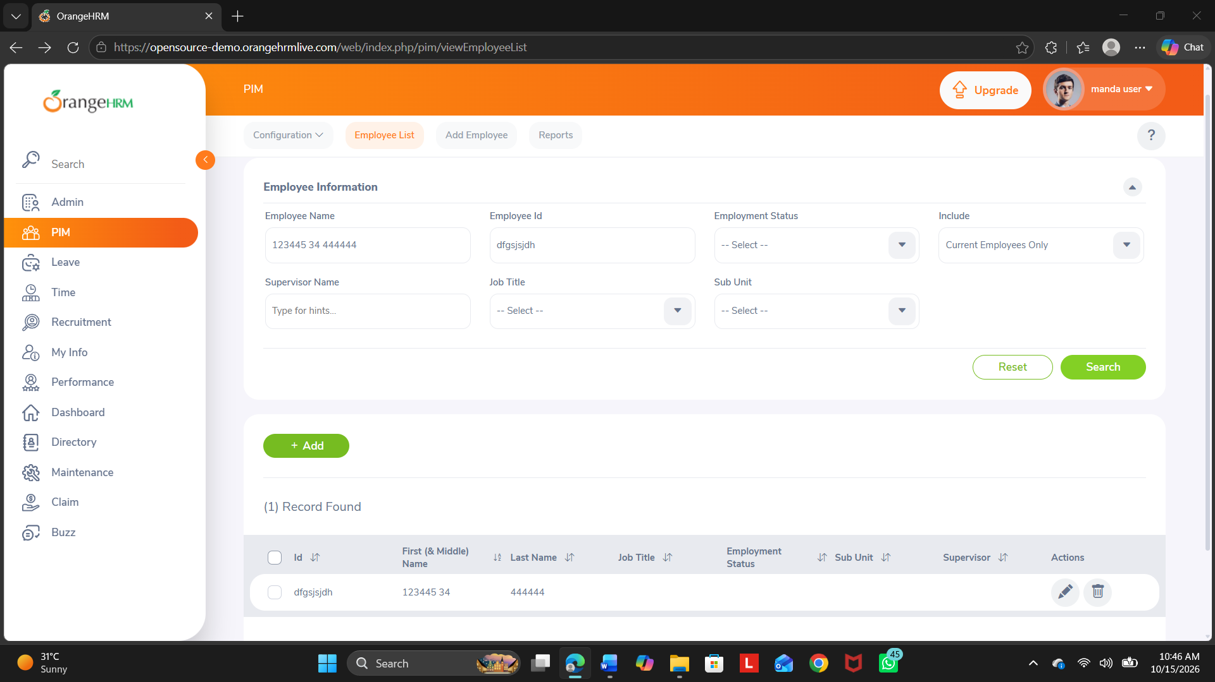
Actual Result: Records displayed
Status: Pass
Comments: Worked

Test Case 007 – Reset Search
Test Case ID: TC007
Input: Previously entered search criteria
Expected Result: Search fields are cleared and the default list is restored
Steps:
- Perform an employee search using search criteria.
- Click Reset.
- Verify that search fields are cleared and the default list is restored.
Screenshot:Actual Result: Search fields are cleared
Status: Pass
Comments: Worked

Test Case 008 – Add Employee Form
Test Case ID: TC008
Input: Add Employee option
Expected Result: Add Employee form is displayed
Steps:
- Log in to the application.
- Open PIM.
- Select Add Employee.
- Verify that the Add Employee form is displayed.
Screenshot:
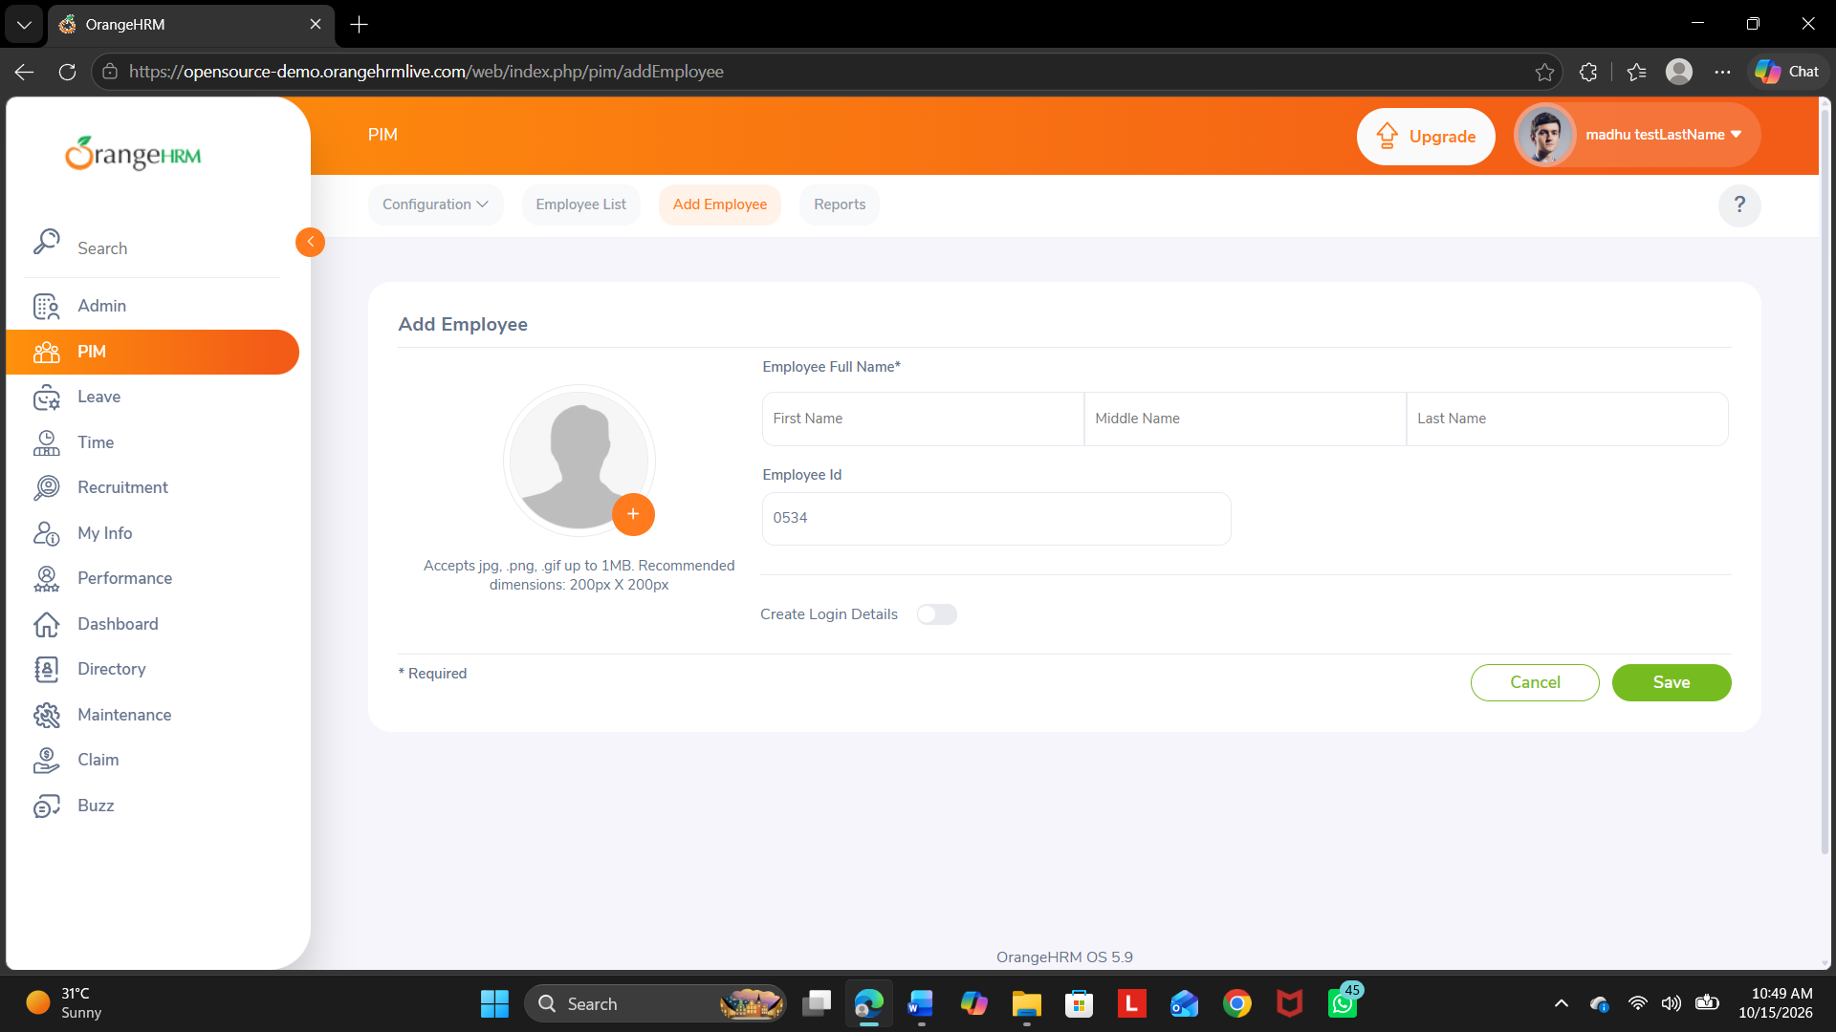Actual Result: Form displayed
Status: Pass
Comments: Worked

Test Case 009 – Employee Form Validation
Test Case ID: TC009
Input: Required fields left blank
Expected Result: Required-field validation is displayed
Steps:
- Open PIM > Add Employee.
- Leave the required fields blank.
- Submit the form.
- Observe the required-field validation.
Screenshot:
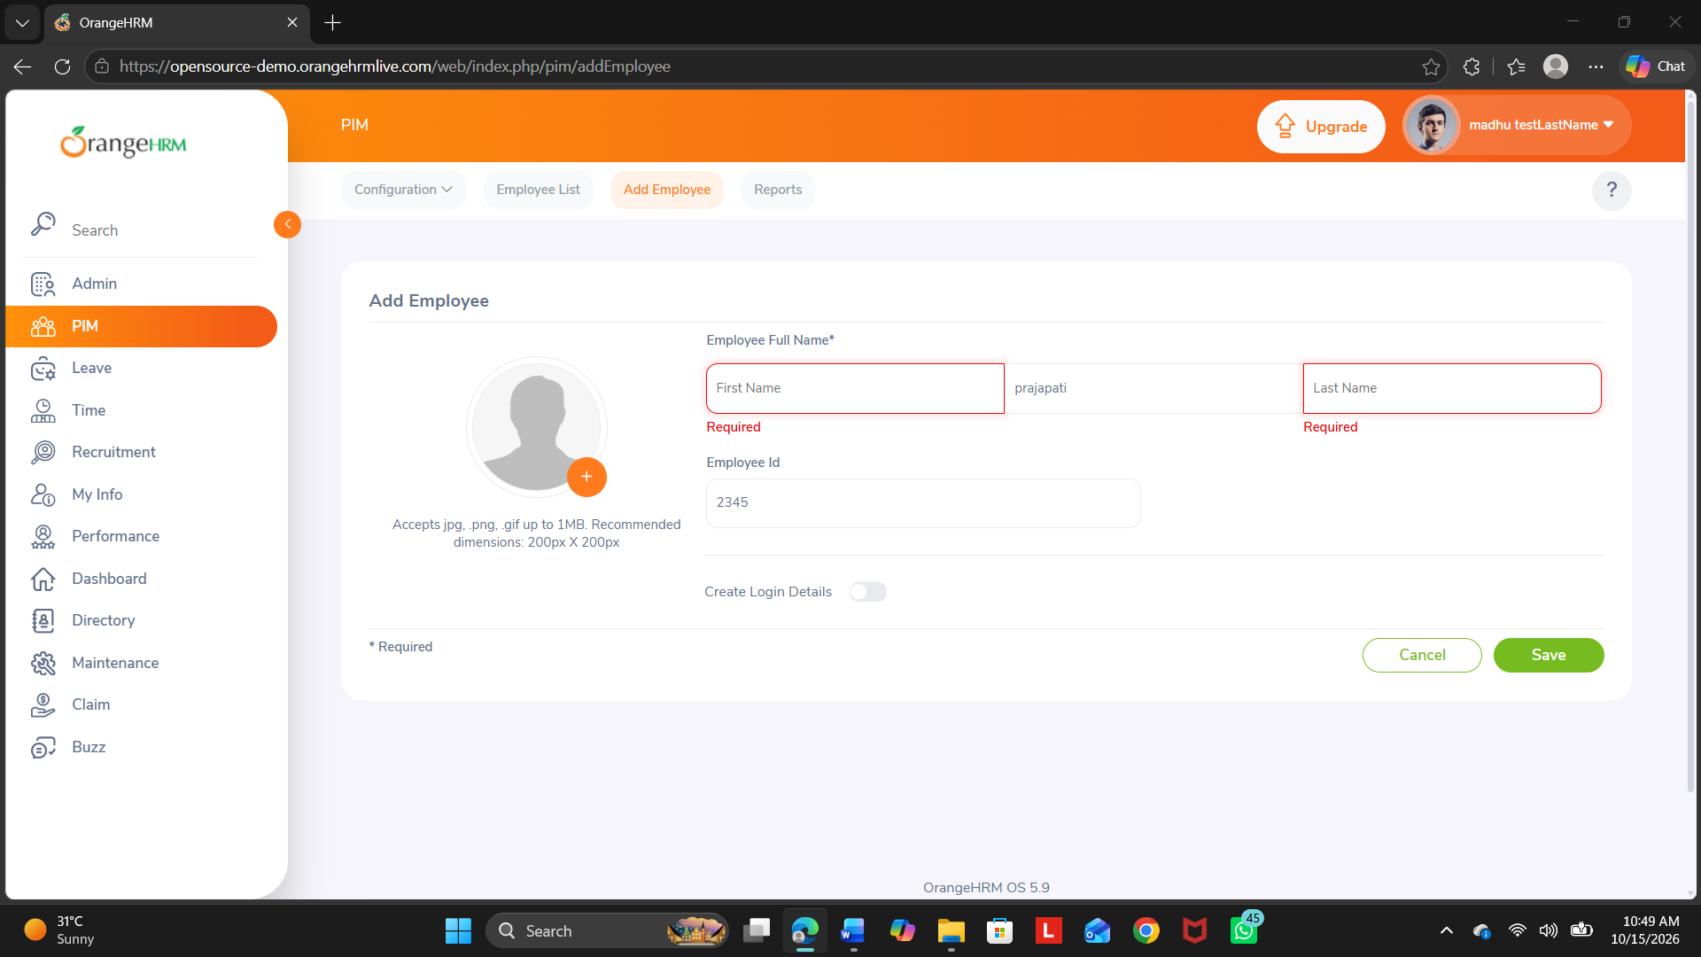Actual Result: Validation message appeared
Status: Pass
Comments: Worked

Test Case 010 – Logout Review
Test Case ID: TC010
Input: Logged-in demo user
Expected Result: Login page is displayed
Steps:
- Log in to the application.
- Open the user menu.
- Click Logout.
- Verify that the login page is displayed.
Screenshot: 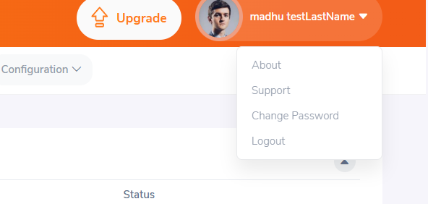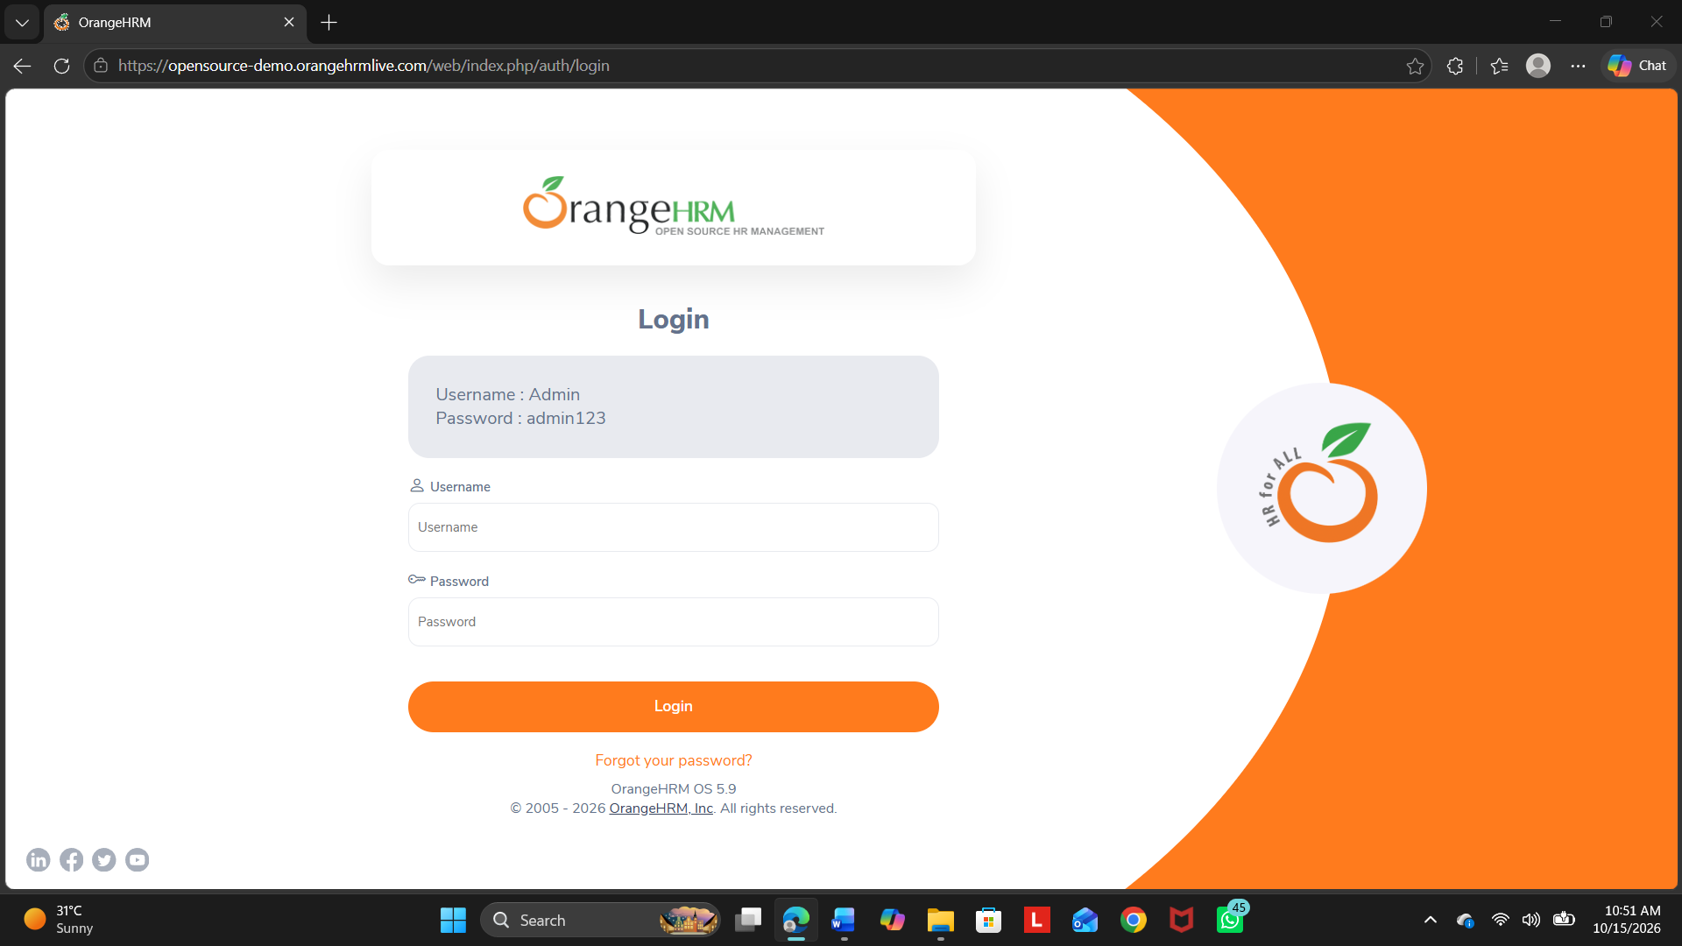
Actual Result: Login page appeared
Status: Pass
Comments: Worked

MODULE ANALYSIS
The following table summarizes the module-wise automation suitability recorded in the Excel workbook.
Module | Critical | Frequent Changes | Automation Recommended | Reason
Login | Yes | No | Yes | Frequently executed and stable.
Registration / Add Employee | Yes | No | Yes | Repetitive form and validation testing.
Employee Details Update | Yes | Yes | Review manually | Business rules may change frequently.
Search Employee | Yes | No | Yes | Repeated search operations.
Logout | No | No | Yes | Simple repetitive functionality.

AUTOMATION CANDIDATE IDENTIFICATION
1. Login Module
The Login module allows authorized users to access the OrangeHRM application using their username and password. It can be tested using valid credentials, invalid credentials, and empty input fields. Automation is suitable because login is a frequently executed and relatively stable functionality.
Automation suitability: Yes Suggested tool: Selenium
Screenshot:

2. Registration / Add Employee Module
The Add Employee module allows an authorized user to add a new employee by entering details in the employee form. Testing can verify required fields, input validation, and successful form submission. Automation is suitable because the form and its validations can be tested repeatedly.
Automation suitability: Yes
Suggested tool: Selenium
Screenshot:

3. Employee Details Update Module
The Employee Details Update module allows users to view or modify employee information. Testing can verify whether existing employee details are displayed correctly and whether permitted changes are saved successfully. Manual testing is recommended for closer examination of business rules and changes in requirements.
Automation suitability: Review manually Suggested approach: Manual testing
Screenshot: 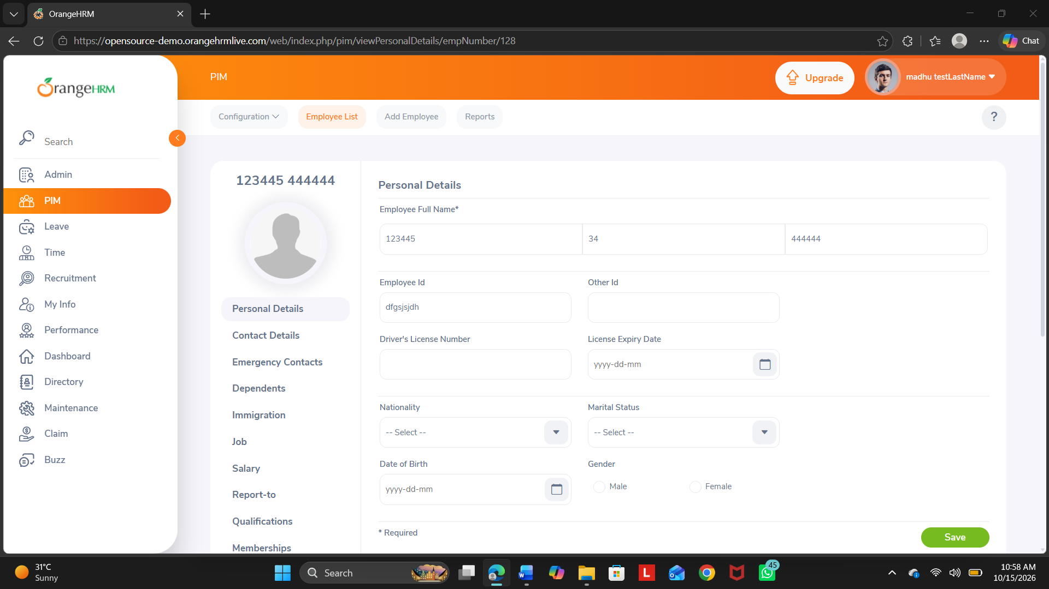

4. Search Employee Module
The Search Employee module allows users to find employees using available search criteria, such as employee name or employee ID. Testing can verify matching results, unsuccessful searches, and search functionality. Automation is suitable because search operations are repetitive and can be tested with different inputs.
Automation suitability: Yes
Suggested tool: Selenium
Screenshot:

5. Logout Module
The Logout module allows users to end their active session and leave the application securely. Testing can verify that the logout option is available and that the user is redirected to the login page after logging out. Automation is suitable because logout is a simple, repetitive operation.
Automation suitability: Yes
Suggested tool: Selenium
Screenshot:

REGRESSION TEST SUITE
Regression test cases and statuses below are taken from the Regression Suite worksheet.

RT001 – Valid Login
Module: Login
Expected Result: Dashboard displayed
Status: Pass
Steps:
- Open the application.
- Enter valid credentials.
- Click Login.
- Verify that the dashboard is displayed.
Screenshot:

RT002 – Invalid Login
Module: Login
Expected Result: Error message displayed
Status: Pass
Steps:
- Open the application.
- Enter invalid credentials.
- Click Login.
- Verify that an error message is displayed.
Screenshot:

RT003 – Search Existing Employee
Module: Search Employee
Expected Result: Matching record displayed
Status: Pass
Steps:
- Log in.
- Open the employee list.
- Search for an existing employee.
- Verify that the matching record is displayed.
Screenshot:

RT004 – Logout
Module: Logout
Expected Result: Return to Login page
Status: Pass
Steps:
- Log in.
- Open the user menu.
- Click Logout.
- Verify that the login page is displayed.
Screenshot:

AUTOMATION FEASIBILITY REPORT
Criteria: Observation
Repetitive Test Cases: Yes — login, search, form validation, and logout are repeatable.
Stable Functionality: Likely for core navigation; verify stability on the demo.
High Business Priority: Yes — especially login and employee search.
Frequently Executed: Yes — these flows are commonly repeated during regression.
Suitable Automation Tool: Selenium is recommended; no automated script has been run in this workbook.
Recommendation: Automate stable, repetitive tests; review frequently changing business rules manually.

REGRESSION TESTING SUMMARY
Metric: Value
Total Modules Analyzed: 5
Automation Candidates: 4
Regression Test Cases: 4
Modules Excluded / Kept Manual: 1 — Employee Details Update, based on planning judgment.
Execution Status: Works correctly
Recommendation: Automate stable, repetitive functionality; retain manual review for frequently changing modules.

