SOFTWARE TESTING LAB
PRACTICAL 1
Understand SDLC and STLC Phases
Sample practical record | Screenshot-style outputs are illustrative

Aim
To understand SDLC and STLC phases for a real-world software project and identify testing activities performed during each development stage.

Procedure
- Select a sample e-commerce login feature as the project example.
- Map the SDLC phases: planning, requirements, design, development, testing, deployment and maintenance.
- Map the STLC phases: requirement analysis, test planning, test case development, environment setup, test execution and test closure.
- Identify the testing activities and deliverables associated with each phase.

Sample Outputs / Screenshots
The following are original, illustrative screenshot-style outputs prepared for the practical topic. They are not captures from a live application. Replace or supplement them with screenshots from your actual lab execution if your instructor requires real execution evidence.

Output 1: Project Overview
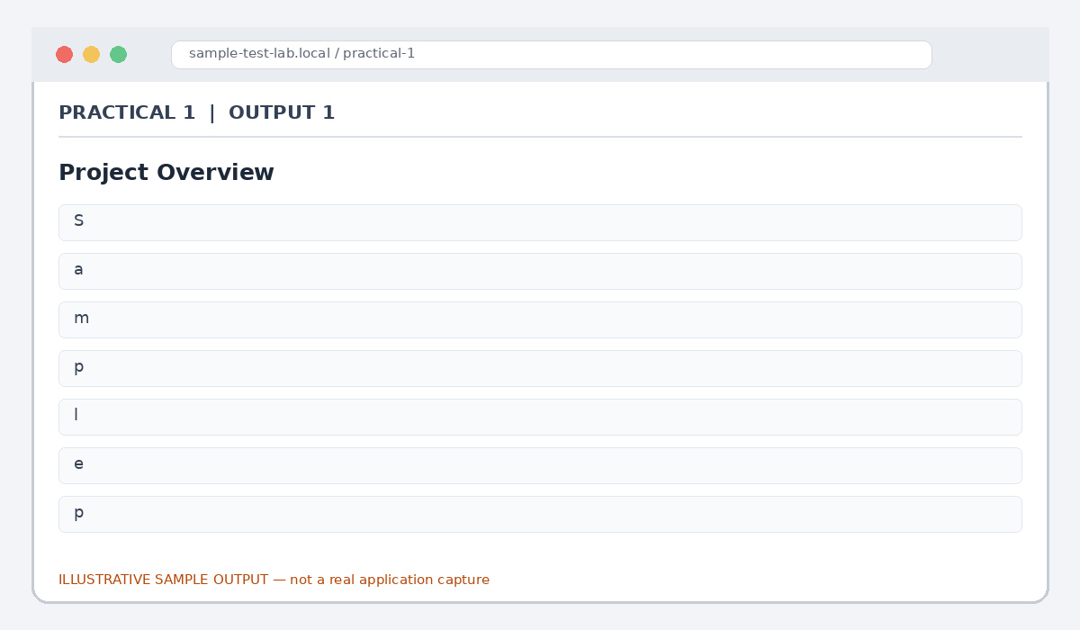
Figure 1.1: Project Overview (illustrative sample)

Output 2: SDLC Phase Map
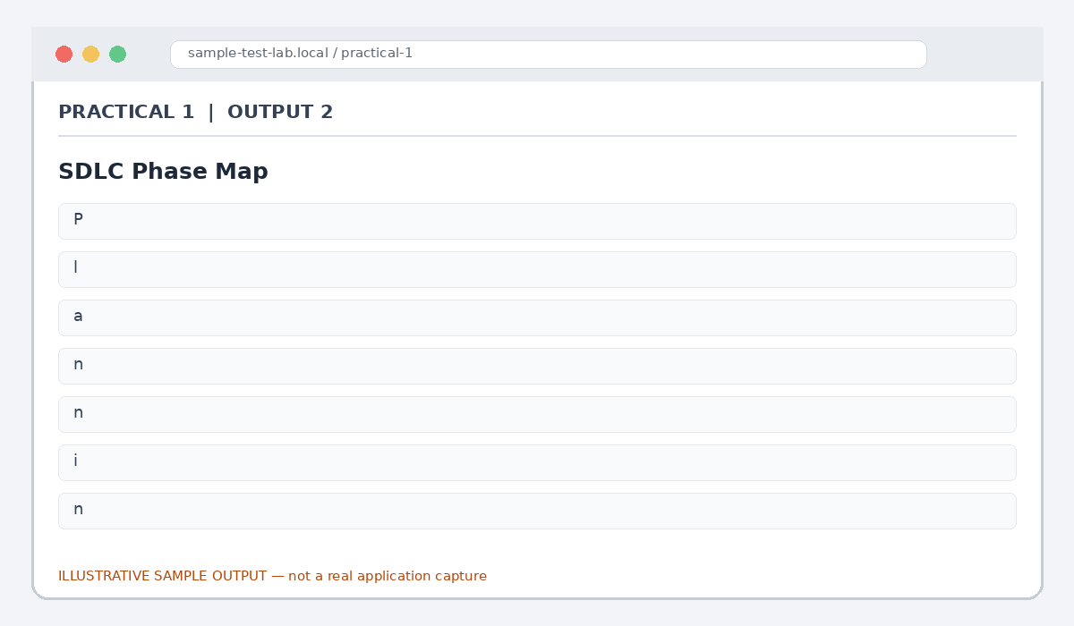
Figure 1.2: SDLC Phase Map (illustrative sample)

Output 3: STLC Phase Map
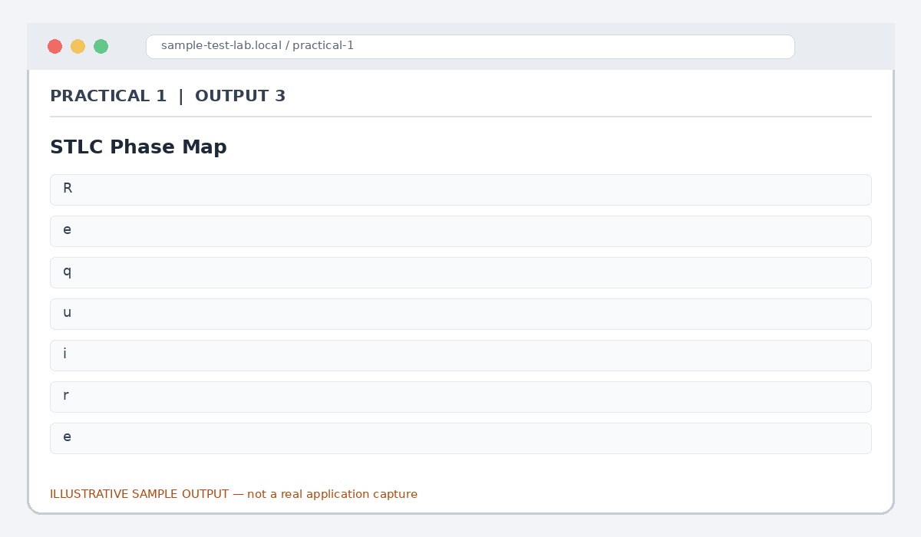
Figure 1.3: STLC Phase Map (illustrative sample)

Output 4: Phase-to-Activity Matrix
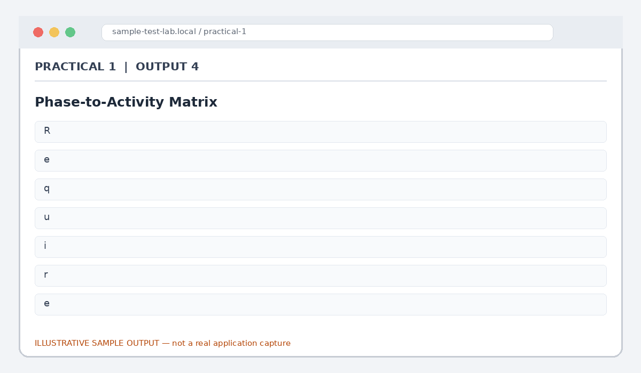
Figure 1.4: Phase-to-Activity Matrix (illustrative sample)

Output 5: Sample Test Evidence
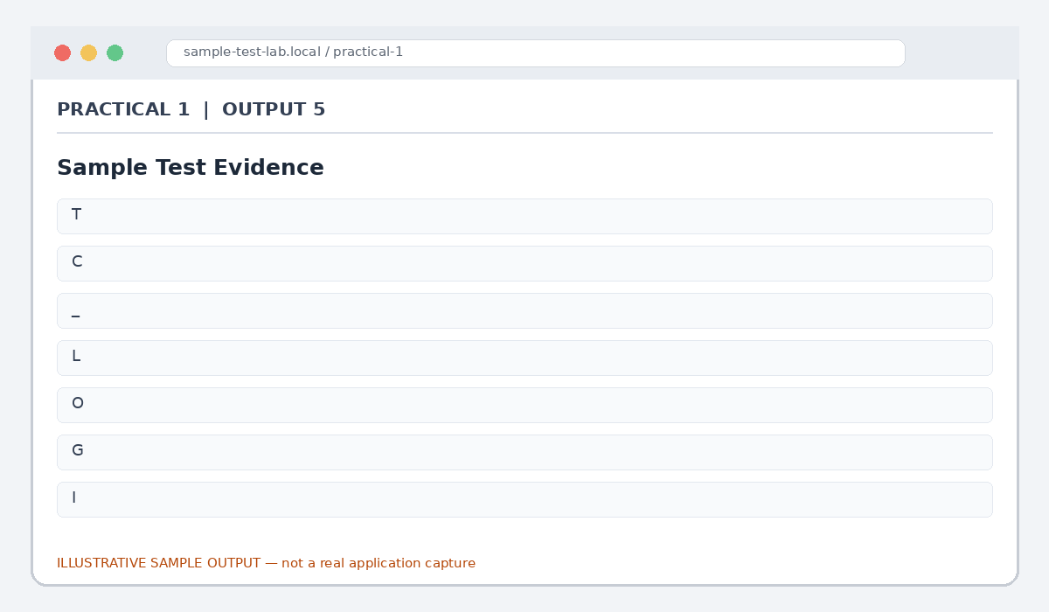
Figure 1.5: Sample Test Evidence (illustrative sample)

Result
SDLC and STLC phases and their related testing activities were identified for the sample e-commerce login feature.

Note for Final Submission
Check the exact rules, requirements, and results from your assigned application/manual before submitting. Any sample status, test data, limits, counts, or defect priorities in this document are examples and should be replaced with actual lab observations where required.

