SOFTWARE TESTING LAB
PRACTICAL 10
Project Modules and Automation/Regression Testing
Sample practical record | Illustrative screenshot-style outputs

Aim
To analyze project modules and identify suitable functionalities for automation testing and regression testing implementation.

Procedure
- List the application's main modules and repeatable workflows.
- Select stable, high-priority scenarios suitable for automation.
- Identify regression tests that should run after code changes.
- Prioritize tests by risk, frequency and business importance.

Outputs / Screenshots
These are original screenshot-style illustrations prepared for the listed practical. They are not screenshots captured from Bugzilla, TestLink, a live website, or a running Selenium session. Replace or supplement them with actual lab screenshots if required.

Output 1: Module Inventory
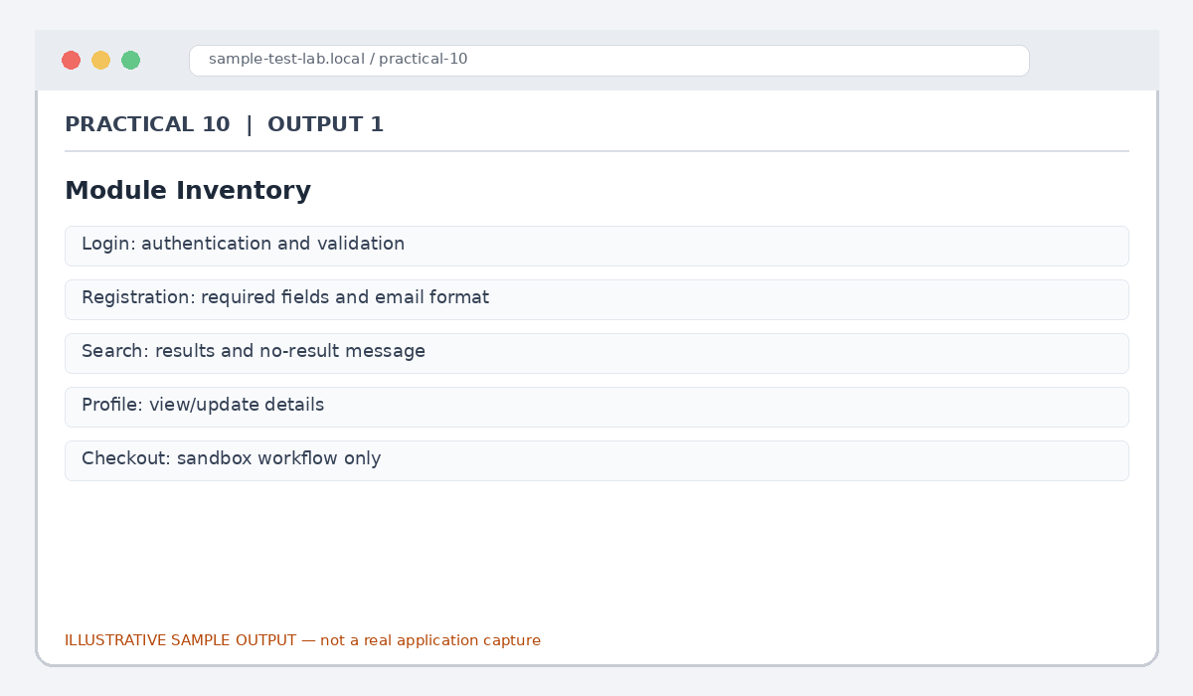
Figure 10.1: Module Inventory (illustrative sample)

Output 2: Automation Suitability
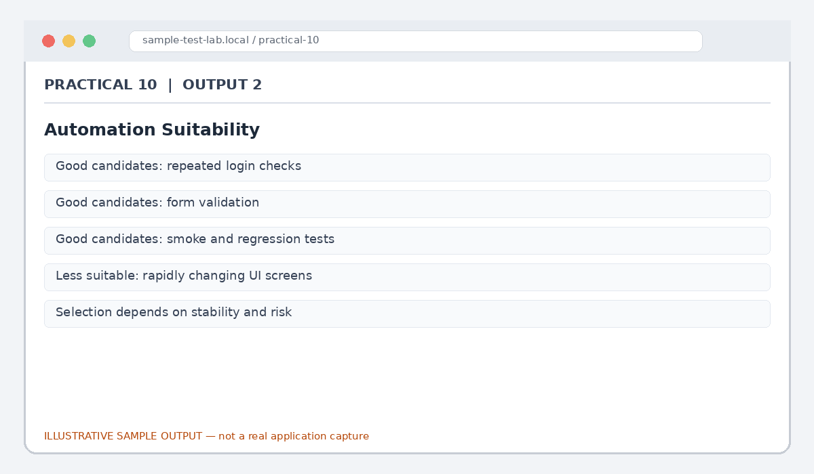
Figure 10.2: Automation Suitability (illustrative sample)

Output 3: Regression Suite
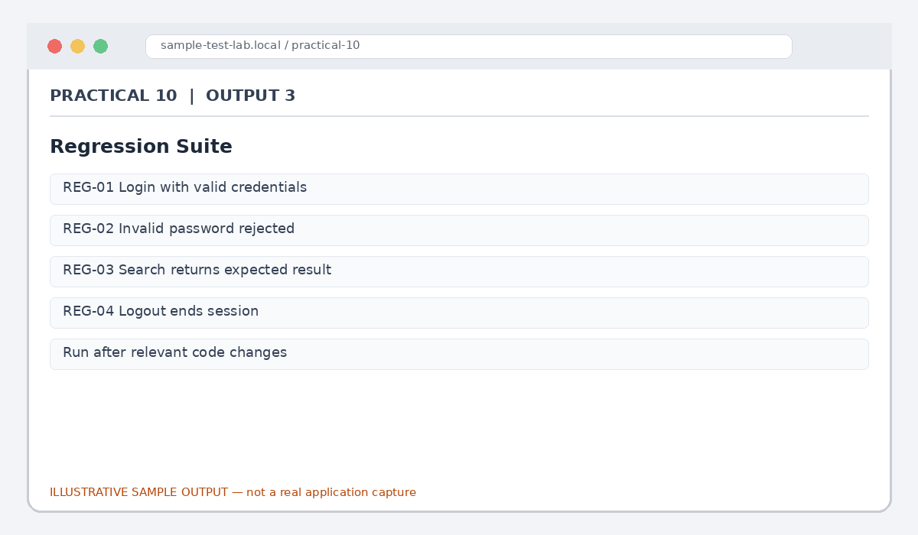
Figure 10.3: Regression Suite (illustrative sample)

Output 4: Priority Matrix
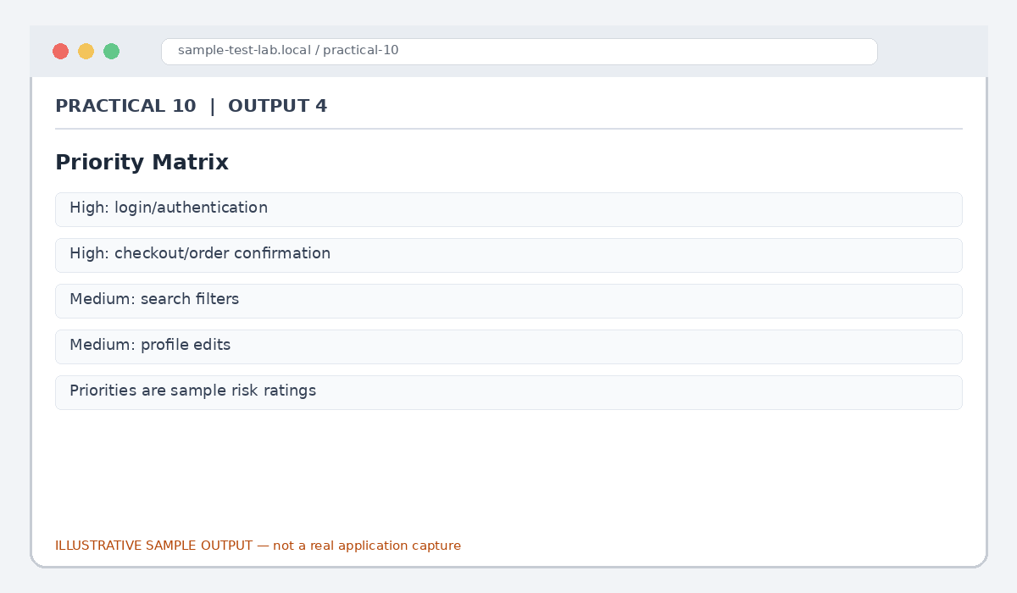
Figure 10.4: Priority Matrix (illustrative sample)

Output 5: Automation Summary
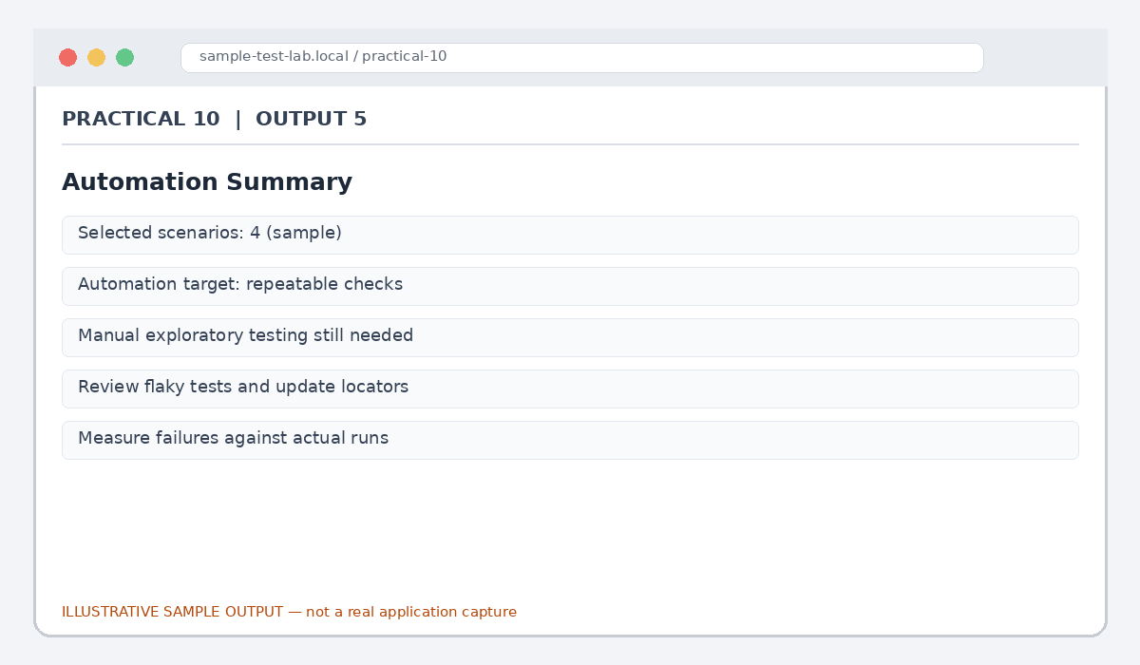
Figure 10.5: Automation Summary (illustrative sample)

Result
Suitable modules and repeatable scenarios were identified for automation and regression testing.

Submission Note
Confirm tool versions, application rules and test outcomes from your own lab setup. Sample statuses, data and counts must be replaced with actual observations where required.

