SOFTWARE TESTING LAB
PRACTICAL 11
Python Automation for Website Navigation, Forms, Links and Regression
Sample practical record | Illustrative screenshot-style outputs

Aim
To analyze automation testing in Python for website navigation, forms, multi-page workflows, links and regression testing scenarios.

Procedure
- Set up Python and a browser automation library in a test environment.
- Write tests for navigation, form entry, links and multi-page workflows.
- Add assertions for expected page titles, messages and URLs.
- Run the regression suite and record pass/fail results.

Outputs / Screenshots
These are original screenshot-style illustrations prepared for the listed practical. They are not screenshots captured from Bugzilla, TestLink, a live website, or a running Selenium session. Replace or supplement them with actual lab screenshots if required.

Output 1: Test Scenario
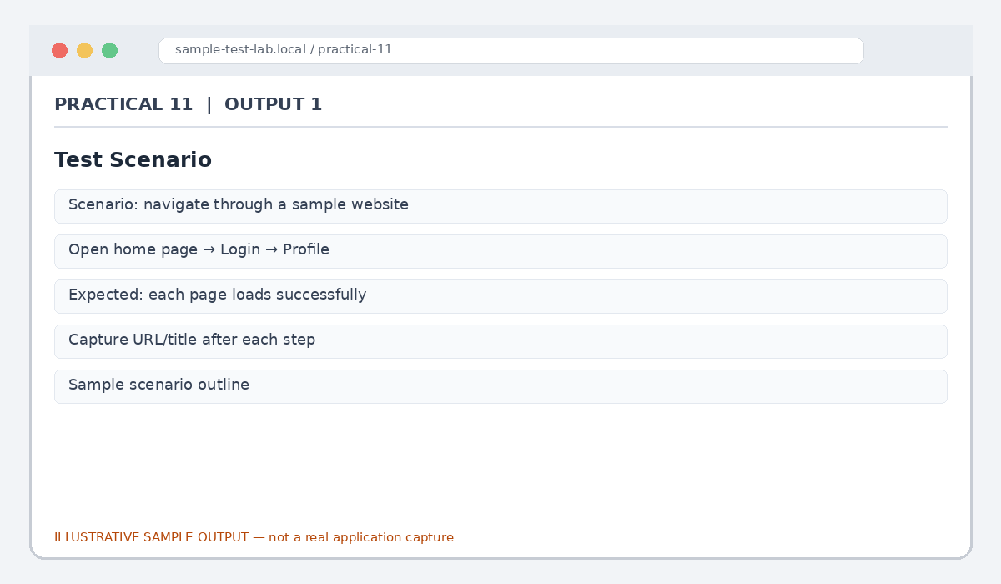
Figure 11.1: Test Scenario (illustrative sample)

Output 2: Navigation Check
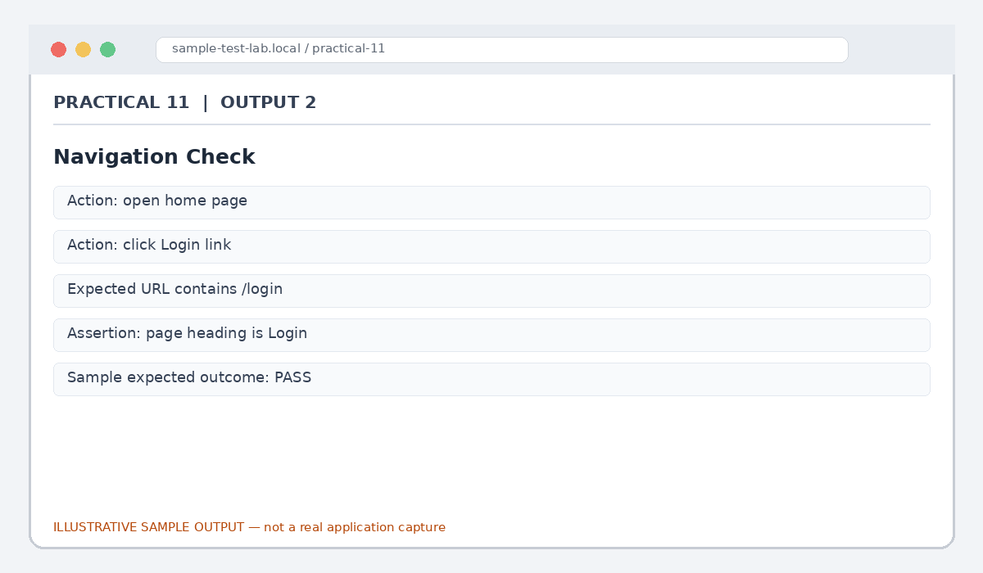
Figure 11.2: Navigation Check (illustrative sample)

Output 3: Form Handling
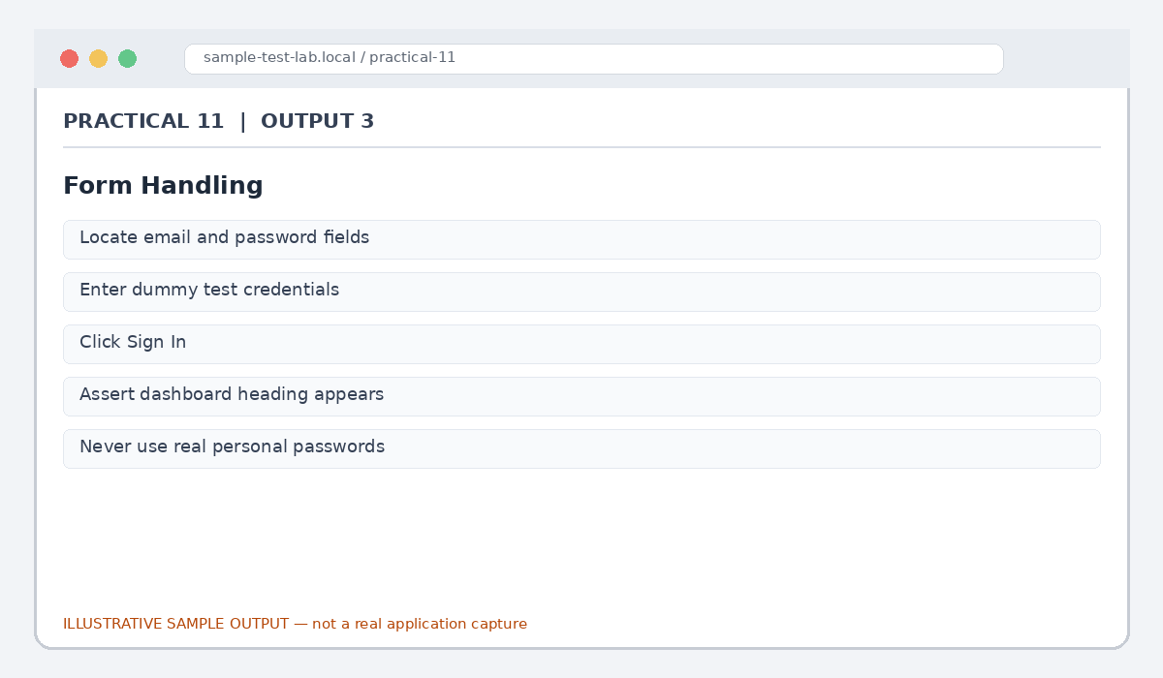
Figure 11.3: Form Handling (illustrative sample)

Output 4: Link Validation
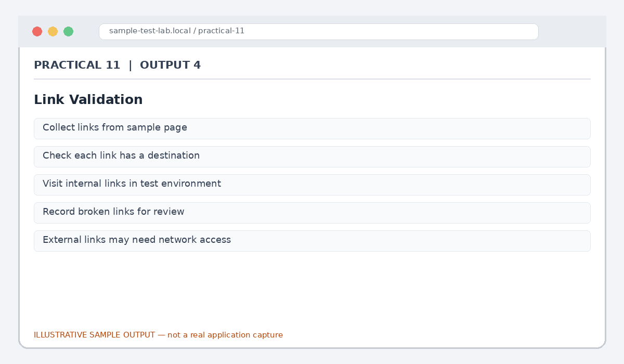
Figure 11.4: Link Validation (illustrative sample)

Output 5: Regression Report
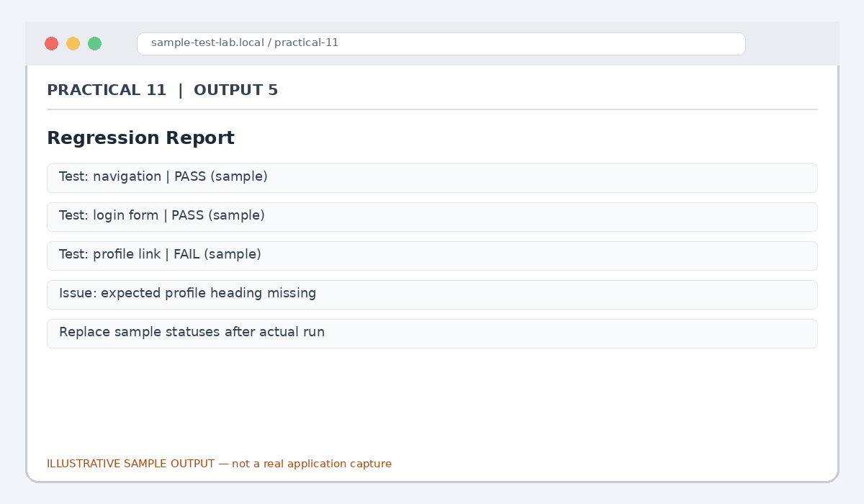
Figure 11.5: Regression Report (illustrative sample)

Result
Python-based website automation scenarios were outlined for navigation, forms, links and regression.

Submission Note
Confirm tool versions, application rules and test outcomes from your own lab setup. Sample statuses, data and counts must be replaced with actual observations where required.

