SOFTWARE TESTING LAB
PRACTICAL 12
AI-powered Software Testing and Generative AI
Sample practical record | Illustrative screenshot-style outputs

Aim
To analyze AI-powered software testing tools and apply Generative AI techniques for test case generation, test data creation, defect prediction, requirement analysis and automated Selenium script generation.

Procedure
- Provide a clear, non-sensitive requirement to an AI assistant.
- Generate draft test cases and test data, then review them against requirements.
- Use AI to summarize likely risks or defect patterns without treating predictions as facts.
- Generate a Selenium script draft and validate it in a safe test environment.

Outputs / Screenshots
These are original screenshot-style illustrations prepared for the listed practical. They are not screenshots captured from Bugzilla, TestLink, a live website, or a running Selenium session. Replace or supplement them with actual lab screenshots if required.

Output 1: Requirement Analysis
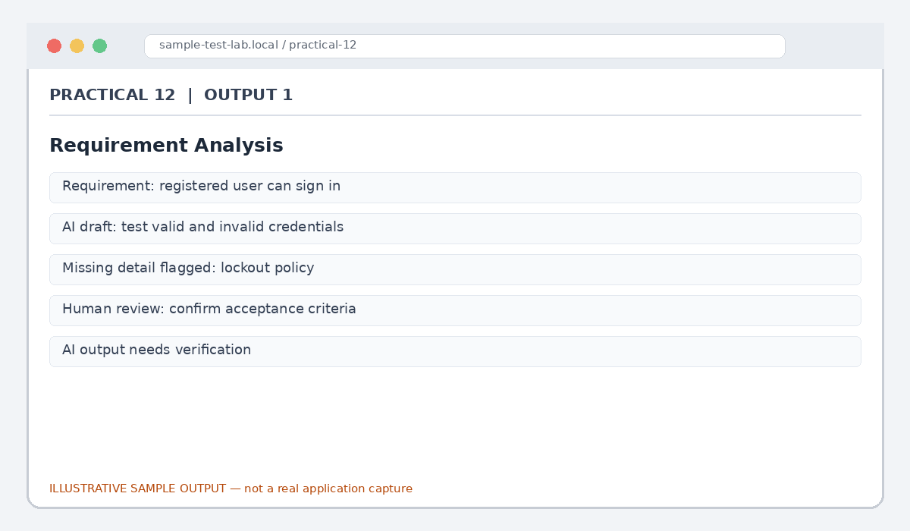
Figure 12.1: Requirement Analysis (illustrative sample)

Output 2: Generated Test Cases
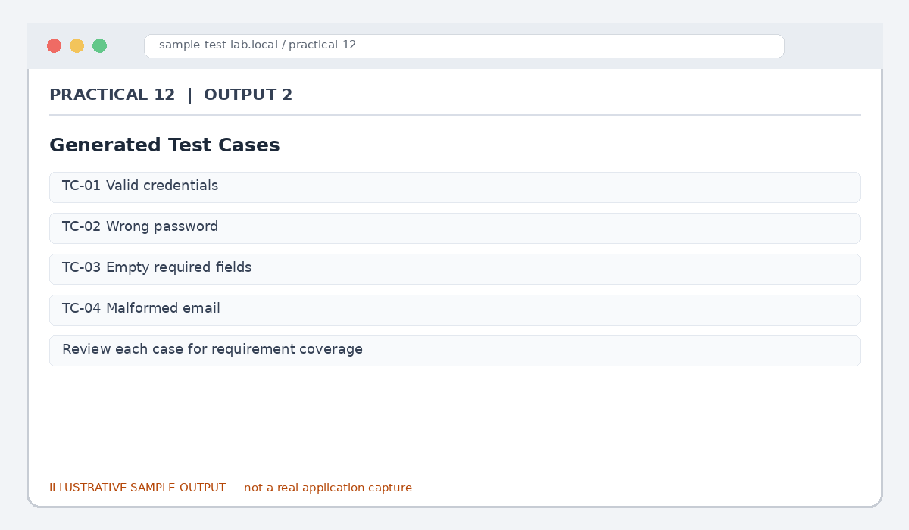
Figure 12.2: Generated Test Cases (illustrative sample)

Output 3: Synthetic Test Data
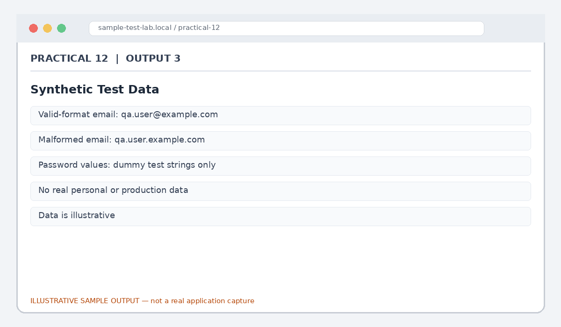
Figure 12.3: Synthetic Test Data (illustrative sample)

Output 4: Defect Risk Summary
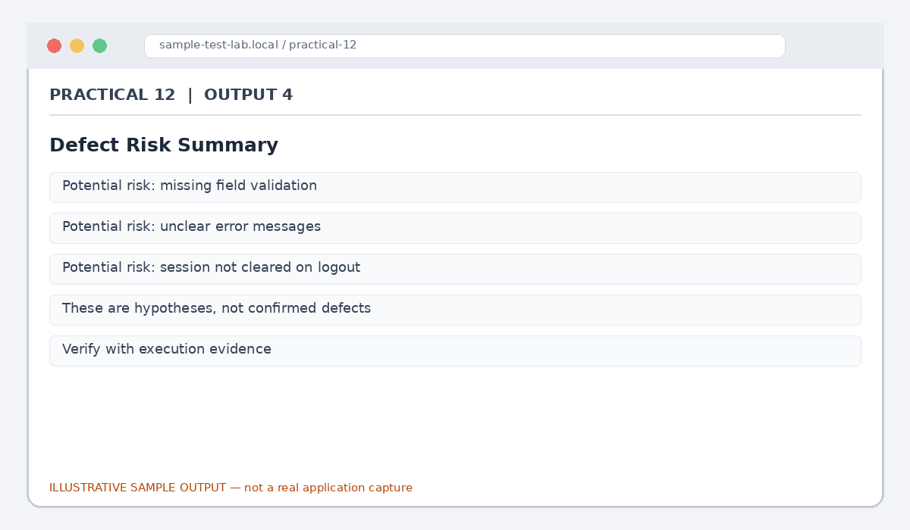
Figure 12.4: Defect Risk Summary (illustrative sample)

Output 5: Selenium Script Draft Review
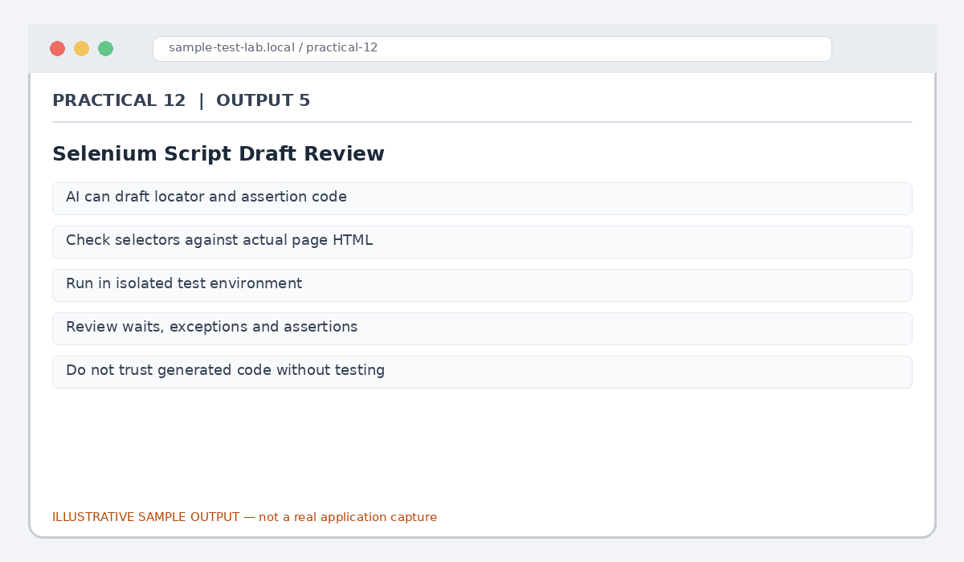
Figure 12.5: Selenium Script Draft Review (illustrative sample)

Result
Generative AI use cases for test design, synthetic data, risk analysis and automation-script drafting were reviewed with human verification emphasized.

Submission Note
Confirm tool versions, application rules and test outcomes from your own lab setup. Sample statuses, data and counts must be replaced with actual observations where required.

