SOFTWARE TESTING LAB
PRACTICAL 13
Configure Python, Selenium WebDriver, IDE and Browser Drivers
Sample practical record | Illustrative screenshot-style outputs

Aim
To create and configure Python, Selenium WebDriver, VS Code/PyCharm IDE, browser drivers and automation testing libraries for Selenium testing.

Procedure
- Install a supported Python version and an IDE.
- Create a virtual environment and install Selenium using pip.
- Install or configure a compatible browser and driver using current Selenium guidance.
- Run a simple script that opens a browser and checks a page title.

Outputs / Screenshots
These are original screenshot-style illustrations prepared for the listed practical. They are not screenshots captured from Bugzilla, TestLink, a live website, or a running Selenium session. Replace or supplement them with actual lab screenshots if required.

Output 1: Environment Overview
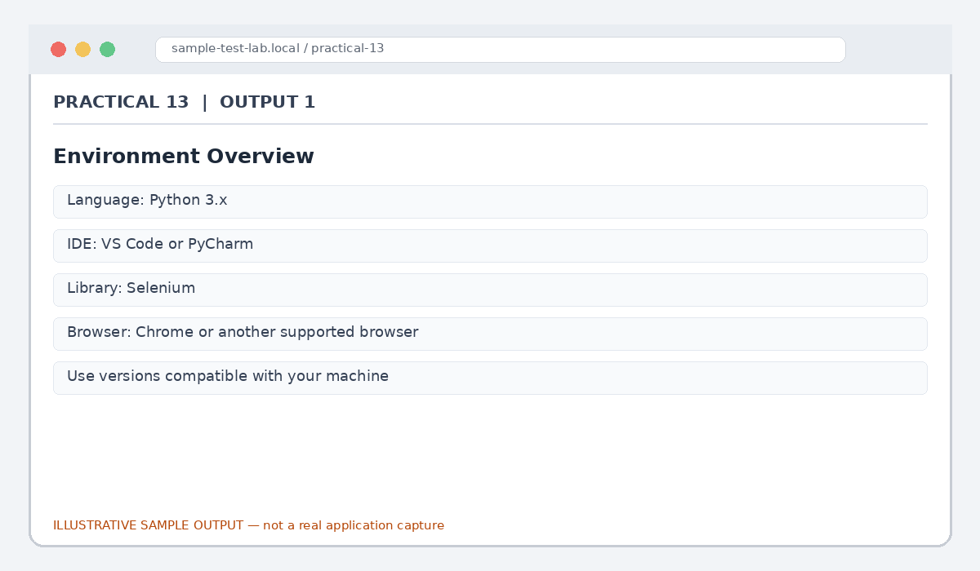
Figure 13.1: Environment Overview (illustrative sample)

Output 2: Virtual Environment
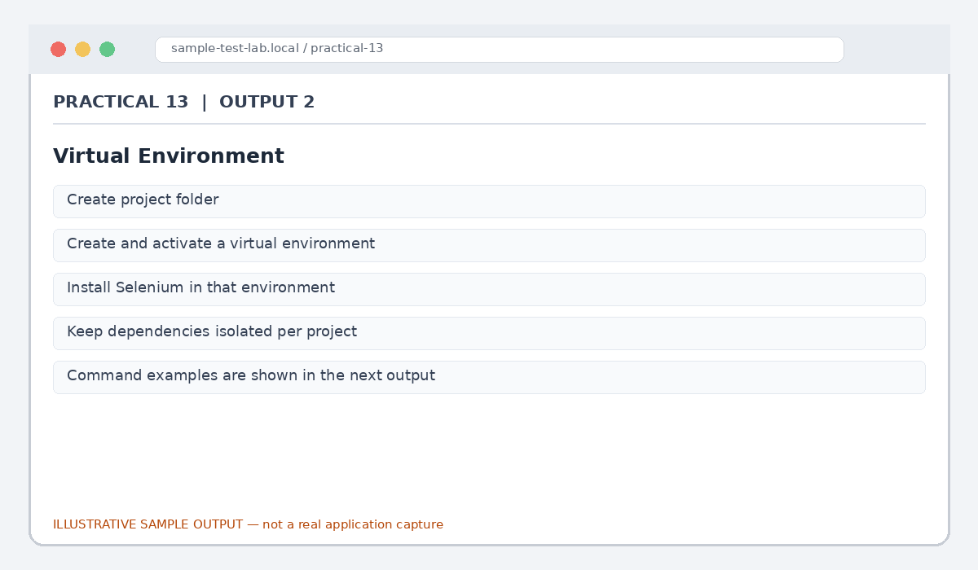
Figure 13.2: Virtual Environment (illustrative sample)

Output 3: Install Command
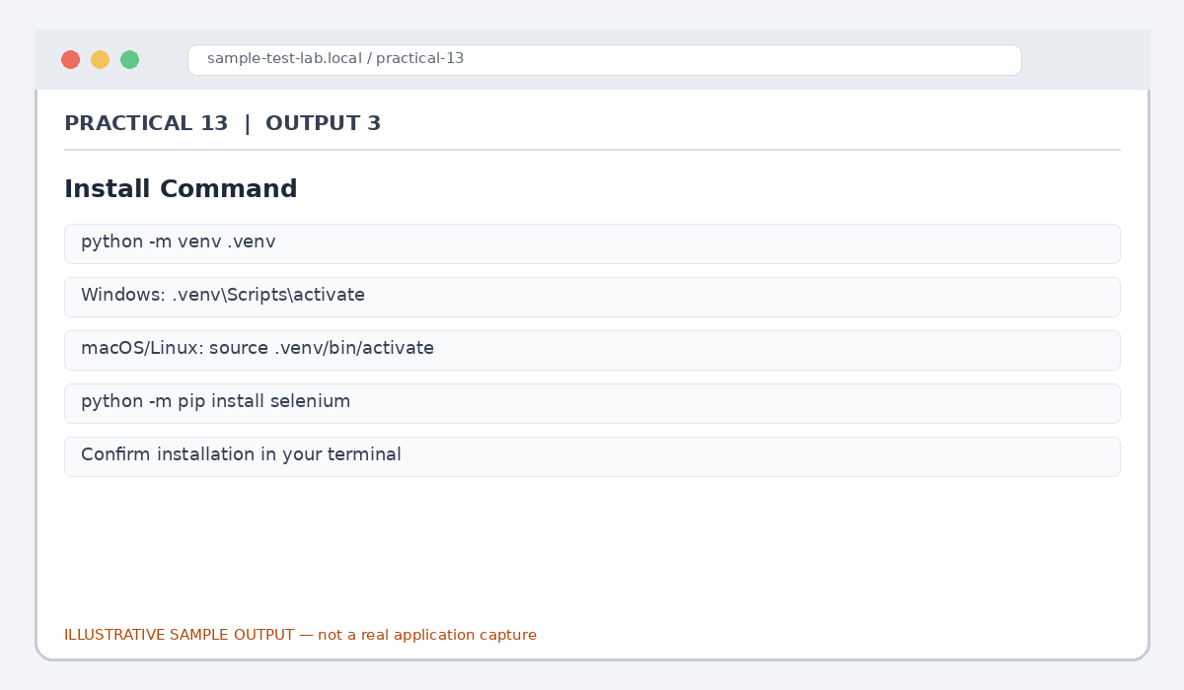
Figure 13.3: Install Command (illustrative sample)

Output 4: First Browser Run
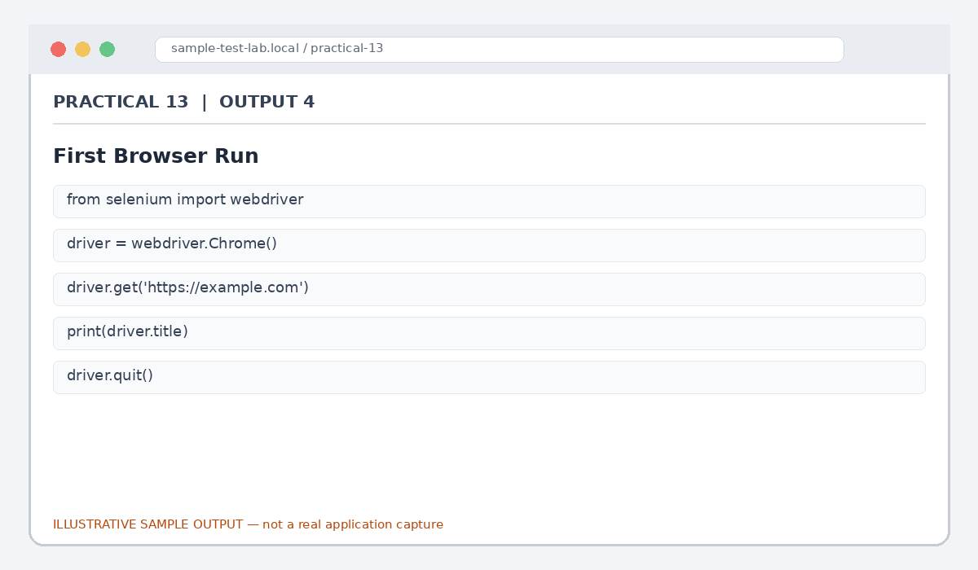
Figure 13.4: First Browser Run (illustrative sample)

Output 5: Setup Verification
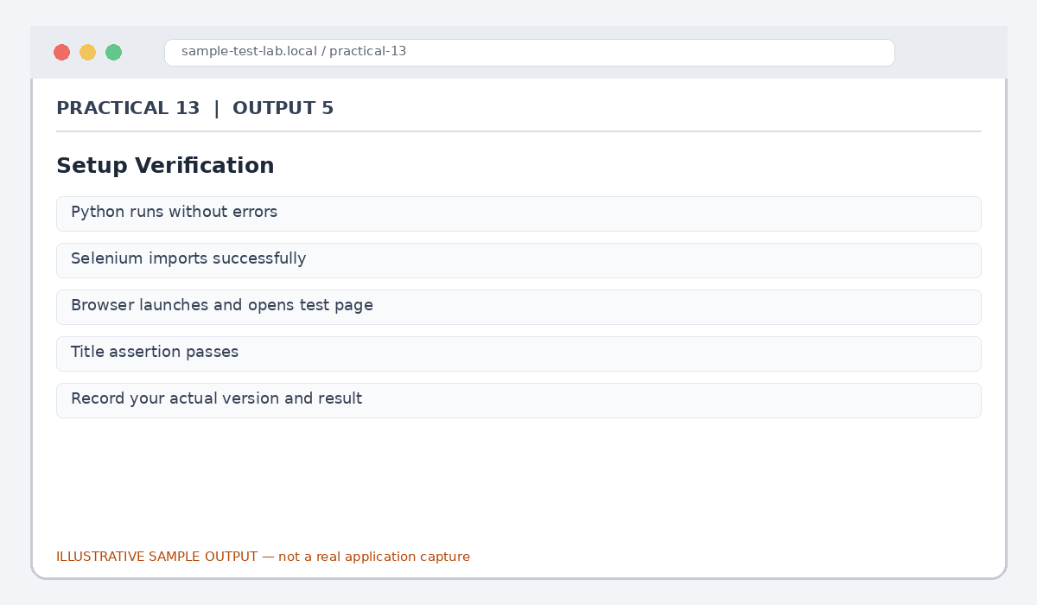
Figure 13.5: Setup Verification (illustrative sample)

Result
The basic Python/Selenium environment setup and verification workflow was documented.

Submission Note
Confirm tool versions, application rules and test outcomes from your own lab setup. Sample statuses, data and counts must be replaced with actual observations where required.

