SOFTWARE TESTING LAB
PRACTICAL 14
Selenium Automation Scripts for Navigation, Forms, Elements and Validation
Sample practical record | Illustrative screenshot-style outputs

Aim
To create Selenium automation scripts in Python for browser navigation, form handling, web element interaction and validation testing.

Procedure
- Open a browser using Selenium WebDriver.
- Navigate to a test page and locate elements using stable selectors.
- Interact with form fields and buttons, then assert the resulting page state.
- Capture failures and close the browser reliably.

Outputs / Screenshots
These are original screenshot-style illustrations prepared for the listed practical. They are not screenshots captured from Bugzilla, TestLink, a live website, or a running Selenium session. Replace or supplement them with actual lab screenshots if required.

Output 1: Browser Navigation
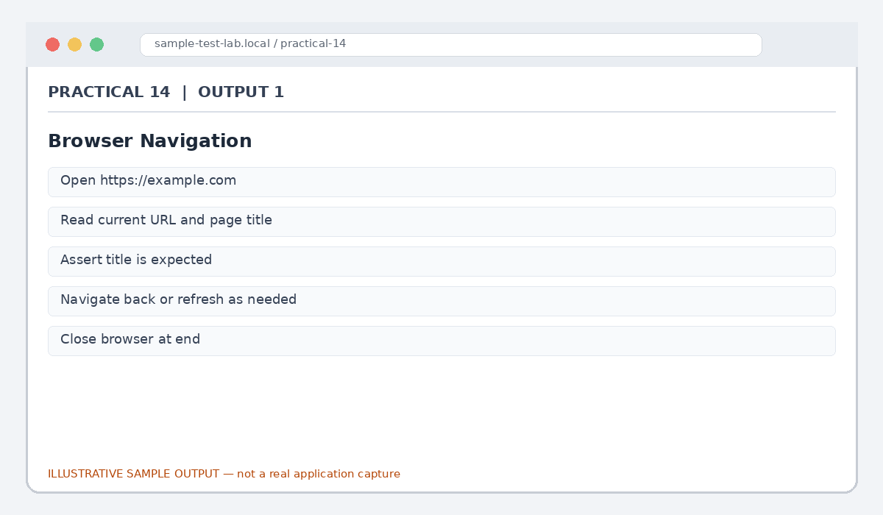
Figure 14.1: Browser Navigation (illustrative sample)

Output 2: Element Interaction
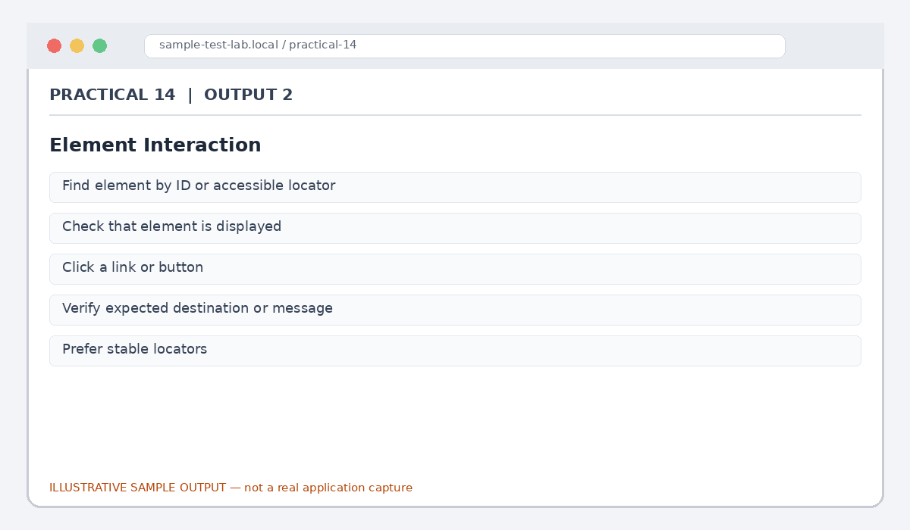
Figure 14.2: Element Interaction (illustrative sample)

Output 3: Form Handling
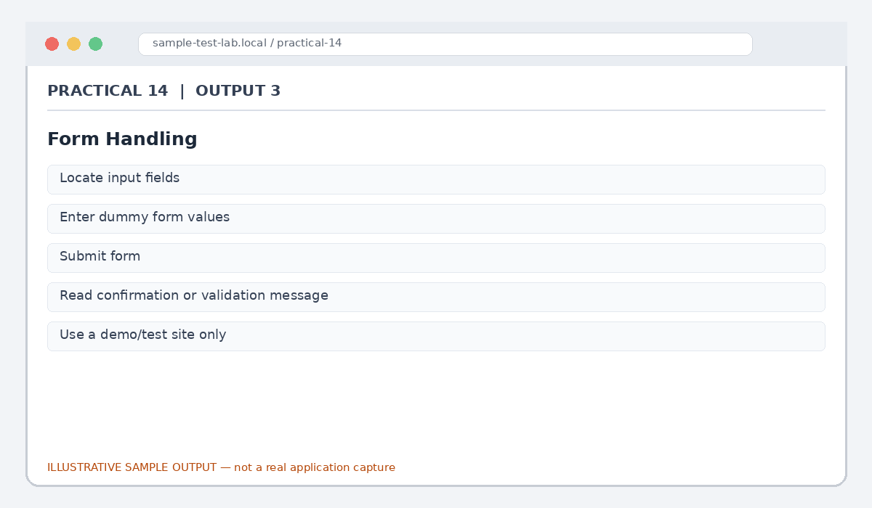
Figure 14.3: Form Handling (illustrative sample)

Output 4: Validation Assertion
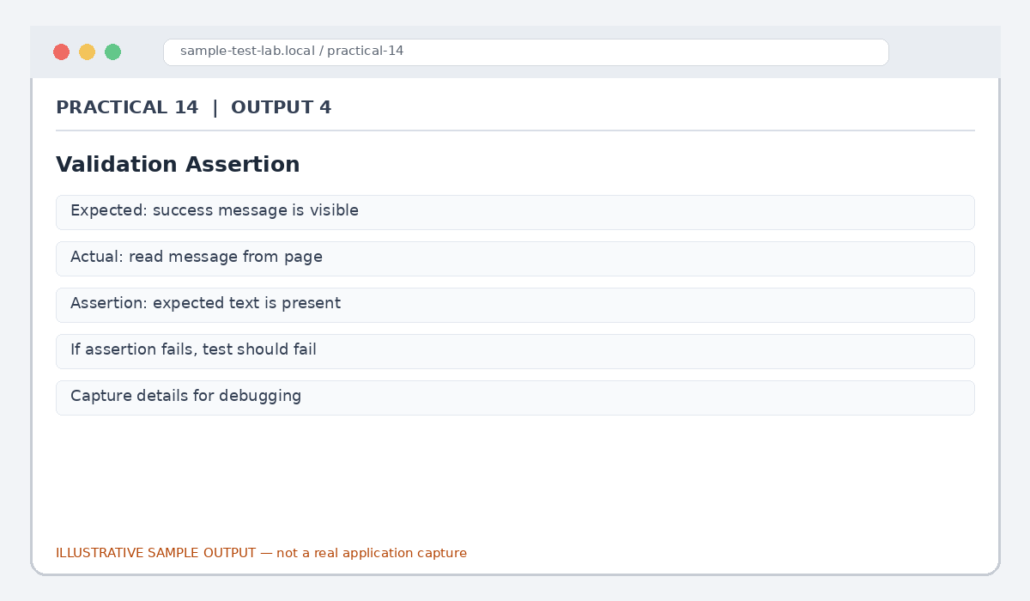
Figure 14.4: Validation Assertion (illustrative sample)

Output 5: Exception Handling
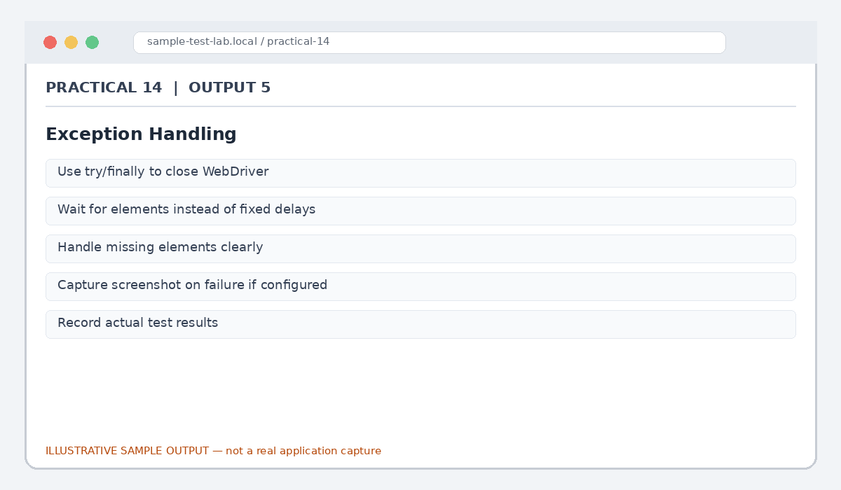
Figure 14.5: Exception Handling (illustrative sample)

Result
Sample Selenium workflows for navigation, element interaction, forms and assertions were documented.

Submission Note
Confirm tool versions, application rules and test outcomes from your own lab setup. Sample statuses, data and counts must be replaced with actual observations where required.

