SOFTWARE TESTING LAB
PRACTICAL 15
Automated Login, Authentication Validation, Assertions and Exception Handling
Sample practical record | Illustrative screenshot-style outputs

Aim
To create automated login functionality, authentication validation, assertions and exception-handling scenarios using Selenium WebDriver with Python.

Procedure
- Use a dedicated test login page and dummy test account.
- Automate valid, invalid and empty credential scenarios.
- Assert that successful login reaches the expected page and invalid login remains blocked.
- Handle timeouts or missing elements and ensure the browser closes.

Outputs / Screenshots
These are original screenshot-style illustrations prepared for the listed practical. They are not screenshots captured from Bugzilla, TestLink, a live website, or a running Selenium session. Replace or supplement them with actual lab screenshots if required.

Output 1: Login Test Setup
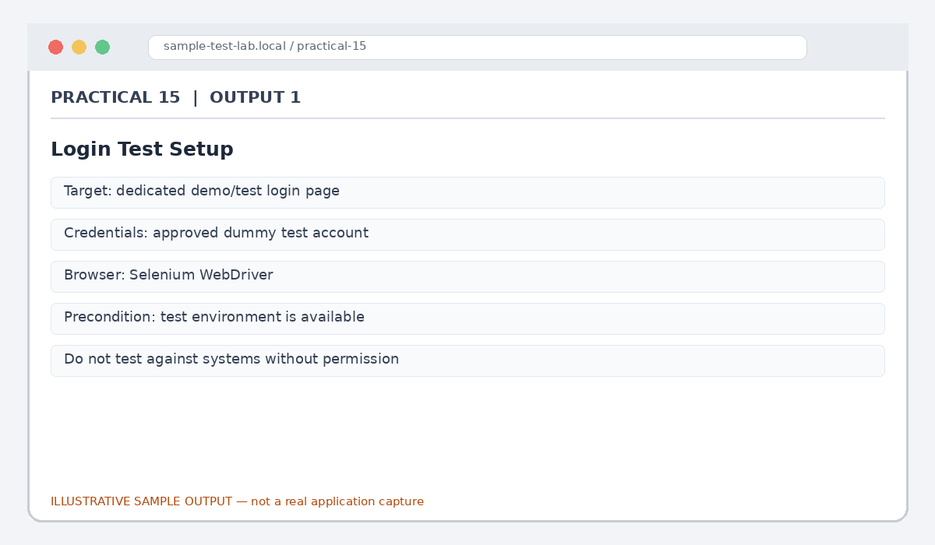
Figure 15.1: Login Test Setup (illustrative sample)

Output 2: Valid Login Scenario
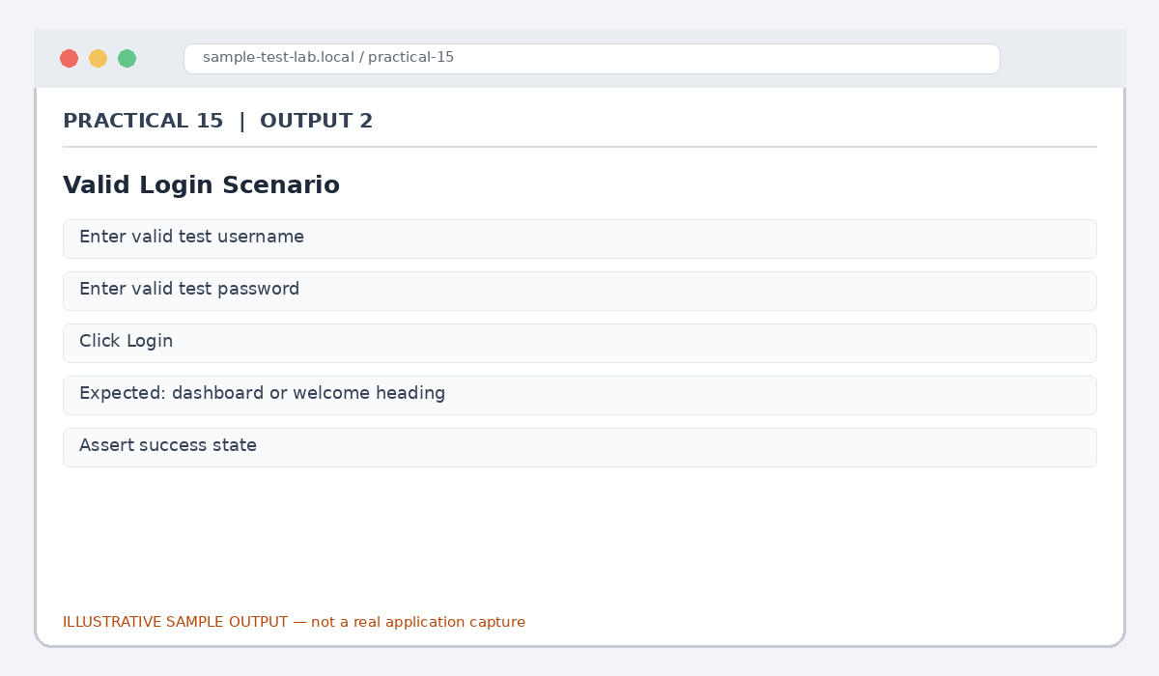
Figure 15.2: Valid Login Scenario (illustrative sample)

Output 3: Invalid Login Scenario
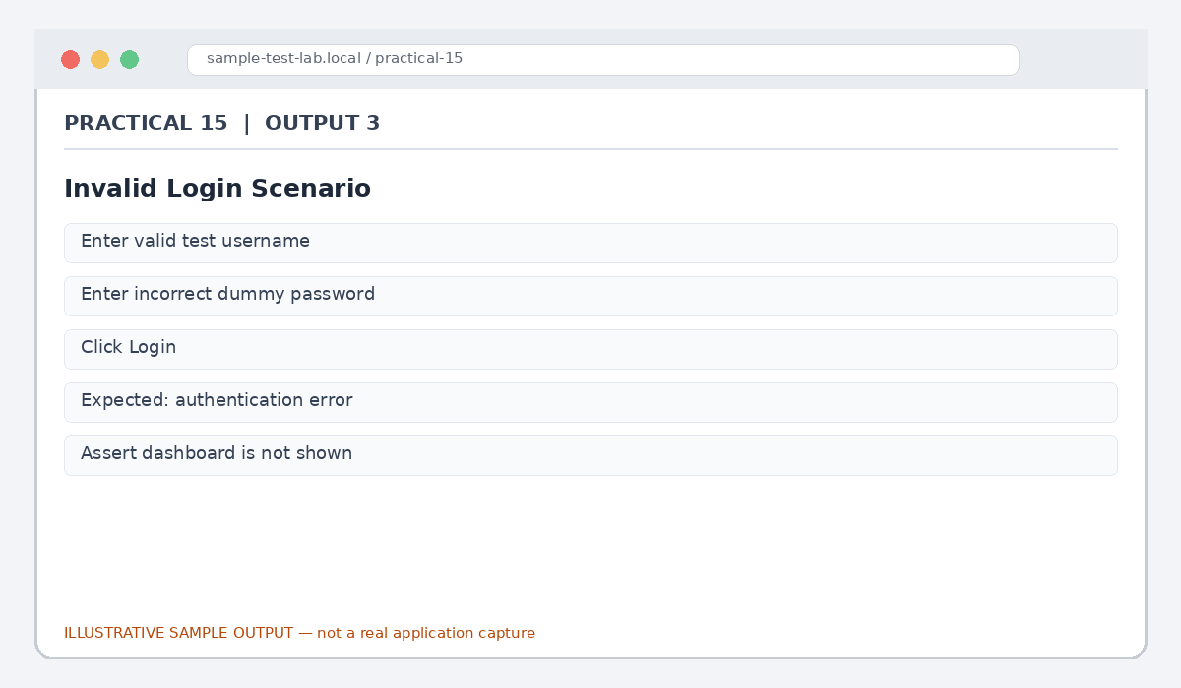
Figure 15.3: Invalid Login Scenario (illustrative sample)

Output 4: Authentication Validation
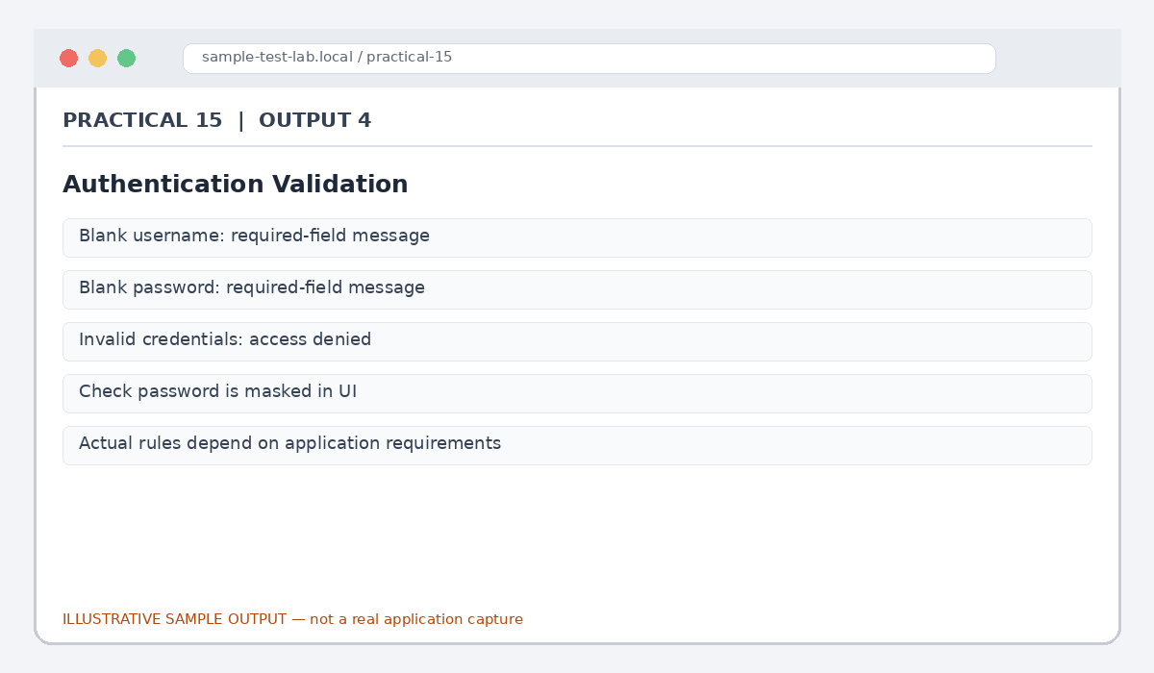
Figure 15.4: Authentication Validation (illustrative sample)

Output 5: Assertions and Exceptions
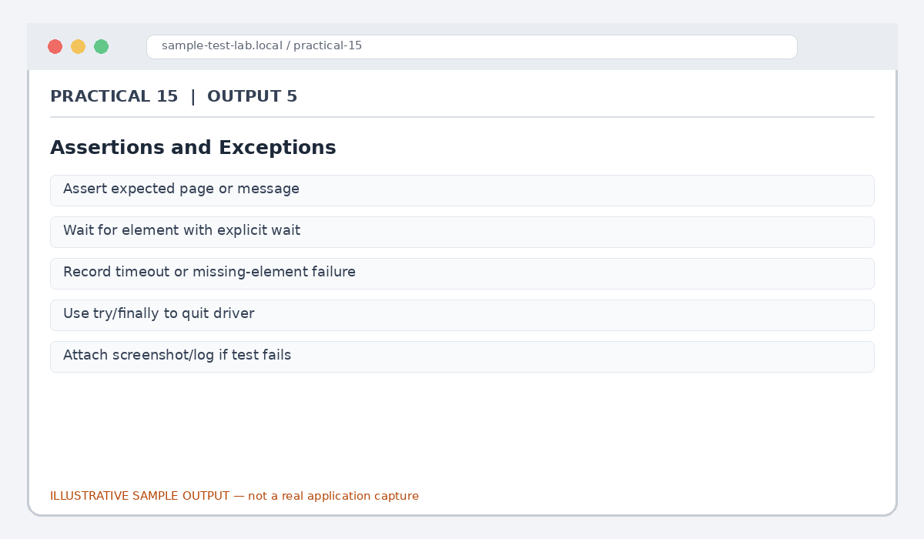
Figure 15.5: Assertions and Exceptions (illustrative sample)

Result
Automated login test scenarios were outlined for successful and unsuccessful authentication, validation, assertions and exception handling.

Submission Note
Confirm tool versions, application rules and test outcomes from your own lab setup. Sample statuses, data and counts must be replaced with actual observations where required.

