SOFTWARE TESTING LAB
PRACTICAL 2
Test Plan, RTM, Testing Scope and Testing Strategy
Sample practical record | Screenshot-style outputs are illustrative

Aim
To prepare a professional test plan, Requirement Traceability Matrix (RTM), testing scope document and testing strategy for a sample application.

Procedure
- Choose a sample application and define its features to be tested.
- Document objectives, scope, resources, schedule, environment, risks and entry/exit criteria in a test plan.
- Map each requirement to one or more test cases in an RTM.
- Define the test approach, test levels, test types, tools and reporting process.

Sample Outputs / Screenshots
The following are original, illustrative screenshot-style outputs prepared for the practical topic. They are not captures from a live application. Replace or supplement them with screenshots from your actual lab execution if your instructor requires real execution evidence.

Output 1: Test Plan - Overview
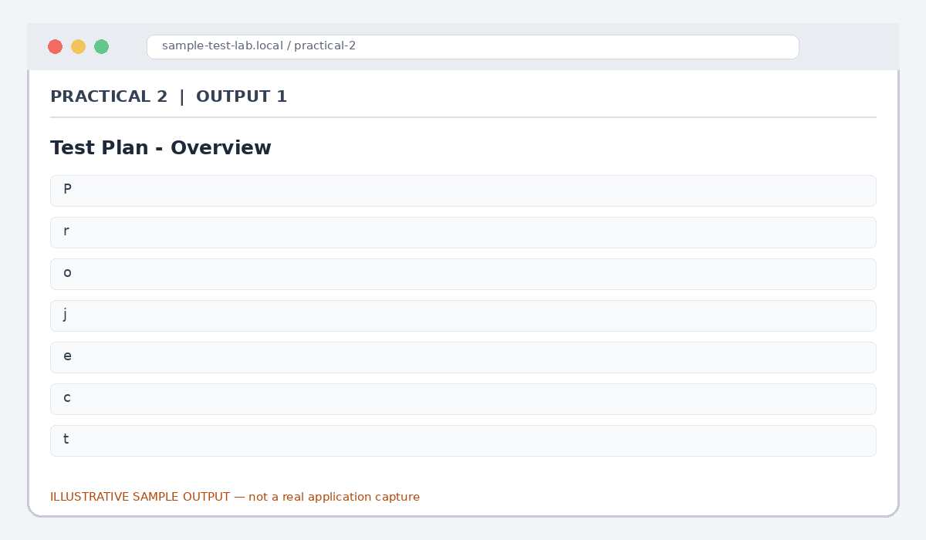
Figure 2.1: Test Plan - Overview (illustrative sample)

Output 2: Testing Scope
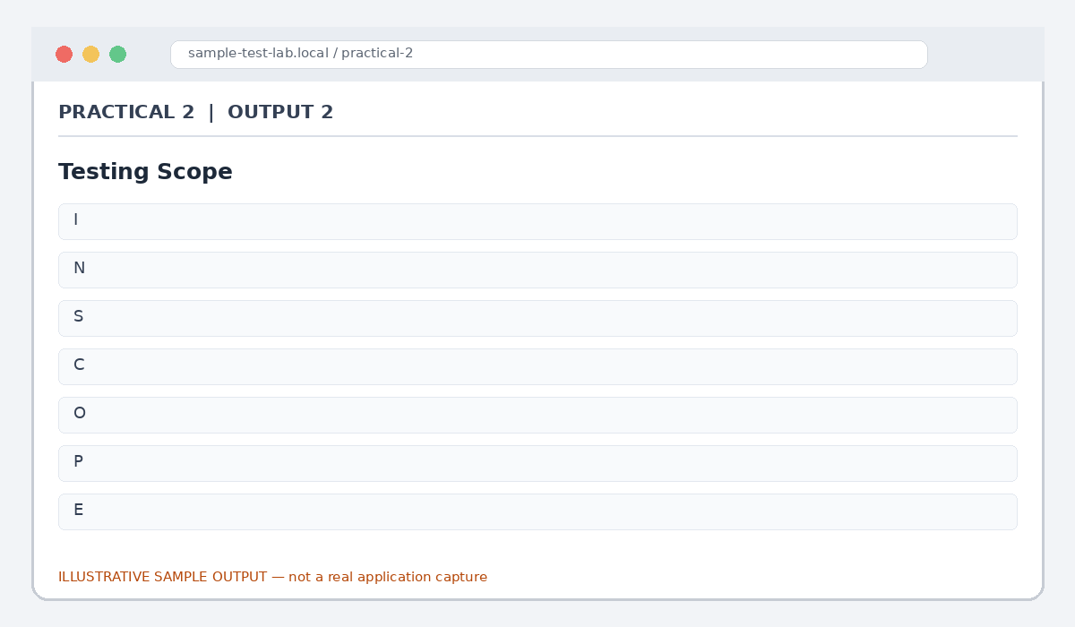
Figure 2.2: Testing Scope (illustrative sample)

Output 3: Testing Strategy
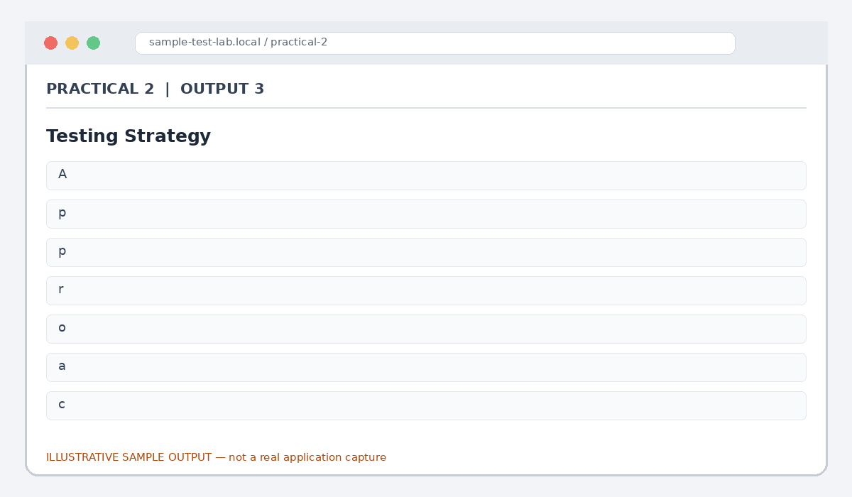
Figure 2.3: Testing Strategy (illustrative sample)

Output 4: Requirement Traceability Matrix
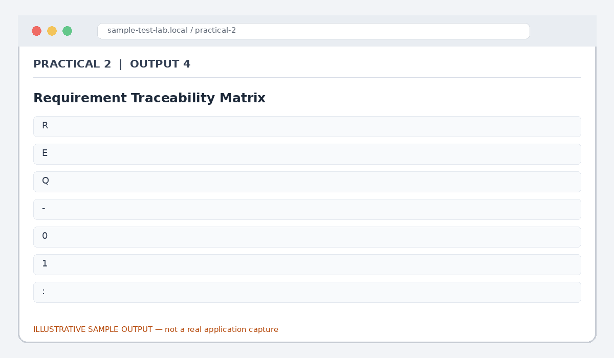
Figure 2.4: Requirement Traceability Matrix (illustrative sample)

Output 5: Entry and Exit Criteria
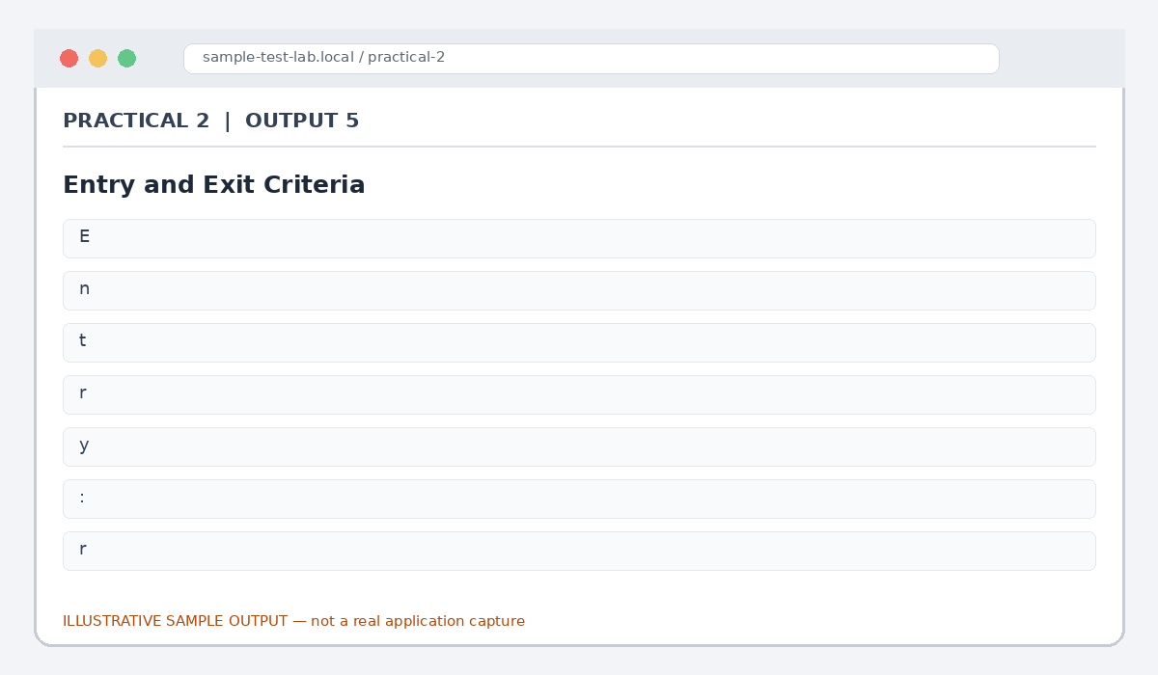
Figure 2.5: Entry and Exit Criteria (illustrative sample)

Result
A sample test plan, testing scope, testing strategy and RTM were prepared for an e-commerce application.

Note for Final Submission
Check the exact rules, requirements, and results from your assigned application/manual before submitting. Any sample status, test data, limits, counts, or defect priorities in this document are examples and should be replaced with actual lab observations where required.

