SOFTWARE TESTING LAB
PRACTICAL 3
Requirement Reviews, Walkthroughs, Inspections and Peer Reviews
Sample practical record | Screenshot-style outputs are illustrative

Aim
To understand requirement reviews, code walkthroughs, inspections and peer review activities using sample project documents.

Procedure
- Review a sample login requirement for clarity, completeness and testability.
- Conduct a walkthrough by explaining the requirement or code flow to reviewers.
- Use an inspection checklist to identify defects systematically.
- Record findings, assign owners and track them until resolution.

Sample Outputs / Screenshots
The following are original, illustrative screenshot-style outputs prepared for the practical topic. They are not captures from a live application. Replace or supplement them with screenshots from your actual lab execution if your instructor requires real execution evidence.

Output 1: Sample Requirement
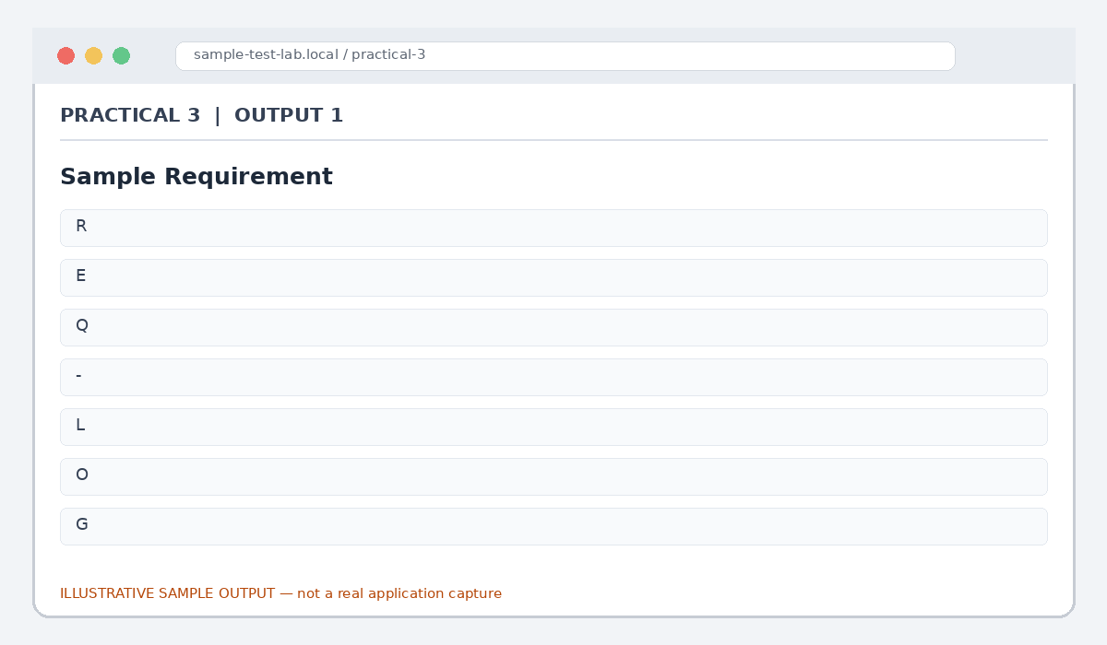
Figure 3.1: Sample Requirement (illustrative sample)

Output 2: Requirement Review Checklist
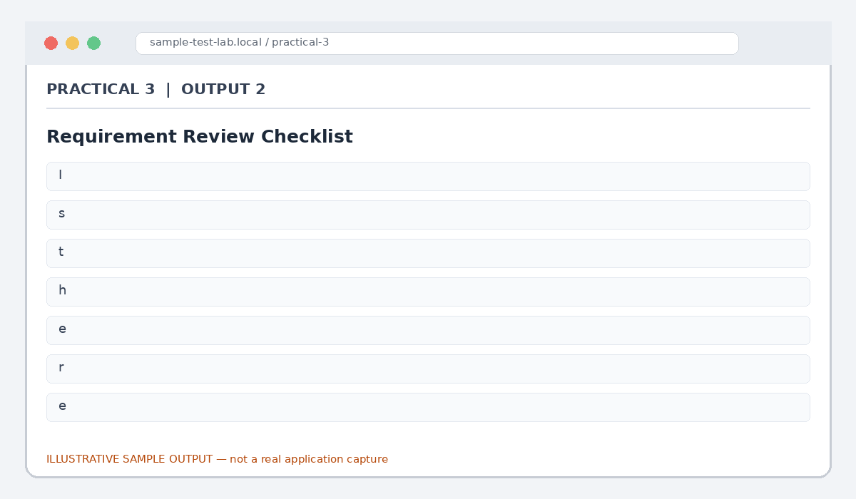
Figure 3.2: Requirement Review Checklist (illustrative sample)

Output 3: Walkthrough Notes
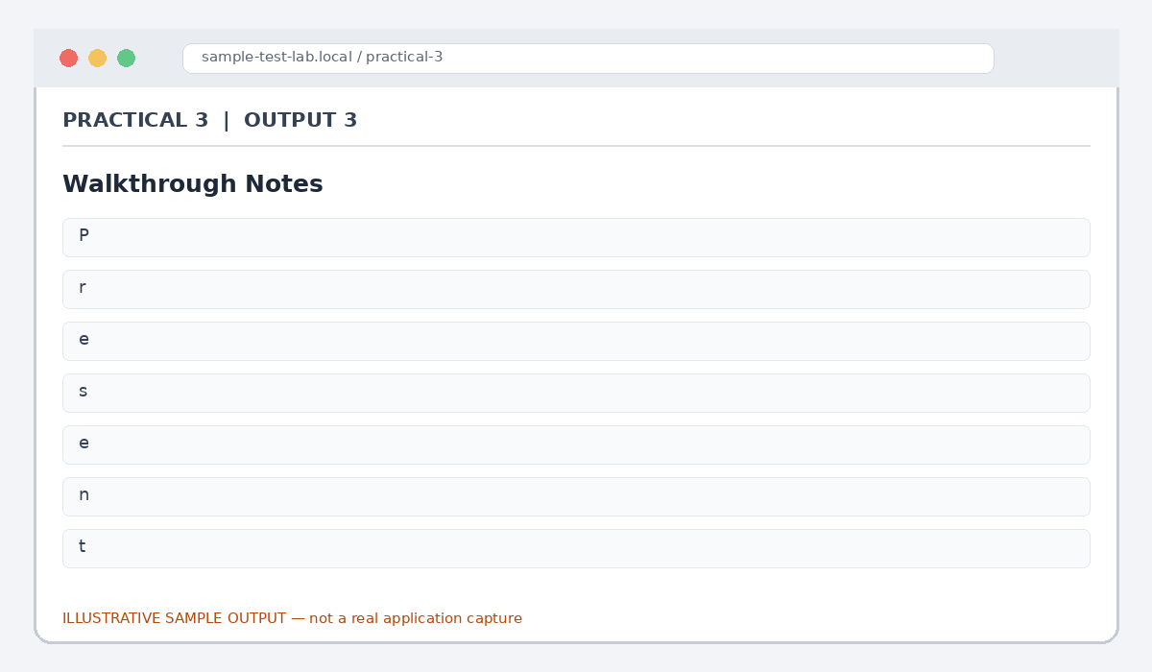
Figure 3.3: Walkthrough Notes (illustrative sample)

Output 4: Inspection Log
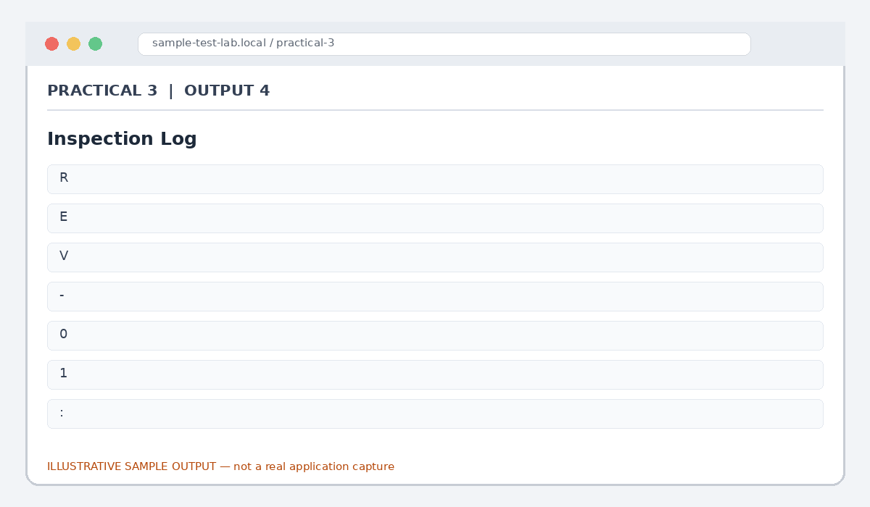
Figure 3.4: Inspection Log (illustrative sample)

Output 5: Peer Review Summary
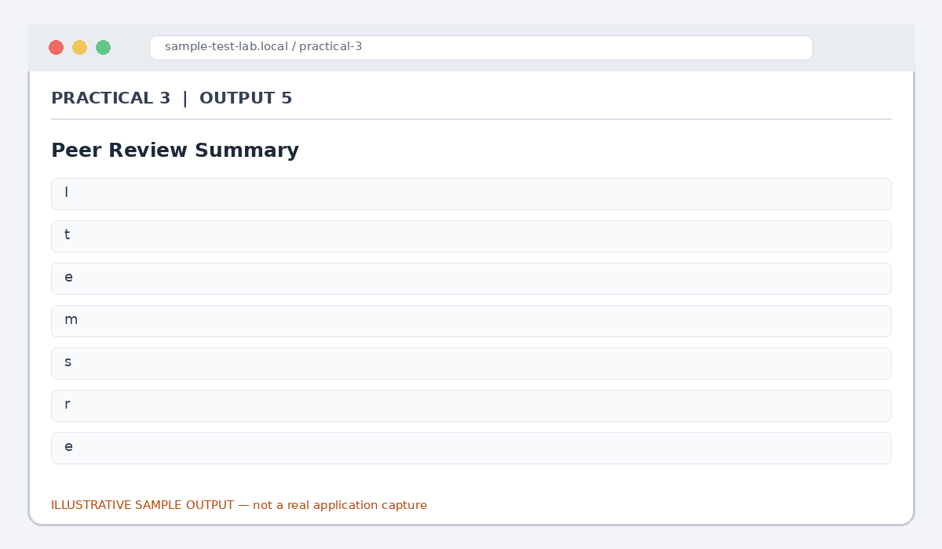
Figure 3.5: Peer Review Summary (illustrative sample)

Result
Sample review and inspection activities were documented, with findings recorded for follow-up.

Note for Final Submission
Check the exact rules, requirements, and results from your assigned application/manual before submitting. Any sample status, test data, limits, counts, or defect priorities in this document are examples and should be replaced with actual lab observations where required.

