SOFTWARE TESTING LAB
PRACTICAL 4
Functional, Non-functional, Positive and Negative Test Cases
Sample practical record | Screenshot-style outputs are illustrative

Aim
To apply functional, non-functional, positive and negative test cases for modules such as login, registration and payment systems.

Procedure
- Identify the main functions and quality attributes of the selected modules.
- Write positive cases using valid inputs and negative cases using invalid or missing inputs.
- Record preconditions, steps, test data, expected results and actual results.
- Classify cases as functional or non-functional and mark sample execution status.

Sample Outputs / Screenshots
The following are original, illustrative screenshot-style outputs prepared for the practical topic. They are not captures from a live application. Replace or supplement them with screenshots from your actual lab execution if your instructor requires real execution evidence.

Output 1: Login - Positive Test
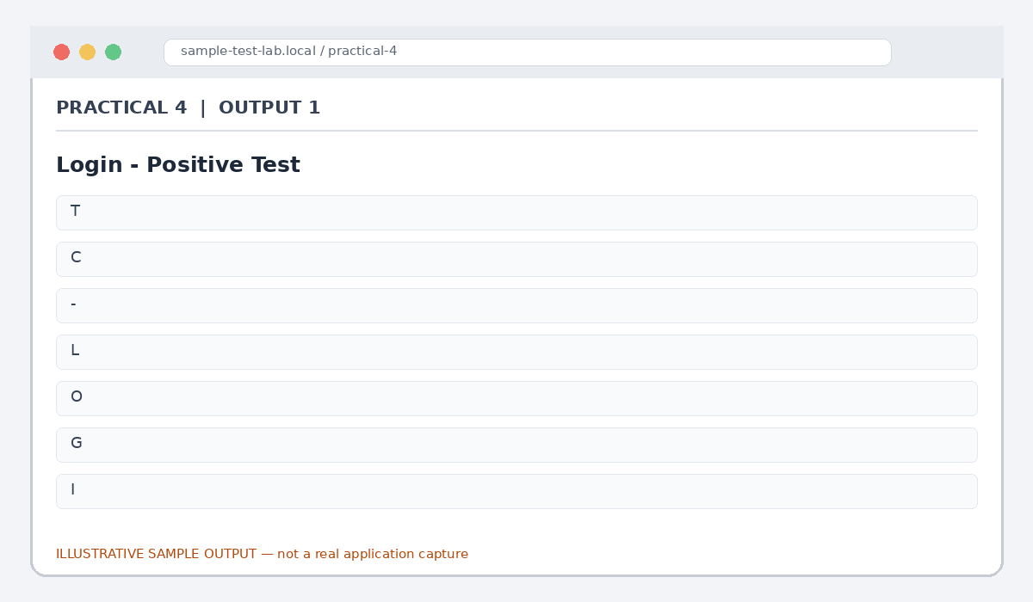
Figure 4.1: Login - Positive Test (illustrative sample)

Output 2: Login - Negative Test
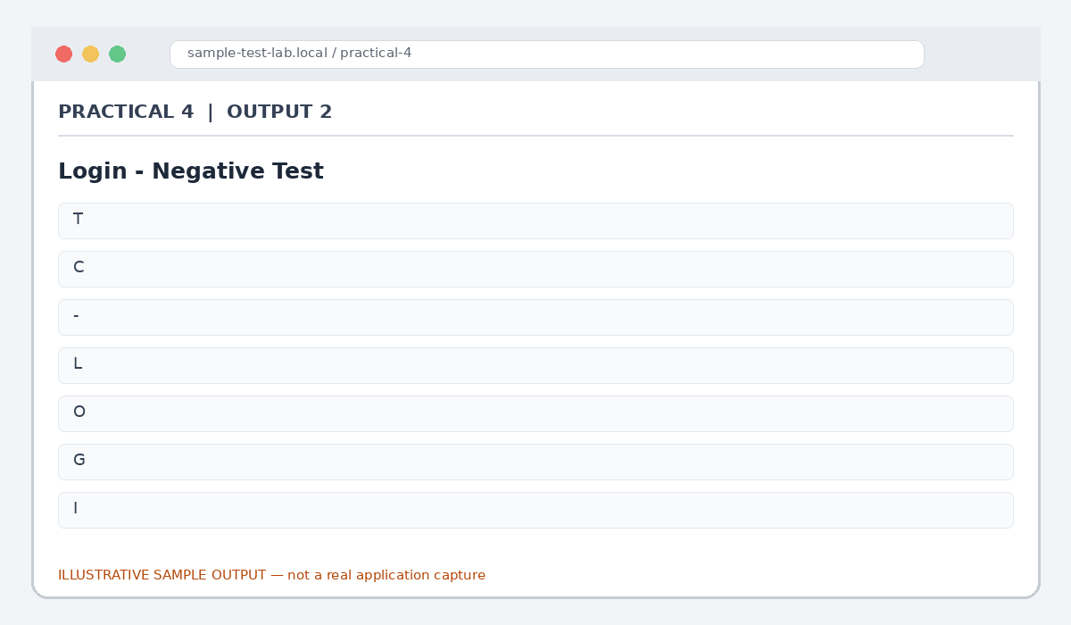
Figure 4.2: Login - Negative Test (illustrative sample)

Output 3: Registration Validation
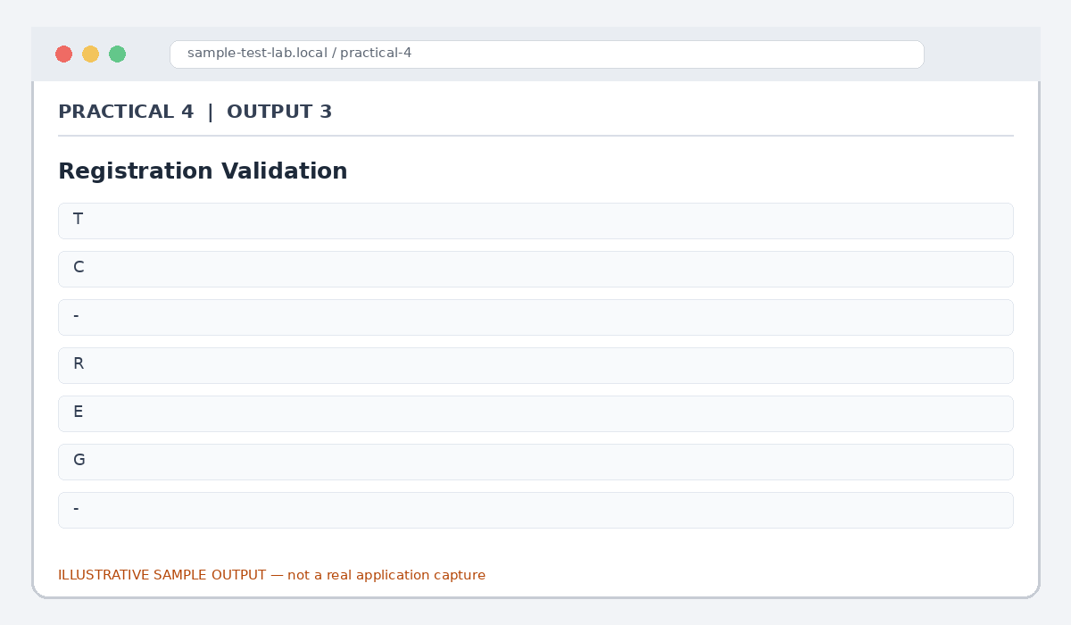
Figure 4.3: Registration Validation (illustrative sample)

Output 4: Payment - Functional Check
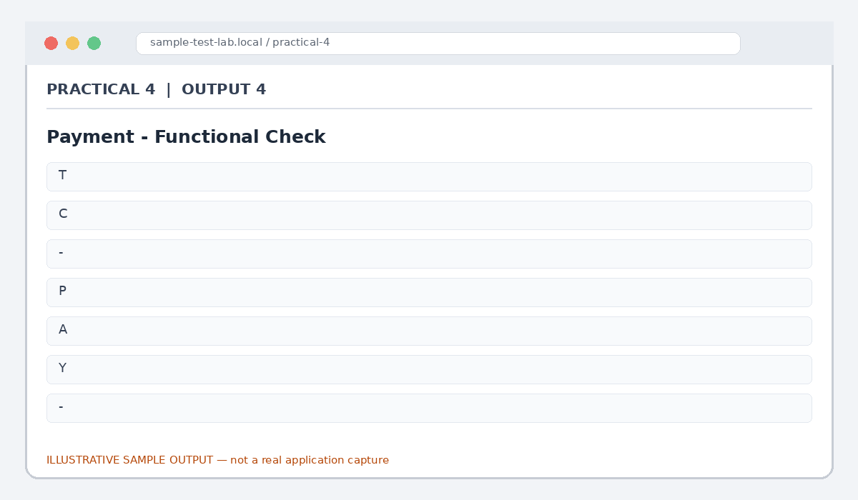
Figure 4.4: Payment - Functional Check (illustrative sample)

Output 5: Non-functional Checks
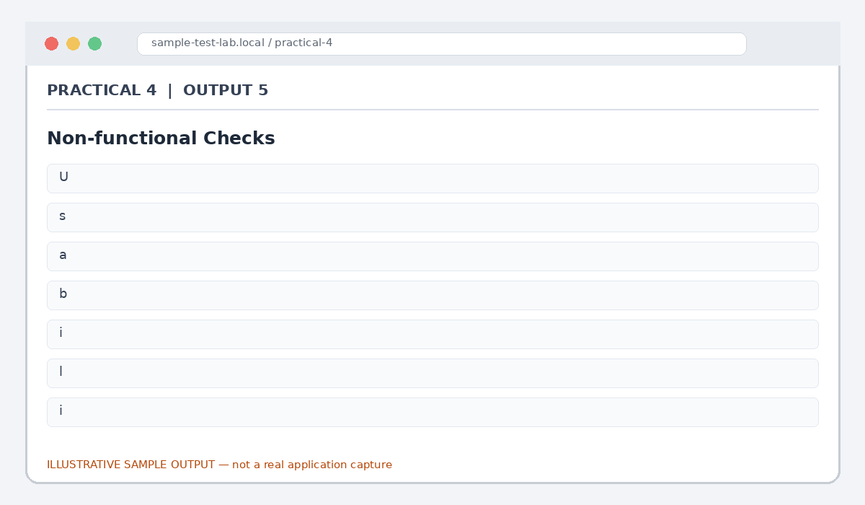
Figure 4.5: Non-functional Checks (illustrative sample)

Result
Positive, negative, functional and non-functional sample test cases were designed for login, registration and payment-related flows.

Note for Final Submission
Check the exact rules, requirements, and results from your assigned application/manual before submitting. Any sample status, test data, limits, counts, or defect priorities in this document are examples and should be replaced with actual lab observations where required.

